Catalogue Solution Migration Process

Version 1.1
Version | Date | Lead Author | Comments
1.0 | 08 May 2019 | Paul Lucas | Base-lined
1.1 | 20 November 2019 | Les Fawcett | Minor changes to align with Service Management and Buying Catalogue

- INTRODUCTION

Document Purpose
  - The purpose of this document is to describe the responsibilities of various parties in the migration of a Source Solution to one or more Target Solutions.
  - This document applies to the migration to and from both Type 1 and Type 2 Catalogue Solutions.
  - Note, capitalised terms in this document are either defined in the schedule 1 (Definitions) of the Call Off Agreement or in the glossary at Annex 1 to this document.

Structure
  - This document sets out:
    - In Section 2: the principles applicable to the migration between Catalogue Solutions;
    - In Section 3: the key features applicable to the migration between Catalogue Solutions;
    - In Section 4: the key responsibilities applicable to the migration between Catalogue Solutions;
    - In Section 5: the processes applied to the migration between Catalogue Solutions.

Context
  - The migration of services for a Service Recipient may encompass:
    - a single Source Solution to Target Solution migration; or
    - multiple Source Solution migrations to a single Target Solution; or
    - a single Source Solution migration to multiple Target Solutions; or
    - multiple Source Solution migrations to multiple Target Solutions.
  - The remainder of this document relates to a Service Recipient migrating from a single Source Solution to a single Target Solution and the obligations on parties to ensure an effective migration. The process can be applied equally to the other migration scenarios set out in paragraph 1.4 and the Supplier shall collaborate with all relevant Source Solution Suppliers and Target Solution Suppliers to facilitate the overall migration required by the Service Recipient.
  - The process is described in four parts, namely the principles, key features, key responsibilities and process obligations.
  - Within the context of this document the Supplier may be the Source Solution Supplier, Target Solution Supplier or both.).
- CATALOGUE SOLUTION MIGRATION - PRINCIPLES
  - The following principles apply to the migration between Catalogue Solutions:
    - it is critical that Service Recipients are able to migrate effectively between Catalogue Solutions in order to secure the most economically advantageous services and to adapt to emerging business needs;
    - the Supplier is, subject to any current technical and operational constraints, committed to provide reasonable endeavours in enabling Service Recipients to migrate to and from their Catalogue Solutions in an efficient and effective manner;
    - the Supplier will collaborate effectively with other suppliers, Service Recipients, Call Off Ordering Parties and any other party contributing to the migration; and
    - the Supplier shall ensure that all data is managed safely and securely and in accordance with all relevant guidelines and best practice.
- CATALOGUE SOLUTION MIGRATION – KEY FEATURES
  - If the Data Migration Approach of the Source Solution Supplier agreed under the Data Migration Standard approved by the Catalogue Authority states that the Source Solution does not hold any data of relevance to migration, the Source Solution Supplier shall notify the Service Recipient and Target Solution Supplier of this fact and shall be relieved of its other responsibilities under this ancillary document.
  - If the Data Migration Approach of the Target Solution Supplier approved by the Catalogue Authority states that the Target Solution does not hold any data of relevance to migration, the Target Solution Supplier shall notify the Service Recipient and Source Solution Supplier of this fact and shall be relieved of its other responsibilities under this ancillary document.
  - Where data is to be migrated from the Source Solution the Source Solution Supplier shall provide such data to the Target Solution Supplier and/or the Service Recipient in accordance with the process set out in this document, their applicable Data Migration Approach and Documented Data Extract.
  - Where data is to be migrated to the Target Solution the Target Solution Supplier shall accept the data in the form set out in the Source Solution Supplier’s Documented Data Extract and shall process such data in accordance with the process set out in this document and their applicable Data Migration Approach.
  - The Supplier shall ensure compliance with the Information Governance Standard with regard to the processing of all data within their boundary of responsibility and shall, to the extent applicable, adhere to their responsibilities and SLAs as set out in the remainder of this document.
  - The Service Recipient as Data Controller shall have ultimate responsibility for validating and signing off the data migration and the Supplier shall fully support the Service Recipient in executing such responsibility.
  - Where the Service Recipient is a GP Practice, the migration must be executed in compliance with Chapter 8c of the General Practice GPG, which provides guidance to organisations undertaking a Data Migration.
  - The Supplier will need to provide a data migration service that facilitates the extraction and analysis of the contents of patient records, audit logs and any other associated documents, attachments and administrative information from the Source Solution in a safe and effective manner such that it can be transformed, loaded and replicated in the Target Solution.
  - All parties involved in the migration process which may include Source Solution Suppliers, Target Solution Suppliers, third party or specialist suppliers, the Service Recipient, Call Off Ordering Party, CCG/CSUs and other organisations will collaborate to ensure that:
    - the time required to complete the migration and switch Catalogue Solutions is minimised and must not extend the migration period beyond the Service Level Agreement timescales;
    - the impact on and disruption to core working hours and the provision of health and care services is minimised;
    - aspects of the migration process which cause disruption to normal operations and provision of services take place outside core working hours wherever possible;
    - any questions regarding e.g. interpretation and mapping of data are resolved quickly and are appropriately documented;
    - no clinical data or access to clinical data is lost during the migration;
    - any requests for information relevant to executing the migration are responded to as quickly and efficiently as possible;
    - details and arrangements of the 'rollback' scenarios and procedures whereby the Service Recipient opts not to continue with the data migration are agreed and documented.
  - Where clinical data is stored in a system (either a Catalogue Solution or non-Catalogue Solution) which is required to integrate with the Target Solution but is not part of the overall migration (e.g. where a Service Recipient uses a separate system for say Document Management which stores clinical data and that system is not migrating), then the Target System Supplier shall ensure that such system is appropriately integrated with the Target Solution. The parties will collaborate to ensure no clinical data or access to clinical data is lost during the data migration.
- CATALOGUE SOLUTION MIGRATION – KEY RESPONSIBILITIES

All Parties
  - The following key responsibilities apply to all parties involved in the migration:
    - All material associated with the migration shall be maintained to facilitate continual improvement. To include for example, issue logs, data mapping tables and lessons learned.
    - The parties consent to the sharing of non-patient-identifiable information regarding the output of data migration audits with other suppliers and organisations undertaking a migration.
    - If the Cut-Over Period associated with a migration exceeds 72 hours, whether planned or unplanned, it will be reported to the Migration Management Agent.
    - If the Cut-Over period has an impact on core working hours, whether planned or unplanned, it will be reported to the Migration Management Agent.

Service Recipients
  - The following key responsibilities apply to Service Recipients or the Call Off Ordering Party where they are acting on the Service Recipient’s behalf:
    - Service Recipients, as the Data Controller, hold overall responsibility for the oversight of the data aspects of the migration and ensuring that all data is migrated securely and in line with the relevant legislation, Standards and guidelines.
    - Service Recipients are responsible for:
      - the mapping of local codes
      - validation of the data transformation activities
      - authorising Go-Live
      - authorising final sign-off and handover of the data migration activities
      - reporting and escalating issues to Migration Management Agent
      - undertaking a review of the data migration activity and sharing the output as part of the continuous review process
      - ensuring users are appropriately trained in the use of the Target Solution and calling on support from the Supplier as required.
  - Service Recipients and/or the Call Off Ordering Party may choose to engage the support of a third party supplier to assist with the migration process.
  - A failure by the Service Recipient (or party acting on their behalf) to fulfil the responsibilities set out in paragraph 4.2, or as specified elsewhere in this document, shall be a Relief Event under the Call Off Agreement.

Supplier
  - The following key responsibilities apply to the Supplier (whether acting as the Source Solution Supplier or the Target Solution Supplier):
    - The Supplier will support the Service Recipient or other parties involved in the migration in any way as is reasonably required to ensure the migration activities are completed as efficiently as possible and in line with this document.
    - The Supplier will provide their Data Migration Approach and a Documented Data Extract (DDE), adapted where necessary to all parties involved in the migration.
    - The Supplier will demonstrate how their Data Migration Approach, mapping tables and associated processes will be reviewed to take account of lessons learned and improvements identified as part of the continuous review process.
    - The Supplier shall retain comprehensive evidence relating to each relevant stage of the agreed migration process and will provide the same to Migration Management Agent and/or the Service Recipient upon request.
    - The Supplier shall provide a response to any clarification points raised by Migration Management Agent regarding any information submitted by the Supplier within five working days of receipt of such a request.
    - The Supplier shall provide data migration reports, to include the following information as a minimum, to Migration Management Agent on request. These will not be requested in excess of four times per year:
      - Number of data migrations completed since the last report
      - ODS code (or other identifier where an ODS code is not applicable) of each Service Recipient or other organisation for which a data migration has been completed. In the case of a Service Recipient merger/split or the formation of a new organisation, then the ODS code of the new organisation will be returned
      - The Cut-Over Period for each completed data migration (the duration of the Cut-Over period for each data migration)
      - Each Cut-Over Period that overlapped with core working hours for each completed data migration. There should be no (or very few) such examples of this, but it is important that any examples that do occur are reported

Overall elapsed time for each completed data migration (the amount of time from when the order for the new Catalogue Solution is placed via the agreed mechanism to the date of Business Go-Live) During the reporting period the Supplier may have acted as both a Source and Target Solution Supplier. A full response shall be submitted for each data migration in which they have been involved. Where a particular item of information is not applicable, this should be stated but the Authority reserves a right to request that information as an ad-hoc requirement.
  - A failure by the Source Solution Supplier to fulfil the responsibilities applicable to them as set out in paragraph 4.5, or as specified elsewhere in this document, shall be a Default under the relevant Call Off Agreement.
  - A failure by the Target Solution Supplier to fulfil the responsibilities applicable to them as set out in paragraph 4.5, or as specified elsewhere in this document, shall be a Default under the relevant Call Off Agreement.

Migration Management Agent
  - The following key responsibilities apply to the Migration Management Agent:
    - The Migration Management Agent will act as a point of escalation with regards to migration issues.
    - The Migration Management Agent will facilitate resolution of migration related issues upon request from any of the parties involved in the migration.
  - A failure by the Migration Management Agent to fulfil the responsibilities set out in paragraph 4.8, or as specified elsewhere in this document, shall be a Relief Event under the Call Off Agreement.
Supplier Principles: SLA
The Supplier shall provide a response to the Migration Management Agent on points of clarification raised regarding any information submitted, or any other queries relating to a migration, within five working days of receiving such request.

- CATALOGUE SOLUTION MIGRATION - PROCESS
  - The diagrams and steps set out below show the key elements of the data migration process. It includes four main actors: Service Recipient/CCG (to include any other organisation which may be responsible for a data migration), Source Solution Supplier, Target Solution Supplier and Migration Management Agent. The role of Migration Management Agent in the actual migration process is limited and involvement will mostly be retained for escalations. This process is split into the following three phases:
    - Phase 1: Data Migration Preparation
    - Phase 2: Data Transformation
    - Phase 3: Business Go-Live

  - Phase 1: Data Migration Preparation
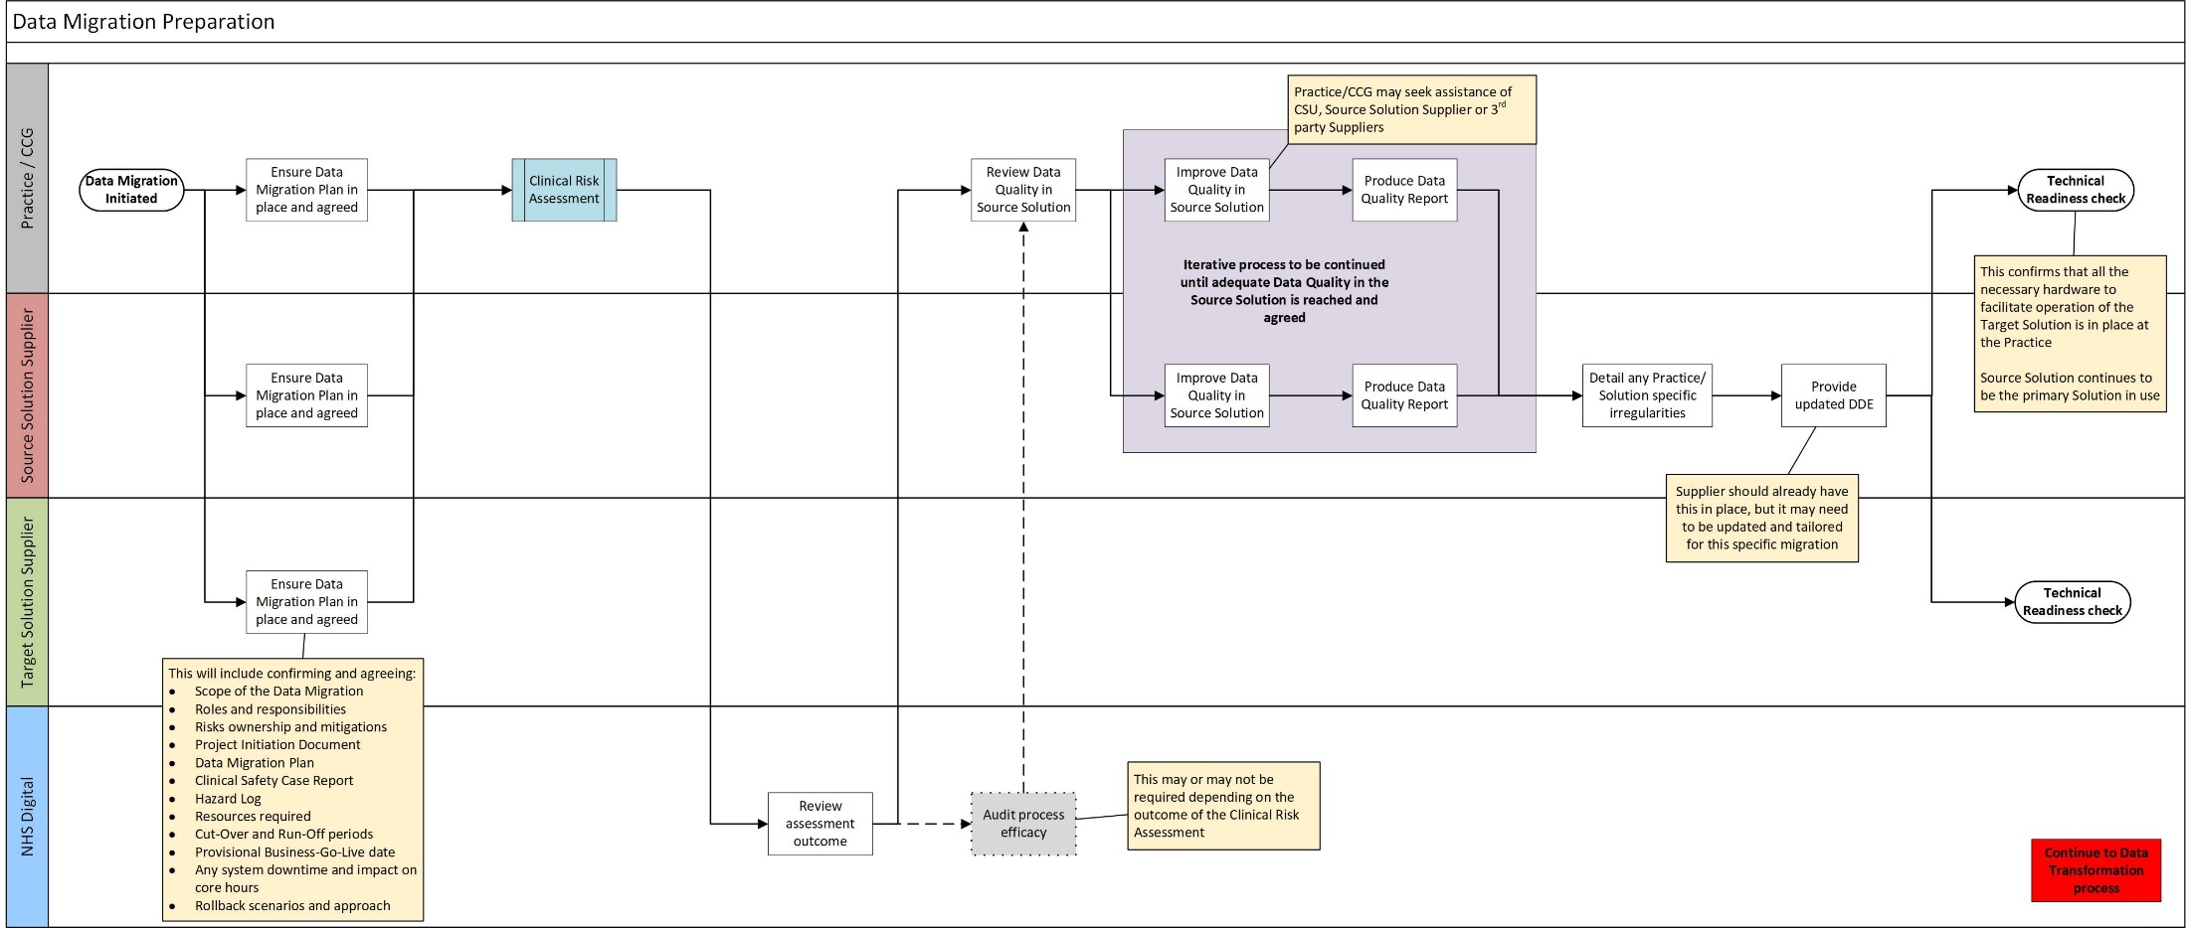

Step 1: Process Triggered
  - The Data Migration process is triggered when a Service Recipient is included in a Call Off Agreement that requires the migration of data between one or more Source Solutions and one or more Target Solutions. The obligation to fulfil the Source Solution Supplier responsibilities in this document are included in that supplier’s exit obligations and the obligation to fulfil the Target Solution Supplier responsibilities in this document are included in that supplier’s implementation obligations.
Step 2: Data Migration Approach and Plans
  - The Source and Target Solution Suppliers will ensure that they have accurate and up to date Data Migration Approach documents in place and that plans for the data migration have been agreed between all parties such that they can be published and shared. This must include recognition of any dependencies with regard to other systems integrated with the Source and/or Target Solution to be migrated and an approach as to how this will be handled. Each data migration event should be considered as an individual case, therefore any specific details and aspects of the data migration must be agreed and the documentation updated accordingly and shared amongst all parties. This includes, but is not limited to:
    - Contractual arrangements and payments
    - Scope of the data migration i.e. are there any third parties involved, are there any integrated systems which hold data etc
    - Roles and responsibilities
    - Risk assessment including ownership and transfer of risks and any mitigation in place
    - Project Initiation Document
    - Clinical Safety Case Report and Hazard Log (Suppliers are required to have these in place in order to comply with the Clinical Safety Standard)
    - Resources required from each party
    - Anticipated timescales and agreement of a provisional Business Go-Live date
    - Arrangements for the Cut-Over Period
    - Run-Off period
    - Any downtime and/or limited availability of the Source or Target Solution the Service Recipient may be subject to, or where manual data entry into the Target Solution may be required. This will be reported to the Migration Management Agent.
    - Review process
    - Rollback scenarios and plan if the Service Recipient opts to withdraw from the purchase of the Target Solution.
Step 2: SLA
The Source and Target Suppliers will share the responsibility for delivering Step 2 of the process once it has been triggered. This element of the process will take no more than ten working days following the triggering of Data Migration.
Step 3: Clinical Risk Assessments
  - Once the Data Migration Approach and plans for the data migration have been agreed by all parties, the Service Recipient (or other party acting on behalf of the Service Recipient) has responsibility for completing a Clinical Risk Assessment to include consideration of clinical and patient safety. Where the Service Recipient considers there to be material risk associated with the migration, they shall issue the assessment to the Migration Management Agent for review. The review may provide recommendations which the relevant parties shall, acting reasonable, act upon. Should the review determine that a Migration Management Agent led audit to validate the efficacy of the processes, procedures and tools to be used by the Supplier is required, the parties shall support and facilitate the execution of such audit.
Step 3: SLAs
Service Recipient or the organisation involved in the Data Migration has one week from agreement of the Data Migration Approach and plans to complete the Clinical Risk Assessment.
If applicable, the Migration Management Agent has two weeks from receipt of the Clinical Risk Assessment outputs to complete the review and determine if a follow up audit is required. Any timescales associated with the audit if required will be set and agreed on a case by case basis.
Step 4: Source Solution data quality review
  - It is then necessary to review the quality of the data held in the Source Solution and to work to improve this up to a minimum standard which will be agreed by all parties. The Information Quality Assurance Programme provides guidance regarding this data quality review and improvement, data cleansing and preparation of the data for a migration. The Service Recipient may seek assistance from the CCG, CSU, Source Solution Supplier, or a third party supplier in order to undertake this activity. This process of review and improvement result in the creation of a data quality report which can be used to guide further iterations of the data quality review process and will cover:
    - any irregularities in the data
    - standard data quality checks
    - assessment of any misused concepts (e.g. use of clinical findings terms recorded as observables in SNOMED CT)
    - any bespoke requirements of the Service Recipient or organisation being migrated.
  - This report should be refreshed as the process continues and can be used to track the issues and improvements in the data quality. This process to improve the quality of the data in the Source Solution up to the minimum agreed standard will continue until all parties are satisfied. It will need to be completed and approved by someone of appropriate authority and seniority within the responsible organisation. Once this point is reached, a final data quality report may be produced to be signed off and used as an agreement between the Service Recipient and the Source Solution Supplier regarding the quality of the data to be migrated.
Step 4: SLA
This process will be completed within six weeks and both the Source and Target Suppliers will share the responsibility for delivering this Step.
Step 5: Documented Data Extract
  - Following the review and improvement of the Source Solution data quality, the Documented Data Extract should then be updated to include any specific irregularities and requirements associated with the way in which data has been entered into the Source Solution. This will be made available to the relevant parties as instructed by the Service Recipient. The DDE should provide all the information required by the Target Solution Supplier to be able to transform and load the data. Any bespoke mapping or issues logs resulting from Step 4 will also be made available to all parties.
Step 6: Technical Readiness check
  - The Technical Readiness check is to ensure that the Target Solution is ready to be deployed for use by the Service Recipient. Until this is confirmed or the Service Recipient has in place clear plans to achieve technical readiness, the preparation for the data migration cannot be completed and the data extracts should not be taken. The Source Solution continues to be the primary Solution in use by the Service Recipient.

  - Phase 2: Data Transformation
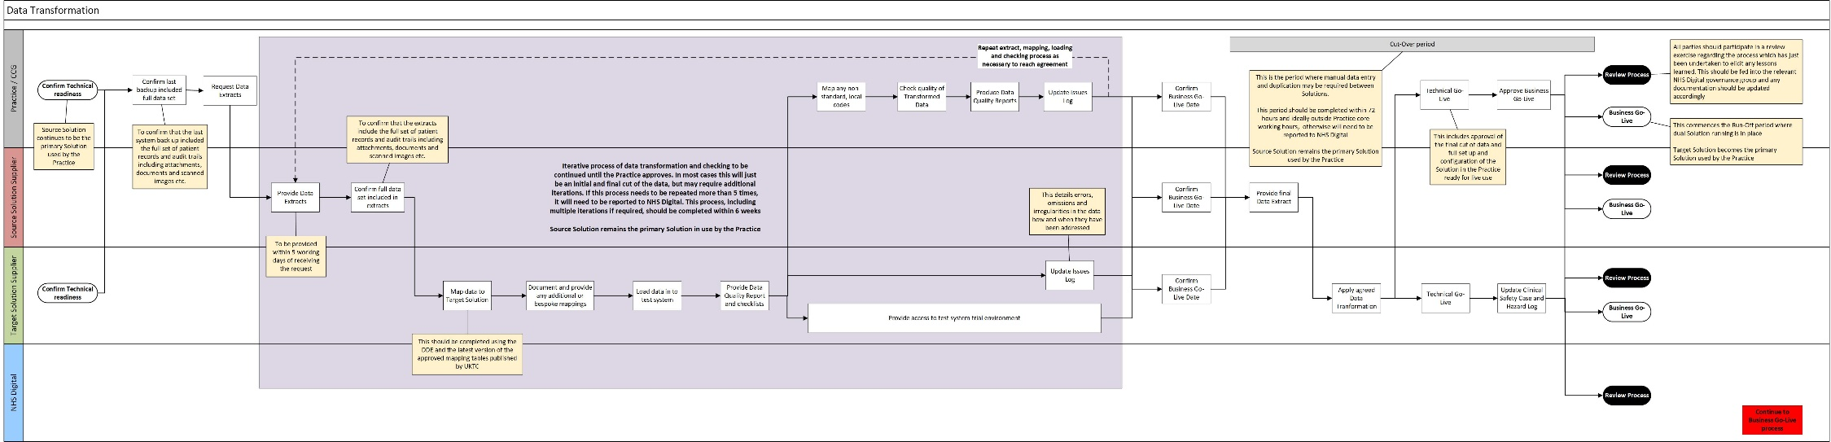

Step 7: Data Extracts
  - Once technical readiness is confirmed, or the Service Recipient has in place clear plans to achieve technical readiness, and prior to the provision of any data extracts, it is necessary for the Service Recipient to confirm that the most recent system backup included the full set of patient records and audit trails, including documents, attached images and any other applicable tasks, appointments or administrative information. Once this is confirmed and the data extracts are requested by the Service Recipient, the Source Solution Supplier shall (without undue delay and in no circumstances in more than two working days) provide all of the data extracts to the Target Solution Supplier and/or the Service Recipient/other organisation (as instructed by the Service Recipient as Data Controller) in a suitable encrypted, electronic format as documented in the DDE.
  - After taking and providing the data extracts, the Source Solution Supplier must confirm that these extracts include the full set of patient records and audit trails, including documents, attached images and any other applicable tasks, appointments or administrative information. These extracts will also need to be in human readable format without any undue degradation such that a user has no need to access a legacy Solution to view historic data once the migration is complete.
Step 7: SLAs
The Service Recipient has two working days after confirmation of technical readiness to confirm that the last system backup was complete.
From the receipt of the request from the Service Recipient, the Source Solution Supplier has no more than five working days to provide all of the data extract(s) to the Target Solution Supplier and/or Service Recipient as required.
Step 8: Target Solution Supplier data transformation and loading
  - The Target Solution Supplier will then undertake an exercise to map the data received from the Source Solution Supplier into a format which can be loaded into the Target Solution. This mapping will be completed using the DDE and the latest version of the mapping tables published by the NHS Digital National Release Centre (formerly UKTC) which are available from TRUD. Where this is not possible, the Target Solution Supplier will document and provide the mappings that have been used for the data transformation activities, including any bespoke mapping between the Source Solution and the Target Solution. The transformed data can then be loaded into the Target Solution and a data quality report and checklist provided to the Service Recipient to facilitate their review.
Step 8: SLA
The Target Solution Supplier has five working days from receipt of the data extracts to complete the data transformation, load the information into the Target Solution and provide a data quality report and checklist to the organisation responsible for the Data Migration NB. in the event that multiple iterations of data extracts and transformation are required, this SLA applies to the transformation activities required for each set of extracts provided.

Step 9: Test system access and data quality review
  - The Target Solution Supplier will provide the Service Recipient with access to a test system trial environment to enable the quality of the transformed data to be reviewed. During this checking the organisation responsible for the data migration is responsible for completing the mapping of any non-standard or local codes or data items which the Target Solution Supplier has been unable to map as part of their data transformation activities. These should be identified in the reports and checklists provided by the Target Solution Supplier and documented for future reference. During the data quality review process, an issues log detailing any mapping issues and how they have been resolved will be maintained by all relevant parties. Once the checking is complete the Service Recipient shall provide a report to the Target Solution Supplier. This report will inform any further iterations of data extracts and transformation which may be required and may then also be used as an agreement to progress to the next step.
Steps 7-9: Note and SLAs
Steps 7-9 of this process may need to be repeated several times in order to fully and accurately complete and sign off the data transformation activities. Suppliers will need to undertake further mapping and transformation activities and/or facilitate the provision of additional data extracts to support this.
There should not be a need for any more than five separate iterations of data extracts (whether full, partial or deltas) or data transformation for a migration. In the event that this data transformation process needs to repeated more than five times, it will be necessary for the Service Recipient and Source Solution Supplier to notify the Migration Management Agent in order that it can be assessed if the migration has been compromised. Throughout this, all parties must be aware of any potential data loss or overwriting of information and highlight and handle this accordingly.
Steps 7-9, including multiple iterations if required will be completed within six weeks of the first request for data extracts from the Service Recipient and or Target Solution Supplier.

Step 9: SLAs
The Target Solution Supplier has two working days following loading of the data to make a test system trial environment available to the specified users of the Service Recipient.
The Service Recipient has five working days to check the quality of the transformed data, to undertake the mapping of any non-standard local codes and to provide a report to the Target Solution Supplier.
Step 10: Cut-over period and Business Go-Live
  - Once agreement is reached regarding the data transformation activities undertaken, all parties involved in the migration will confirm the Business Go-Live date which should have been set during the Data Migration preparation phase. This triggers the provision of the final data extract by the Source Solution Supplier and the start of the Cut-Over period. The Target Solution Supplier will then apply the data transformation and mapping as agreed and documented during steps 7-9. Once this is complete and the data is loaded into the Target Solution, Technical Go-Live is triggered. This is the process of ensuring the Target Solution is fully set up and configured for live use by the Service Recipient, for examples setting up smartcards, printers, prescriptions, flows of data between systems, rotas etc. The Service Recipient will then need to give final approval before Business Go-Live.
  - It is essential that all parties involved in the migration collaborate effectively to ensure that the Cut-Over Period is as short as possible and wherever practicable takes place outside of core working hours. If the Cut-Over Period exceeds 72 hours, whether planned or unplanned, and/or has an impact on core working hours, this will need to be reported to the Migration Management Agent by the Target Solution Supplier without undue delay and in no circumstances later than 5 working days after completion of the Cut-Over Period. The Source Solution remains the primary Solution in use during this period.
Step 10: SLAs
The Cut-Over Period will not exceed 72 hours. Any period beyond this must be reported to the Migration Management Agent by the Target Solution Supplier without undue delay and in no circumstances later than 5 working days after completion of the Cut-Over Period.
Any disruption to core working hours as a result of the Cut-Over Period will need to be reported to the Migration Management Agent by the Target Solution Supplier without undue delay and in no circumstances later than 5 working days after completion of the Cut-Over Period.
Step 10a: Process Review
  - A review led by the Service Recipient or Call Off Ordering Party and contributed to by the Supplier should be undertaken to elicit any lessons learned and to feed into the cycle of continuous improvement of the processes and procedures associated with a data migration. This review can take place alongside the subsequent steps of the data migration process and should not delay it. The review should include consideration of the effectiveness of the following aspects as a minimum:
    - The process which has just been completed
    - Mapping tables
    - Data Migration Approach
    - Documented Data Extract
    - Hazard Log and Clinical Safety Case
    - Issues Logs.
  - Documentation should be updated and maintained by the relevant parties as necessary in order that it can be shared with the Migration Management Agent in the case of any incidents or issues and/or if requested as part of continuous improvement and for reference in subsequent data migrations.
Step 10a: SLA
This review will be completed within two weeks of Business Go-Live

  - Phase 3: Business Go-Live
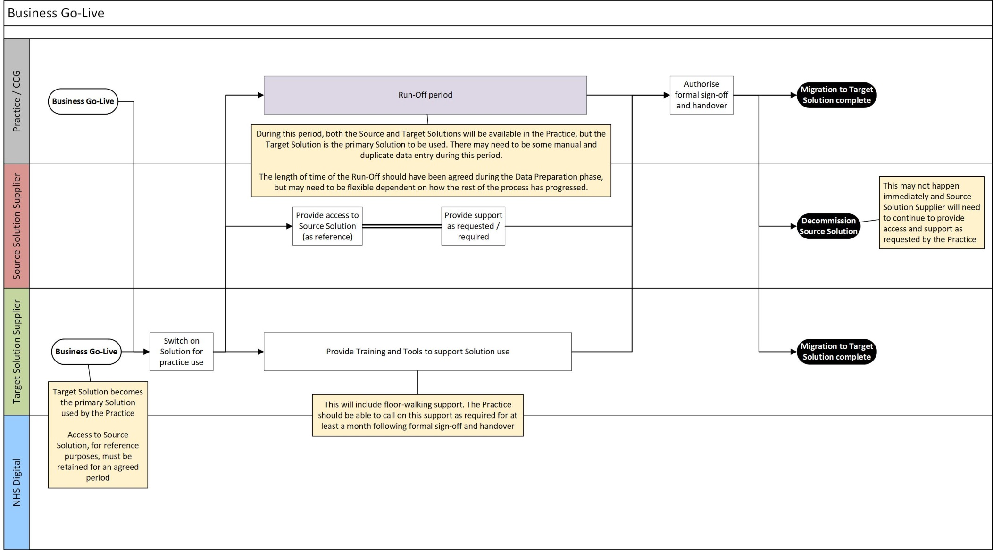

Step 11: Business Go-Live
  - Business Go-Live is where the Target Solution is switched on for live use and becomes the primary Solution to be used by the Service Recipient. The Source Solution should not be switched off at this point in case there are any issues with the switch on of the Target Solution, although access levels and usage may be restricted such that it is used for reference purposes only.
Step 11: SLA
The Target Solution Supplier has two working days to attain Business Go-Live following approval by the Service Recipient to do so.
Step 12: Run-Off period
  - This triggers the “run-off period” where there is dual running of the Source and Target Solutions, but the Target Solution is the primary Solution in use and the Source Solution is likely to be used for reference purposes only. The period of time for the run-off period will have been agreed during the Data Migration Preparation phase and will be recorded in the relevant documentation. During this period, the Source Solution Supplier will continue to provide access to the Source Solution for reference purposes only, along with continuing to provide support services as required. The duration of the run-off period will need to be flexible based on the specifics of the data migration and how it has progressed and the ability of the Service Recipient to fulfil their obligations. The Service Recipient may require support from the Source Solution Supplier a significant amount of time into the future in order to be able to respond fully to Freedom of Information requests and similar and will therefore need to be able to facilitate this
  - During and/or in advance of this period, the Target Solution Supplier will provide staff, facilities and training, including floor-walking staff, as required to ensure that the Service Recipient is supported in its use of the Target Solution and can meet any necessary responsibilities and obligations effectively.
Step 13: Authorisation and handover
  - Once someone of suitable authority and seniority from the Service Recipient has verified that all their obligations can be met and they can operate efficiently using the Target Solution, they can authorise formal sign-off and completion of the data migration activities and handover to the Target Solution Supplier. At this point, the Source Solution can be decommissioned but only on the explicit confirmation of the Service Recipient. Arrangements will be in place to ensure that access to Source Solution data and audit trails in human readable format without any undue degradation is maintained in accordance with the relevant contractual arrangements. This will include the provision of any necessary support services from the Source Solution Supplier.
  - In the period following handover, the Target Solution Supplier will provide further floor-walking support and training if required and requested.
  - Until sign-off of the data migration is authorised, it is possible that the Service Recipient could choose to abort the data migration and revert to the Source Solution. Arrangements for this scenario should have been agreed between all parties during the Data Migration Preparation phase. Where payment for the Data Migration Services is required, this will only be made once the Buyer has validated that the Target Solution is operating in a satisfactory manner and that all data has been transferred successfully.
  - This completes the data migration and the migration of Catalogue Solutions. The Target Solution Supplier will continue to provide support as required by the Service Recipient to ensure that the training and support needs of staff and the quality of data recorded in the Target Solution are maintained and improved. Any data migration related incidents raised following formal sign off and handover will be raised through the usual incident management process.

ANNEX 1 – GLOSSARY OF TERMS

“Business Go-live” means the date on which Milestone M1 is Achieved for a Service Instance;

“Cut-Over Period” means the time between the provision of the final data extract to the Target Solution Supplier from the Source Solution Supplier to the point of Business Go-Live;

“Data Migration Approach” means the data migration approach for a Catalogue Solution that the Supplier is obligated to produce as part of compliance assessment against the Data Migration Standard;

“Documented Data Extract (DDE)” means the document that describes the format and content of the data extract(s) applicable to a Catalogue Solution that the Supplier is obligated to produce as part of compliance assessment against the Data Migration Standard;

“Migration Management Agent” means the organisation that provides oversight and an escalation point for Catalogue Solution migrations, which shall be NHS Digital for Type 1 Catalogue Solutions and the Call Off Ordering Party for Type 2 Catalogue Solutions;

“Source Solution” means a Catalogue Solution that is being replaced by one or more other Catalogue Solutions;

“Source Solution Supplier” means a Supplier whose Catalogue Solution is being replaced by one or more Catalogue Solutions from one or more Target Solution Suppliers;

“Target Solution” means a Catalogue Solution that is replacing one or more Catalogue Solutions from one or more Source Solution Suppliers;

“Target Solution Supplier” means a Supplier whose Catalogue Solution is replacing one or more Catalogue Solutions from one or more Source Solution Suppliers;

