Document filename: | AA2 Implementing the Allergy Archetype in the GP2GP Message
Project / Programme | GP Connect | Project | Access Record Structured
Document Reference | AA2
Project Manager | Simon Fitzgerald | Status | Final
Owner | Simon Fitzgerald | Version | 1
Author | Pete Salisbury | Version issue date | 09/10/2018

Implementing the GPSoC Allergy Archetype in the GP2GP Message

Improving allergy interoperability

Document management
Revision History
Version | Date | Summary of Changes
0.1 | 14/03/2018 | Initial draft
0.2 | 22/06/2018 | Second draft following initial reviews with team
0.3 | 29/08/2018 | Technical author initial review
0.4 | 25/09/2018 | Updated following clinical and further technical review
0.5 | 27/09/2018 | Added new template and reviewed
0.6 | 28/09/2018 | Baselined
1.0 | 09/10/2018 | Updated following clinical approval

Reviewers
This document must be reviewed by the following people:
Reviewer name | Title / Responsibility | Date | Version
Leo Fogarty | Clinical Safety Officer, GP2GP
Neill Jones | Clinical Safety Lead, GP2GP
Pete Turnbull | Interoperability Lead, SNOMED in Primary Care
Andrew Perry | UK Terminology Centre
Simon Fitzgerald | GP Connect Project Manager for Structured Data
Marcus Baw | GP Connect and GPSoC Clinical Advisor
Rob Jeeves | GP Connect Clinical Advisor

Approved by
This document must be approved by the following people:
Name | Signature | Title | Date | Version
Neill Jones |  | GP2GP Clinical Lead
Marcus Baw |  | GP Connect and GPSoC Clinical Advisor

Glossary of Terms
Term / Abbreviation | What it stands for
AMP | Actual Medicinal Product
Archetype | A formal re-usable model of a domain concept.
dm+d | Dictionary of medications and devices is a UK terminology system published by TRUD.
FHIR | Fast Healthcare Interoperable Resources is a healthcare interoperability standard supported by HL7.
GP2GP | Electronic transfer of a patient’s electronic health record between two general practices.
GPSoC | General Practice Systems of Choice framework
SNOMED-CT | Systematized Nomenclature Of Medicine Clinical Terms is a systematically organised computer processable collection of medical terms providing codes, terms, synonyms and definitions used in clinical documentation and reporting.
TRUD | Technology Reference data Update Distribution is a service provided by the UK terminology centre at NHS Digital to provide updates to terminology.
VMP | Virtual Medicinal Product
VTM | Virtual Therapeutic Moiety

References
Document No. | Document title | Author
AA1 | GPSoC Allergy Archetype Implementation Guidance | Pete Salisbury
AA3 | Implementing the Allergy Archetype in FHIR | Pete Salisbury
AA4 | GPSoC Allergy Archetype - GP Connect Allergy Guidance | Pete Salisbury

Document Control:
The controlled copy of this document is maintained in the NHS Digital corporate network. Any copies of this document held outside of that area, in whatever format (e.g. paper, email attachment), are considered to have passed out of control and should be checked for currency and validity.

Contents
1. Introduction 5
1.1. Purpose of document 5
2. Current state 5
2.1. Drug allergies 6
2.2. Allergy, unspecified 6
3. Representing the allergy archetype in the GP2GP message 6
3.1. Migrating the wrapper code to SNOMED 6
3.2. Representing a drug allergy in the ObservationStatement 7
4. Processing incoming allergies that are in the allergy archetype format 10
4.1. Recognising the new wrapper 10
4.2. Triggering decision support based on the ‘value’ element 10
4.3. Processing the allergy archetype qualifiers 10
Appendix A – New allergy format 11
Appendix B – Current allergy population examples 12
4.4. EMIS Web 12
4.5. Microtest Evolution 13
4.6. TPP SystmOne 14
4.7. Vision 15

Introduction
This document will detail how allergies are currently represented within the GP2GP message by the GP systems suppliers.

It will then specify how to represent allergies that are in the format of the GPSoC Allergy Archetype. It will also detail the transition from the current state to the new state and the new requirements for GP systems suppliers.

Purpose of document

Background context
The way in which allergies are represented in the GP2GP message is different from other types of data. All allergies are contained within ObservationStatements which are wrapped in a CompoundStatement that identifies that they are either drug allergies or non-drug allergies. Drug allergies can currently be represented differently within an observation statement, dependent on the supplier that is producing the message and how it was recorded in the system. On import, all systems are able to deal with the variance in format that is produced across suppliers.

The combination of these factors in the processing of inbound allergies allows for an approach where no change to the format or name of the GP2GP message is required. It is possible for the importing system to identify allergies coded in the new format using a new identifying code in the CompoundStatement wrapper. It can then use the existing import and degradation process to import allergies in the allergy archetype format even before any new import code has been implemented.

To achieve this, a change will be required by suppliers before any implementations to recognise the new allergy wrapper.

When the archetype is implemented compliant systems will also be able to process any qualifiers that are contained within the message.

Current state
The allergy archetype work applies specifically to allergies classed as drug allergies, but this document will also detail the changes to the wrapper for non-drug allergies required to make it SNOMED compliant.

In the GP2GP message, allergies can be represented as one of two types of allergy. All clinical items from the allergies section in a clinical system are exported into a CompoundStatement that identifies them using Read2 codes as one of the following types:

- 14L..00 H/O Drug Allergy
- SN53.00 Allergy, unspecified

This means that even if a receiving system does not understand the code that is contained in the message it is still identified as an allergy using one of the 2 codes above and can be processed accordingly.

This enables clinical systems to safely deal with any incoming allergies by using the current import and degradation to highlight any coded information contained within the wrapper that it doesn’t understand and use this information to trigger the decision support system.

Drug allergies
There are currently varying methods of representing drug allergy data within the GP2GP message. The allergy is always represented in an ObservationStatement that is contained in a CompoundStatement ‘wrapper’, which indicates that it is a drug allergy.

How the allergy is represented can change dependent on which GP clinical system it has been exported from and the level of data that was captured in the clinical system when the allergy was recorded.

Allergy, unspecified
Non-drug allergies are for the most part consistently represented across the different systems. The only change resulting from the introduction of the drug allergy archetype is the updating of the code in the CompoundStatement layer that identifies them to be a SNOMED code as described in this document. All other environmental allergy details can remain the same.

Representing the allergy archetype in the GP2GP message
For all clinical systems to support the move to the safe processing of allergies as GP clinical systems suppliers move from the current state to the new representation of allergies, it will be necessary for systems to be able to identify allergies in both the new and the old format. To do this we propose that any new format allergies are enclosed in a CompoundStatement ‘wrapper’ that will be identified by a SNOMED code.

Migrating the wrapper code to SNOMED
To make this possible before the transition to represent allergies in the new format begins, GP systems suppliers MUST be able to recognise CompoundStatements with either of the existing Read2 allergy identifier codes or the new SNOMED identifier codes as containing allergies. This MUST then trigger the appropriate action from the supplier’s decision support system.

All drug allergies that are present in the message in the new drug allergy archetype format SHALL be contained in CompoundStatement using the following SNOMED codes:

Type of Allergy | code - SNOMED ConceptID | displayName - SNOMED Preferred Term
H/O Drug allergy | 735933002 | History of allergy to drug’
H/O Allergy, unspecified | 161611007 | H/O: non-drug allergy

Representing a drug allergy in the ObservationStatement
When the allergy archetype is implemented the GP systems supplier MUST represent allergies in the GP2GP message in a consistent format. As before, this will be in an ObservationStatement within the appropriate wrapper as detailed above. This section provides details for populating each element where the population requirements change due to the introduction of the allergy archetype. The full example is given in Appendix B.

Populating the code field
The code element in the ObservationStatement MUST be populated in one of two ways:

- If there is a precoordinated code that is associated with the allergy in the sending system, then this MUST be used to populate the code element. This MUST be populated using the coding system that the code was input into this system as per the usual GP2GP requirements. For legacy terminologies, where there is a SNOMED map this must be populated as a translation element. Other translations SHOULD also still be populated – see example below:
- If there is no precoordinated code then the code element MUST be populated with the SNOMED code ‘735933002’ ‘History of allergy to drug’ – see example below:

Representing the qualifiers of the archetype
The qualifiers for the allergy archetype MUST be carried as qualifiers at the code level in the ObservationStatement if they are present in the GP clinical system. There are 3 qualifiers defined in the logical model for the allergy archetype. These are: severity, certainty and reaction. Where these have been recorded in the clinical system they MUST be populated in the qualifiers as a SNOMED code using the following attributes:
Qualifier | Attribute Name | Value
Severity | name@code | 272141005
 | name@displayName | Severities
 | name@codeSystem | 2.16.840.1.113883.2.1.3.2.4.15
 | value@code | The SNOMED code of the value – for example, 24484000.
 | value@displayName | The rubric relevant to the selected code. For the example above, ‘Severe’.
 | value@codeSystem | 2.16.840.1.113883.2.1.3.2.4.15
Certainty | name@code | 255544004
 | name@displayName | Certainties (qualifier value)
 | name@codeSystem | 2.16.840.1.113883.2.1.3.2.4.15
 | value@code | The SNOMED code of the value – for example, 1491118016.
 | value@displayName | The rubric relevant to the selected code. For the example above, ‘Improbable diagnosis’.
 | value@codeSystem | 2.16.840.1.113883.2.1.3.2.4.15
Reaction | name@code | 282100009
 | name@displayName | Adverse reaction to substance (disorder)
 | name@codeSystem | 2.16.840.1.113883.2.1.3.2.4.15
 | value@code | The SNOMED code of the value – for example,112625008.
 | value@displayName | The rubric relevant to the selected code. For the example above, ‘Cutaneous eruption’.
 | value@codeSystem | 2.16.840.1.113883.2.1.3.2.4.15

See the below example of how to populate the allergy archetype qualifiers in the GP2GP message:

All qualifiers MUST also be written in to the pertinentInformation in key value pairs as text using the displayName attributes until all GP systems are allergy archetype compliant. Similar to the example below:

Representing local qualifiers
Any local qualifiers that are present in the system may also be populated as qualifiers to the code but may be in a codeSystem other than SNOMED. All local qualifiers to the allergy MUST also be added as qualifiers to the code element. These elements are usually locally coded and if in the same codeSystem as the code SHOULD NOT carry a codeSystem attribution – see example below:

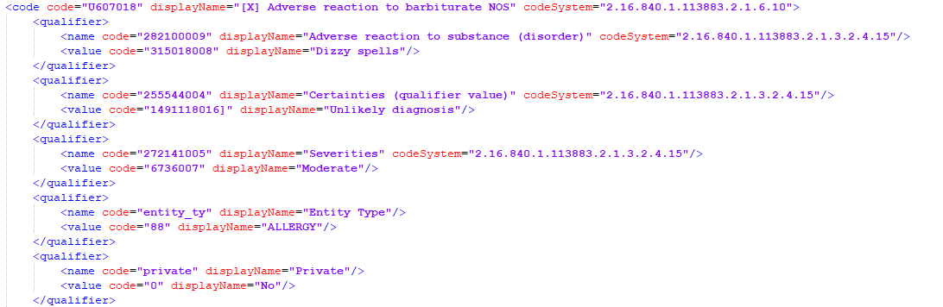

All local qualifiers that were output as text in key value pairs to the pertinentInformation element MUST continue to be output in the same format.

Using the ‘value’ to represent the causative agent
The causative agent of the allergy MUST be represented using the value element in the ObservationStatement. If the causative agent was input into the system using the causative agent list defined in dm+d, then this MUST be populated in the code attribute of the value element.

Populating translations to the value element
If the causative agent was implemented using a code not defined in the causative agent list but the code has a map to the list, then the mapped code MUST be included as a translation to the natively input code.

Processing incoming allergies that are in the allergy archetype format
When importing allergies, the existing GP2GP processes for degradation of any allergies that aren’t understood by the receiving system MUST still be observed and decision support systems triggered until any degraded allergies have been re-coded by a user with the appropriate permissions.

Recognising the new wrapper
When processing any items contained in the CompoundStatement coded with the SNOMED code 735933002 ‘History of drug allergy’ or 161611007 H/O: non-drug allergy the receiving system MUST recognise them as an allergy and treat them accordingly.

Triggering decision support based on the ‘value’ element
The clinical decision support system MUST recognise any codes item in the ‘value’ element or one of the contained translations if it is a member of the published allergy archetype causative agent list. The decision support system MUST then take the appropriate action relating to the allergy performing the prescribing and contraindication checking and alerting the user in line with the usual system decision support processes.

Processing the allergy archetype qualifiers
All allergy archetype qualifiers received in the format described in section 3.2.2 above MUST be processed and rendered to the user.

If relevant qualifiers exist within the clinical system the qualifiers SHOULD be added to the appropriate field in the clinical system.

Appendix A – New allergy format
Below is an example of how the ObservationStatement would be populated:

Appendix B – Current allergy population examples

EMIS Web
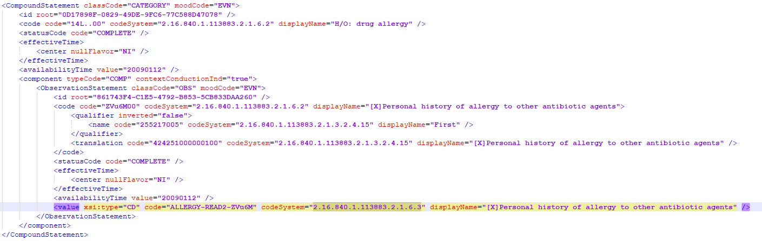

Microtest Evolution
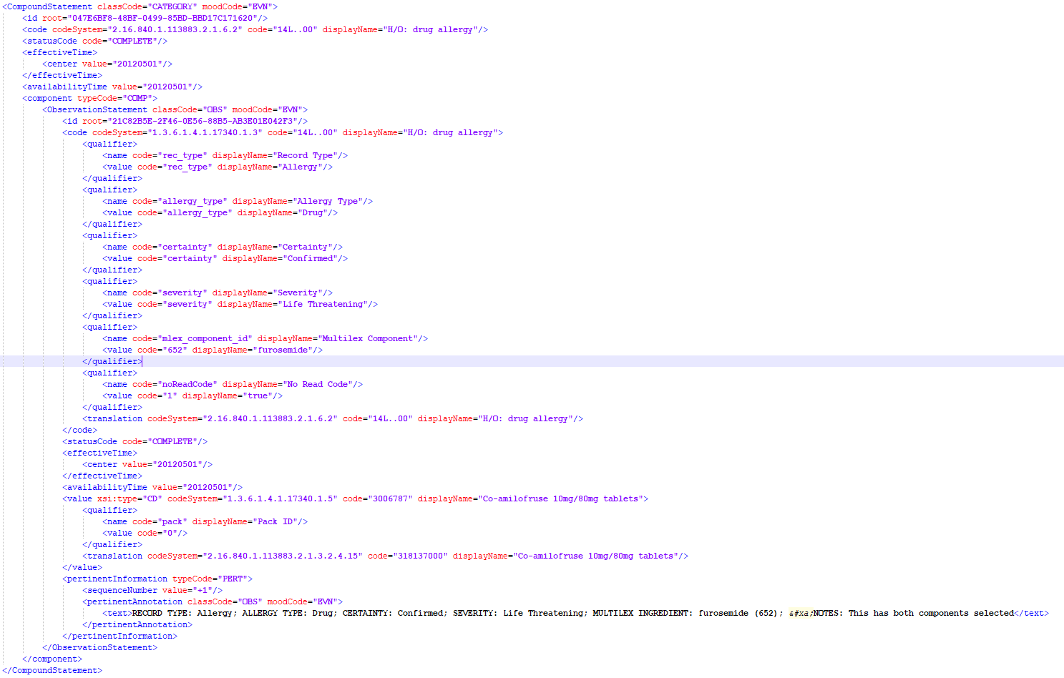

TPP SystmOne
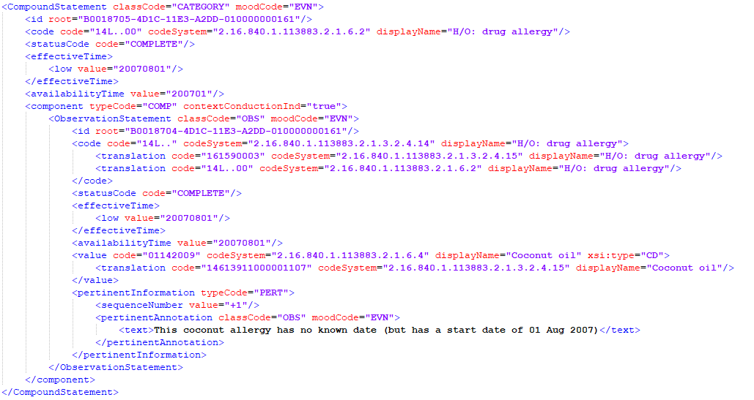

Vision
