Published 01 August 2016
SFTP Transfers
Guidance

Contents
Introduction 3
Tools 3
High Level Steps 3
Using puttygen.exe to create an SSH key pair 3
Installing and configuring WinSCP 4
To install WinSCP 5
Further reading 10

Introduction
This document is intended to give a step-by-step guide to setting up a SFTP transfer from a Windows platform (server or desktop) using freely available tools from the internet.
This document outlines one example of the many SFTP options available, and will not cover all the options available for each of the tools used within, but links will be given to the original documentation online where further reading would be beneficial.
Finally, no official support is provided for this document. When followed correctly, the steps in this document work. Where problems occur, we urge you to find the relevant documentation online and use these as a basis for your own troubleshooting.

Tools
The following applications will be used to set up the automated transfer:
- Puttygen.exe – a free tool to generate private & public SSH keys:
  - http://www.chiark.greenend.org.uk/~sgtatham/putty/download.html
- WinSCP – a free SSH and SFTP client with the ability to run scripted connections (the version used in this document is the “Installation package (sponsored)” from WinSCP 4.3.7 on the Downloads page):
  - http://winscp.net/eng/index.php
Details on downloading, installing and configuring all of the above are given below.

High Level Steps
The high-level steps for setting up automated transfers are as follows:
- Use puttygen.exe to create a public/private SSH key pair
- Download and install WinSCP
- Manually configure an upload / download using WinSCP
Below is a step-by-step guide showing how to achieve all of these tasks for anyone not familiar with the technology.

Using puttygen.exe to create an SSH key pair
- Download puttygen.exe from http://www.chiark.greenend.org.uk/~sgtatham/putty/download.html
- This is a flat executable and requires no installation. Save it to a suitable location and double-click to run the app:
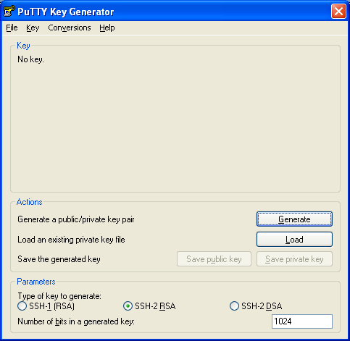

- When presented with the screen above, leave all the default settings in place and click the button marked “Generate”
- Wiggle your mouse randomly over the blank area to generate the data that is used to make the key:
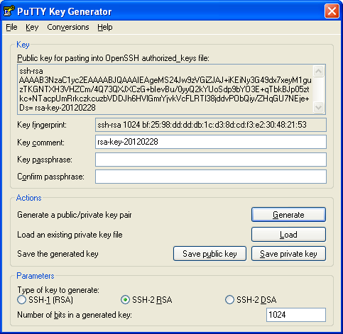
- Leaving the “Key passphrase” field blank (some SFTP clients are unable to import passphrase connected keys) click the button marked “Save public key” to save the public key.
- Then click the button marked “Save private key” to save the private key. (Ignore the warning about not having a passphrase to protect it.)
- Keep the private key safe and import this into your SFTP client / server. Send the public key to NHS Digital (seft.team@nhs.net).

Installing and configuring WinSCP
For this you will need four things:
- Hostname or IP to connect to
- Username
- Password
- Private SSH Key (as generated by puttygen above)
To install WinSCP:
- Open a web browser to http://winscp.net/eng/download.php
- Locate and download the latest version – at the time of writing, 4.3.7 was latest available version. Click on the hyperlink marked “Installation package” to download:
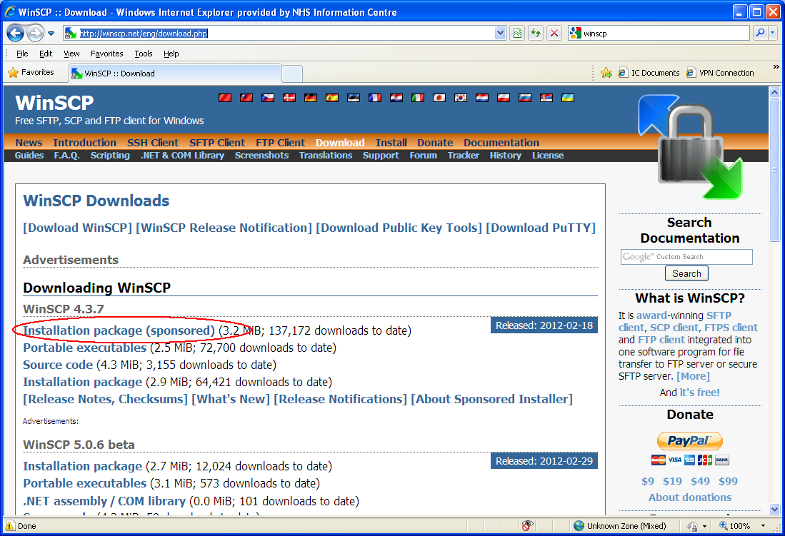
- Choose the option to Save “winscp437setup-sponsored.exe” to a location of your choice.
- Once downloaded, locate “winscp437setup-sponsored.exe” and double-click to start the install (NB – you will need admin rights over the machine to do this)
- Click past any security warnings and choose English as the setup language
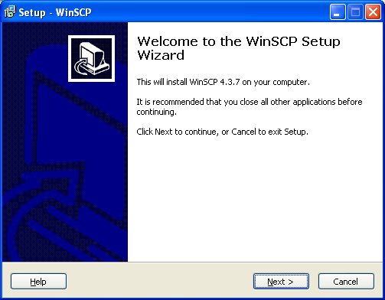
- Click Next on the welcome window
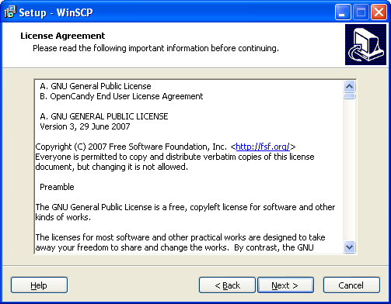
- Click Next on the License Agreement window
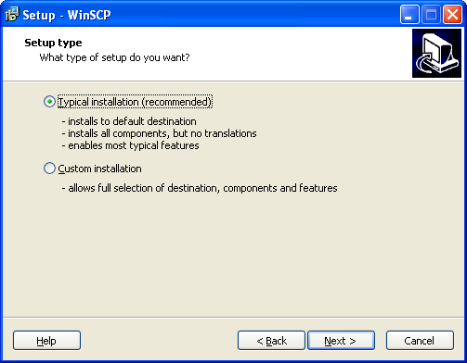
- Choose to install the Typical Installation and click Next
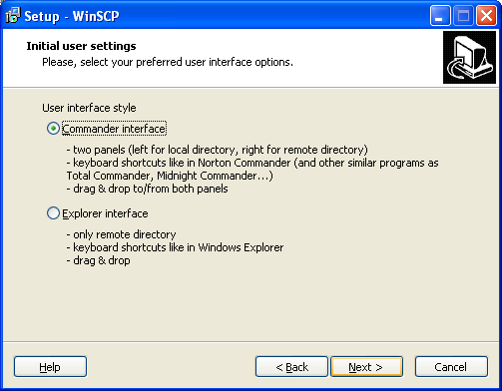
- Choose to use the Commander interface and click Next
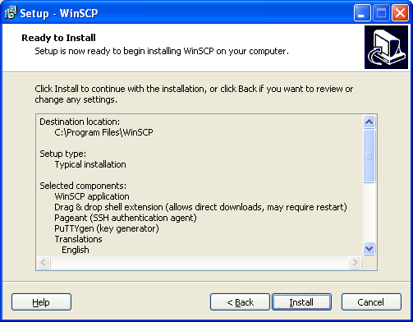
- Click Install to start the install
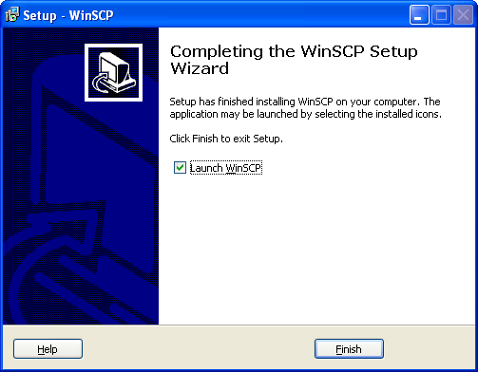
- Ensure that “Launch WinSCP” is selected and then click Finish to end the install and launch WinSCP for the first time:
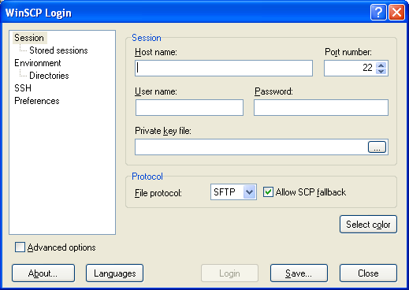
- Enter the Hostname, Username and Password details in the relevant areas above. Then click on the “…” button in the Private key file space to locate your private key:
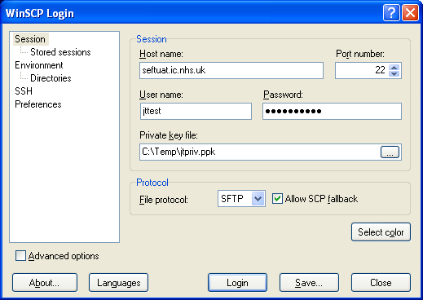
Please Note:
This example was set up in our UAT environment. When you set up your transfer the host will be www.seftprod.hscic.gov.uk

- Select, ‘SSH’ from the left-hand menu, please select and confirm that ‘Enable Compression’ is ticked
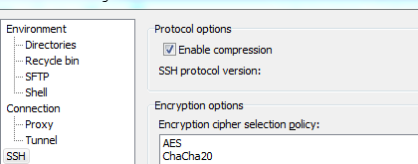

- Next, click the “Save” button to save the session – this is essential for the scripting to work later on:
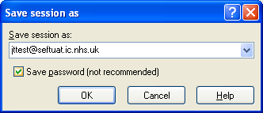.
- The default name will appear similar to that above, choose this or any other name you prefer. Ensure that the option to “Save password” is ticked as above (this is not ticked by default)
- You should now be able to see your session in “Stored sessions”:
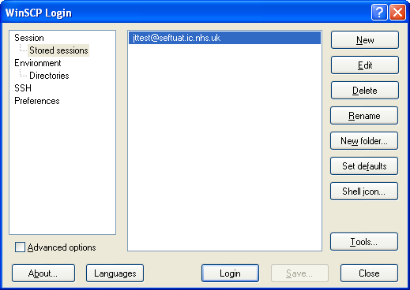
- Finally, test the session works by clicking Login
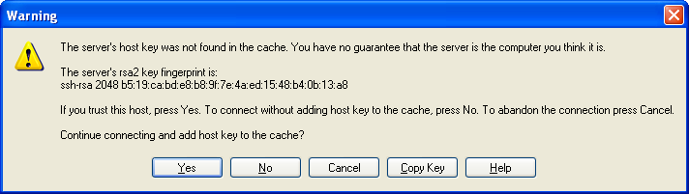
- First time you connect, a warning will appear advising that the server’s host was not found in the cache. Click Yes to continue connecting and add host key to the cache.
- If the connection has been successful, the following window will appear showing your session name at the top, your local folders and files in the pane on the left, and your remotely accessible folders on the right:
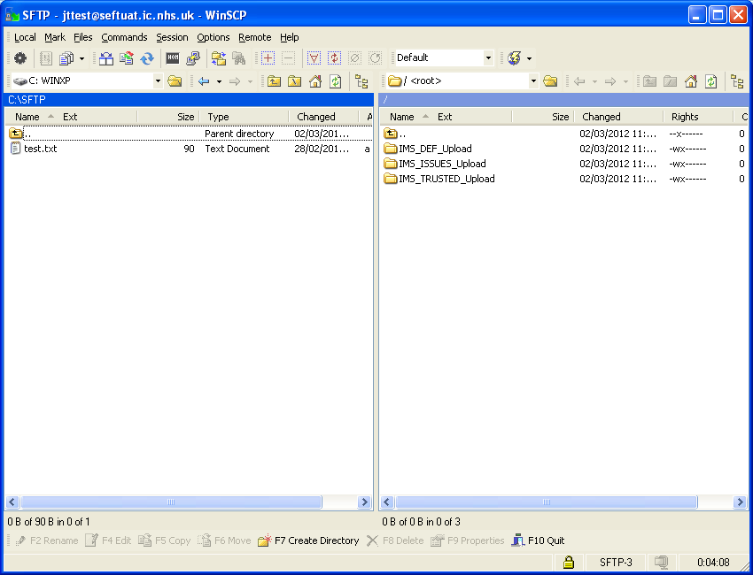
- At this point you can transfer a file. Open the folder in the right hand pane that equates to the transfer that you wish to perform. If you are uploading a file then search for and drag a file from your local drive in the left hand pane to the right hand pane. If you are downloading a file, select the file in the right hand pane and drag it to your local folder in the left hand pane.

Further reading
For more information on any of the tools or technologies covered in this document, please have a look at the following websites:
- WinSCP
  - Documentation - http://winscp.net/eng/docs/start
  - Example scripts - http://winscp.net/eng/docs/scripts
  - General scripting info - http://winscp.net/eng/docs/guide_automation
- PuttyGen
  - Is actually covered on the WinSCP site - http://winscp.net/eng/docs/ui_puttygen

