|  |  |  |  |
| --- | --- | --- | --- |
| HSCIC-FNT-TO-TAR-0081.03 CDA Document Technical Requirements v2.1.docx | | | |
| Directorate / Programme | OTS | Project | OTS |
| Document Reference | | HSCIC-FNT-TO-TAR-0081.03 | |
| Project Manager | Shaun Fletcher | Status | Published |
| Owner | Mike Curtis | Version | 2.1 |
| Author | Brendan McEnroe | Version issue date | 19/05/2014 |

CDA Document Technical Requirements

Document Management

Revision History

|  |  |  |
| --- | --- | --- |
| Version | Date | Summary of Changes |
| 0.1 | May 2011 | 1stdraft |
| 0.2 | July 2011 | 2nd draft |
| 1.0 | 15th Aug 2011 | 1st Release for internal approval |
| 1.1 | 22nd Aug 2011 | Minor clarifications added to remove ambiguities |
| 2.0 | 15th Sep 2011 | Approved version |
| 2.1 | 19/05/14 | Brendan McEnroe – Updates to format |

Reviewers

This document must be reviewed by the following people:

|  |  |  |  |
| --- | --- | --- | --- |
| Reviewer name | Title / Responsibility | Date | Version |
| Mike Curtis | GPSoC Lead Architect |  |  |
| Adam Hatherly | Senior Architect |  |  |

Approved by

This document must be approved by the following people:

|  |  |  |  |  |
| --- | --- | --- | --- | --- |
| Name | Signature | Title | Date | Version |
| Mike Curtis |  | Lead Architect GPSoC |  |  |
| Shaun Fletcher |  | GPSoC Programme Manager |  |  |

Distribution

This document will be distributed to:

|  |  |  |  |
| --- | --- | --- | --- |
| Reviewer name | Title / Responsibility | Date | Version |
| GPSoC Suppliers |  |  |  |
| GPSoC Programme Office |  |  |  |

Related Documents:

The table below lists other related documents, which should be understood in the context of this document:

|  |  |  |  |
| --- | --- | --- | --- |
| Ref No | Doc Reference Number | Title | Version |
|  |  |  |  |

Glossary of Terms

|  |  |  |
| --- | --- | --- |
| Term | Abbreviation | What it stands for |
| CDA | CDA | Clinical Document Architecture – an HL7 standard for the structure (format, content) of clinical documents |
| CDA Document | - | An instance of a clinical document in CDA format |
| CRE Type |  | A Care Record Element categorisation predominantly designed for use with the Summary Care Record held on PSIS but also for more general use |
| Domain Message Specification | DMS | A set of documented requirements related to a specific messaging domain covering a range of messages interactions between systems across that domain. This is the successor to the MIM (Message Implementation Manual) that covered many different domains which reached version 8 – all further developments being spawned off into their own domains to become DMSs. |
| Data Transfer Service | DTS | A Store and Collect mail facility operated by BT and now part of the range of ‘Spine’ services |
| Interoperability Tool-Kit | ITK | Interoperability Tool-Kit – a set of technical standards covering the exchange of messages between the messaging components of systems. |
| Point to Point | P2P | Refers to sending messages directly from one system to another either directly or via an intermediary service such as DTS or TMS – in the case of TMS the message travels through TMS to another end point and not to any central sine service |
| Trading Partner | TP | A system and/or organisation which the host system exchanges messages with. An organisation may have many systems each with their own identifier which equates to a Trading Partner ID. A system (with a single Trading Partner ID) may support multiple organisations. Examples include the 5 character cipher used to identify GP systems and NHAIS systems for NHAIS registration links, 15-char EDI Sender/recipient IDs used in Pathology messaging, a Spine ASID, etc. |

Document Control:

The controlled copy of this document is maintained in the HSCIC corporate network. Any copies of this document held outside of that area, in whatever format (e.g. paper, email attachment), are considered to have passed out of control and should be checked for currency and validity.

This document is valid from: **19th May 2014**

Contents

1 Introduction 6

1.1 Purpose 6

1.2 Scope 6

1.3 Document Topology 7

1.4 Background 7

1.5 Definitions 7

2 Overview of CDA Technical Requirements 9

2.1 General Principles 9

2.2 Attachments 12

2.3 Coding Schemes 12

3 CDA Document - Population Requirements 13

3.1 Overview 13

3.2 Use of Care Record Element Types 15

3.3 Use of Document ‘Code’ and Document Ontology 18

3.4 Use of Coded Clinical Content 18

3.5 UUIDs and Version Numbers 20

3.6 CDA Document Assembly Requirements 22

3.7 Multiple Recipients 26

3.8 Versioning and Compatibility 26

Appendix A. Process Flow Diagrams 29

A.1. Process Message 29

A.2. Process Document 30

A.3. Process Document - Clinician 31

## 

# Introduction

The requirements specified in this document apply to systems sending and/or receiving CDA documents and should be read by all suppliers of these systems. It provides both guidance and explicit requirements for systems on how to construct and populate CDA documents and will therefore assist suppliers of systems receiving these documents with the deconstruction and subsequent processing of them. The scope of the document within the CDA Interoperability architecture is illustrated for a sending system by the yellow dashed edge circle in Figure 1 below. (Note: The corresponding diagram for a receiving system is can be found in the CDA Document Receiver Requirements document.)

Figure 1: CDA Interoperability Architecture

## Purpose

The purpose of this document is to provide detailed system requirements to system developers. It must be read and understood within the context provided by the other documents published in the CDA Interoperability baseline.

## Scope

This document ONLY covers the technical requirements involved in constructing a CDA document for sending in a Point to Point situation and deconstructing a CDA document when received Point to Point. It DOES NOT cover CDA documents sent to or retrieved from PSIS and NOR DOES it cover business rules around the sending or receiving of CDA documents (e.g. who to send a document to, whether the recipient is required to act upon the contents, etc).

## Document Topology

The diagram below illustrates the scope of the baseline documentation defining requirements across the generic CDA interoperability environment with the area covered by this document circled. Suppliers must read associated documentation from this CDA interoperability baseline in order to comply with the overall requirements for CDA interoperability.

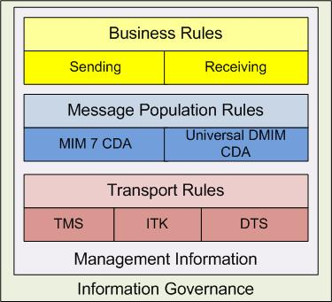

Figure 1: Documentation Map

## Background

The requirements within this document have been drawn from the various requirements documents published by NHS CFH relating to ‘Spine messaging’ over TMS and CDA documentation published by NHS CFH as part of the Summary Care Record Release 2 requirements. In particular, it draws requirements from the ‘PSIS and CDA Domains Technical Compliance’ and ‘Compliance Requirements for CDA Domains and PSIS Query’ documents.

## Definitions

Where used in this document set, the keywords MUST, SHOULD and MAY are to be interpreted as follows:

* **MUST**: This word, or the terms "**REQUIRED**" or "**SHALL**", means that the definition is an absolute` requirement of the specification.
* **SHOULD**: This word, or the adjective "**RECOMMENDED**", means that there may exist valid reasons in particular circumstances to ignore a particular item, but the full implications **MUST** be understood and carefully weighed before choosing a different course.
* **MAY**: This word, or the adjective “**OPTIONAL**”, means that an item is truly optional. One implementer may choose to include the item because a particular implementation requires it or because the implementer feels that it enhances the implementation while another implementer may omit the same item. An implementation which does not include a particular option **MUST** be prepared to interoperate with another implementation which does include the option, though perhaps with reduced functionality. In the same vein an implementation which does include a particular option **MUST** be prepared to interoperate with another implementation which does not include the option (except, of course, for the feature the option provides).
* **SHOULD NOT**: This phrase, or the phrase "**NOT RECOMMENDED**" mean that there may exist valid reasons in particular circumstances when the particular behaviour is acceptable or even useful, but the full implications should be understood and the case carefully weighed before implementing any behaviour described with this label.

# Overview of CDA Technical Requirements

The requirements contained in this document apply to CDA Documents specified in MIM 7.2.02 and individual DMS message specifications published by NHS CFH after MIM 7.2.02. One of the main changes to messages in the post MIM 7 DMS versions is the modification of various templates to allow non-SDS identifiers to be used for people, organisations and devices and for clinical codes other than SNOMED CT to be used. This is to support more widespread use of the messages outside of the Spine environment to or from parties who are not connected to any Spine service.

Of particular note is the development of the ‘Patient’ template– the newer variant entitled ‘PatientUniversal’ – which allows additional patient demographic such as name, address, date of birth, etc rather than just NHS number in the original MIM 7 Patient template. Other templates have had similarly named new templates for Recipient types (Organisation, Workgroup, etc), Author, Encompassing Encounter, etc. (see Figures 4a & 4b below)

Note that many of the DMS message variants have the same Interaction ID as their MIM 7 equivalent but use different template IDs for the revised templates. Attribute names within the templates have been preserved thus providing both forward and backward compatibility across templates for these attributes.

## General Principles

The format of a HL7 Clinical Document Architecture (CDA) document comprises of:

* The ‘ClinicalDocument’ with an XML or non-XML body (see Figures 3a & 3b)
* Within the XML body the ‘ClassificationSection’ comprising:
  + Text Sections (‘SectionChoice), which may be nested up to six levels, and must only contain standard CDA markup.
  + ‘CodedEntry’ Templates
  + Care Record Element (CRE) Types) ’CRETypeListChoice’)

And is illustrated in the images below:

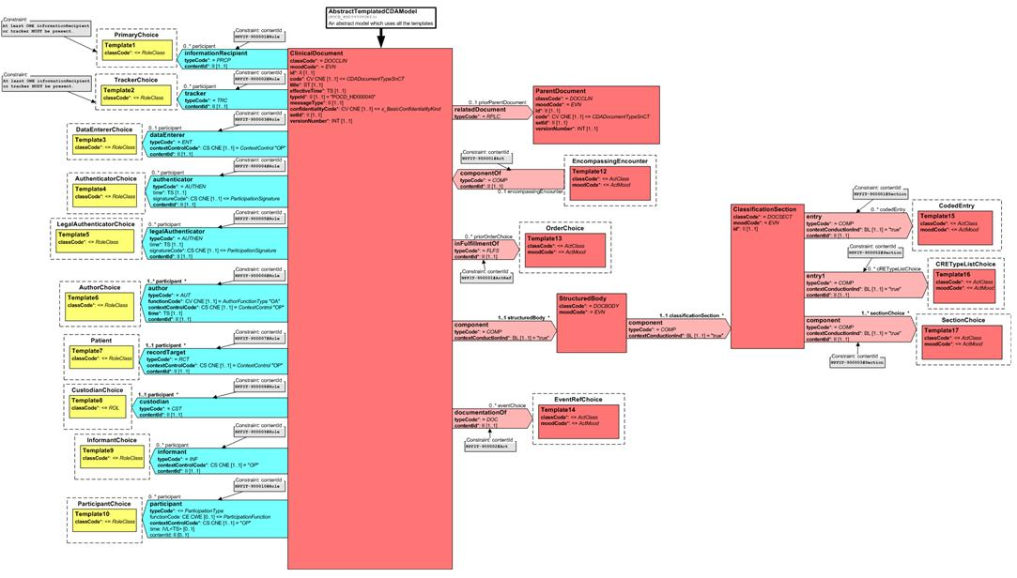

Figure 2 – MIM 7 CDA Document RMIM

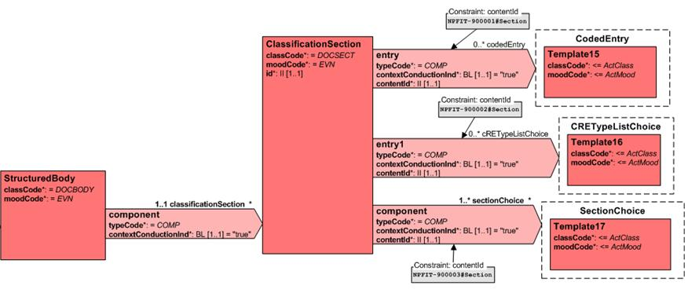

Figure 3a – MIM 7 StructuredBody

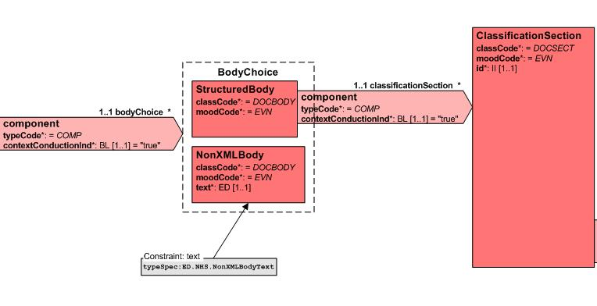

Figure 3b: DMS showing new BodyChoice Act

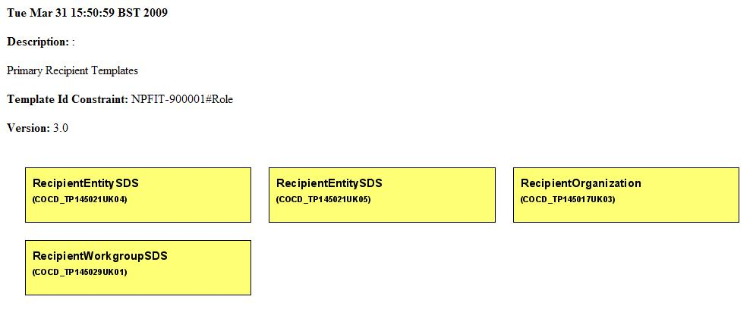

Figure 4a: Old Recipient Templates

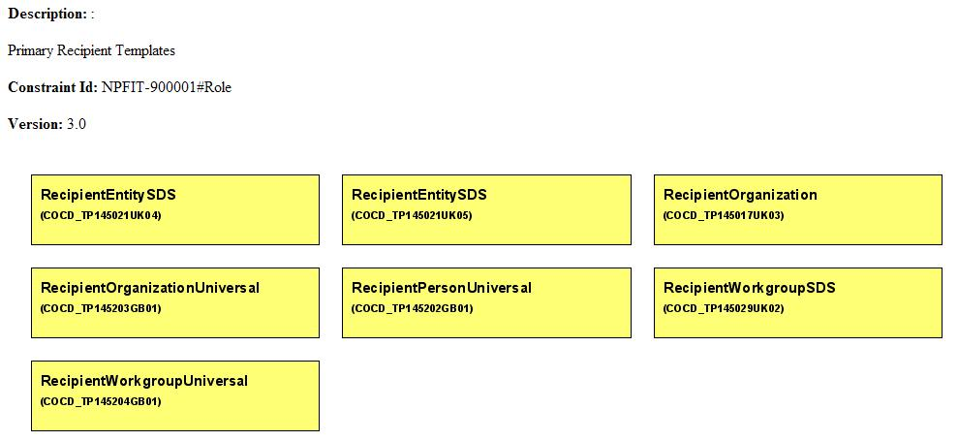

Figure 4b: New Recipient Templates

*Medications* and *Allergies and Adverse Reactions* should be coded (where these exist) using SNOMEDCT and, if present, must be indexed against the respective CRE Types. Information other than *Medication* or *Allergies and Adverse Reactions* must be text only, or text and equivalent codes, and must **not** be indexed against CRE types, until such time as NHS CFH provides formal guidance on the use of additional CRE Types.

Care Professionals will want to link care information within a Document, to indicate that data items are related in clinically relevant ways. For example, a Care Professional might wish to indicate that a diagnosis is the reason for a medication. Detailed guidance is available within the MIM/DMIM and other documents in the CDA Interoperability baseline.

Detailed information relating to the content of each CDA document is provided in the relevant class models in the Business Analysis models.

## Attachments

The CDA messages documented in MIM 7.2.02 do not allow the inclusion of attachments or embedded binary objects, however, the later DMS versions of the CDA domains covered by this document do allow attachments (binary objects) to be included within CDA documents. Systems using the DMS CDA messages may therefore include attachments subject to the requirements included within the DMS documentation and the ‘Technical Guidance on the Implementation of CDA Domains’ document

## Coding Schemes

The CDA messages documented in MIM 7.2.02 only allow the use of SNOMED CT clinical codes within the ‘Coded Entry’ element of messages, however, the later DMS versions of the CDA domains covered by this document allow other coding schemes to be used together with a mapped/translated SNOMED CT equivalent where approved mapping/translations exist.

Systems using the DMS CDA messages may therefore include clinical codes other than SNOMED CT subject to the constraints included elsewhere on the use of Coded Entry and CRE Types.

# CDA Document - Population Requirements

## Overview

This section sets out requirements for the construction of CDA documents. Suppliers **must** read this document within the context of all other documents contained within the CDA Interoperability baseline.

Whilst the requirements within this section are primarily aimed at systems creating and sending CDA Documents, suppliers of systems receiving CDA Documents should also use these requirements to understand how sending systems are required to populate messages and therefore what to expect when receiving one.HL7 CDA and NPfIT CDA – General Principles

In line with the NPfIT CDA document simplification in July 2007, the structure of an NPfIT CDA document is summarised in Figure 2, below.



Figure 2 NPfIT CDA Document Structure (High Level)

The body of a NPfIT CDA document consists principally of a number of text sections, each of which contain markup[1] adhering to the CDA standard. In order to support business (document display) needs, text sections are nested in order to provide standardised[2] formatting not available in Standard CDA markup. For the purposes of NPfIT’s CDA model, CDA <content> tags are used to delimit text fragments within the original text which contain (as a minimum) information also represented by a coded entry associated with that fragment, also within the document.

A CDA document will contain the summary of a period of care and may include multiple encounters. Multiple care summaries (e.g. multiple Discharge Reports, ED Reports, Outpatient Reports) must NOT be sent in a single clinical document. Document ‘types’ are specified using the document type ontology (see CDA Interoperability Baseline Index)) which classifies documents by speciality and purpose (e.g. orthopaedics, discharge).

## Use of Care Record Element Types

Care Record Element (CRE) Types are the agreed method for classifying clinical information. Coded Entries should be appropriately classified by a CRE type. The complete set of CRE types is shown in “Figure 3 - CRE types”. CRE Types are no longer defined in the MIM *CREType* vocabulary; rather they are defined as a SNOMED-CT® subset.

| **Req ID** | **Requirement Text** | **Status** |
| --- | --- | --- |
| **CT01** | Compliant systems **MUST** treat the set of CRE types as configurable, as it is expected to evolve over time. This configuration will include additions to the CRE types, and also the number of levels in the CRE type hierarchy increasing beyond 2. | **Must** |
| **CT02** | Systems **MUST** classify coded entries by CRE type for those CRE types listed as ‘Yes’ in the Required column of Figure 3. Systems **MUST** **NOT** classify coded entries by CRE type where the Required column does not say ‘Yes’. | **Must** |
| **CT03** | Coded Clinical Entries **SHOULD** be classified with a single, appropriate, CRE type entry (i.e. a code can only have one CRE type). | **Should** |
| **CT04** | For every CRE type classification [of coded clinical content entries and, transitively, of text fragments in the document’s text blocks] supported in the release (see figure 3, overleaf), the contributing system **SHOULD** construct a CRE type index entry in the document. CRE type index entries relate a SNOMED-coded CRE type to a number of coded entries included in that document (i.e. a CRE type may have many codes). | **Should** |

|  | **Care Record Element – Level 1 (Supertype)** | **Care Record Element – Level 2 (Subtype)** | **Required** |
| --- | --- | --- | --- |
| 1 | Personal Demographics |  | Not Used (Not Instantiable) |
| 2 | Care Events |  |  |
| 3 | Documents and Correspondence | Care Professional Documentation |  |
| 4 | Documents and Correspondence | Patient/Carer Correspondence |  |
| 5 | Documents and Correspondence | Third Party Correspondence |  |
| 6 | Risks and Warnings | Allergies and Adverse Reactions | Yes |
| 7 | Risks and Warnings | Risks to Patient |  |
| 8 | Risks and Warnings | Risks to Care Professional or Third Party |  |
| 9 | Problems and Issues |  |  |
| 10 | Diagnoses |  |  |
| 11 | Findings | Clinical Observations and Findings |  |
| 12 | Findings | Investigation Results |  |
| 13 | Social Context | Social and Personal Circumstances |  |
| 14 | Social Context | Services, Care Professionals and Carers |  |
| 15 | Social Context | Lifestyle |  |
| 16 | Family History |  |  |
| 17 | Procedures | Treatments |  |
| 18 | Procedures | Investigations |  |
| 19 | Procedures | Administrative Procedures |  |
| 20 | Procedures | Provision of Advice and Information to Patients and Carers |  |
| 21 | Medication Record | Medication | Yes |
| 22 | Medication Record | Medication Recommendations |  |
| 23 | Personal Preferences |  |  |

Figure 3 - CRE types

A static class model of the complete set of CREs/types is shown in Figure 4 below.

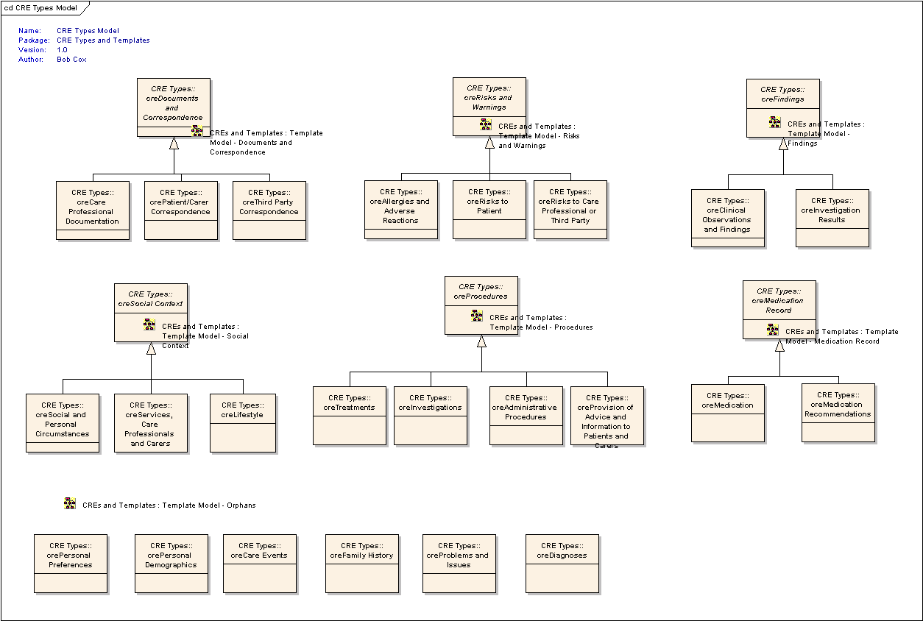

Figure 4 CRE Types – Static Class Model

## Use of Document ‘Code’ and Document Ontology

Systems creating CDA Documents must populate the document ‘code’ attribute within the ‘ClinicalDocument ‘Act according to the Document Ontology requirements (see CDA Interoperability Baseline Index). This requires systems to support two SNOMED CT subsets (see DMS documentation) in order to construct appropriate post coordinated expressions to represent the type of CDA document correctly. Note that systems developed prior to the publication of these subsets and the document ontology requirements will usually populate the attribute with a single pre-coordinated SNOMED CT code from the UKTC published subset ‘Document Type’.

| **Req ID** | **Requirement Text** | **Status** |
| --- | --- | --- |
| **CT06** | A Sending system **MUST** support the use of the SNOMED CT subsets during the creation of CDA Documents and populate the ‘code’ attribute of the ‘CliniclalDocument’ Act with a post-coordinated SNOMED CT expression according to the Document Ontology requirements (See CDA Interoperability Baseline Index). (see Note below) | Must |
| **CT07** | A Receiving system **MUST** preserve the ‘code’ attribute of the ‘CliniclalDocument’ Act when processing the CDA Document whether from the pre-coordinated ‘Document Type’ subset or the post-coordinated Document Ontology subsets . (See CDA Document – Receiver Requirements) | Must |

**Note**

The current message definitions in the MIM/DMS do not explicitly refer to using SNOMED compositional grammar concepts to encode the document ontology codes into the single clinicaldocument.code attribute. Further guidance will be issued along with the Document Ontology standard.

## Use of Coded Clinical Content

It is a goal of NHS CFH that all clinically-relevant textual information, within every document type, should relate to an equivalent SNOMED-coded clinical fragment , validated by a template mechanism. Appropriate HL7 structures used for coding are specified in the MIM/DMS templates.

Template-constrained coded entries (in CDA documents) are the mechanism used to exchange structured clinical information between systems. These are common, agreed structures for clinical data representation, and are the cornerstone of clinical data interoperability.

| **Req ID** | **Requirement Text** | **Status** |
| --- | --- | --- |
| CT10 | Each CDA document **MAY** contain any number of coded content entries corresponding to tagged text fragments within that document’s text block(s). For every coded entry included in the document there **MUST** be at least one reference to content within the document’s text sections. | **Must** |
| CT11 | The following table lists templates which **MAY** be used within CDA Documents. Sending systems **MAY** include these templates in CDA Documents.   |  | | --- | | **Template name** | | ***AllergicOrAdverseReactionEvent*** | | ***AllergicOrAdverseReactionEventSNOMEDCT*** | | ***AllergyPropensity*** | | ***AllergyPropensitySNOMEDCT*** | | ***MedicationAdministrationCourseSNOMEDCT*** | | ***MedicationAdministrationDose*** | | ***MedicationAdministrationDoseSNOMEDCT*** | | ***PlanMedicationAdministration (T)*** | | ***PlanMedicationAdministrationSNOMEDCT*** | | ***RequestMedicationAdministration*** | | ***RequestMedicationAdministrationSNOMEDCT*** | | ***RequestMedicationSupply*** | | ***RequestMedicationSupplySNOMEDCT*** | | ***SupplyMedication*** | | ***SupplyMedicationSNOMEDCT*** | | ***NullifyDocument*** | | ***TextSection/TextSectionSNOMEDCT*** |   And the following required sub-templates(T)/Classes(C) of some of the above medication related templates (when used)   |  | | --- | | **Template name** | | ***AcuteScriptFlag (C)*** | | ***AdministrationDetails (C)*** | | ***AdministrationType (C)*** | | ***DosageInstructions (C)*** | | ***ManufacturedProduct (C)*** | | ***Material (C)*** | | ***MedicationDiscontinuation (T)*** | | ***MedicationQuantity*** | | ***ReasonForMedication (T)*** | | ***SupplyInstructions (C)*** |   There are further optional sub-templates and classes that may also be used to support the above templates.  If a sending system is capable of constructing coded clinical entry within other templates not listed above but included in the message definitions, the system **MAY** ONLY do so with agreement by the Authority. | **May** |
| CT12 | If a local system is not able to construct a MIM/DMS-compliant coded entry to represent coded clinical information in a document, then that information **MUST** still be represented as text within the clinical document. | **Must** |
| CT13 | Coded clinical content within CDA documents **MUST** validate against the set of MIM/DMS-specified templates and appropriate constraints. | **Must** |
| CT14 | All clinical content within coded entries of a CDA document **MUST** also be represented within the text sections of that document. | **Must** |
| CT15 | References to coded entries within a document (for example when using *Problem Link Assertion* or *Link Assertion* templates/coded entries) **MUST** be to coded entries within that same document. | **Must** |
| CT16 | A receiving system is not obliged to process any coded entries present in a CDA Document. However, if a system does support any form of processing of coded entries, the way in which this data is processed **MUST** be approved by the Authority. | **Must** |

## UUIDs and Version Numbers

| **Req ID** | **Requirement Text** | **Status** |
| --- | --- | --- |
| CT20 | Production of Universally Unique Identifiers (UUIDs) for use in all aspects of documents, storage, and messaging, is the responsibility of a local system and **MUST** be in accordance with ‘Utilising Unique Identifiers in NPfIT Systems’. Use of other mechanisms **MUST** be approved by the Authority. | **Must** |
| CT21 | Systems creating new CDA documents destined to be sent **MUST** generate a new clinical document ID (UUID) locally, regardless of whether that document starts a new document set, or is a replacement / upissue of an existing document (in a CDA document ***set***). | **Must** |
| CT21.1 | The entire document sent to each recipient **MUST** be identical and carry the same UUID. i.e. copies sent to primary recipients and copy recipients will receive the same information identified by the same UUID. | **Must** |
| CT22 | Systems creating new CDA document sets (i.e. a document with no parent / replace relationship) **MUST** generate a new setID (UUID) for that document. | **Must** |
| CT23 | A document replacement/revision **MUST** keep the parent document’s “set ID” constant (which links a chain of document versions). The setId of a replacement document must match the setId in the parentDocument setId field which **MUST** be the same as the setId of the parent document. | **Must** |
| CT24 | When creating a new document set, the sending system **MUST** set the version number to integer ‘1’. | **Must** |
| CT25 | On creation of a replacement of a CDA document, the version number of the replacement document **SHOULD** be the version number of the document being replaced (the parentDocument), incremented by (integer) one. | **Should** |
| CT26 | *Use of UUIDs in coded entries*   1. New coded entries (coded entries which represent coded information which has not previously been included in the document set) **MUST** be attributed with a new UUID for that coded entry's id. 2. When replacing a document it is likely that much of the document is pure restatement of a prior version. For coded content entries restated from the previous version of the document (i.e. identical, unchanged) then the UUID from the original coded entry (from the parent document) **MUST** be re-used. In this case, the related text fragment (with the document text section(s)) **MUST** be identical.[3] 3. If it is not possible to verify that clinical content of a coded content entry is completely unaltered (identical), or it is known that the clinical content has been altered, then a new UUID **MUST** be issued for that component in the replacement. This is equivalent to creating a new coded content entry (and removing the updated one from the new document version). 4. If the same object of clinical information, represented as a coded entry within a document, is included in another document set, then these identical coded content entries **SHOULD** share the same UUID. | **Must** |

## CDA Document Assembly Requirements

**NB: Please note that domains may have specific assembly requirements. Where this is the case, the domain will provide documentation detailing the requirements.**

### Prime and Copy Recipient Messages

The requirements in the table below apply to the assembly of clinical content of the HL7 CDA Documents covered by this document.

| Req ID | Requirement Text | Status |
| --- | --- | --- |
| CT30 | The text sections within CDA documents MUST be composed using standard CDA markup. | Must |
| CS31.1 | Suppliers SHOULD NOT use HTML attributes and tags for such things as font sizes, table borders and spacing, font and background colours and other such styles, since it is expected that style elements will be applied using XSLT and CSS style sheets. | Should |
| CT31.2 | Table widths and table cell widths MAY be used. | May |
| CT31.3 | Where used, table and cell widths SHOULD be percentages, not fixed widths. | Should |
| CT32 | Where an originating system has the functionality to support coded clinical entries for medications, CDA documents created by that system SHOULD include coded entries where possible. | Should |
| CT32.1 | If an originating system has the functionality to support SNOMED CT coded entries for medications, then CDA documents generated by that system and which contain medication information MUST include SNOMEDCT coded medication entries. | Must |
| CT32.1.1 | If the native coding scheme of the originating system is not SNOMED CT, the system MAY include medication coded using other approved clinical coding schemes. | May |
| CT32.1.2 | If the coding scheme used is not SNOMED CT, the originating systems SHOULD include a SNOMED CT translated code along with the native code. | Should |
| CT32.2 | Where a CDA document contains medication recommendations or medication history, this information MUST be carried as text only. | Must |
| CT32.3 | Where an originating system does not have functionality to support coded clinical entries for medications, then CDA documents created by that system SHOULD contain medication information as text. | Should |
| CT23 | Where an originating system has the functionality to support coded clinical entries for allergies and drug sensitivities, CDA documents created by that system SHOULD include coded entries where possible. | Should |
| CT33.1 | If an originating system has the functionality to support SNOMED CT coded entries for allergies and drug sensitivities, then CDA documents generated by that system and which contain medication information MUST include SNOMEDCT coded medication entries. | Must |
| CT33.1.1 | If the native coding scheme of the originating system is not SNOMED CT, the system MAY include allergies and drug sensitivities coded using other approved clinical coding schemes. | May |
| CT33.1.2 | If the coding scheme used is not SNOMED CT, the originating systems SHOULD include a SNOMED CT translated code along with the native code. | Should |
| CT33.2 | Where an originating system does not have functionality to support coded clinical entries for allergies and drug sensitivities, then CDA documents created by that system SHOULD contain allergies and drug sensitivities information as text. | SHOULD |
| CT34 | Originating systems SHOULD minimise the amount of effort required by system users to construct CDA Documents. | Should |
| CT34.1 | Originating systems SHOULD provide functionality to pre-populate CDA documents with pertinent information from the Local patient record. | Should |
| CT34.2 | Where pertinent information from the Local patient record is available, but cannot be pre-populated into the CDA document, originating systems’ user interfaces SHOULD enable the easy transfer of information from the Local patient record to the CDA document, e.g. via “drag-and-drop”, or “copy-and-paste” type functionality. | Should |
| CT34.3 | When assembling system generated text, within text sections, systems SHOULD comply with relevant Common User Interface standards, e.g. for the representation of dates and times. | Should |
| CT35 | Originating systems MAY display the contents of a CDA document in alternative formats but MUST ensure that the document author has access to ALL document content so that full verification can take place. | May |
| CT36 | When a CDA document is constructed, it MUST include the significant interval or timestamp of the encounter, using EncompassingEncounter.effectivetime. | Must |
| CT37 | To avoid unnecessary and potentially disruptive duplication, the following items (where present) SHOULD not be included in the text section of CDA documents:  Title  Timestamp  Document ID  Document Version  Author (including all attributes)  Data Enterer (including all attributes)  Authenticator (including all attributes)  Recipient (including all attributes)  Custodian Org (including all attributes)  Patient’s NHS Number  Encompassing Encounter  Encounter Type  Care Setting Type  Care Setting Place (including all attributes)  Care Setting Org (including all attributes)  Responsible Party (including all attributes)  EffectiveTime  Participants (including all attributes) | Should |
| CT37.1 | Where an item from the list above is carried in a CDA document, it MUST be carried as an HL7 CDA Class Attribute. | Must |
| CT37.2 | Originating systems MUST make clear to system users which information is carried in the HL7 CDA Class Attributes, so that system users know not to include the information within the text section(s). | Must |

### Nullification Messages

The requirements in the table below relate to documents which need to be withdrawn which is achieved through the sending of a ‘nullification’ variant of the original CDA Document.

| Req ID | Requirement Text | Status |
| --- | --- | --- |
| CT40 | Nullification documents MUST be constructed using a Level 1 Text Section. | Must |
| CT40.1 | The Title of the first Level 1 Text Section MUST be “Document Withdrawn” | Must |
| CT40.1.1 | The Text of the Level 1 Text Section MUST be populated with the value of ClinicalDocument.title taken from the document being withdrawn. | Must |
| CT40.2 | The Title of the first Level 2 Text Section MUST be “Withdrawn Document Created” | Must |
| CT40.2.1 | The text of the first Level 2 Text Section MUST be populated with the value of ClinicalDocument.effective time taken from the document being withdrawn. | Must |
| CT40.3 | The Title of the second Level 2 Text Section MUST be “Reason for Withdrawal” | Must |
| CT40.3.1 | The text of the second Level 2 Text Section MUST be populated with the Display Name of the Reason.code carried in the Nullification Document. The text for the second Level 2 Test Section MUST be taken from the published vocabulary. | Must |
| CT42 | When nullifying a document/document set, the inter-document relationship type ‘replace’ MUST be used. | Must |

### Replacement Messages

The requirements in the table below relate to documents which are being replaced.

| Req ID | Requirement Text | Status |
| --- | --- | --- |
| CT50 | While CDA offers three modes of inter-document relationship (Replace, Append, Transform), systems **MAY ONLY** use Append or Transform relationships within the Non-Coded CDA Document. Suppliers **MUST** obtain agreement from the Authority to use Append or Transform relationships. | May |
| CT51 | When replacing a document the inter-document relationship type ‘replace’ **MUST** be used when:   * + correcting erroneous information, or   + updating, i.e. adding further information / detail to a document | Must |
| CT52 | Systems sending an update to some, but not all parts of a document, **MUST** submit a replacement document containing the retained (unmodified) text fragments, markup, and related coded content entries (copied: with identical UUID and originalText <reference>) along with any new/modified text/tags and coded entries.  Consequently, a partial update is achieved by means of a full update with unchanged data being carried again in the replacing document. | Must |
| CT53 | Removal of tagged text with an equivalent coded entry **MUST** result in the removal of the related coded entry also. | Must |
| CT54 | The author of a document replacement may not match the parent document’s author. The author of the document replacement **SHOULD** be recorded as the user who is contributing that replacement.  *[NB:* Implication: the author of a replacement document takes responsibility for that replacement.] | Should |

## Multiple Recipients

| Reqt. ID | Requirement Text | Rating |
| --- | --- | --- |
| CT60 | The contents of a CDA document MUST be the same for every recipient.  This MUST be achieved by addressing an identical clinical message payload (document) to each of the recipients, including identical UUIDs (document, set, coded entry), version number, and content tag IDs. The payload must be syntactically and semantically identical regardless of the number of receivers. | Must |

## Versioning and Compatibility

Maintaining compatibility of clinical documents (elements in the longitudinal care record) over the lifetime of a patient’s record is very clearly a requirement for the NHS. Given the diverse nature of the NHS estate, and in particular the range of different systems across NHS IT suppliers, it is clear that solutions to this complex problem are essential.

In this section we show how versions at both document and coded template level provide guidance to connecting suppliers as to what they can and cannot interpret, and put forward a general strategy for future clinical document structures to provide forward-compatibility.

### Versioning

Multiple levels of versioning exist within CDA clinical documents. These are expressed at

1. **Document** level – message type and version of that message type are combined into the messageType attribute, whose structure is:

**POCD_MT**<message type>**UK**<message type version> **or**

**POCD_MT**<message type>**GB**<message type version>

This information is represented in CDA document metadata in the messageType field.

1. **Template** level, within a document – includes Clinical content entries and CRE Indexing / Mapping entries, and most other ‘Acts’ within a document . This is represented within each Act, as attribute ‘templateId’ denoting the template which is used to derive – and validate – the structure. This takes the form

**COCD_TP<template type id>UK<template version> or**

**COCD_TP<template type id>GB<template version>**

### Backward Compatibility

It is clear that as types of documents and coded templates increase in number, i.e. as they mature as representations of clinical concepts, there will be an ongoing requirement on suppliers to maintain document-and template-level backward compatibility across the lifetime of the data stored in the patient record. It is the intention that these sets are additive over time, and that change is minimised wherever possible. In order to simplify the backward-compatibility problem, the Clinical Messaging team needs to adhere to strict change control rules.

### Forward Compatibility

When designing for forward compatibility, it is key to abstract information models into those elements which may change, and those elements which may not. This follows from an analysis of likely future change to ‘current’ models.

HL7 CDA has simplified the problem of providing forward compatibility. All current and future document types use the same logical structures in CDA, whether Discharge report or Nullify Document. One minor difference between document types is the inclusion/use of the ‘Encompassing encounter’ element – naturally systems must be designed to handle presence/non-presence of optional structures. It is assured that, structurally at least, systems will be able to parse, and render, any CDA documents in the future and systems should be designed to handle the generic CDA structure.

CDA Clinical documents do differ, of course: not structurally, but through which template-driven coded entries are allowed in each document type. It is natural that this set of templates, as a vocabulary, changes/grows over time, and this is where the focus of forward compatibility must lie.

| **Req ID** | **Requirement Text** | **Status** |
| --- | --- | --- |
| CT70 | Suppliers **MUST** design messaging validation against the generic CDA model, provided in ‘Technical Guidance for Implementation of Templated CDA Domains’. | **Must** |
| CT71 | When interpreting coded entries in a CDA document, systems **SHOULD** ‘check the label’, located in each ‘entry’ act relationship (contains a coded entry) as element ‘npfitlc:contentId’, where that entry consists of  root element “2.16.840.1.113883.2.1.3.2.4.18.16”, and  extension of the format  **COCD_TP_**<template ID>**UK**<version number>**#**<HL7 class name text> or **COCD_TP_**<template ID>**GB**<version number>**#**<HL7 class name text>  Systems **SHOULD** verify the *template ID* and *version* against an internal compatibility / capability matrix to check if/how they can apply processing, prior to attempting to process that entry. | **Should** |

1. Process Flow Diagrams
2. Process Message



**Notes**

1. It is expected that ebXML validation and HL7 validation will be the responsibility of different parts of a local system’s infrastructure: ebXML is generally an MHS responsibility, HL7 processing will probably reside in the local clinical system. Implementations may vary.
2. There is some overlap between ‘process HL7 layer’ and ‘process document’ (see next section).
3. Process Document



**Notes**

1. The above diagram illustrates processing for a TMS connected system.
2. For a definitive list of all response codes returned in the MCCI response, please consult the Point to Point Error Codes document].
3. The link between notification of a document receipt and the selection and subsequent rendering of that document may not be immediate, as the response to that notification is a manual (asynchronous) process.
4. Process Document - Clinician



Notes

Validate clinical document is a local process not defined within these requirements.

1. HL7 CDA markup is presentation-oriented XML
2. These nested text sections replicate xhtml headings (H1-H6) not available in CDA markup and must be rendered as such.
3. The related <content id=a###> markup in the document text section will be identical, as this is included in the identical coded entry.