l
Document filename: | SCR FHIR API Technical Specification for the GP Summary XHTML v1.0
Project / Programme: | SCR FHIR API | Project: | GP Summary XHTML
Document Reference:
Project Manager: | Jill Sharples | Status: | Final
Owner: | Robert Jordan | Version: | 1.0
Author: | Brian Diggle and Simon Immanuel | Version issue date: | 15/09/2022

SCR FHIR API Technical Specification for the GP Summary XHTML

Document management
Revision History
Version | Date | Summary of Changes
0.1 | 28/04/2022 | Initial draft for review
0.2 | 20/05/2022 | SCR Team review and comments applied
0.3 | 09/06/2022 | Technical Architect review and updates applied
1.0 | 14/09/2022 | Final updates applied ready for release

Reviewers
This document must be reviewed by the following people:
Reviewer name | Title / Responsibility | Date | Version
Robert Jordan | SCR Product Manager | 15/09/2022 | 1.0
Dr Robert Jeeves | SCR Clinical Lead and Clinical Safety Officer | 14/09/2022 | 1.0
Gina Jacobs | Senior Business Analyst | 14/09/2022 | 1.0
Simon Immanuel | Technical Architect | 14/09/2022 | 1.0
Jon Erskine | SCR Service Manager | 14/09/2022 | 1.0

Approved by
This document must be approved by the following people:
Name | Signature | Title | Date | Version
Robert Marsh | Approved | Head of Live Services | 20/09/2022 | 1.0

Referenced Documents
Document Location | Title | Version
https://gpitbjss.atlassian.net/wiki/spaces/NIA/pages/11647975517/SCR+FHIR+API+Requirements+for+GPIT+NME | GP Summary Presentation Text Specification Refactored for SCR FHIR API | 4.0

Glossary of Terms
Term / Abbreviation | What it stands for
API | Application Programme Interface
ASCII | American Standard Code for Information Interchange, is a character encoding standard for electronic communication.
CSS | Cascading Style Sheet. See https://www.w3.org/Style/CSS/Overview.en.html
FHIR | Fast Health Interoperability Report. See http://hl7.org/fhir/
GP Summary | The GP summary is a component of the Summary Care Record and aims to provide a summary of the information held in a patient's general practice record and make it available to authorised staff in other areas of the health and care system involved in the patient’s direct care.
Presentation Text | A key element of the payload is described as the “Presentation Text.” This is an XHTML representation of the Summary Care Record which is intended to be presented to clinicians for viewing.
SCR | Summary Care Record. The Summary Care Record is an electronic record which provides authorised healthcare staff involved in a patient’s direct care with faster, easier access to essential information about a patient.
WAI | Web Accessibility Initiative. See https://www.w3.org/WAI/
XHTML | EXtensible HyperText Markup Language. See https://www.w3.org/TR/xhtml1/
XML | Extensible Markup Language. A markup language is a set of codes, or tags, that describes the text in a digital document
XMLNS | A collection of XML elements and attributes identified by an Internationalized Resource Identifier

Overview
When creating a new GP Summary for upload to the SCR FHIR API, a key element of the payload is described as the “Presentation Text.” This is an XHTML representation of the care record which is intended to be presented to clinicians for viewing.
As a creator of a GP Summary, you therefore must create this presentation text in XHTML format following the overall guidance within this document, and also the detailed rules set out in the Presentation Text Specification.
The GP Summary document is created in the format of a FHIR Document. Within this structure, sections of the FHIR document are found in the Composition Section element.
The section element is an array. Each of the Care Record Element sections which make up the GP Summary, such as “Allergies and Adverse Reactions” are found as items in this within this array.
The basic structure of the GP Summary in FHIR is illustrated below:

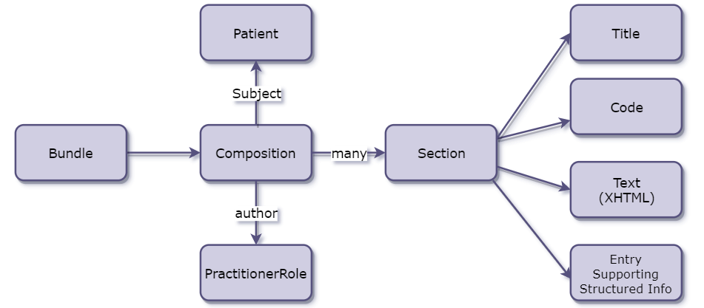

Requirements for XHTML placed in the FHIR GP Summary
Each requirement has a priority, which is stated using the keywords MUST, SHOULD and MAY:
- MUST: This word, or the terms "REQUIRED" or "SHALL", means that the definition is an absolute requirement of the specification.
- MUST NOT: This phrase, or the phrase "SHALL NOT", mean that the definition is an absolute prohibition of the specification.
- SHOULD: This word, or the adjective "RECOMMENDED", means that there may exist valid reasons in particular circumstances to ignore a particular item, but the full implications must be understood and carefully weighed before choosing a different course.
- MAY: This word, or the adjective "OPTIONAL", mean that an item is truly optional.
The XHTML which is present within Composition.Section.Text for each of the Care Record Elements MUST conform to a constrained subset of the XHTML standard as defined below.
These restrictions are specifically designed to prevent: -
- Inclusion of external hyperlinks that invoke or reference material not within the message.
  - This is considered necessary to ensure all material relevant is communicated and to avoid risks from linking to material that is not constrained by the message specification and may thus include viruses or other rogue software.
- Inclusion of complex formatting which may not be supported by a receiving system.
- Representation of structured computer parable semantics in a document that is intended only for presentation to a human reader.
XHTML should be formed correctly: -
- All opening tags MUST either be balanced by closing tags or must be marked empty.
- All tags MUST be in lowercase since, unlike HTML, XML is case-sensitive.
- All attribute values MUST be enclosed in quotations.
The following XHTML tags and attributes are permitted:
Tag | Description | Usage | Permitted attributes
<div> | One instance per section | Structural | xmlns=\"http://www.w3.org/1999/xhtml\”
<h2>  <h3>  <h4>  <h5>  <h6> | Heading levels.  Restriction: These are not permitted to contain any sub-elements. | Used to represent headings and their relative position within the document contents | id, class
<p> | Paragraph | Used to contain data as paragraphs | id, class
<ol>  <ul> | Outline list numbered and unnumbered. | Used to contain data as numbered or unnumbered lists. Unnumbered lists may be rendered in any order. Numbered lists must be rendered in number order. Lists may contain other lists as sub lists. | id, class
<li> | List item | A list item in a list | id, class
<table> | Table | Used to contain data in a tabular form. May not be used to control layout, grouping, or positioning of data | summary, id, class
<caption> | Table caption | Must appear immediately after the <table> start tag. | class
<thead> | Table header | Used to define a table header | id, class
<tfoot> | Table footer | Used to define a table footer
<tbody> | Table body | Used to define a table body | id, class
<tr> | Table row | Used to define a row in a table | id, class
<td> | Table cell | Used to define a cell in a table. | id, rowspan, colspan, abbr, headers
<th> | Table header cell | Used to define a header cell in a table. | id, class
<br/> | Section break | Used to define a line break

Note: <h1> and <title> MUST NOT be used as these are reserved for use by applications which display GP Summary presentation text within their own user interface context.
Quotation markup will also not be used for inline quotes as language independence is not a requirement.

Common Attributes
Style, in the form of CSS (https://www.w3.org/Style/CSS/Overview.en.html), is not a permitted attribute - either inline style, or when referring to an external style sheet.
It is the sender’s responsibility to ensure information is represented safely and appropriately with this attribute absent.
A number of CSS classes will be predefined to assist styling of XHTML content when rendered in the Summary Care Record Application. When consuming the SCR, please see NHS England service manual for guidance: Design system - NHS England service manual (service-manual.nhs.uk)

Representation of Tabular Data
Tables are complex structures that can be difficult to render in an accessible way. Therefore, a specific table structure is required from sending systems to ensure that a table can be accessibly rendered by a receiving system.
The general structure of a table to be used is:
<table summary=”A summary of the contents of a table”>
<caption>Table Caption</caption>
<!-- Table Header -->
<thead>
<tr>
<th>Table Header 1</td>
<th>Table Header 2</td>
….
</tr>
</thead>
<!-- Table Footer-->
<tfoot>
<tr>
<td>Table Footer 1</td>
<td>Table Footer 2</td>
….
</tr>
</tfoot>
<!-- Table Body -->
<tbody>
<tr>
<td>Table Content Row 1 Column 1</td>
<td>Table Content Row 1 Column 2</td>
…
</tr>
<tr>
<td>Table Content Row 2 Column 1</td>
<td>Table Content Row 2 Column 2</td>
…
</tr>
…
</tbody>
</table>

Table Structure
The table structure is defined using the <table> tag. Within the table tag, the following attributes are allowed:
- Table summary: A summary of the table e.g. “This table includes information about this patient’s acute medications”. This attribute is mandatory.
The table structure is defined using the <table> tag. Within the <table> tag, the following attributes are mandatory:
- summary
This attribute provides a summary of the contents of the table.
E.g.
<table summary=”This table includes information about this patient’s acute medications”>

Table Caption
The table caption will describe the title and/or nature of what is contained within the table. The <caption> element is only permitted immediately after the <table> start tag.

Table Header
The table header consists of one or more table rows (each containing table cells). These rows are contained within a <thead> tag. These rows are used to define the contents of columns within the table. The table row(s) and cells can take any attribution allowed for these tags.
Support is for two dimensional tables only. Table should not be used for indentation or alignment of semantically unrelated items.

Table Rows and Cells
Table rows and cells are used to contain the data content of the table. Each row will contain a number of cells. The number of cells in a row should not exceed the number of cells in the header to avoid orphan cells appearing in the table with no header.
A table row is defined by the <tr> tag and may contain many cells. A cell is defined by a <td> tag and may contain data or the following tags only:
- <a>
- <ol>
- <ul>
- <li>
The td tag allows the following attributes:
- rowspan: Indicates the number of rows this cell should span
- colspan: Indicates the number of columns this cell should span
- abbr: Specifies an abbreviated version of the content in a cell
- headers: Specifies which header(s) to use
Abbr may be optional for implementation by receiving systems (although its use assists in providing an accessible interface). Therefore, senders must ensure that the document is clinically safe if this attribute is not used.
The use of ‘abbr’ attribute is as per XHTML and WAI guidelines. Note that the ‘abbr’ attribute should not be defined for table cells that are to appear in the table body.

Reserved Characters
Certain ASCII characters should not be used within XHTML or even plain text fragments as they have a special meaning. Whereas this applies to all data types, problems are most likely to arise within Encapsulated Data or Strings. Therefore, the following characters must only be used via the appropriate entity name.
Character | Description | Entity Name
" | quotation mark | %quot;
' | apostrophe | &apos;
& | ampersand | &amp;
< | less-than | &lt;
> | greater-than | &gt;
e.g. The following will cause syntactical errors in a message due to the presence of a ampersand character:
<value>Patient was sent to A & E</value>
It should be expressed as:
<value>Patient was sent to A &amp; E</value>
More information can be found at http://www.w3.org/TR/xhtml1

