|  |  |  |  |
| --- | --- | --- | --- |
| Document filename: SCR - Spine Mini Service Provider Requirements-v1.3.docx | | | |
| Directorate / Programme | HSCIC - Architecture | Project | Interoperability |
| Document Reference | | HSCIC-ITK-ARCH-311 | |
| Project Manager | Mike Fisher | Status | Draft |
| Owner |  | Version | 1.3 |
| Author | Mike Kelly | Version issue date | 18/09/2014 |

ITK Spine Mini Service – SCR Provider Requirements

Document Management

Revision History

|  |  |  |
| --- | --- | --- |
| Version | Date | Summary of Changes |
| 1.0 | 15/07/2014 | First version issued by HSCIC |
| 1.1 | 28/07/2014 | Amended |
| 1.2 | 12/08/2014 | Amended after internal review |
| 1.3 | 18/09/2014 | Amended after external review |

Reviewers

This document must be reviewed by the following people: author to indicate reviewers

|  |  |  |  |
| --- | --- | --- | --- |
| Reviewer name | Title / Responsibility | Date | Version |
| George Hope | ITK Architecture Lead |  | 1.3 |
| Sanjay Paul | ITK Architect |  | 1.3 |
| Richard Dobson | ITK Accreditation Manager |  | 1.3 |
| David Barnet | ITK Communication and Messaging |  | 1.3 |
| Nigel Saville | ITK Accreditation |  | 1.3 |

Approved by

This document must be approved by the following people: author to indicate approvers

|  |  |  |  |  |
| --- | --- | --- | --- | --- |
| Name | Signature | Title | Date | Version |
| Shaun Fletcher |  | Head of Architecture |  | 1.3 |
|  |  |  |  |  |

Reference Documents

|  |  |  |  |
| --- | --- | --- | --- |
| Ref no | Doc Reference Number | Title | Version |
|  |  |  |  |
|  |  |  |  |
|  |  |  |  |

Document Control:

The controlled copy of this document is maintained in the HSCIC corporate network. Any copies of this document held outside of that area, in whatever format (e.g. paper, email attachment), are considered to have passed out of control and should be checked for currency and validity.

Contents

1 Introduction 4

1.1 Purpose of Document 4

1.2 ITK Documentation Set 4

1.3 Audience 5

2 High Level Overview 6

2.1 Level 0 view 6

3 SCR Service Definitions 9

3.1 Mini Service to Spine Service mapping 10

4 SCR Implementation Principles 11

4.1 SCR Business Logic 11

4.2 SCR Mini Service to Spine Service - Error Mapping 15

4.3 getRBACStatus 17

4.4 getSCRStatus 19

4.5 queryPTV 21

4.6 createPTV 23

4.7 querySCR 25

4.8 runReport 29

5 Glossary 32

# Introduction

Spine Mini Services are a specification to enable suppliers of third party software to provide solutions that provide a greatly simplified interface for accessing a subset of Spine services. The intent is to thus lower the “barrier to entry” to the Spine.

This document forms part of the overall document set for the Interoperability Toolkit (ITK).

## Purpose of Document

This document is a specification for the implementation of services that are expected to be provided by a Spine Mini Service Provider (SMSP). There are also requirements in here for the design process. The implementation specification provides some requirements for some non-functional behaviour of the SMSP as well as some guidance for implementation decisions.

Some of the requirements in this document will be assured using the Common Assurance Process and some will be assured using the ITK Accreditation process.

## ITK Documentation Set

The position of this document in relation to the document set is shown below.

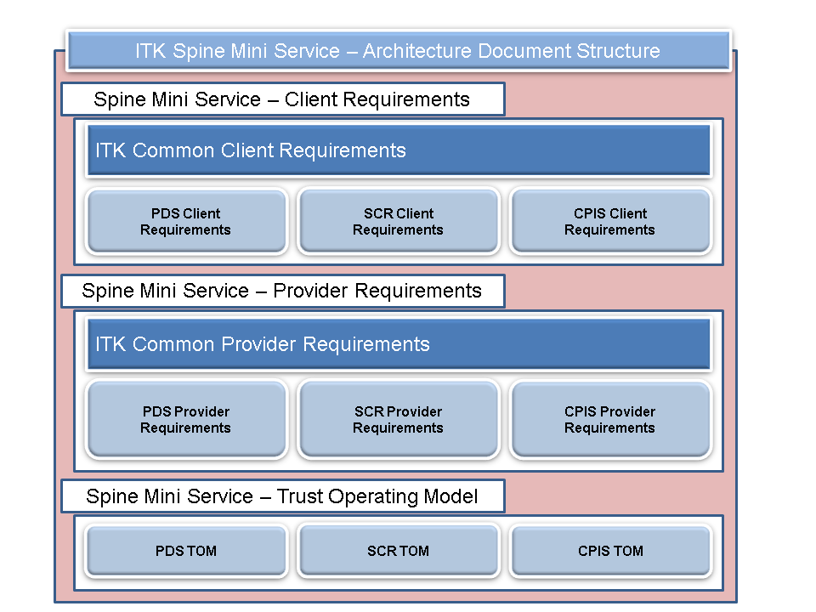**Figure 1 – The ITK Spine Mini Services Architecture Document Set.**

## Audience

The primary audience for this document are the developers (analysts, architects, developers) working on the ITK Component of the Spine Mini Service being developed. Within a Trust, the Project Manager and technical team will find the entire document set relevant.

These requirements are common/generic to all ITK Spine Mini Service Provider implementations.

# High Level Overview

## Level 0 view

A SMSP is an application which handles the complexity of dealing with the Spine TMS boundary yet provides a simplified interface to its clients. The complexity saving can be expressed both in terms of relaxed requirements for certain system calls and or syntactically and semantically more concise messaging.

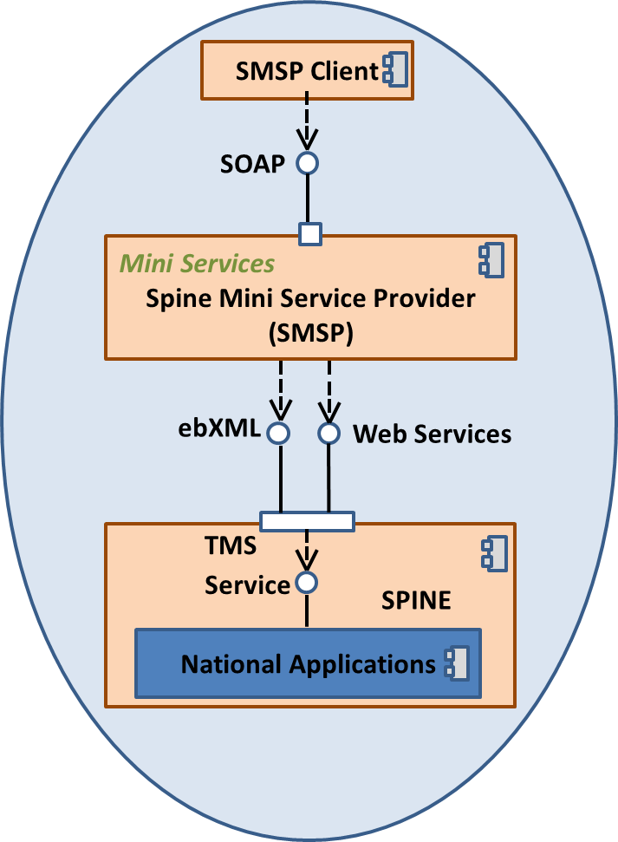

Figure 2: High Level view of an ITK Spine Mini Service

This document specifically focuses on a subset of SCR services that are of potential wide use in increasing adoption of the viewing of SCR. The diagram below illustrates the SCR services which are elaborated in this specification.



Figure 3: SCR Services in scope of this document

A SMSP MAY (and indeed, in some cases MUST) provide internal business logic above and beyond simple adaptor logic (e.g. filtering, protocol translation etc.). The following sections in the document are logical groupings of related principles of the architecture of an SMSP that must be considered and have some additional requirements. Some areas may overlap areas that are covered in other related documents from the Mini Services pack; notably the Interface specification and the Vocabulary specification.

# SCR Service Definitions

All the services will be SOAP services and will be synchronous over HTTP. A given response object is deterministic for any given request object to a given endpoint. The following diagram shows an overall view of the request and response message pairs in scope of this document.

Note, in any service response some elements may be either *blank* indicating that the Spine has this information and *it is blank*, or may be *omitted* indicating that the Spine has simply returned no information about this field.



Figure 4: SCR Spine Mini Service Messages

It is mandatory to implement all of the mini services.

## Mini Service to Spine Service mapping

|  |  |
| --- | --- |
| **Ref** | **Description** |
| **SMSP-** **MESSAGES-001** | **Appropriate usage of National Application services MUST be elaborated in documentation** |
| (1) | The SMSP MUST provide documentation that elaborates the message mapping from the SMSP API to the MIM messaging used to access National Applications in order for HSCIC to assure suitability. This must also take into account how these messages interact in the context of any caching that may be implemented (see SMSP-CACHE-002: Design documentation MUST consider caching) |
| **NB:** | **Note:** Suppliers SHOULD use MIM 6.2.02 for Spine Mini Services. However, in practice the Mini Services interface does not mandate any particular MIM, though the following MUST NOT to be used:   * MIM 1.x * MIM 2.x * MIM 3.x   Suppliers SHOULD NOT implement messaging using MIM 4.x |

The following table is a set of service mappings indicating which Spine services (some whose responses maybe cached) SHOULD be used to fulfil the required Mini Service. It is the supplier’s responsibility to demonstrate accurate and performant usage of SCR.

|  |  |
| --- | --- |
| **Mini Service** | **Suggested Spine Service(s)** |
| getRBACStatus | SDS Lookup |
| getSCRStatus | Get Resource Permissions PSIS Document List Data |
| queryPTV  createPTV | NA |
| querySCR | SDS Lookup  Get Resource Permissions  PSIS Document List Data  PSIS Document Data  Alert Raised |
| runReport | SDS Lookup |

# SCR Implementation Principles

## SCR Business Logic

|  |  |
| --- | --- |
| **Ref** | **Description** |
| **SMSP-SCR-001** | **The SMSP MUST implement a Permission To View business service** |
| (1) | The SMSP MUST implement a Permission to View (PTV) business service that records that a patient has given an explicit permission to view their SCR.  The PTV service MUST store PTV records in a secure repository.  A PTV exists between a patient and an individual care professional (as defined by SDS User and SDS Role Profile identifiers). Each PTV record SHOULD include:   * The NHS number of the patient the PTV applies to * The SDS Role Profile identifier for the care professional with the PTV * The SDS User identifier for the care professional with the PTV * Start date/time of PTV * End date/time of PTV   Multiple PTV records can exist between a single patient and many care professionals.  Only a single active PTV record should exist between a patient and a care professional. If a new PTV record is created for an active patient / care professional record, this should replace it.  Any PTV records that pass their end date/time MUST be automatically deleted from the PTV repository.  Note deletion can be a hard delete, where the record is physically removed from the repository, or it can be a soft delete, where the record is simply marked as deleted.  Any network communication between the SMSP and a separate PTV service MUST be encrypted.  Data stored in the PTV repository SHOULD, where possible, be encrypted. |

|  |  |
| --- | --- |
| **SMSP-SCR-002** | **The SMSP MUST support configuration items** |
| (1) | The SMSP MUST provide a configuration item for default PTV duration. A value of 30 days SHOULD be set.  The SMSP MUST provide a configuration item for maximum PTV duration. A value of 90 days SHOULD be set.  Where the SMSP implements a cache it MUST provide a configuration item for Cache RBAC duration. A value of 24 hours SHOULD be set.  Where the SMSP implements a cache it MUST provide a configuration item for Cache ACS duration. A value of 24 hours SHOULD be set.  The SMSP MUST provide a configuration item for a list of national RBAC codes for permission to view SCR with PTV. A value of B0370 SHOULD be set.  The SMSP MUST provide a configuration item for a list of national RBAC codes for permission to view SCR without PTV i.e. in an emergency. A value of B0168 SHOULD be set.  The SMSP MUST provide a configuration item for the time at which the daily operational report is run.  The SMSP MUST provide a configuration item for the maximum report size. This defines the maximum number of report records the runReport interaction can return.  Where changes are made to configuration items the SMSP SHOULD not require restarting for them to be applied. |

|  |  |
| --- | --- |
| **SMSP-SCR-003** | **The SMSP MAY cache retrieved Spine data** |
| (1) | The SMSP MAY implement caching of retrieved Spine data, specifically RBAC and Consent.  The SMSP MUST NOT implement caching of SCRs.  Where caching is implemented the following MUST be implemented.  Any network communication between the SMSP and a separate cache service MUST be encrypted.  Data stored in the cache, where possible, SHOULD be encrypted.  Each cache record MUST include:   * Creation date/time * Expiry date/time   The creation date/time of a cache record MUST be set by the date/time of the interaction with the SMSP.  The expiry date/time of a cache record MUST be set by:  Creation date/time + Cache record type duration  Cache record type duration for RBAC and ACS are defined as SMSP configuration items.  Any cache records that pass their expiry date/time MUST be automatically deleted from the cache.  Cache records relating to a single patient MAY be either physically or logically grouped together and treated as a single patient cache record if desired. In this situation either the expiry date/time of all the constituent cache records need to be aligned, or the first constituent record expiration triggers deletion of the whole patient cache record.  When writing a cache record if a record already exists for the primary key then the current record SHOULD be updated and a new creation and expiry date/time set.  If a cache record is found for RBAC data then SDS need not be queried and the cached data used for the RBAC check.  If a cache record is not found for RBAC data then after a successful SDS query and RBAC check, the RBAC data MUST be written to the cache.  If a cache record is found for ACS data then ACS need not be queried and the cached data used for the Consent check.  If a cache record is not found for ACS data then after a successful ACS query and Consent check, the ACS data MUST be written to the cache. |

|  |  |
| --- | --- |
| **SMSP-SCR-004** | **The SMSP MUST audit all activity** |
| (1) | All SMSP activity must be recorded in an audit log. |
| (2) | The following events MUST be audited:   * getRBACStatus   + Request message received   + SDS LDAP query sent   + SDS LDAP result received   + SMSP RBAC Cache query   + SMSP RBAC Cache result   + SMSP RBAC Cache write   + Response message sent * getSCRStatus   + Request message received   + Get Resource Permissions query sent   + Get resource Permissions result received   + PSIS Document List Data query sent   + PSIS Document List Data result received   + SMSP ACS Cache query   + SMSP ACS Cache result   + SMSP ACS Cache write   + Response message sent * queryPTV   + Request message received   + Response message sent * createPTV   + Request message received   + PTV write   + Response message sent * querySCR   + Request message received   + SDS LDAP query sent   + SDS LDAP result received   + Get Resource Permissions query sent   + Get resource Permissions result received   + PSIS Document List Data query sent   + PSIS Document List Data result received   + PSIS Document Data query sent   + PSIS Document Data result received   + Alert sent   + PTV read   + PTV write   + SMSP RBAC Cache query   + SMSP RBAC Cache result   + SMSP RBAC Cache write   + SMSP ACS Cache query   + SMSP ACS Cache result   + SMSP ACS Cache write   + Response message sent * runReport   + Request message received   + Response message sent * Configuration   + Configuration item change * Daily Operational Report   + Operational report run start   + Operational report run end |
| (3) | The structure of an audit log record SHOULD conform to the common provider requirements. |

|  |  |
| --- | --- |
| **Ref** | **Description** |
| **SMSP-SCR-005** | **The SMSP MUST implement a daily operational report business service** |
| (1) | The SMSP MUST run a daily operational report.  The report MUST be in CSV format.  Report structure MUST be:  “Organisation identity as ODS code”,”Care Professional SDS User Identity”,”Care Professional SDS Role Profile Identity”,”Emergency Access in format T or F”,”Emergency Access Reason”,”Date and time of SCR query in format YYYYMMDDHHMMSS”  Records SHOULD be sorted by ascending date and time.  Any missing values SHOULD be empty i.e. “”  The report MUST include records for all organisations the provider may support.  The report MUST be run daily and cover the 24 hour time period of the previous day midnight (inclusive) to midnight (exclusive). So a report run on for example 5th of August will cover the time period 3rd August 24:00:00 to 4th August 23:59:59.  The time at which the report is run is a configuration item.  The report result MUST be saved as a CSV text file in a secure file store location.  The CSV text file name MUST be formatted as:  SCR SMSP Operational Report ProviderID=XXX Period=DD-MM-YYYY  The ProviderID MUST be set to a value that uniquely identifies a SCR SMSP instance.  There SHOULD be a manual process in place to securely send the operational reports to the SCR Programme at HSCIC. |

## SCR Mini Service to Spine Service - Error Mapping

|  |  |
| --- | --- |
| **SMSP-SCR-006** | **Error codes MUST provide sufficient detail about the outcome of calls to national applications** |
| There are many scenarios where a final outcome of one or more calls to SCR is that a business error is returned from SCR itself. This is important information to pass back to the SMSP client so that it has the opportunity to handle it appropriately and/or inform the user about the nature of the problem.  Whilst the precise details of error handling and mapping are a responsibility of each supplier’s implementation, the following business error scenarios MUST be distinguishable by use of the appropriate SMSP error code:   |  |  | | --- | --- | | **Business Error Scenario** | **SMSP Error Code** | | **RBAC Check Failed**  The user identified in the request does not have appropriate Spine RBAC to query for a SCR. | **SCR-0001** | | **ACS Check Failed**  The patient identified in the request has not given Spine Access Control Services consent. | **SCR-0002** | | **PTV Check Failed**  There is no valid recorded permission to view between the patient identified in the request and the user. | **SCR-0003** | | **SCR Not Found**  There is no SCR for the patient identified in the request. | **SCR-0004** |   For business error scenarios returned by SCR other than those listed above then a generic code of SMSP-9999 MAY be used as a default.  The provider SHOULD implement an error log where more detailed error messages relating to called Spine services and internal SMSP errors can be logged.  The structure of an error log record SHOULD conform to the common provider requirements. | |

## getRBACStatus

The ‘*getRBACStatus*’ service provides the ability to ascertain the Spine RBAC status for accessing any SCR for the user.

Key Points:

### This is an attended session authentication with smartcard interaction only (see Client Access Methods in ITK Spine Mini Service – Common Client Requirements).

### The SSO token in the message header needs to be mapped to SDS User identifier and SDS Role Profile identifier..

**Request Message**

|  |  |  |  |
| --- | --- | --- | --- |
| **Parameter** | **Attributes** | **Description** | **Cardinality** |
|  |  |  | 1..1 |

**Response Message**

|  |  |  |  |
| --- | --- | --- | --- |
| **Parameter** | **Attributes** | **Description** | **Cardinality** |
| **Response Code** |  | A response code returned:  SMSP-0000 Success  SMSP-0001 Input message validation error  SMSP-0002 Response message validation error  SMSP-0004 Could not connect to Spine  SMSP-0005 Author Credentials Error  SMSP-9999 Generic Spine Mini Service Provider software failure  NB: See the “ITK Spine Mini Services Vocabulary Specification” For a list of these codes and their meanings. | 1..1 |
| **Response Display Name** |  | A response code display name, containing the explanation of the response or error. | 1..1 |
| **Payload** |  | |  |  |  |  | | --- | --- | --- | --- | | **Parameter** | **Attributes** | **Description** | **Cardinality** | | **With PTV** |  | A Boolean flag indicating whether or not the care professional has RBAC permission to access a SCR when a patient has given Permission To View. The value of the parameter will either be ‘TRUE’ or ‘FALSE’. | 1..1 | | **In Emergency** |  | A Boolean flag indicating whether or not the care professional has RBAC permission to access a SCR in an emergency situation, i.e. a patient does not have to give Permission To View. The value of the parameter will either be ‘TRUE’ or ‘FALSE’. | 1..1 | | 0..1 |

## getSCRStatus

The ‘*getSCRStatus*’ service provides the ability to ascertain the status of a SCR for a given NHS Number.

Key Points:

### This can use any of the four client access methods for the interaction (see Client Access Methods in ITK Spine Mini Service – Common Client Requirements).

### The NHS number within the request is considered to be verified.

### Field validation will be performed for mandatory fields and field formatting.

**Request Message**

|  |  |  |  |
| --- | --- | --- | --- |
| **Parameter** | **Attributes** | **Description** | **Cardinality** |
| **NHS Number** |  | The NHS standard identifier for an individual.  [Max 10 Numerical Characters only]  [Modulus 11 check] | 1..1 |

**Response Message**

|  |  |  |  |
| --- | --- | --- | --- |
| **Parameter** | **Attributes** | **Description** | **Cardinality** |
| **Response Code** |  | A response code returned:  SMSP-0000 Success  SMSP-0001 Input message validation error  SMSP-0002 Response message validation error  SMSP-0004 Could not connect to Spine  SMSP-0005 Author Credentials Error  SMSP-9999 Generic Spine Mini Service Provider software failure  NB: See the “ITK Spine Mini Services Vocabulary Specification” For a list of these codes and their meanings | 1..1 |
| **Response Display Name** |  | A response code display name, containing the explanation of the response or error. | 1..1 |
| **Payload** |  | |  |  |  |  | | --- | --- | --- | --- | | **Parameter** | **Attributes** | **Description** | **Cardinality** | | **SCR Exists** |  | A Boolean flag indicating whether or not the NHS Number passed in the request has a SCR, the specified patient has a GP summary with a status of Normal. The value of the parameter will either be ‘TRUE’ or ‘FALSE’. | 1..1 | | **SCR Consent** |  | The Spine Access Control Service (ACS) patient consent value for the NHS Number passed in the request:  0 - No, the patient does not have a Summary Care Record (has opted out)  2 - Ask / <no value>, the patient must be asked every time for permission to view their Summary Care Record  [Max 1 Numerical Character only]  Note a consent value of “Yes” is depreciated in Spine 2 so is no longer used. | 1..1 | | 0..1 |

## queryPTV

The ‘*queryPTV’* service provides the ability to check if a Permission To View (PTV) exists between a patient and the user.

Key Points:

### This is an attended session authenticated with smartcard interaction only (see Client Access Methods in ITK Spine Mini Service – Common Client Requirements).

### The NHS Number within the request is considered to be verified.

### Field validation will be performed for mandatory fields and field formatting.

**Request Message**

|  |  |  |  |
| --- | --- | --- | --- |
| **Parameter** | **Attributes** | **Description** | **Cardinality** |
| **NHS Number** |  | The NHS standard identifier for an individual.  [Max 10 Numerical Characters only]  [Modulus 11 check] | 1..1 |

**Response Message**

|  |  |  |  |
| --- | --- | --- | --- |
| **Parameter** | **Attributes** | **Description** | **Cardinality** |
| **Response Code** |  | A response code returned:  SMSP-0000 Success  SMSP-0001 Input message validation error  SMSP-0002 Response message validation error  SMSP-0005 Author Credentials Error  SMSP-9999 Generic Spine Mini Service Provider software failure  NB: See the “ITK Spine Mini Services Vocabulary Specification” For a list of these codes and their meanings | 1..1 |
| **Response Display Name** |  | A response code display name, containing the explanation of the response or error. | 1..1 |
| **Payload** |  | |  |  |  |  | | --- | --- | --- | --- | | **Parameter** | **Attributes** | **Description** | **Cardinality** | | **PTV Exists** |  | A Boolean flag indicating whether or not a current PTV exists between the patient identified by the NHS Number and the care professional. The value of the parameter will either be ‘TRUE’ or ‘FALSE’. | 1..1 | | 0..1 |

## createPTV

The “createPTV” service provides the ability to create a Permission To View (PTV) between a patient and a list of care professional Spine Directory Service (SDS) users.

Key Points:

### This can use any of the four client access methods for the interaction (see Client Access Methods in ITK Spine Mini Service – Common Client Requirements).

### The NHS Number within the request is considered to be verified.

### Field validation will be performed for mandatory fields and field formatting.

### The start date/time of the PTV must be set by date/time of the interaction with SMSP.

### The end date/time of the PTV must be set by start date/time + default PTV duration or start date/time + request supplied PTV duration.

### Default PTV duration is defined as a SMSP configuration item

### Request supplied PTV duration must not exceed maximum PTV duration.

### Maximum PTV duration is defined as a SMSP configuration item.

**Request Message**

|  |  |  |  |  |  |
| --- | --- | --- | --- | --- | --- |
| **Parameter** | **Attributes** | | **Description** | | **Cardinality** |
| **NHS Number** | |  | | The NHS standard identifier for an individual.  [Max 10 Numerical Characters only]  [Modulus 11 check] | 1..1 |
| **Care Professional List** | |  | | |  |  |  |  | | --- | --- | --- | --- | | **Parameter** | **Attributes** | **Description** | **Cardinality** | | **Care Professional Role** |  | SDS Role Profile identifier for care professional. | 1..1 | | **Care Professional Identifier** |  | SDS User identifier for care professional. | 1..1 | | 1..50 |
| **PTV Duration** | |  | | Duration of PTV.  [DD:HH:MM] | 0..1 |

**Response Message**

|  |  |  |  |
| --- | --- | --- | --- |
| **Parameter** | **Attributes** | **Description** | **Cardinality** |
| **Response Code** |  | A response code returned:  SMSP-0000 Success  SMSP-0001 Input message validation error  SMSP-0002 Response message validation error  SMSP-0004 Could not connect to Spine  SMSP-0005 Author Credentials Error  SMSP-9999 Generic Spine Mini Service Provider software failure  NB: See the “ITK Spine Mini Services Vocabulary Specification” For a list of these codes and their meanings | 1..1 |
| **Response Display Name** |  | A response code display name, containing the explanation of the response or error. | 1..1 |

## querySCR

The ‘querySCR’ service provides the ability to retrieve a SCR for a specific patient by the user.

Key Points:

### This is an attended session authenticated with smartcard interaction only (see Client Access Methods in ITK Spine Mini Service – Common Client Requirements).

### The NHS Number within the request is considered to be verified.

### Field validation will be performed for mandatory fields and field formatting.

### If the Create PTV parameter is TRUE then a PTV between the patient identified by the NHS Number and the care professional identified in the request header must be created first as defined in createPTV service.

### The SMSP must carry out authorisation checks against RBAC, Consent and PTV before querying PSIS or the SMSP cache.

### The RBAC check must check that the SDS User Role Profile identifier has the correct RBAC permissions to retrieve a SCR. If the RBAC check fails the interaction must terminate and return an appropriate error response.

### The patient consent check must check the Spine Access Control Service (ACS) for the patient consent value. This can have one of the following values: Yes – The Patient need not be asked for permission to view their Summary Care Record, No - The patient does not have a Summary Care Record (has opted out) or Ask / <no value> - The patient must be asked every time for permission to view their Summary Care Record. If the consent check fails, value equals No; the interaction must terminate and return an appropriate error response. If the consent check fails then the value should be "assumed" and the process should continue. In some circumstances ACS may have a Ask / <no value> setting, however within the actual SCR content there may be an explicit local dissent code that is held on the originating GP system that does not give consent. In this situation the SCR is still returned as it will contain no content i.e. will be empty.

### If the patient has an Ask / <no value> in ACS then the PTV check must check that the SDS Role Profile identifier has a valid PTV for the patient. If the PTV check fails the interaction must terminate and return an appropriate error response.

### Where Emergency Access is TRUE the PTV check does not need to be carried out.

### When all authorisation checks have been passed, the SMSP must initiate a PSIS Document List Query message to TMS for the patient. This will return a list of document identifiers (UUIDs) for the documents associated with the patient. At most there will be a single SCR document associated with a patient. To retrieve the document contents the SMSP must initiate a PSIS Document Query message to TMS for the document UUID. If either of the PSIS queries fails the interaction MUST terminate and return an appropriate error response.

### When the interaction is being called with an emergency access an appropriate alert message must be sent to TMS. The ReasonCoded segment of the Spine message should be set to TBD.

### When the interaction is being called with a self-claim legitimate relationship an appropriate alert message must be sent to TMS. The ReasonCoded segment of the Spine message should be set to TBD.

**Request Message**

|  |  |  |  |
| --- | --- | --- | --- |
| **Parameter** | **Attributes** | **Description** | **Cardinality** |
| **NHS Number** |  | The NHS standard identifier for an individual.  [Max 10 Numerical Characters only]  [Modulus 11 check] | 1..1 |
| **Self Claim LR** |  | A Boolean flag indicating whether or not the request is being called based on a self-claim legitimate relationship between the care professional and patient. The value of the parameter will either be ‘TRUE’ or ‘FALSE’. | 1..1 |
| **Emergency Access** |  | A Boolean flag indicating whether or not the request is being called as an emergency access i.e. the care professional has not been able to obtain patient permission to view. The value of the parameter will either be ‘TRUE’ or ‘FALSE’. | 1..1 |
| **Emergency Access Reason** |  | Emergency access reason.  [Max 128 Characters] | 0..1 |
| **Create PTV** |  | A Boolean flag indicating whether or not a PTV should be created between the patient and the care professional (the user initiating request). The value of the parameter will either be ‘TRUE’ or ‘FALSE’. | 1..1 |
| **PTV Duration** |  | Duration of PTV.  [DD:HH:MM] | 0..1 |

**Response Message**

|  |  |  |  |
| --- | --- | --- | --- |
| **Parameter** | **Attributes** | **Description** | **Cardinality** |
| **Response Code** |  | A response code returned:  SMSP-0000 Success  SMSP-0001 Input message validation error  SMSP-0002 Response message validation error  SMSP-0004 Could not connect to Spine  SMSP-0005 Author Credentials Error  SMSP-9999 Generic Spine Mini Service Provider software failure  SCR-0001 – RBAC Check Failed  SCR-0002 – ACS Check Failed  SCR-0003 - PTV Check Failed  SCR-0004 – SCR not found  NB: See the “ITK Spine Mini Services Vocabulary Specification” For a list of these codes and their meanings | 1..1 |
| **Response Display Name** |  | A response code display name, containing the explanation of the response or error. | 1..1 |
| **Payload** |  | |  |  |  |  | | --- | --- | --- | --- | | **Parameter** | **Attributes** | **Description** | **Cardinality** | | **SCR** |  | The Summary Care Record in XML format as stored in Spine PSIS. | 1..1 | | 0..1 |

## runReport

The ‘runReport’ service provides the ability to run standard activity reports against the SMSP audit log and return CSV reports.

Key Points:

### This can be attended without smartcard, attended with smartcard or attended session authentication with smartcard interaction (see Client Access Methods in ITK Spine Mini Service – Common Client Requirements).

### Field validation will be performed for mandatory fields and field formatting.

### Start Date <= End Date.

### Reports MUST only contain successful SCR query audit events.

### The organisation owning the ASID associated with the user initiating the interaction MUST be used to filter the report so only records associated with that organisation are retrieved.

### If the number of report records found exceed the maximum report size as defined as a configuration item, only the first maximum report size records are returned where found records are ordered by ascending SCR query date and time.

**Request Message**

|  |  |  |  |
| --- | --- | --- | --- |
| **Parameter** | **Attributes** | **Description** | **Cardinality** |
| **Start Date** |  | Start date of the reporting period in the format of YYYYMMDD  [Numerical Characters only in YYYYMMDD format] | 1..1 |
| **End Date** |  | End date of the reporting period in the format of YYYYMMDD  [Numerical Characters only in YYYYMMDD format] | 1..1 |
| **NHS Number** |  | The NHS standard identifier for an individual.  [Max 10 Numerical Characters only]  [Modulus 11 check] | 0..1 |
| **Care Professional Identifier** |  | SDS User Identifier for care professional. | 0..1 |

**Response Message**

|  |  |  |  |
| --- | --- | --- | --- |
| **Parameter** | **Attributes** | **Description** | **Cardinality** |
| **Response Code** |  | A response code returned:  SMSP-0000 Success  SMSP-0001 Input message validation error  SMSP-0002 Response message validation error  SMSP-0005 Author Credentials Error  SMSP-9999 Generic Spine Mini Service Provider software failure  NB: See the “ITK Spine Mini Services Vocabulary Specification” For a list of these codes and their meanings | 1..1 |
| **Response Display Name** |  | A response code display name, containing the explanation of the response or error. | 1..1 |
| **Payload** |  | |  |  |  |  | | --- | --- | --- | --- | | **Parameter** | **Attributes** | **Description** | **Cardinality** | | **Report** |  | Report in CSV format.  Report structure consists of an initial header record followed by multiple report records.  The header record consists of:  “Date and time of report generation in format YYYYMMDDHHMMSS”,”Number of report records returned”,”Number of report records found”,” Start date of the reporting period in the format of YYYYMMDD”,” End date of the reporting period in the format of YYYYMMDD”,” The NHS standard identifier for an individual”,” SDS User Identifier for care professional”  A report record consists of:  “Organisation identity as ODS code”,”Organisation name”,”NHS Number”,”Patient first name and last name”,”Care Professional SDS User Identity”,”Care Professional SDS Role Profile Identity,”Care professional name”,”Emergency Access in format T or F”,”Emergency Access Reason”,”Date and time of SCR query in format YYYYMMDDHHMMSS”  Report records should be sorted by ascending SCR query date and time.  Any missing values should be empty i.e. “” | 1..1 | | 0..1 |

# 

# Glossary

|  |  |
| --- | --- |
| Term | Description |
| ACS | Access Control Service. |
| CSV | Comma Separated Values. |
| EIS | External Interface Specification |
| IG | Information Governance |
| ITK | Interoperability Toolkit. Initiative by DHID Tech Office to create lightweight messaging standards to accelerate connectivity between deployed solutions. |
| ITK Distribution Envelope | Standard ITK term referencing a part of the message wrapper. See standard ITK documentation for further elaboration |
| LR | Legitimate Relationship |
| MIM | Message Implementation Manual |
| PSIS | Personal Spine Information Service |
| PTV | Permission to View |
| RBAC | Role Based Access Control. Used across NHS systems to control access to systems for authenticated system users |
| SCR | Summary Care Record |
| SMSP | Spine Mini Service Provider. Middleware that provides access to lightweight, filtered services on National Applications |
| SSO | Single Sign On. Mechanism by which a system user authenticates once and can subsequently use various disparate applications without being required to authenticate again. |

* * * End of Document * * *