|  |  |  |  |
| --- | --- | --- | --- |
| Document filename: SCR - SPINE Mini Service Client Requirements-01docx | | | |
| Directorate / Programme | HSCIC - Architecture | Project | Interoperability |
| Document Reference | |  | |
| Project Manager | Mike Fisher | Status | Draft |
| Owner |  | Version | 0.4.0 |
| Author | Emma Swift | Version issue date | 10th August 2015 |

SCR – SPINE Mini Service Client Requirements

Document Management

Revision History

|  |  |  |
| --- | --- | --- |
| Version | Date | Summary of Changes |
| 0.1 | 29th July 2014 | First Draft |
| 0.2 | 14th August 2014 | Updated after comments |
| 0.3 | 12th September 2014 | Updated after supplier comments |
| 0.3.1 | 29th September 2014 | Updated after supplier comments |
| 0.3.2 | 7th February 2015 | Updated after supplier comments |
| 0.4 | 10th August 2015 | Revised as a result of learnings from the SCR Spine Mini Service pilot |

Reviewers

This document must be reviewed by the following people: author to indicate reviewers

|  |  |  |  |
| --- | --- | --- | --- |
| Reviewer name | Title / Responsibility | Date | Version |
| Mike Fisher | SCR SMS Project Manager |  | 0.1 |
| Mike Kelly | SCR Programme Technical Architect |  | 0.3 |
| George Hope | ITK Architecture Lead |  | 0.1 |
| Richard Dobson | ITK Accreditation Manager |  | 0.1 |
| Nigel Saville | ITK Accreditation |  | 0.1 |
| Kevin Sprague | ITK Messaging |  | 0.1 |

Approved by

This document must be approved by the following people: author to indicate approvers

|  |  |  |  |  |
| --- | --- | --- | --- | --- |
| Name | Signature | Title | Date | Version |
| James Spirit |  | SCR Development Programme Manager |  | 0.4.0 |

Reference Documents

|  |  |  |  |
| --- | --- | --- | --- |
| Ref | Doc Reference Number | Title | Version |
| 1 |  | ITK SCR Spine Mini Services Client Compliance Matrix | TBA |
| 2 | NPFIT-SCR-SCRDOCS- 0003.01 | Principles for Implementing Permission to View for the Summary Care Record to support the diversity of care settings in the NHS v2.0 (Approved) | 2.0 |
| 3 | NPFIT-SHR-MODL-SUMREC-0025 | GP Summary Presentation Text Specification |  |

Glossary

| Term | Abbreviation | Description |
| --- | --- | --- |
| Care Episode | None | All care provided to a patient, for the duration of particular illness or condition. |
| Care Professional | None | An individual who provides care to a patient. |
| Demographic Batch Service | DBS | A NHS Demographic SPINE service that allows NHS staff and systems to verify or find a patient’s NHS number |
| Document Effective Time | None | The date and time that GP System created a GP Summary message. This information is stored within the GP Summary message. |
| GP Summary Message | None | The electronic message containing the information associated with a patient’s Summary Care Record. There are two types GP Summary message, Initial GP Summary and GP Summary. |
| GP Summary Presentation Text | None | A SCR Programme requirements document that defines the structure of the text section within the GP Summary Message |
| Legitimate Relationship | LR | A legitimate relationship (LR) is a connection between a patient and one or more Care Professionals that justifies access to the patient’s sensitive personal data (such as clinical information). |
| Permission to View | PTV | In order to view a Summary Care Record during a specific care episode, the patient must give his or her permission. This is recorded electronically and labelled Permission to View. |
| SCR Consent Preference | None | A value recorded on the NHS SPINE that indicates if a patient dissents to having a SCR. |
| Self-Claim Legitimate Relationship | Self Claim LR | This is a type of Legitimate Relationship, whereby a Care Professional who accesses a patient’s record, claims the existence of a Legitimate Relationship without the involvement of any third party. |
| SPINE Demographic Service | None | The NHS SPINE service that stores and manages patient demographic information. |
| SPINE Mini Service | None | A SPINE Mini Service is a combination of a SPINE Mini Service Provider and SPINE Mini Service Client, that together provide an end to end NHS SPINE related service |
| SPINE Mini Service Client | SMS Client | An external system, such as a SCR Viewing system that makes use of a SPINE Mini Service to access SPINE Services |
| SPINE Mini Service Provider | SMS Provider | A piece of software that offers specific NHS SPINE services for SMS Clients by the use of ITK interactions. |
| Summary Care Record | SCR | An electronic record held on the SPINE, which contains key clinical information about the patient, sourced from the patient’s registered GP Practice |
| User Role Profile | URP | A NHS SPINE recorded identity that uniquely identifies a NHS SPINE recorded user in a specific role, in a specific organisation. A user may have multiple URPs. |

Document Control:

The controlled copy of this document is maintained in the HSCIC corporate network. Any copies of this document held outside of that area, in whatever format (e.g. paper, email attachment), are considered to have passed out of control and should be checked for currency and validity.

Contents

1 Introduction 6

1.1 Purpose of Document 6

1.2 ITK Documentation Set 7

1.3 Audience 7

1.4 Summary Care Record Background 7

1.5 SCR Care Settings 8

1.6 Scope of the Summary Care Record SPINE Mini-Service 9

1.7 Requirement Notes and Document Structure 10

2 SCR SMS Client Requirements 11

2.1.1 Assumptions 11

2.2 SCR Access Workflow Requirements 11

2.2.1 Pre-conditions to accessing a patient’s SCR 11

2.2.2 Permission to View Process 14

2.2.2.1 Permission to View Requirements 17

2.2.2.2 Obtaining Permission to View 19

2.3 Creating Permission to View on behalf of Care Professionals 23

2.4 Accessing a locally stored copy of the SCR 24

2.5 Rendering the Summary Care Record 26

2.6 Handling Error Situations 28

2.7 Reporting 28

2.8 Auditing 29

2.9 Care Settings 29

3 Messaging Requirements 29

3.1.1 Attended and Non-Attended Interactions 29

4 Appendix 1 - Legitimate Relationship Requirements 30

5 Appendix 2 – Auditable Actions / Event 30

6 Appendix 4 - Summary of Information Governance Requirements 32

7 Appendix 4 - Example of Permission to View Process 34

# Introduction

SPINE Mini Services is a specification to enable suppliers of third party software, to provide solutions that provide a greatly simplified interface for accessing a subset of SPINE services. The intent is to thus lower the “barrier to entry” to the SPINE. In addition Spine Mini Services also aim to minimise the assurance requirements for connecting clients.

This document forms part of the overall document set for the Interoperability Toolkit (ITK).

## Purpose of Document

This document is a specification for the implementation of services that are expected to be provided by a Summary Care Record SPINE Mini Service Client (SMS Client). This includes requirements that define how the SMS Client will:

* Interact with the SCR SPINE Mini Service Provider (SCR SMS Provider).
* Control access to a patient’s Summary Care Record (SCR).
* Render and manage SCR content once a Care Professional has accessed a patient’s SCR.

.

## ITK Documentation Set

The position of this document in relation to the document set is shown below.

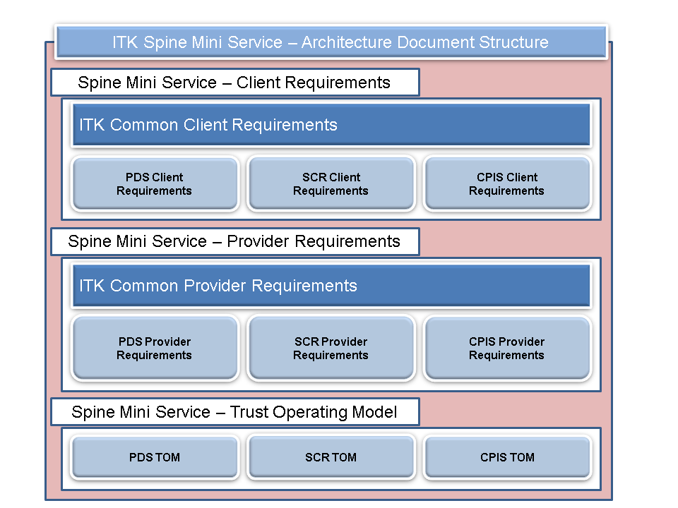**Figure 1 – The ITK SPINE Mini Services Architecture Document Set.**

## Audience

The primary audience for this document are the developers (analysts, architects, developers) working on the ITK Component of the SPINE Mini Service being developed. Within a Trust, the Project Manager and technical team will find the entire document set relevant.

## Summary Care Record Background

The Summary Care Record (SCR) is an electronic record, designed to provide healthcare staff working in urgent and emergency care settings, with faster and easier access to essential patient information. Approximately 97% of patients have a SCR and it is estimated that all eligible patients in England will have a SCR by early 2016.

Each patient’s SCR consists of a GP Summary message held on the NHS SPINE (SPINE), which contains key clinical information about the patient, sourced from the patient’s registered GP Practice. GP Practices create and send a GP Summary message to the SPINE (replacing any previous version), in response to various patient related events (such as change to the patient’s medication). A patient will only have a single accessible GP Summary (which will have a recorded document state of “Normal”) at any point in time and this version will be accessible to viewing systems and their users. Patients may choose not have a SCR at any time, which will both prevent the creation/update of the patient’s SCR and also make that patient’s SCR inaccessible to anyone (or system) that attempts to gain access.

SCRs are accessed in a variety of care settings by care professionals. The viewing of SCR is subject to a number of Information Governance (IG) controls and documented SCR Programme requirements, to ensure that a SCR is only accessed by appropriate care professionals, in suitable circumstances. These IG controls can be summarised as follows:

* The viewer must have the appropriate Role Base Access (RBAC) in order to access the record. This in turn necessitates that the individual is NHS Smartcard authenticated.
* The viewer must have a legitimate reason to access that patient’s SCR in the context of the particular episode of patient care (care episode). For example, the patient may be registered for care within an Emergency Department and the viewer may be one of the care professionals providing care to the patient.
* The patient must not have dissented to have Summary Care Record. This is termed the patient’s SCR Consent Preference and is recorded both centrally on SPINE and also locally within the patient’s registered GP Practice.
* The patient must have provided “Permission to View” their SCR, for the duration of the care episode, to appropriate individuals involved in their care. In exceptional circumstances a care professional may choose to access a patient’s SCR without the patient’s permission. For example, access may be necessary for emergency reasons. Permission to View will be managed by the SCR SMS Provider and enforced via the SMS Client.
* Electronic Alerts are generated and subsequently investigated by NHS Privacy Officers, when:
  + A SCR is accessed without the patient’s permission

and/or

* + The equivalent of Self-Claim Legitimate Relationship is created by an individual, who subsequently accesses the patient’s SCR.

The IG controls associated with accessing a SCR, when access is provided via a SCR SMS Client, must be implemented in combination by the appropriate, SPINE services, the SCR SMS Provider and SMS Client itself.

## SCR Care Settings

The current SCR Programme Business Case states that SCRs are designed to be accessed in urgent and unscheduled care settings. Current viewing sites include Emergency Departments, Walk in Centres, Minor Injury Units, hospital pharmacies, GP “Out of Hours” services and prisons. SCR accesses in other types of care settings are likely to occur in the future. Analysis of access to SCRs in various urgent and unscheduled care settings has identified common features and also common business / system processes. As patient encounters and access to the SCR in these care settings is unplanned:

* The patient’s demographics will be unknown prior to the patient encounter and will need to be identified and verified.
* It will not be known if the patient has a SCR available to access (i.e. has a GP Summary in a suitable state been “uploaded” to the NHS SPINE).
* It will be unclear if the patient has dissented to have SCR via the SCR Consent Preference.
* It is unlikely that there is the equivalent of a pre-existing Legitimate Relationship between the patient and the care professional(s) and this will need to be created.
* It is unlikely that Permission to View exists between the patient and the care professional(s) and will need to be created and managed.
* The patient may be incapable of giving consent to access their SCR for some reason. For example, the patient may be unconscious or incapacitated in some way.
* The need to access the SCR is immediate and urgent.
* It is likely that there will be a single point of admission for patients. For example, a reception desk.

## Scope of the Summary Care Record SPINE Mini-Service

At a high level, it is proposed that the SCR SMS Provider and its SMS Clients will provide functionality that will allow the following business use cases to be fulfilled.

| **Use Case** | **Description** |
| --- | --- |
| Access a Summary Care Record | A Care Professional retrieves and views a patient’s SCR without assistance from any clinical support staff such as a receptionist. As part of the process to access the SCR, the Care Professional creates Permission to View if appropriate, for him / herself and any colleagues who require access to the SCR. |
| Create Permission to View for a Care Professional | A non-clinical user (Administrative Support User), such as a receptionist or call handler, verifies the identity of the patient and obtains and records the patient’s “Permission to View” their SCR, on behalf one or more Care Professionals who will subsequently access the SCR. |

## Requirement Notes and Document Structure

The requirements in this document are divided into two main sections:

* **SCR Access Workflow Requirements** – This section contains the SMS Client requirements associated with a Care Professional accessing and subsequently managing the content of a patient’s Summary Care Record.
* **SCR Client Messaging Requirements** – The section contains the SMS Client requirements associated with making use of SCR SMS Provider messaging.

## SCR SMS Client Requirements

## Assumptions

For the purpose of these requirements the following terms MUST be interpreted as follows:

|  |  |
| --- | --- |
| **Term** | **Meaning** |
| Administrative Support User | An individual who has the appropriate local permissions to create “Permission to View” on behalf of one or more Care Professionals, but does not have the RBAC activities (in his or her current role) to access a SCR. |
| Care Professional | Refers to an individual, in a specific Smartcard Role, who potentially may access a patient’s Summary Care Record |
| GP Summary | This term encompasses both Initial GP Summary and GP Summary messages. |
| Permission to View Process | This encompasses the various steps and processes associated with a Care Professional either, gaining the patient’s explicit permission to access their SCR or a Care Professional accessing a SCR for emergency reasons. |
| Render a SCR | This will refer to display of a SCR in any format, electronic or paper. |
| Role | This must be interpreted as being equivalent to a User’s current SPINE authenticated User Role Profile (URP). |
| SCR SMS Provider | The instance of the SCR Spine Mini Service Provider which the SMS Client uses to access SCR related services. |
| SMS Client | The instance of the external application that makes use of the SCR SMS Provider services to obtain SCR related services and content. For example, the SMS Client will render a patient’s SCR. |
| User | A generic term to refer an individual who may either be Care Professional or an Administrative Support User |
| User Session | The time period between a user “logging onto” a client system and then explicitly logging out of the system or being automatically logged out by the system after a system defined time of user inactivity. |

## SCR Access Workflow Requirements

## Pre-conditions to accessing a patient’s SCR

The requirements in this section specify pre-conditions that must be in place, prior to a Care Professional accessing a patient’s SCR. In summary the SCR SMS Client must ensure that:

* The patient’s identity MUST be verified against the SPINE Demographic Service.
* The Care Professional MUST be Smartcard authenticated.
* The Care Professional MUST have the appropriate RBAC permissions to access the patient’s SCR. Note:
  + The SCR SMS Provider will provide the functionality to identify if a Care Professional (identified via their URP) has the appropriate RBAC Activities to access a patient’s SCR.
  + Multiple RBAC Activities control access to a patient’s SCR. A distinct RBAC Activity is required to access a patient’s SCR with the patient’s permission which differs from the RBAC Activity to access a SCR for emergency reasons. As a consequence a Care Professional may only have the RBAC permissions to access a SCR with the patient’s permission and not for emergency reasons.
* A Legitimate Relationship or the equivalent of must exist between the Care Professional and the patient

|  |
| --- |
| MSCA-SCR-01:The patient’s identity MUST be verified against the SPINE Demographic Service |
| 1. Before allowing a Care Professional to access a patient’s SCR or attempting to make use of any SCR SMS Provider related services, the SMS Client MUST verify the patient's identity by verifying the patient's demographic details held on the SMS Client, with the patient's demographic details held on the Spine Demographic Service. 2. The selected patient’s NHS number MUST be traced and \ or verified in one of the following ways:  * Using the Demographic Batch Service (DBS).   OR   * In a non-interactive (system-driven) function, as part of an SMS Client using the algorithms in A.   OR   * Or in a non-interactive (system) function, as part of an integrated SPINE Demographic Service SMS Client using the algorithms in A.   OR   * The patient’s SPINE Demographic Service record must be confirmed (by a User) through an interactive tracing process using an SMS Client.   OR   * The patient’s SPINE Demographic Service record must be confirmed (by a user) through an interactive tracing process using an integrated SPINE Demographic Service SMS Client.   **A: Demographic Verification Algorithm in a Non-Interactive Scenarios**  One of the following algorithms MUST be used:   * If no NHS Number exists locally, an exact match on SPINE Demographic Service of Surname, Forename, Gender, Date of Birth, Postcode may be considered a verified match.   OR   * If an NHS Number exists locally then it can be considered verified if the NHS Number and Date of Birth (YYYYMMDD) match a SPINE Demographic Service record.   OR   * If an NHS Number exists locally then it can be considered verified, if the NHS Number, 2 out of 3 of the elements of Date Birth (a single element being YYYY, MM or DD), the first 3 characters of Surname, first character of Forename all match the SPINE Demographic Service record. |

|  |
| --- |
| **MSCA-SCR-02: The Care Professional MUST be Smartcard Authenticated** |
| Before allowing a Care Professional to access a selected patient’s SCR, the SMS Client MUST ensure that the Care Professional:   * Is authenticated using a standard NHS Smartcard that complies with SPINE authentication requirements applicable to NHS Smartcards. Refer to [Ref.1].   AND   * Has selected a SPINE User Role Profile (URP) that allows access to the selected patient’s SCR. Refer to **MSCA-SCR-03**. |

|  |
| --- |
| **MSCA-SCR-03: The Care Professional MUST have the RBAC Permissions to access the patient’s SCR** |
| 1. The SMS Client MUST ensure that only individuals with the appropriate RBAC activities in their current Smartcard Role (URP) can access a patient’s SCR. 2. The SMS Client must use the SCR SMS Provider to identify if an individual has the appropriate RBAC activities to access a patient's SCR. 3. The SMS Client MUST ensure that a Care Professional is only offered the options to access a SCR, that match the RBAC activities associated with the Care Professional’s current Smartcard Role (URP). For example, if the Care Professional did not have the RBAC to access SCRs for emergency reasons, that option must not be offered to the Care Professional by the SMS Client. |

|  |
| --- |
| **MSCA-SCR-04: A legitimate relationship or the equivalent of MUST exist between the Care Professional and the patient** |
| **Overview**  The SMS Client MUST ensure that a Care Professional can only access a patient’s SCR if in the context of the current care episode, the Care Professional has a legitimate reason to access the patient’s SCR. Legitimate Relationships are distinct from the existence of Permission to View.  The equivalent of a legitimate relationship (LR) MUST exist between the Care Professional and the selected patient, before the SCR Viewing System can allow access to the patient’s SCR.  In most cases, a user viewing a patient's SCR will not be the same user that recorded or retrieved the patient's details at the beginning of the episode of care, i.e. there is role separation. This is a self-referral LR.  In cases where the same user records the patient's details on the system or retrieves the patient's pre-existing details, and then views their SCR, there is no role separation. This is a Self-Claim LR and an Alert must be raised when created. A Self-Claim LR has duration of 5 days and once expired, a new LR must be created in order to access a patient’s SCR.  **Requirement**  The equivalent of a legitimate relationship MUST exist between the Care Professional and the selected patient in the context of the current care episode, before the SMS Client can allow access to the patient’s SCR.  In order ensure that sufficient controls are in place:   1. The SMS Client MUST ensure that a legitimate relationship or the equivalent exists between the Care Professional and the patient, prior to allowing Care Professional to access the SCR. 2. The SMS Client MUST support LRs through existing system behaviour or by implementing Spine LRs. 3. The SMS Client MUST trigger a Self-Claim Alert via the appropriate SMS Provider interaction if the same person who has registered a patient for the care episode also accesses the patient’s SCR. 4. The SMS Client must be assured against the relevant sections of the Information Governance Baseline associated with legitimate relationships, to ensure that SCR access is only allowed when a Care Professional has legitimate reason. Appendix 1 contains an extract of the relevant Information Governance Baseline requirements. |

## Permission to View Process

This section is concerned with the requirements and processes associated with obtaining the patient’s Permission to View (PTV) their SCR and also accessing the SCR for emergency reasons. Permission to View has the following features:

1. It starts and ends at specific point in time, with a duration appropriate to the circumstances of the SCR access.
2. It is associated with a specific patient and one or more Care Professionals who potentially may need to access a patient’s SCR during a specific care episode. For example, a hospital pharmacist may require access to a patient’s SCR during the patient’s stay in hospital, in order to dispense medication.
3. A patient should be asked prior to any SCR access, whether he / she agrees to one or more Care Professionals accessing his/ her SCR. Example questions include, *"Is it okay if myself and my colleagues can view your SCR for the duration of your stay in this hospital?", or "Is it okay if I can view your SCR until the end of today?* The patient’s response will govern which Care Professional(s) can be granted Permission to View and the SCR SMS Client must ensure it only creates Permission to View for those Care Professionals.
4. There is no RBAC control associated with the creation and management of Permission to View, as opposed to actually viewing or accessing the SCR (which is RBAC controlled). Instead the SMS Client must ensure that only users with appropriate local permissions can create Permission to View either for themselves or on behalf of others.
5. Permission to View may be created either by via SMS Clients by:

* The Care Professional who will subsequently access the patient’s SCR.

OR

* An Administrative Support User, who creates Permission to View on behalf of one or more Care Professionals.

**Process to obtain Permission to View for a Care Professional**

The SMS Client must enforce a specific “Permission to View Process” via its user interface to help ensure that a patient SCR is only accessed in appropriate circumstances. This process is summarised below:

1. If the patient does not have an accessible SCR, the SMS Client SHOULD clearly indicate this to any Care Professional who attempts to access the SCR. For example, a patient will not have an accessible SCR, if a GP Summary Message associated with that patient, has not yet been uploaded to the SPINE.
2. If the patient does have an accessible SCR AND “Permission to View” is currently recorded between the patient and the Care Professional, the SMS Client must allow the Care Professional to access the patient’s SCR on request, providing all other pre-conditions for SCR access have been fulfilled.
3. If the patient does have an accessible SCR AND “Permission to View” is NOT currently recorded between the patient and the Care Professional, the SMS Client MUST (subject to RBAC permissions) provide the Care Professional with the following options for access appropriate to the current care episode:

* Access the patient’s SCR with permission, for that Care Professional only
* Access the patient’s SCR with permission for the Care Professional and other colleagues who may require access during the current care episode
* Emergency Access to the SCR
* Option to indicate that the patient has refused access.

1. It is possible an Administrative Support User to obtain and record a patient’s “Permission to View” on behalf of one or more Care Professionals who may be involved in the patient’s current care episode.

The diagram below provides a simplified illustration of the Permission to View Process:



Example screenshots of a system that has implemented the Permission to View Process are provided in Appendix 4.

**Managing Permission to View**

Permission to View will be stored and managed by SMS Provider. Consequently the SMS Client must use SCR SMS Provider interactions to:

* Identify if “Permission to View” currently exists between a selected patient and Care Professional.
* Request the creation of “Permission to View” between a specified patient and Care Professional(s).

The patient’s “Permission to View” their SCR has a duration. Once expired, the Care Professional must obtain again the patient’s “Permission to View” in order to access the patient’s SCR again. The SMS Provider will set the duration of” Permission to View” to default duration of 30 days.

* The SMS Client may specify a different duration of “Permission to View” between a patient and one or more Care Professionals. Any appropriate duration can be specified, providing it does not exceed a maximum duration, which will be enforced by the SMS Provider.

Note, the default and maximum durations of Permission to View will be configurable items, managed by the SMS Provider.

**Emergency Access**

If access to a patient’s SCR is for emergency reasons:

* The SMS Client must ensure that the Care Professional provides a reason for the emergency access, prior to allowing access to the SCR.
* The SMS Client must raise the equivalent of a SPINE Access Alert via the SCR SMS Provider, to notify Privacy Officer(s) in the organisation associated with Care Professional’s current role (URP), of the “emergency” SCR access. This content of the alert must include the reason for the emergency access, provided by the Care Professional.
* Emergency access can only be initiated by a Care Professional accessing the SCR and cannot be created by a non-clinical Administrative Support User.
* Permission to View must not be created. The SMS Client must only allow access to the patient’s SCR either for the duration of the current view or at most the duration of the current client session only.

## Permission to View Requirements

|  |
| --- |
| **MSCA-SCR-05: Adhere to the Principles for Implementing Permission to View for the Summary Care Record** |
| Any organisation that provides access to the SCR via a SMS Client MUST adhere to the principles stated in the document “Principles for Implementing Permission to View for the Summary Care Record to support the diversity of care settings in the NHS” [Ref. 2]. |

|  |
| --- |
| **MSCA-SCR-06: The Client MUST use the SCR SMS Provider to identify if a patient has an accessible SCR** |
| The Client MUST use the SCR SMS Provider to identify if a patient has an accessible SCR. A patient MUST be considered to have an accessible SCR if the response from SMS Provider indicates:   1. The patient has a SPINE stored GP Summary that has Document State of Normal**.** 2. The patient is not recorded on SPINE as opting out \ dissenting to have a SCR. |

|  |
| --- |
| **MSCA-SCR-07: Users SHOULD be informed if a SCR is accessible.** |
| The SMS Client SHOULD clearly indicate to a Care Professional or Administrative Support User whether a selected patient has an accessible SCR, before the Care Professional makes any attempt to:   1. Access that patient’s SCR . 2. Obtain the patient’s permission to access their SCR.   Refer to **MSCA-SCR-06** for the definition of an accessible SCR. |

|  |
| --- |
| **MSCA-SCR-08: Pre-conditions to initiating the “Permission to View Process”** |
| Prior to allowing a Care Professional to initiate the “Permission to View” process, the SMS Client MUST:   1. Identify if selected patient has an accessible SCR. Refer to **MSCA-SCR-06** for the definition of an accessible SCR. 2. Use the SCR SMS Provider to identify if Permission to View is recorded on the SMS Provider, as currently existing between specified patient and Care Professional’s current Smartcard Role (URP). 3. Ensure that the Care Professional has the appropriate RBAC activities to access the patient’s SCR. Refer to **MSCA-SCR-03**. |

|  |
| --- |
| **MSCA-SCR-09: The Care Professional MUST be informed if the patient does not have an accessible Summary Care Record** |
| If a Care Professional attempts to access a specific patient’s SCR AND it is identified that the patient DOES NOT have an accessible SCR, the SMS Client MUST:   1. NOT allow access to the selected patient’s SCR   AND   1. Indicate clearly to the Care Professional that the patient’s SCR is not available for access and the reason(s) why the SCR is not available for access.   Refer to **MSCA-SCR-06** for the definition of an accessible SCR. |

|  |
| --- |
| **MSCA-SCR-10: The Care Professional MUST be able to access the patient SCR in the circumstance where Permission to View currently exists** |
| The SMS Client MUST allow the Care Professional to access a patient’s SCR on request if:   1. It is identified that the patient DOES have an accessible SCR. Refer to **MSCA-SCR-06** for the definition of an accessible SCR.   AND   1. Permission to View is currently recorded within the SMS Provider, as existing between the patient and Care Professional’s current Smartcard Role (URP).   AND   1. All other pre-conditions for accessing a patient’s SCR have been fulfilled. Refer to **MSCA-SCR-01, MSCA-SCR-02, MSCA-SCR-03 and MSCA-SCR-04** for the details of the pre-conditions. |

## Obtaining Permission to View

|  |
| --- |
| **MSCA-SCR-11: Obtaining Permission to View** |
| The SMS Client MUST implement the following process via its user interface to obtain ”Permission to View” or record access to the SCR for emergency reasons if:   1. A Care Professional chooses to access the SCR of a patient who has an accessible SCR. Refer to **MSCA-SCR-06** for the definition of an accessible SCR.   AND   1. Permission to View is not recorded in the SMS Provider as existing between the patient and Care Professional in the SCR SMS Provider.   The process is as follows:   * The SMS Client MUST display to the user "Has this patient given permission to view their Summary Care Record?" and "The usual legal, ethical and professional obligations apply when accessing a patient's clinical record". * The SMS Client MUST make available to the user, any options which are appropriate to the current care episode AND MUST NOT make available any of the options for which the user does not have the correct RBAC activities in their current Smartcard Role. * The SMS Client MUST ensure that only Care Professionals with appropriate local permissions, can create Permission to View on behalf of other Care Professionals (within their current team) (Option 1b below):   **1. Yes (View Record)**  **Obtain permission for:**  **1a. Yourself only**  **1b. Your workgroup or team**  **2. No (Access Refused)**  **3. Emergency Access**  The SMS Client MAY implement different wording for any of the options above, providing it has been agreed with the SCR Programme.  Further details of the functionality associated with each options is specified as follows:  Refer to **MSCA-SCR-12** for the behaviour associated with options 1 and 1a  Refer to **MSCA-SCR-13** for option 1b.  Refer to **MSCA-SCR-16** for option 2.  Refer to **MSCA-SCR-14** and **MSCA-SCR-15** for option 3  There are no restrictions on how many times a user can go through this “Permission to View” process for a given patient, regardless of previous outcomes. |

|  |
| --- |
| **MSCA-SCR-12: Creating Permission to view for the current Care Professional Only (Permission to View Option 1 and 1a )** |
| If a Care Professional chooses to access the patient’s SCR for him / herself only (*Permission to View Options 1 and 1a*).  AND  Permission to View is not currently recorded (by the SMS Provider) as existing between the selected patient and the Care Professional.   1. The SMS Client MUST request the SCR SMS Provider creates Permission to View between the Care Professional in their current Smartcard Role and the selected patient for a specific duration. Refer to **MSCA-SCR-17** for the requirements associated with specifying the duration of Permission to View. 2. The SMS Client MUST immediately make the selected patient’s SCR available to the Care Professional to access, providing all other pre-conditions for accessing the selected patient’s SCR have been fulfilled. Refer to **MSCA-SCR-01, MSCA-SCR-02, MSCA-SCR-03** and **MSCA-SCR-04** for the details of the pre-conditions. |

|  |
| --- |
| **MSCA-SCR-13: Creating Permission to view for multiple Care Professionals (Permission to View Option 1b )** |
| If a Care Professional chooses to create Permission to View for him / herself AND other Care Professionals who may be involved in the patient’s current care episode (*Permission to View Option 1b)*  AND  If Permission to View is not currently recorded (by the SCR SMS Provider) as existing between a patient and a Care Professional (who has the RBAC to access a SCR in their current Smartcard Role):   1. The SMS Client MUST request the SCR SMS Provider creates Permission to View between appropriate Care Professionals involved in the patient’s current care episode and the selected patient for a specific duration. Refer to:    * **MSCA-SCR-17** for the requirements associated with specifying the duration of Permission to View.    * **MSCA-SCR-35** for the requirements associated with identifying which Care Professionals should be granted Permission to View in the context of a specific care episode. 2. MUST immediately make the selected patient’s SCR available to the Care Professional to access, providing all other pre-conditions for accessing the selected patient’s SCR have been fulfilled. Refer to **MSCA-SCR-01, MSCA-SCR-02, MSCA-SCR-03** and **MSCA-SCR-04** for the details of the pre-conditions. |

|  |
| --- |
| **MSCA-SCR-14: Confirmation of Emergency Access** |
| If a Care Professional chooses to access the SCR for emergency reasons (**Option 3. Emergency Access**), the SMS Client MUST:   1. Display the following to the Care Professional   "You may access this patient's record in the best interests of the patient if they are not able to give permission themselves, e.g. the patient is unconscious or confused. This action will be audited by the system and an alert will be sent to your privacy officer for monitoring purposes. Any breaches of patient confidentiality will be investigated and may be a matter for disciplinary proceedings. If in doubt, speak to your manager or privacy officer".   1. Ensure that Care Professional provides a reason for the emergency access. The Care Professional MAY enter the reason for the access in free text or the SMS Client may allow the Care Professional to choose from a list of appropriate values. For example, “The patient is unconscious and requires care”. 2. The system MUST allow the user to either to continue and access the patient's SCR, or cancel and return to the screen they came from prior to choosing to view the patient's SCR. Refer to **MSCA-SCR-15** for the requirement associated with accessing a SCR for emergency reasons. |

|  |
| --- |
| **MSCA-SCR-15: Accessing the SCR for Emergency Reasons** |
| If a Care Professional confirms that they wish to access the SCR for emergency reasons (as defined in **MSCA-SCR-14**) the SMS Client MUST:   1. Raise a SPINE Access Alert via the appropriate SMS Provider interaction, indicating that the Care Professional has accessed the selected patient’s SCR in an emergency. The SMS Client MUST ensure that the reason for the “emergency access” specified by the Care Professional (referred to in **MSCA-SCR-14)**, is included within the SPINE Alert. 2. Immediately make the selected patient’s SCR available to the Care Professional to access, providing all other pre-conditions for accessing the selected patient’s SCR have been fulfilled. Refer to **MSCA-SCR-01, MSCA-SCR-02, MSCA-SCR-03** and **MSCA-SCR-04** for the details of the pre-conditions. |

|  |
| --- |
| **MSCA-SCR-16: Patient refuses Permission to View** |
| If the Care Professional selects the option indicating that the patient has refused “Permission to View” (**Option 2. No (Access Refused)**), the SMS Client MUST NOT allow the Care Professional to access the patient’s SCR until Permission to View has been obtained. |

|  |
| --- |
| **MSCA-SCR-17: Duration of Permission to View** |
| The SMS Client MUST fulfil the following requirements when specifying the duration of Permission to View for either a specific Care Professional or group of Care Professionals:   1. The duration of Permission to View MUST NOT exceed the maximum duration of Permission to View specified within the SCR SMS Provider. Note the SMS Provider will respond with an error if the SMS Client attempts to exceed to maximum duration of Permission to View.   **“Permission to View” obtained from the patient (Options 1, 1a and 1b)**  If the outcome of Permission to View Process (specified in **MSCA-SCR-11** or **MSCA-SCR-19**) is that the user selects an option indicating that the patient has provided “Permission to View” (*Options 1,1a and 1b*)  AND  Permission to View is NOT currently recorded between the selected patients and Care Professional(s) in the SCR SMS Provider:   * The SMS Client MUST ensure the duration of Permission to view is one of the following:   + For the “default” duration specified in the SMS Provider.   + For the remainder of the current care episode. The duration of care episode will need to be specified explicitly by for SMS Client, when creating Permission to View via the appropriate SCR SMS Provider interaction. For example, the SMS Client may assume that a care episode has duration of 3 days and consequently specify that Permission to View has the same duration.   + For a fixed duration (such as 24 hours, a week, etc.)   + For a duration specified by the user.   + Some other duration, in agreement with the SCR Programme.   **Emergency Access**  If the outcome of Permission to View Process (specified in **MSCA-SCR-11**) is that the Care Professional selects an option indicating that SCR access for emergency reasons (Option 3), then the SMS Client MUST ensure that the Care Professional can access the patient’s SCR for one of the following:   * For the current view only i.e. the Care Professional would be prompted again for Permission to View, if another attempt to access the patient’s SCR was made in the same user session. * For the remainder of the user's current user session. * Some other duration, in agreement with the SCR Programme.   **Note 1:** Suppliers should choose the one or more duration options which best suits the care setting that their system is used in and in consultation with organisations and their users. For suppliers whose products are used in multiple care settings, a different set of options may be used for each care setting.  **Note 2:** It is required that the option(s) available in the system and chosen by the user for duration will reflect the questions that will be asked of the patient in the particular care setting. For example: "Is it okay if myself and my colleagues can view your SCR for the duration of your stay in this hospital?", or "Is it okay if I can view your SCR until the end of today?" |

|  |
| --- |
| **MSCA-SCR-35: Applicability of Permission to View** |
| The SMS Client MUST fulfil the following requirements when specifying the applicability of Permission to View for either a specific Care Professional or a number of Care Professionals:   1. Permission to View will apply between a specific patient and one or more Care Professionals each in a specific Smartcard Role, identified via URP ID(s). If the same user in a different Smartcard Role wishes to access the same patient's SCR, then the Permission to View process MUST be repeated again to ensure that the access is appropriate for the Care Professional in that Role. 2. **“Permission to View” obtained from the patient for the current Care Professional only (Options 1, 1a)**   If a Care Professional chooses to access the patient’s SCR for him / herself only (*Permission to View Options 1 and 1a*), the SMS Client MUST ensure that Permission to View is only created between the selected patient and the Care Professional in their current Smartcard Role.   1. **“Permission to View” obtained from the patient and multiple Care Professionals (Options 1, 1b)**   If a user (Care Professional or Administrative Support User) chooses an option that indicates that patient has provided Permission to View to multiple Care Professionals involved in his / her care (*Permission to View Options 1 and 1b*), the SMS Client MUST ensure that Permission to View is only created between the patient and those Care Professionals in the user’s current team, that it could be reasonably assumed could be involved in the patient’s current care episode, in the user’s current organisation .  **Note:** It is required that the option(s) available in the system and chosen by the user for applicability will reflect the questions that will be asked of the patient in the particular care setting. For example: "Is it okay if myself and my colleagues can view your SCR for the duration of your stay in this hospital?", or "Is it okay if I can view your SCR until the end of today?" |

## Creating Permission to View on behalf of Care Professionals

The section is concerned with the requirements associated with a non-clinical Administrative Support User creating Permission to View on behalf of one or more Care Professionals.

|  |
| --- |
| **MSCA-SCR-18: It MAY be possible for an Administrative Support User to create the equivalent of a Permission To View on behalf of one or more Care Professionals** |
| The SMS Client MAY implement functionality to allow an Administrative Support User to create Permission To View using the SCR SMS Provider, on behalf of one or more Care Professionals.  The SCR SMS Client MUST ensure that there are sufficient local controls in place, to ensure that only appropriate users are able to create Permission to View on behalf of Care Professionals.  **Note:** An Administrative Support User can be defined an individual who does NOT have the RBAC permissions to access SCR but does have the appropriate local permissions to create Permission to View. |

|  |
| --- |
| **MSCA-SCR-19: Permission to View Process via an Administrative Support User** |
| The SMS Client System MUST ensure that the following process is followed, in order to allow an Administrative Support User to create Permission to View between a selected patient and a group of Care Professionals:   1. The SMS Client MUST display to the user:   "Has this patient given permission to view their Summary Care Record?" and "The usual legal, ethical and professional obligations apply when accessing a patient's clinical record”   1. The SMS Client MUST display the following options:   **1. Yes (View Record)**  **2. No (Access Refused)**  Further details of the functionality associated with each options is specified as follow:  Refer to **MSCA-SCR-20** for the behaviour associated with option 1.  Refer to **MSCA-SCR-21** for option 2.  There are no restrictions on how many times a user can go through this process for a given patient, regardless of previous outcomes. |

|  |
| --- |
| **MSCA-SCR-20: Creation of Permission to View by an Administrative Support User** |
| If the Administrative Support User selects the option, indicating that the patient has provided “Permission to View” their SCR to a specified group of Care Professionals, (Option1 Yes (View Record)):   1. The SMS Client MUST request the SCR SMS Provider creates Permission to View between appropriate Care Professionals involved in the patient’s current care episode and the selected patient for a specific duration. Refer to:    * **MSCA-SCR-17** for the requirements associated with specifying the duration of Permission to View.    * **MSCA-SCR-35** for the requirements associated with identifying which Care Professionals should be granted Permission to View in the context of a specific care episode. |

|  |
| --- |
| **MSCA-SCR-21: Patient refuses Permission to View** |
| If the Administrative Support User selects the option, indicating that the user has not provided “Permission to View” their SCR to the specified group of Care Professionals (**Option 2. No (Access Refused)**), the SMS Client:   1. MUST NOT create Permission to View between the selected patient and any Care Professionals involved in the patient’s current care episode. |

## Accessing a locally stored copy of the SCR

It is possible for a non-clinical user or a Care Professional to “download” a local copy of the patient’s latest SCR (via the SCR SMS Provider) to the SMS Client. Care Professionals using the SMS Client may subsequently access that local copy. This type of access is analogous to viewing a printed copy of a patient’s SCR. It will have the following features:

* The Information Governance and work flow requirements associated with the download of the latest version of the SCR to the SMS Client System will be identical those in place access the patient’s latest SCR. For example Smartcard authentication, appropriate RBAC permissions and Permission to View are all mandated.
* Care Professionals may access this locally stored version of the SCR governed by local system permissions only. For example, Smartcard authentication is not necessary.
* When accessing this locally stored SCR, Care Professionals must be made aware they are accessing a locally stored copy of the SCR and provided with the option of accessing the selected patient’s current SCR (via the SCR SMS Provider) subject to the appropriate access controls.
* If a SCR SMS Client System User does not have the locally defined permissions to access clinical information analogous clinical content contained in a SCR, the SMS Client MUST not allow the user to access the locally stored copy of the SCR.

|  |
| --- |
| **MSCA-SCR-32: The SMS Client MAY provide functionality to allow the download and storage of a SCR** |
| The SMS Client MAY take a copy of the patient's SCR and store it as part of the patient's local clinical record.  If the SMS Client takes a copy of the patient’s SCR (GP Summary message), the SCR Client MUST adhere to the following requirements:   1. A SMS Client MUST only take copy of a SCR, if that patient’s SCR has been accessed using the SMS Client in accordance to the requirements specified in this document. Refer to:    * **MSCA-SCR-01, MSCA-SCR-02, MSCA-SCR-03** and **MSCA-SCR-04** for the details of the pre-conditions to invoke the Permission to View Process.    * **All** the requirements in **Sections 2.2** and Section **2.3** of this document 2. The SMS Client MUST only take a copy of the version of the GP Summary message that was retrieved by the Care Professional. 3. The SMS Client MUST take a copy of the entire GP Summary Message and store the message as a whole. 4. The SCR MUST be “read only” AND SCR content MUST NOT be altered in any way. 5. The SCR MUST subsequently be displayed as a whole (electronically or on paper). 6. Any SCR content stored as part of a patient's local clinical record MUST be labelled with the following text: *"Imported from the patient's Summary Care Record HH:MM DD/MM/YYYY".* 7. Any SCR content stored as part of a patient's local clinical record MUST retain the original document title, creation date/time stamp (effective Time), author, author's organisation, and author's Smartcard Role, date and time the SCR was retrieved from the SCR SMS Provider and MUST make this information available to users. |

|  |
| --- |
| **MSCA-SCR-40: Managing access to a locally stored copy of the SCR** |
| Once SCR content is stored as part of a patient's local clinical record, the SMS Client MUST from that point onwards:   1. Take responsibility for managing the SCR content as part of the patient’s local clinical record. The Information Governance controls associated accessing the current Spine held SCR are not mandated. For example, Smartcard authentication and RBAC controls to access a locally held SCR are not required. 2. Implement suitable Information Governance controls to ensure that the content is only accessed by suitable Care Professionals. If a SCR SMS Client System user does not have the locally defined permissions to access clinical information analogous clinical content contained in a SCR, the SMS Client MUST not allow the user to access the locally stored copy of the SCR. |

|  |
| --- |
| **MSCA-SCR-41: Managing access to a locally stored copy of the SCR** |
| When displaying the locally stored version of the SCR the SMS Client:   1. MUST display prominent text that indicates:    * That the SCR is a local held copy    * Date and time that the SCR was downloaded. 2. MAY implement functionality to accurately identify and indicate to the user, that a later version of the patient’s SCR is available on the Spine. 3. May implement functionality to allow access to the Spine held copy of the SCR which will subject to the Information Governance and workflow requirements specified in this document. |

## Rendering the Summary Care Record

This section specifies the requirements associated with rendering a SCR (electronically and on paper), once the record has been accessed by Care Professional via the SMS Provider. Note:

* A GP Summary message contains presentation text (the GP Summary Presentation Text), which is the portion of the message, which must be rendered to Care Professional when a SCR is accessed. The GP Summary Presentation Text contains the human readable, clinical content of the message.
* The structure of the GP Summary Presentation Text is defined via a HSCIC requirements document known as the Presentation Text Specification [Ref.3] (previously known as the Source to Target Map).There have been a number of versions of this document implemented by GP System suppliers, which has led to variations in the content of the GP Summary Presentation Text in the live environment.
* SMS Clients may display a patient’s SCR on screens of varying sizes but the rendering of the SCR MUST be assured by HSCIC, as being clinically safe and appropriate.
* SMS Clients MAY provide printed copies of the SCR.

|  |
| --- |
| **MSCA-SCR-22: The SMS Client MUST retrieve the patient’s SCR the first time a Care Professional accesses a patient’s SCR in a user session** |
| 1. The SMS Client MUST ensure that the first time a Care Professional accesses a specific patient’s SCR in a user session, that the patient’s SCR (GP Summary) is retrieved from the SCR SMS Provider and displayed to the Care Professional. The SMS Client MUST not display any locally stored version of the SCR. 2. If a Care Professional subsequently changes Smartcard Role (i.e. changes URP) and then accesses the same patient’s SCR in the same session (subject to the requirements for SCR access detailed in this document), the patient’s SCR MUST be re-retrieved from the SCR SMS Provider and then re-displayed to the Care Professional. 3. The SMS Client MUST ensure that a patient’s SCR is only retrieved from the SMS Provider, when a Care Provider will definitely access that SCR in their current user session. The only exception, being when an access does not take place due to an unexpected system event, such as a system error. For example, if a Care Professional chooses to access a patient’s SCR for emergency reasons, the patient’s SCR must only be retrieved via the appropriate SCR SMS interaction, when the Care Professional has confirmed their decision to view the SCR and provided a reason for access as specified in **MSCA-SCR-15.** |

|  |
| --- |
| **MSCA-SCR-23: When rendering the patient’s SCR, the SMS Client MUST ensure that GP Summary Presentation Text is displayed unaltered, in its entirety** |
| When rendering the patient’s SCR (electronically or on paper), the SMS Client MUST ensure that:   1. The associated GP Summary Presentation Text is displayed in its entirety. 2. The content of the GP Summary Presentation Text is not altered in any way. |

|  |
| --- |
| **MSCA-SCR-24: The rendering of patient’s SCR MUST be assured by HSCIC** |
| The rendering of SCRs both on screen and on paper MUST be assured and approved by HSCIC, before any SCRs can be made available to Care Professionals to access. |

|  |
| --- |
| **MSCA-SCR-25: The SMS Client MUST be capable of rendering all GP Summaries returned by the SCR SMS Provider** |
| The SMS Client MUST correctly render (electronically or on paper) all GP Summaries returned by the SCR SMS Provider, regardless of which:   1. GP System generated the GP Summary. 2. The version of the Presentation Text Specification or Source to Target Map was used to structure the GP Summary Presentation Text.   **Note:** HSCIC will supply suitable test data to allow clients to demonstrate adherence to this requirement. |

|  |
| --- |
| **MSCA-SCR-27: When rendering the patient’s SCR, the SMS Client MUST display information identifying the patient** |
| 1. When rendering the patient’s SCR (electronically or on paper), the SMS Client MUST ensure that the following patient identifying information, retrieved from the SPINE Demographic Service, is also rendered:  * NHS Number * Family Name (Surname) * Gender * Forename * Date of Birth * Usual Address Postcode  1. When rendering the patient’s SCR (electronically or on paper), the SMS Client SHOULD ensure that the following patient identifying information, retrieved from the SPINE Demographic Service, is also rendered:  * Usual Address Lines * Date of Death (if applicable) |

|  |
| --- |
| **MSCA-SCR-28: The SMS Client MAY provide functionality to print out a patient’s SCR** |
| The SMS Client MAY provide functionality for a user to print a patient's SCR to a paper copy. In addition to the other SCR rendering requirements, any printed copy of a patient SCR MUST include:   1. The patient’s identifying information, specified on each printed page. Refer to the requirement **MSCA-SCR-27** for details. 2. The following confidentiality statements:    * “NHS CONFIDENTIAL: Personal data about a patient”.    * “Information printed is “uncontrolled” and only accurate at time of printout”.    * “This Printout must be kept confidential”. 3. The date and time of the print out in local time i.e. the date and time must take into account British Summer Time. 4. Information to identify the Care Professional who printed the SCR on each page. This will consist of the Care Professional’s name, organisation, name of their current Smartcard Role, URP ID and UUID as specified in their current SPINE authenticated Smartcard Role. 5. Page number on each printed page, which indicates the current page and also total number of printed pages associated with the print out of the patient’s SCR. For example, “Page 1 of 2”. |

|  |
| --- |
| **MSCA-SCR-29: When rendering the patient’s SCR, the SMS Client MUST ensure that date and time of the SCR’s retrieval is displayed** |
| 1. When rendering the patient’s SCR (electronically or on paper), the SMS Client MUST ensure that the following is clearly displayed to the Care Professional:    * The date and time that the GP Summary was retrieved from Spine.    * A statement that indicates to the Care Professional, that the content of the SCR is only accurate at the time of retrieval. 2. The display of retrieval date and time MUST be in local time, taking into account British Summer Time. |

## Handling Error Situations

This section is concerned with the requirements associated with handling SCR related errors.

|  |
| --- |
| **MSCA-SCR-31: The SMS Client MUST provide functionality to handle error situations in an appropriate way** |
| The SMS Client MUST provide functionality to handle error situations associated with the accessing and rendering of patient SCR in ways that provide the best possible user experience for users. The SMS Client MUST:   1. NOT prompt users with information or decisions relating to system or technical errors. Such errors MUST be resolved by the system in the background without user interaction. 2. MUST NOT keep users waiting for responses from the SCR SMS Provider for unreasonable times. Where responses are delayed, suppliers MUST allow the user to continue using the system. |

## Reporting

The SCR SMS Provider will provide one or more reports that will provide details of SCR accesses that have taken place via the SCR Client. The section provides the detail of the how a SMS Client should make use of the report(s).

|  |
| --- |
| **MSCA-SCR-33: The SMS Client MAY provide access to all reports provided by the SCR SMS Provider** |
| The SMS Client MAY provide functionality to run and access the output of the reports, provided by the SCR SMS Provider, which provides information about SCR accesses made available via the SMS Client within the user’s current organisation. If this requirement is implemented the SMS Client MUST ensure that:   1. Only users with suitable local access permissions and roles, such as System Administrators, can access these SCR SMS Provider reports. 2. All parameters of the report are populated correctly either by an individual with suitable permissions and / or by the SMS Client. 3. The reports and their parameters are clearly labelled in the SMS Client, so it is clear to any user:    * What information is contained in the report    * How to run the report to obtain the information required. 4. The output of the reports is rendered accurately to the user(s) of that report. |

## Auditing

|  |
| --- |
| **MSCA-SCR-34: The SMS Client MUST audit all SCR related activity** |
| For audit purposes, the SMS Client MUST record in accordance with the appropriate HSCIC Information Governance requirements [Ref. 1] and also adhere to the following requirements:   1. All actions and data associated with SCR accesses and related functionality as defined in Appendix 2. 2. For each auditable action, the system MUST record all the data items specified within the HSCIC Information Governance requirements [Ref.1]. 3. The system MUST allow users with the appropriate local permissions such as System Administrators,   to access and query SCR-related audit information.   1. The SMS Client MUST ensure that sufficient audit data is recorded and can be made available to users with the appropriate local permissions, to allow any organisation making use of the SCR SMS Client, to be capable of responding to any:  * Subject Access Request associated with SCR access. * Request associated with the Care Record Guarantee. |

## Care Settings

|  |
| --- |
| **MSCA-SCR-39: Care Settings** |
| The SMS Client MUST ensure that the Care Professionals can only access Summary Care Records in urgent and unscheduled care settings, unless explicit agreement has been obtained from the SCR Programme to allow the viewing of the SCR in a different type care setting. |

## Messaging Requirements

## Attended and Non-Attended Interactions

|  |
| --- |
| **MSCA-SCR-36: Attended SCR SMS Provider Messages** |
| The SCR SMS Provider interactions querySCR, queryPTV, getRBACStatus MUST be attended with a NHS Smartcard. |

|  |
| --- |
| **MSCA-SCR-37: Unattended SCR SMS Provider Messages** |
| The following SCR SMS Provider interactions MAY NOT be attended with a NHS Smartcard:   1. getSCRStatus 2. createPTV 3. runReport |

|  |
| --- |
| **MSCA-SCR-38: The content use of SCR SMS Provider Interactions** |
| In order to ensure that a SCR SMS Provider can accurately identify the Care Professional attempting to access a SCR, the following SCR SMS Provider interactions MUST only be called by SMS Client, in the context of a Care Professional attempting to access a specific patient’s SCR:   1. queryPTV 2. getRBACStatus 3. querySCR |

## Appendix 1 - Legitimate Relationship Requirements

|  |  |
| --- | --- |
| **GP-IG-4-1** | In addition to being authorised to access sensitive person data, users shall only have access to sensitive data within the records of patients with whom they have a legitimate relationship. The system shall enforce this constraint such that consent to the access could be reasonably demonstrated, i.e. the user being a member of the patient's care team, or the patient being registered at the user's practice. This may be a result of the patient being an active registered patient at the user’s practice (as defined, for example, as the organisation part of the user’s User Role Profile). |
| **GP-IG-4-2** | Controls must be in place to prevent normal access to records (i.e. access governed by authentication credentials and access rights by registered users) that may exist within the system that refer to patients that are no longer actively registered with the practice. |
| **GP-IG-4-5** | Where the system provides the ability to view information managed in separate organisations, these controls must ensure that information is only made available if it concerns patients with a currently active |

## Appendix 2 – Auditable Actions / Event

The following events and information must be recorded in the SMS Client audit in accordance with the appropriate HSCIC Information Governance requirements [Ref. 1]. In addition the table provides details of any in addition to the standard Audit data defined in the HSCIC Information Governance requirements [Ref. 1]

| **Auditable Actions** | **Data that must recorded in the audit entry, in addition to the standard Audit data defined in the HSCIC Information Governance requirements [Ref. 1]** |
| --- | --- |
| Confirmation of the verification of the selected patient’s NHS Number.  **Note:** The SCR SMS Client simply needs to indicate that the selected patient’s NHS Number has been verified. | NHS Number of the selected patient |
| Confirmation of the existence of valid Legitimate Relationship or equivalent between the patient and the Care Professional accessing the SCR. Refer to MSCA-SCR-04.  **Note: Th**e SCR SMS Client simply needs to indicate that a valid Legitimate Relationship or equivalent exists between the patient and the Care Professional accessing the SCR | NHS Number of the selected patient |
| All message interaction requests made to the SCR SMS Provider. The interactions will include the request interaction associated with :   * getRBACStatus * getSCRStatus * queryPTV * createPTV * querySCR * runReport | * NHS Number of the selected patient * The identifier of the interaction * The parameters provided by the SMS Clients |
| All message responses received from the SCR SMS Provider. The interactions will include the request responses associated with :   * getRBACStatus * getSCRStatus * queryPTV * createPTV * querySCR * runReport | * NHS Number of the selected patient. * The identifier of the interaction. * All parameters received in the response with exception of the GP Summary Message payload returned via querySCR message response. * Details of any errors received from the SCR SMS Provider |
| Each access of the SCR by the Care Professional via the SMS Client | * NHS Number of the selected patient * Document Identifier of the GP Summary message accessed by the Care Professional |
| The outcome of the Permission to View process. The possible value will be the equivalent to:   * SCR accessed with the patient’s permission * SCR accessed in an emergency * Care Professional refused permission to access SCR | * NHS Number of the selected patient |
| The storage of a SCR accessed by Care Professional | * NHS Number of the selected patient |

## Appendix 4 - Summary of Information Governance Requirements

The key Information Governance requirements taken from ITK SCR Spine Mini Services Client Compliance Matrix [Ref.1] are summarised in this section.

|  |
| --- |
| **MSCA-IG-01: Systems that cause information from the Spine to be displayed to the user MUST be authenticated using their Smartcard.** |
| The SMS Client   1. The system shall integrate with Spine Security Broker mechanisms for notification of:    1. Session Timeout    2. Smartcard Removal MUST restrict users’ use of the system to specific functions, assigned only by the system manager(s) e.g. audit trail 2. MUST NOT allow any user access to their allocated functions until they have entered their user identity and password 3. The application shall prominently display the message specified in GP-IG-2.1-12 of appendix A upon application start-up to remind users of their responsibilities and the legal constraints on the use of the system 4. The application shall make it possible – by clearly and continually displaying the user’s name, role and organisation – for users to validate the role and organisation relevant to the access they are being granted.   See [Ref.1] for full details of relevant IG Requirements on this topic. |

|  |
| --- |
| **MSCA -IG-03: All Audit Trails shall be included as part of the routine system backup.** |
| All Audit Trails shall be included as part of the routine system backup. This shall include:  • Application-level audit log files – the events defined above.  • Operating-system security audit logs – containing events relating to security at the workstation/server level, e.g. login events, changes to security settings, etc. See [Ref.1] full details of relevant IG Requirements on this topic.  All Audit Trails shall be retained in accordance with the audit retention policy as specified by the authority.  See [Ref.1] for full details of relevant IG Requirements on this topic. |

|  |
| --- |
| **MSCA -IG-04: Audit Trails MUST be enabled at all times.** |
| Audit Trails MUST be enabled at all times and there MUST be no means for users, or any other individuals, to disable any Audit Trail.  See [Ref.1] for full details of relevant IG Requirements on this topic. |

|  |
| --- |
| **MSCA -IG-05: The system MUST ensure that all stored personal data is protected from unauthorised access.** |
| The system MUST ensure that all personal and sensitive personal data stored within databases and/or files about a patient, and audit logs, (including and in backup and archive storage) are protected from unauthorised access, modification and from loss or theft. This applies wherever such data is being processed or stored.  The system MUST ensure all data is stored for periods as defined by DH policy and described in the NHS Records Management Code of Practice Parts 1 and 2.  See [Ref.1] for full details of relevant IG Requirements on this topic. |

## Appendix 4 - Example of Permission to View Process

In order to illustrate the Permission to View Process, this section includes screenshots of how the Spine Application SCRa 2 has, implemented the process.

**Indicating that a patient has an accessible SCR**

This screen below illustrates how a system may indicate that a patient has an accessible SCR.

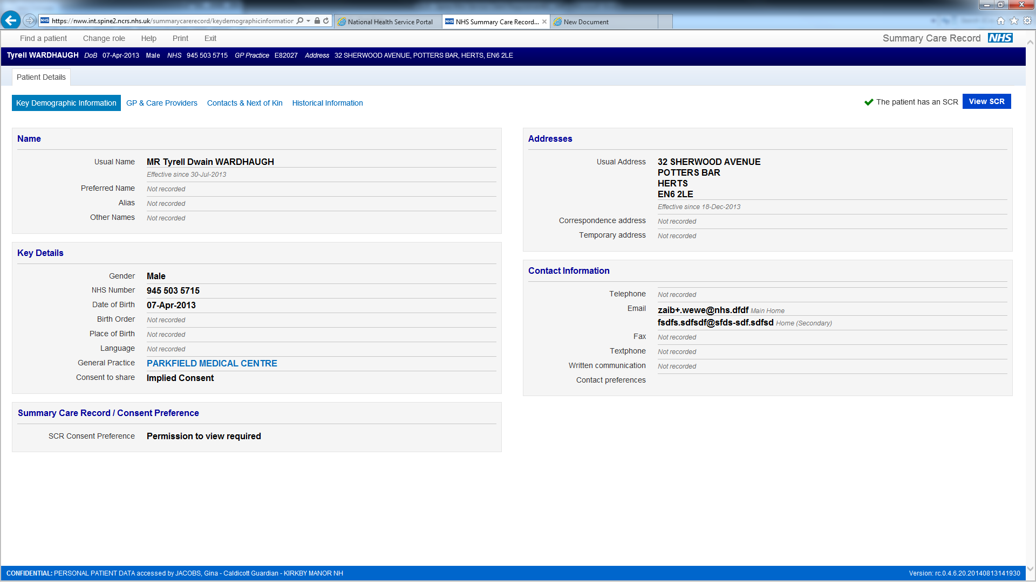

**Indicating that a patient does not have an accessible SCR**

This screen below illustrates how a system may indicate that a patient does not have an accessible SCR.

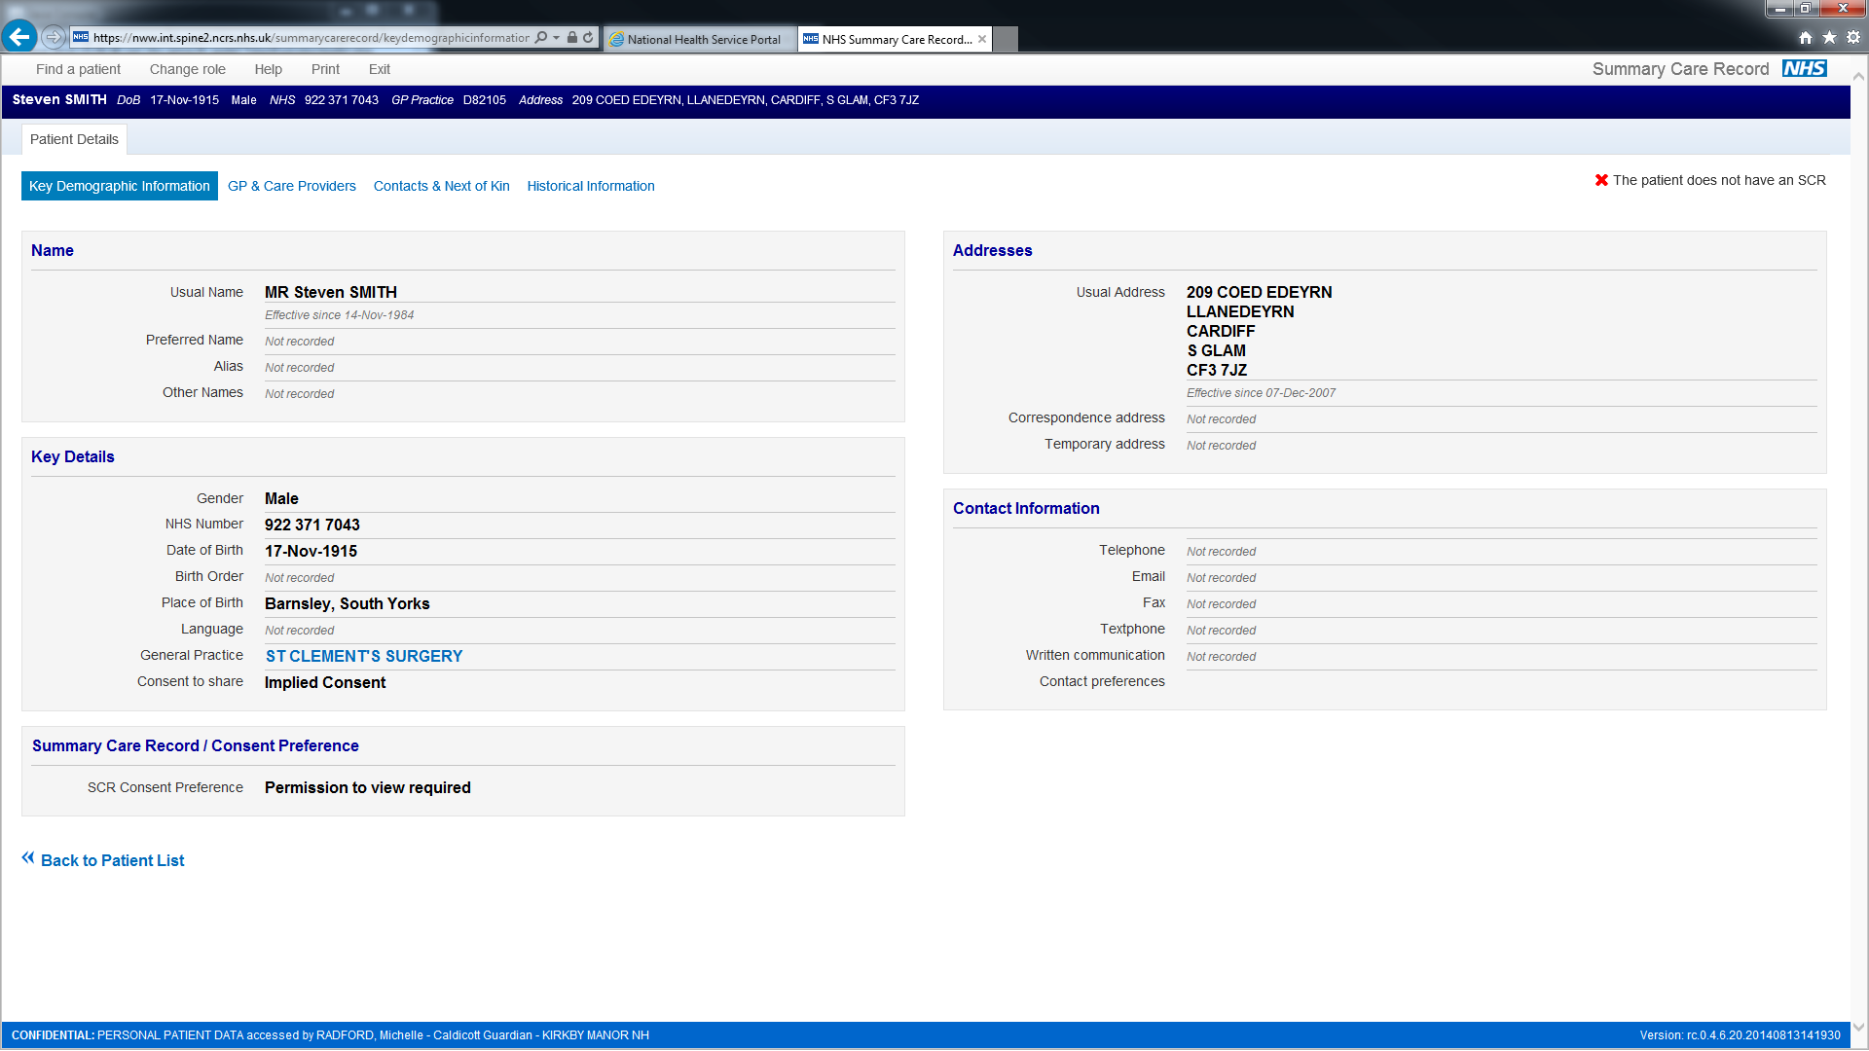

**Obtaining Permission to View**

The screens in this section illustrate how a Care Professional may be prompted to indicate if Permission to View has been obtained for themselves and \ or their colleagues, to access a patient’s SCR. The various combination of options on the screens, reflect the fact that a Care Professional’s RBAC Activities govern which options are available.

**Screen 1**

This screen below illustrates how a system may prompt a Care Professional to indicate if they are accessing a SCR:

* With the patient’s permission for themselves only.
* With the patient’s permission for themselves and other Care Professionals who may be involved in the patient’s care.
* For emergency reasons.

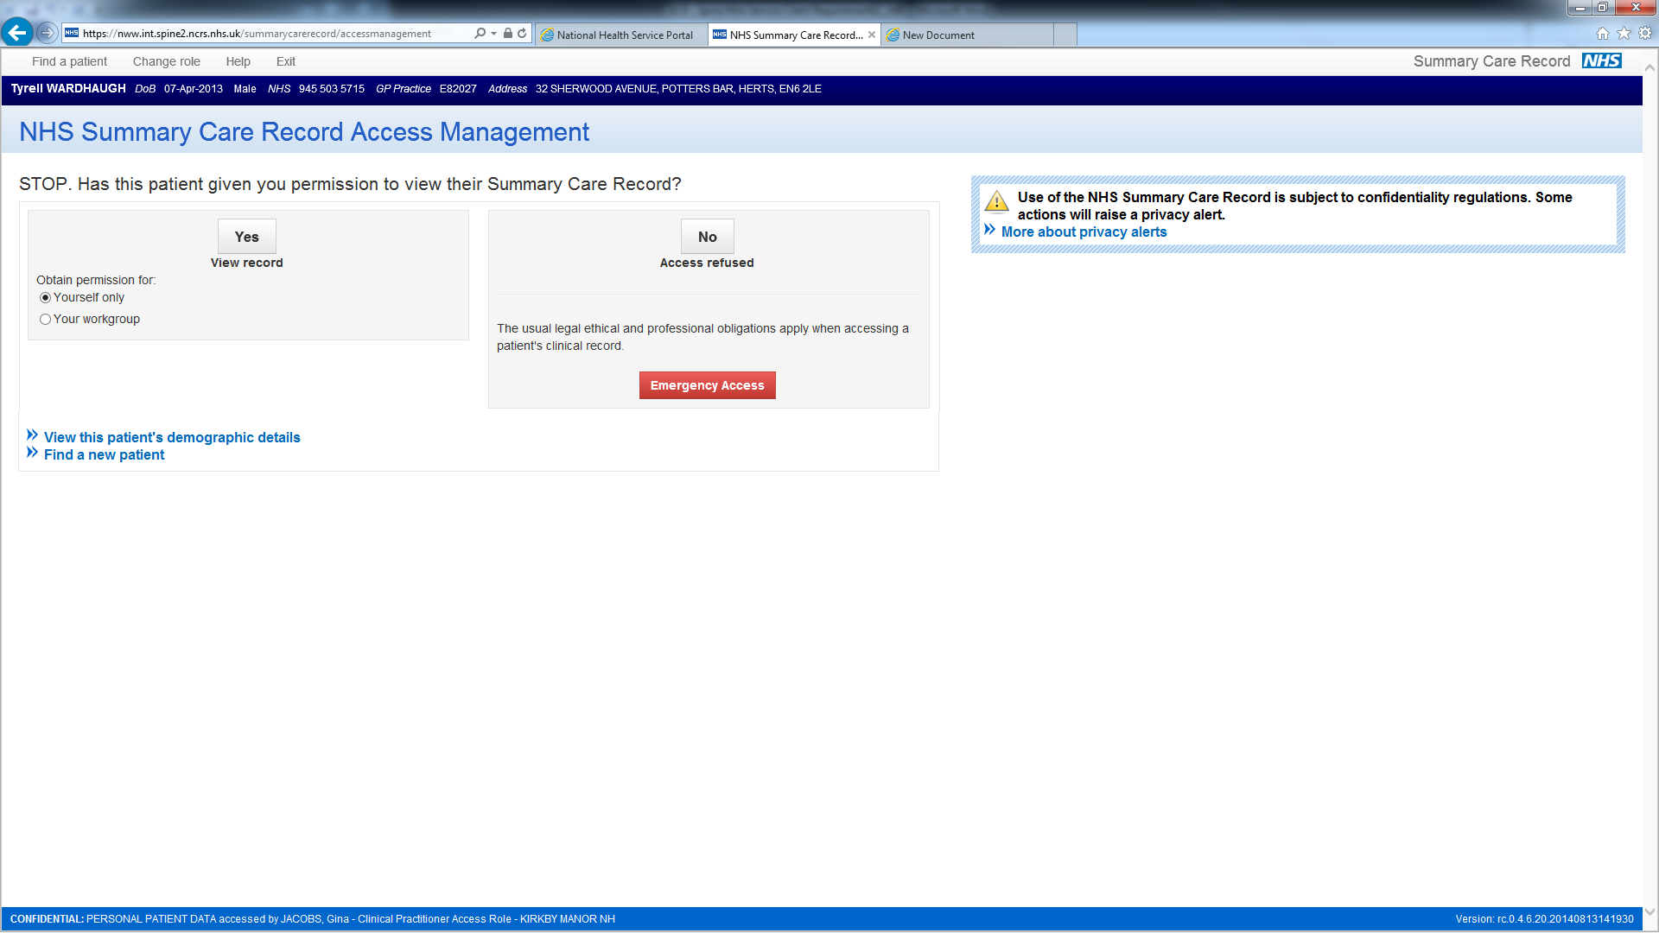

**Screen 2**

This screen below illustrates how system may prompt a Care Professional to indicate if they are accessing a SCR:

* With the patient’s permission for themselves only
* For emergency reasons.

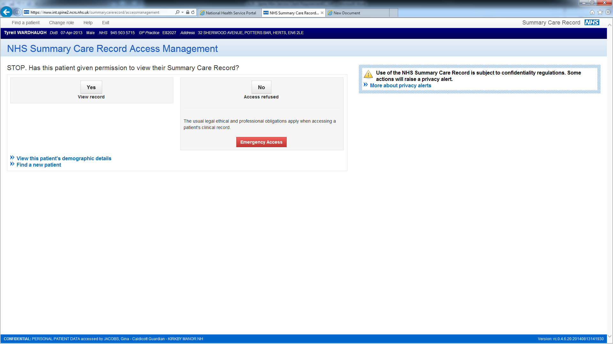

**Screen 4**

This screen illustrates how system may prompt a Care Professional to indicate if they are accessing a SCR with the patient’s permission for themselves only,

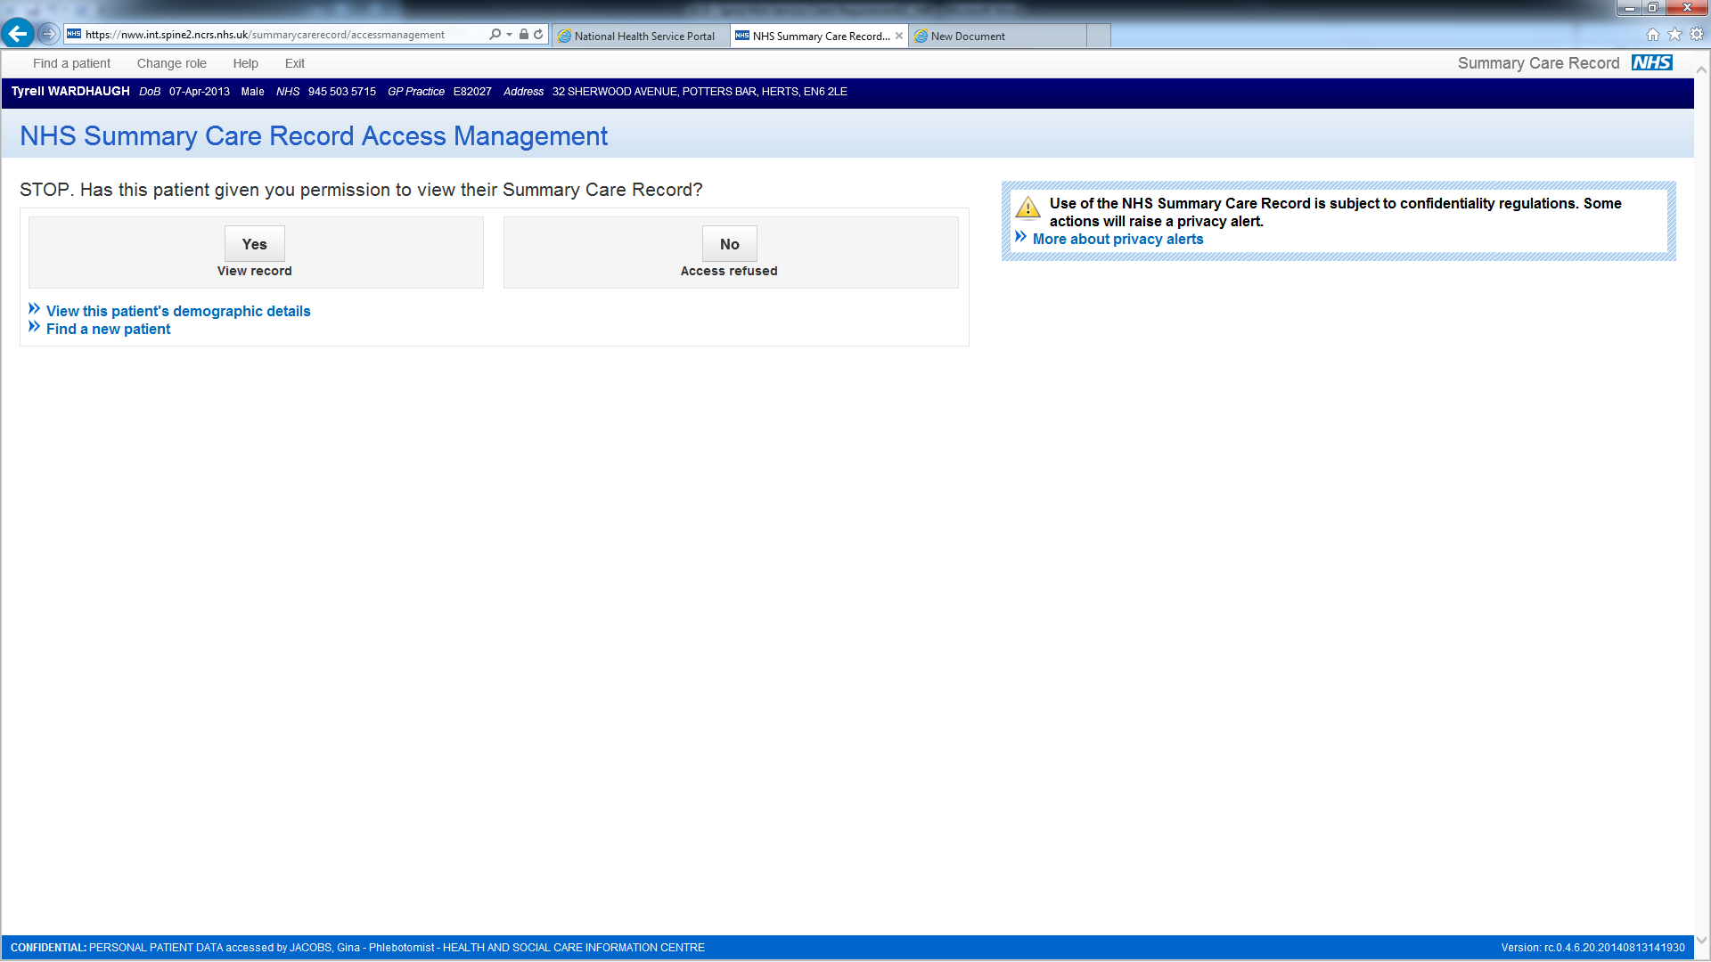

**Accessing the SCR for Emergency Reasons**

The screen below illustrates how a system may prompt a user to provide a reason for accessing a SCR in an emergency.

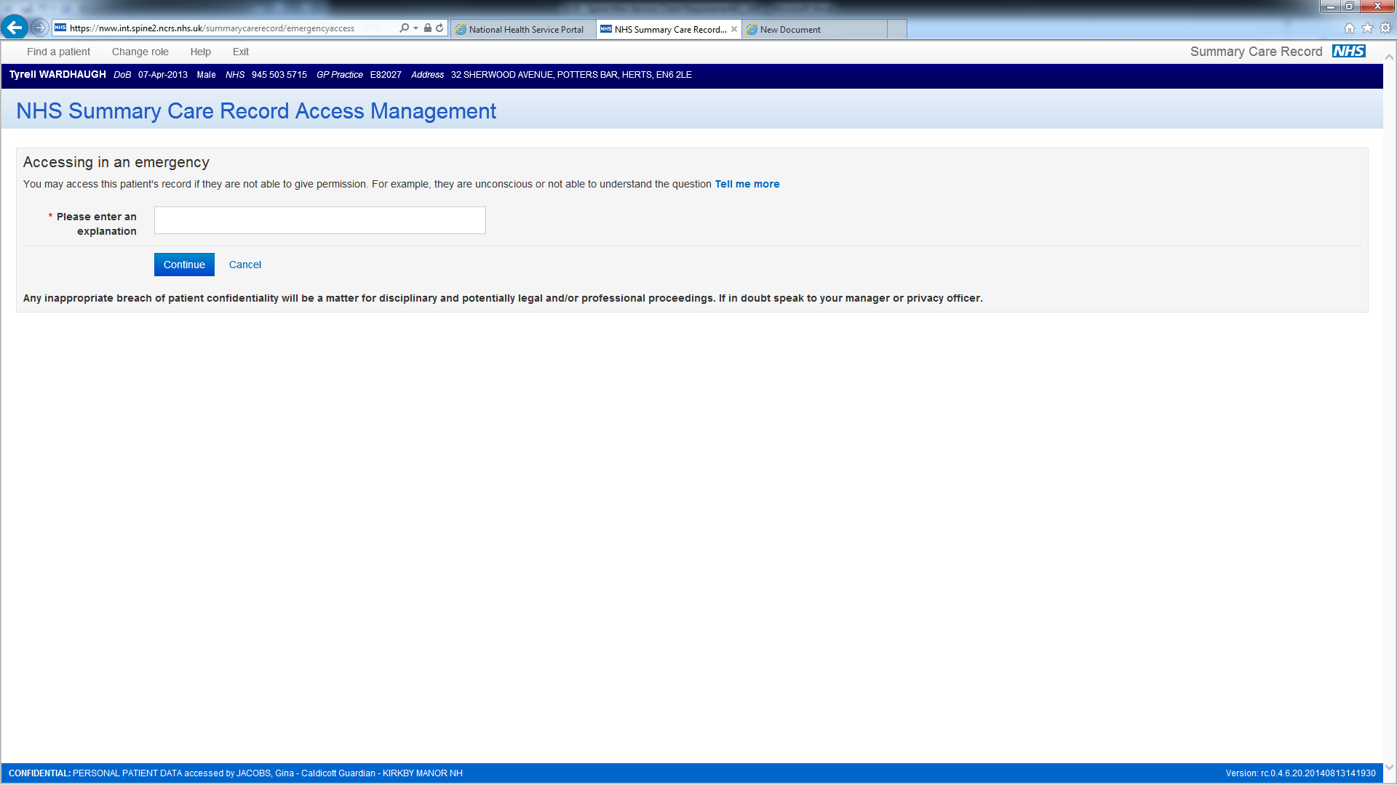

**Administrative Support User creates Permission to View on behalf of Care Professionals**

The screen below illustrates how a system may prompt an Administrative Support User to create Permission to View on behalf of one or more Care Professionals.

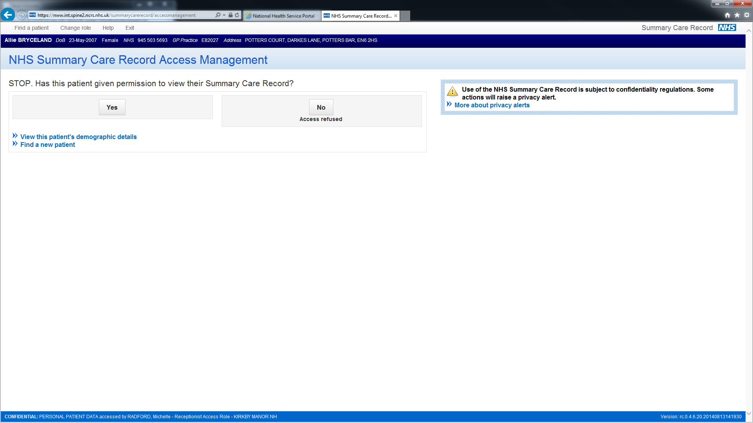

* * * End of Document * * *