|  |  |  |  |
| --- | --- | --- | --- |
| Document filename: | | | |
| Directorate / Programme | Summary Care Record Programme | Project | 1-Click |
| Document Reference: NPFIT-FNT-TO-DPM-1023.04 | |  | |
| Project Manager | James Spirit | Status | Draft |
| Owner | James Spirit | Version | 2.6 |
| Author | Emma Swift | Version issue date | 3rd September 2015 |

SCR 1-Click Supplier Requirements

Document Management

Revision History

|  |  |  |
| --- | --- | --- |
| Version | Date | Summary of Changes |
| 0.1 | 30/04/2009 | First draft for comment |
| 0.2 | 05/05/2009 | Amendments following SCR Team Feedback |
| 0.3 | 12/05/2009 | Amendments following SCR Team Feedback |
| 0.4 | 05/06/2009 | Workshop review comments from SCR Team |
| 0.5 | 10/06/2009 | Final revisions from SCR Team |
| 0.6 | 06/07/2009 | Additional Screenshots |
| 1.0 | 14/07/2009 | Final Amendments |
| 1.1 | 28/10/2009 | Additional comments from Security |
| 1.2 | 24/02/2011 | Further updates following BT and CFH review |
| 1.3 | 08/03/2011 | Updates following BT updates |
| 1.4 | 21/03/2011 | Updates following internal review |
| 1.5 | 13/04/2011 | Further updates following internal review |
| 1.6 | 04/07/2011 | Changes to align with EIS 11.6 Clarification Set 5. |
| 1.7 | 14/07/2011 | Minor wording change |
| 2.0 | 18/07/2011 | Approved for release. |
| 2.1 | 22/09/2014 | Updated to take into account Spine 2 changes |
| 2.2 | 20/10/2014 | Updated to take into account supplier comments |
| 2.3 | 02/12/2014 | Updated after internal HSCIC Review |
| 2.4 | 02/02/2015 | Updated after internal HSCIC Review |
| 2.5 | 21/04/2015 | Updated after internal HSCIC Review |
| 2.7 | 04/04/2016 | Updated after internal HSCIC Review |

Reviewers

This document must be reviewed by the following people: author to indicate reviewers

|  |  |  |  |
| --- | --- | --- | --- |
| Reviewer name | Title / Responsibility | Date | Version |
| Mike Kelly | SCR Programme Senior Technical Architect | 01/10/2014 | 2.2 |

Approved by

This document must be approved by the following people: author to indicate approvers

|  |  |  |  |  |
| --- | --- | --- | --- | --- |
| Name | Signature | Title | Date | Version |
| James Spirit |  | SCR Development Programme Manager | 02/10/2014 | 2.2 |

Reference Documents

| Ref | Doc Reference Number | Title | Version |
| --- | --- | --- | --- |
| 1 | NPFIT-FNT-TO-TIN-1537.02 | External Interface Specification: EIS 11.6 Clarifications Set 5 | 1.0 |
| 2 | N/A | SPINE External Interface Specification | Latest Version |
| 3 | NPFIT-SCR-SCRDOCS-0003.02 | Principles for Implementing Permission to View for the Summary Care Record to support the diversity of care settings in the NHS | 2.0 |
| 4 | N/A | Spine Warranted Environment Specification 2014a | Latest Version |
| 5 | NPFIT-FNT-TO-TIN- 0427.10 | Information Governance Requirements for ESP and GPSoC Systems |  |
| 6 | N/A | SPINE External Interface Specification Part 6 (SSB) |  |
| 7 | N/A | SPINE External Interface Specification EIS Part 7 (SSB API). |  |

Glossary

| Term | Abbreviation | Description |
| --- | --- | --- |
| 1-Click | 1-Click | A service within SCRa that allows an authenticated User to access a subset of SCRa functionality from a calling application. |
| Alert Viewer Application | Alert Viewer | A nationally available SPINE application that allows NHS Privacy Officers to identify and manage Spine Alerts. |
| Child Protection Information Service | CPIS | A SPINE service that allows the sharing of Child Protection information. |
| External Interface Specification | EIS | A document produced to aid in the connection of external systems to the NHS SPINE. |
| Legitimate Relationship | LR | A legitimate relationship (LR) is a connection between a patient and one or more Care Professionals that justifies access to the patient’s sensitive personal data. |
| Permission to View | PTV | In order to view a Summary Care Record during a specific care episode, the patient must give his or her permission. This is recorded electronically and labelled Permission to View. |
| Self-Claim Legitimate Relationship | Self Claim LR | This is a type of Legitimate Relationship, whereby a Care Professional who accesses a patient’s record, claims the existence of a Legitimate Relationship without the involvement of any third party. |
| SPINE | N/A | A national, central service that underpins the NHS Care Records Service. |
| SPINE Privacy Alerts | Alerts | Spine recorded messages that are generated and made available local NHS Privacy Officers (via the SPINE Alert Viewer application) in response to user actions that potentially require further investigation. |
| SPINE Demographics Service | PDS | The SPINE service that stores and manages patient demographic information. |
| Summary Care Record | SCR | An electronic record held on the SPINE, which contains key clinical information about the patient, sourced from the patient’s registered GP Practice. |
| Summary Care Record Application | SCRa | A national SPINE browser based application that allows authenticated Users access to patient information held within the NHS SPINE. |
| User Role Profile | URP | A NHS SPINE recorded identity that uniquely identifies a NHS SPINE recorded User in a specific role, in a specific organisation. A User may have multiple URPs. |
| Window | N/A | Term being used in this document to reference a new browser screen that will be launched from the requesting supplier application. |

Document Control:

The controlled copy of this document is maintained in the HSCIC corporate network. Any copies of this document held outside of that area, in whatever format (e.g. paper, email attachment), are considered to have passed out of control and should be checked for currency and validity.

Contents

1 Introduction 6

1.1 Purpose 6

1.2 Document Structure 6

1.3 Intended Audience 6

2 Background and Overview Summary Care Record and 1-Click Service 7

2.1 SCR Care Settings 7

2.2 Information Governance Controls and Accessing a SCR 7

2.3 1-Click Functionality 9

3 Supplier Compliance Requirements 13

3.1 Preconditions to calling 1-Click 13

3.2 Invoking the 1-Click Service 15

3.3 Displaying 1-Click Content 16

3.4 Auditing 18

3.4 Error Handling 18

4 HSCIC Information Governance Requirements 20

4.1 NHS Smartcard Authentication 20

5 Technical Requirements, Guidance and Compliance Documentation for making use of the 1-Click Service 21

5.1.1 Technical Guidance and Specifications 21

5.1.2 Notes 21

5.1.2.1 NHS SPINE External Interface Specification Versions 21

5.1.2.2 Spine Warranted Environment Specification (WES) 21

5.2 Guidance for Invoking the 1-Click Service 22

5.3 Sample Message 22

5.3.1 Notes 22

5.4 1-Click Service Arguments 22

5.5 Error Handling 24

5.5.1 Common 1-Click Errors 24

6 Appendix 1 – RBAC Activities 26

7 Appendix 2 – 1-Click Screens 27

8 Appendix 3 - Obtaining the SSO Token ID and URP ID and ASID 34

8.1.1 Introduction and Glossary of Technical Terms 34

8.1.2 Smartcard Authentication 35

8.1.3 Getting the SSO Token 35

8.1.4 Getting the User and Role Ids 35

## Introduction

This document specifies the supplier compliance requirements associated with the integration of the 1-Click service into a supplier’s system, to provide access to a selected patient’s Summary Care Record (SCR).

1-Click is a web service that allows a calling application, to access a subset of Summary Care Record Application (SCRa) functionality. SCRa and 1-Click both allow NHS Spine (SPINE) authenticated Users, to access SPINE held patient information. This includes the patient’s:

* Summary Care Record
* Child Protection information made available via the CPIS service
* Demographic Information. Note only very limited demographic information is available via 1-Click.

This document is concerned only with the requirements and guidance associated with using the 1-Click service to access a patient’s Summary Care Record. The requirements associated with delivering access to other patient related information made available via 1-Click, can be provided on request by HSCIC.

## Assurance Exclusions

The scope of the 1-Click requirements does not include the assurance of the requirements associated obtaining compliance with:

* Spine Demographic Service
* Spine services associated with the creation, querying and management of Spine Legitimate Relationships which are created outside of the 1-Click Service.

## Purpose

This document contains a set of compliance requirements that suppliers must follow in order to integrate the SCR 1-Click functionality to allow access a selected patient’s SCR. The document aligns to NHS Spine 2 Release 3.

## Document Structure

This document is divided into the following sections:

* Background and Overview of the SCR and 1-Click Service.
* Supplier Compliance Requirements for making use of the 1-Click Service to access a patient’s SCR.
* Technical Requirements, Guidance and Compliance Documentation for connecting to the 1-Click Service

## Intended Audience

This document presents compliance requirements and testing/technical guidance to suppliers, technical architects and system designers, who are integrating the 1-Click functionality within their calling applications. This document is not intended for end users.

## Background and Overview Summary Care Record and 1-Click Service

An authenticated user of 1-Click can gain read-only access to a patient’s Summary Care Record. The Summary Care Record (SCR) is an electronic record, designed to provide healthcare staff working in urgent and emergency care settings, with faster and easier access to essential patient information. Approximately 54 million SCRs have been created and it is estimated that all eligible patients in England will have a SCR by the end of 2015.

Each patient’s SCR consists of a GP Summary message held on the SPINE, which contains key clinical information about the patient, sourced from the patient’s registered GP Practice. GP Practices create and send a GP Summary message to the SPINE (replacing any previous version), in response to various patient related events (such as change to the patient’s medication). A patient will only have a single accessible GP Summary (which will have a recorded document state of “Normal”) at any point in time and this version will be accessible to viewing systems and their Users. Patients may choose not to have a SCR at any time, which will both prevent the creation/update of the patient’s SCR and also make that patient’s SCR inaccessible to anyone (or system) that attempts to gain access.

## SCR Care Settings

The SCR Programme Business Case states that SCRs are designed to be accessed in urgent and unscheduled care settings. Current viewing sites include Emergency Departments, Walk in Centres, Minor Injury Units, hospital pharmacies, GP “Out of Hours” services and prisons. SCR accesses in other types of care settings are likely to occur in the future.

**Note** - Explicit agreement must be obtained from the SCR Programme and the appropriate governance process must be followed, to allow the viewing of SCRs in non-urgent and non-emergency care settings.

## Information Governance Controls and Accessing a SCR

The viewing of SCRs by Care Professionals is subject to a number of Information Governance (IG) controls and documented SCR Programme requirements, to ensure that a SCR is only accessed by appropriate care professionals, in suitable circumstances. These can be summarised as follows:

* The viewer must have the appropriate Role Based Access (RBAC) in order to access a SCR. This in turn necessitates that the individual is NHS Smartcard authenticated. The 1-Click service verifies that the User is both SPINE authenticated and has the appropriate RBAC permissions, prior to allowing access to a patient’s SCR. The details of the RBAC permissions associated with gaining access a SCR via 1-Click are detailed in Appendix 1.
* The viewer must have a legitimate reason to access that patient’s SCR in the context of the particular episode of patient care (care episode). For example, the patient may be registered for care within an Emergency Department and the viewer may be one of the care professionals providing care to the patient. In order to gain access to a patient’s Summary Care Record via 1-Click, a SPINE recorded Legitimate Relationship (LR) must exist between the selected patient and User. A recent update to the spine 1-Click service means that the spine LR may be created in one of two ways:
  + By the 1-Click service itself providing the User has the appropriate Role Based Access to create a Spine Self-Claim LR.

OR

* + By the calling application prior to invoking the1-Click service.

* The patient must not have dissented to have Summary Care Record. This is termed the patient’s SCR Consent Preference and is recorded both centrally on SPINE and also locally within the patient’s registered GP Practice. Users cannot access a patient’s SCR via the 1-Click service or by other SCR “viewing” system, if a patient has dissented.
* The patient must have provided “Permission to View” their SCR, for the duration of the care episode, to appropriate individuals involved in their care. In exceptional circumstances a care professional may choose to access a patient’s SCR without the patient’s permission. For example, access may be necessary for emergency reasons. 1-Click provides the functionality associated with implementing the Permission to View process. This includes functionality to access a SCR:
  + With the patient’s permission. 1-Click and SCRa both set “Permission to View” to have a duration of 5 days.
  + For emergency reasons.
  + For legal reasons. For example, it may be necessary to access a patient’s SCR because of a court order.

Guidance on the use of Permission to View is provided in [Ref.3].

* Electronic privacy alerts are generated, sent to SPINE and subsequently investigated by NHS Privacy Officers, when:
  + An SCR is accessed without the patient’s permission

and/or

* + The equivalent of a Self-Claim Legitimate Relationship is created by an individual, who subsequently accesses the patient’s SCR. The majority of accesses to the SCR via 1-Click will lead to the creation of a Self-Claim LR and hence the generation of a Self-Claim privacy alert.

The 1-Click service generates SPINE Alerts in the appropriate circumstances and also ensures that these Alerts are made available to NHS Privacy Officers via the SPINE Alert Viewer.

The Information Governance (IG) controls associated with accessing a patient’s SCR will be implemented in the main by the 1-Click service. The requirements stated in this document, will define any IG related requirements which must implemented by a supplier system.

## 1-Click Functionality

The 1-Click service allows an external calling application to provide access to a selected patient’s SCR, to a specific user. The SCR may be rendered in a separate browser or in a browser object / component embedded in the calling application. In response to a request from calling application, the 1-Click service will provide functionality to:

* Verify the User is SPINE authenticated
* Verify the user has a current SPINE session
* Implement the SCR related IG controls
* Render the SCR in the appropriate browser or browser object / component.

The parameters associated with 1-Click call are summarised in the table below:

| **Argument Title** | **Argument** | **Detail** |
| --- | --- | --- |
| SSO Token Id | SSOTokenId | The ID and pointer to a User’s current Spine session. |
| User Role Profile Id | URPId | The ID of the User’s current Spine authenticated role. |
| Patient Id (NHS Number) | PatientId | The NHS Number of the patient’s whose SCR may be accessed. |
| Accredited System Id | ASID | The Accredited System Id of the calling application. |
| JSState | JSState | A value to indicate if JavaScript should or should not be enabled when displaying 1-Click “screens”. |

The diagram below provides a high level illustration of current 1-Click behaviour with regard SCR access. The order of events in the diagram is indicative and the 1-Click may carry out the various checks and processes in a different order:



More detail on the functionality offered by the 1-Click service is provided below and Appendix 2 provides screen shots of the service.

|  |  |
| --- | --- |
| 1-Click Functionality | Description |
| Authenticate and Authorise User | 1-Click will only allow access to a SCR if the User (identified by a URP Id):   * Is currently SPINE authenticated. * Has a current valid SPINE session. This is referenced via a SSO Token Id parameter. * Has the appropriate Role Based Access, in their current role (referenced by URP Id parameter) to access a SCR with the patient’s permission. |
| Manage 1-Click Session | The 1-Click service will manage the User 1-Click / SCRa session. |
| Verify the patient has an accessible SCR | The 1-Click service will only allow access to a patient’s SCR if:   * The patient’s SPINE held SCR Consent Preference does not indicate that the selected patient has dissented to have a SCR. * The patient has current GP Summary message held on SPINE which has a Document State of Normal. |
| Manage the SCR “Permission to View” process | The 1-Click Service will allow immediate access to a patient’s SCR if “Permission to View” is currently recorded on the SPINE as existing between the selected patient and user in their current role (referenced by URP Id parameter).  If “Permission to View” is not recorded as existing between the selected patient and the user, the 1-Click Service will offer one or more of the following options (via various screens displayed to the User) to access the patient’s SCR:   * Access the SCR with the patient’s permission. If the User chooses this option, the application will create “Permission to View” (recorded on Spine) between the patient and User with duration of 5 days. * Allow the User to access a patient’s SCR for emergency reasons. * Allow the User to access the patient’s SCR for legal reasons.   The User’s RBAC permissions in his/her current role will control which “options” for access are made available. |
| Manage Legitimate Relationship | The 1-Click Service will only allow a user to access a patient’s SCR, if a current SPINE held LR is recorded as existing between the User in their current role and the selected patient.  If a SPINE recorded LR does not exist, providing the user has the appropriate RBAC permissions, the 1-Click Service will create Self-Claim LR with a duration of 5 days between the User (in their current role) and the selected patient. The LR will be created “in the background” by the 1-Click Service, if “Permission to View” is created when User chooses either to access the SCR:   * With the patient’s permission * For emergency reasons * For “legal” reasons |
| Manage Alerting | The 1-Click Service will generate SPINE Alerts in the background and make these available to Privacy Offices in the appropriate organisation if:   * The User chooses to access a patient’s SCR without the patient’s permission i.e. for emergency or “legal” reasons. * A Self-Claim LR is created during the SCR access |
| Display a patient SCR | The 1-Click Service will display / render the selected patient’s SCR (GP Summary). |
| Print a patient’s SCR | The 1-Click Service will provide functionality to print the selected patient’s SCR (GP Summary). |
| View Help | The 1-Click Service will provide access to online, application “Help” |

## Supplier Compliance Requirements

For the purpose of these requirements the following terms MUST be interpreted as follows:

| **Term** | **Meaning** |
| --- | --- |
| 1-Click content | Any human readable content returned to the Calling Application by the 1-Click Service. |
| 1-Click View | The browser window or browser object / component User to display 1-Click content. |
| Accredited System ID (ASid) | The HSCIC allocated unique identifier of the Calling Application |
| Browser | A web browser |
| Browser object / component | A component of a web browser that can be used to display 1-Click content |
| Calling Application | The application that makes the call to 1-Click Service and makes available the resulting 1-Click “screens” \ content to Users. |
| GP Summary | This term encompasses both Initial GP Summary and GP Summary messages. |
| Render a SCR | This will refer to display of a SCR in any format, electronic or paper. |
| Role | This must be interpreted as being equivalent to a User’s current SPINE authenticated User Role Profile (URP). |
| NASP | National Application Service Provider for the NHS Spine before the transition to Spine 2. British Telecom provided this service. |
| Spine User Session | This is the period of time when a User has authenticated with a smartcard and connection successfully to Spine Services. |
| SSO Token ID | The ID and pointer User’s current Spine session. |
| User | The individual who is attempting to access the patient SCR via the 1-Click service |
| User Role Profile (URP) | A NHS SPINE recorded identity that uniquely identifies a NHS SPINE recorded user in a specific role, in a specific organisation. A user may have multiple URPs associated with a UUID and Smartcard. |
| Identity Agent | Software components that must installed on any client system that attempts to make use of the NHS Spine. These components are responsible for initiating the NHS SPINE User authentication process which should lead to creation of a SPINE User session, interacting with SPINE and storing the SPINE (SSO) Token ID. |

## Preconditions to calling 1-Click

The requirements in this section define the requirements that must and should be adhered to by a supplier’s Calling Application, prior to invoking the 1-Click function. In summary:

* The patient’s identity **should** be verified against the SPINE Demographic Service.
* The Calling Application **should** verify that the User has the appropriate Role Based Access in their current role (URP), to access the patient’s SCR via 1-Click function
* The User **must** be Smartcard authenticated and a valid Spine User session **must** be in place.

|  |
| --- |
| **1-CL.01 The patient’s identify SHOULD be verified against the SPINE Demographic Service** |
| 1. Before launching 1-Click to access a specific patient’s SCR, the Calling Application SHOULD verify that patient's identity by verifying the patient's demographic details held on the Calling System, with the patient's demographic details held on the SPINE Demographic Service. 2. The selected patient’s NHS number SHOULD be traced and \ or verified in one of the following ways by the Calling Application:  * Using the Demographic Batch Service (DBS).   OR   * Using the algorithms in A, in a non-interactive (system) function, within a Calling Application which is integrated with the SPINE Demographic Service.   OR   * Confirmation by a user through an interactive tracing process, using a Calling Application which is integrated with the SPINE Demographic Service.   **A: Demographic Verification Algorithm**  One of the following algorithms MUST be used:   * If no NHS Number exists locally, an exact match on SPINE Demographic Service of Surname, Forename, Gender, Date of Birth and Postcode may be considered a verified match.   OR   * If an NHS Number exists locally then it can be considered verified if the NHS Number and Date of Birth (YYYYMMDD) match a SPINE Demographic Service record.   OR   * If an NHS Number exists locally then it can be considered verified, if the NHS Number, 2 out of 3 of the elements of Date Birth (a single element being YYYY, MM or DD), the first 3 characters of Surname, first character of Forename all match the SPINE Demographic Service record. |

|  |
| --- |
| **1-CL.02 The Calling Application SHOULD verify that the User has the appropriate RBAC to access the patient’s SCR** |
| Before allowing a User to access a selected patient’s SCR via 1-Click, the Calling Application SHOULD ensure that the User’s current SPINE User Role Profile (URP) contains the RBAC activity that allows access to a patient’s SCR with the patient’s permission. The RBAC Activity that enables access to a SCR with the patient’s permission is B0257 - View non-ETP Clinical Data within CSA.  Note: The existence of a current Spine recorded LR between the User and the selected patient is a prerequisite to access a patient’s SCR using 1-Click. The RBAC Activity B0085 - Claim a relationship with a patient, will provide the appropriate permissions to create a SPINE recorded Self-Claim LR via the 1-Click Service. Refer to Appendix 1 for additional details. |

|  |
| --- |
| **1-CL.03 The Calling Application MUST ensure that the User is Smartcard authenticated** |
| The Calling Application MUST ensure prior to invoking the 1-Click service that the user:  (i) Is authenticated using a standard NHS Smartcard that complies with SPINE authentication requirements applicable to NHS Smartcards.  (ii) Has a valid current SPINE authenticated session in place.  Refer to **1-CL.16** for the relevant requirements from the HSCIC Information Governance Requirements Baseline.  Refer to the EIS [Ref.2] for the technical requirements and guidance associated with the use of NHS Smartcards. Specifically:   * The EIS Part 6 [Ref.6] for details of the Spine Security Broker. * The EIS Part 7 [Ref.7] for details of the Spine Security Broker API. |

## Invoking the 1-Click Service

|  |
| --- |
| **1-CL.04 Invoking the 1-Click Function** |
| 1. When invoking the 1-Click Service, Calling Application MUST send the data in the table below via a HTTP POST request to the 1-Click service.  | **Argument Title** | **Argument** | **Type** | **Mandatory** | | --- | --- | --- | --- | | SSO Token Id | SSOTokenId | CHAR | Yes | | User Role Profile Id | URPId | CHAR | Yes | | NHS Number | PatientId | CHAR | Yes | | Accredited System ID | ASID | CHAR | Yes | | Javascript State | JSState | CHAR | Yes |   The following conditions MUST be true prior to the Calling Application sending the request to 1-Click:   1. The SSO Token be valid AND MUST be associated with User who is currently attempting to access the selected patient’s SCR, in the current SPINE User Session. 2. The SSO Token MUST be retrieved from the instance of Identity Agent associated with the User who is currently attempting to access the selected patient’s SCR. 3. The User Role Profile Id MUST be valid AND MUST identify the current Role of the User who is currently attempting to access the selected patient’s SCR, in the current SPINE User Session. 4. The NHS Number MUST be associated with the selected patient whose SCR, the User is attempting to access. 5. The ASID MUST be that of the Calling Application. If the Calling Application does not have ASID the Calling Application MUST populate the ASID parameter with the value of 200000000520. 6. The JSState MUST be set to either 1 or 0 to indicate whether 1-Click must run in a JavaScript enabled or disabled state.   Note: Technical guidance on the invocation of the 1-Click service can be found in Section 5 of this document. |

|  |
| --- |
| **1-CL.05 All attempts to invoke the 1-Click service MUST be User initiated** |
| 1. The Calling Application MUST not create or maintain any automated invocation of the 1-Click Service. 2. All attempts to access a patient’s SCR via the 1-Click service MUST be User initiated. |

## Displaying 1-Click Content

The section specifies the requirements that (1-Click) Calling Systems must adhere to, when displaying 1-Click service content.

It is assumed that:

* Calling Applications may be browser based or non-browser based.
* TheCalling Application MUST present the 1-Click View either in a separate (child) browser window or within a browser object / component embedded within the Calling Application itself
* It is the responsibility of the Calling Application to manage the browser window or browser object / component used to display the 1-Click View.
* A User may use the 1-Click service to access the SCRs of multiple patients in the same User Session but the Calling Application Must ensure that:
* There is only one instance of the 1-Click Service launched at any one time for a given User.
* Patient context is maintained i.e. the patient information presented in the SCR 1-Click View corresponds to the patient information presented in the Calling Application.
* It is the responsibility of the Calling Application to manage the browser window or object component used to display the 1-Click content \ view.
* If either the user’s Spine authenticated session and \ or the user’s Calling Application sessions ends, all patient information displayed in the 1-Click View must be made inaccessible to the user by the Calling Application. For example, a 1-Click browser window may be closed to prevent access.

It is worth noting that the 1-Click Service currently offers the following functionality:

* If a user’s Spine authenticated session ends, the 1-Click service will detect this and will end the 1-Click session, thus preventing any further access to a patient’s SCR.
* It will only allow one 1-Click session per Spine User Session at any point in time. For example, if a Calling Application is currently hosting one 1-Click View (1-Click View 1) and the Calling Application attempts to display a second 1-Click View (1-Click View 2):
  + The 1-Click service will end the 1-Click session in the first 1-Click View (1-Click View 1).
  + Allow the display of 1-Click content in the second 1-Click (1-Click View 2).

|  |
| --- |
| **1-CL.06 Environment** |
| 1. The Calling Application MUST present the view of SCR 1-Click in a separate “child” browser window or in a browser object / component (1-Click View) embedded in the application. 2. The 1-Click View MUST only present data that has been provided by the SCR 1-Click service. 3. The Calling Application MUST ensure that 1-Click content is displayed in a simple “child” browser window or a browser object / component, with no controls, menus or toolbars made available to the User, which could allow the User to control or change the 1-Click content, beyond changing the size and\or closing the1-Click View. 4. Browser based Calling Applications SHOULD launch any child 1-Click window in the same process space as the Calling Application. |

|  |
| --- |
| **1-CL.07 The Calling Application MUST ensure that there is only one instance of the 1-Click Service launched at any one time for a given User** |
| The Calling Application MUST ensure that there is only instance of SCR 1-Click launched at any one time for a given Spine User Session, even if the Calling Application allows multiple concurrent User sessions for the same User. |

|  |
| --- |
| **1-CL.08 Patient context** |
| 1. The Calling Application MUST ensure any User of the 1-Click service, can verify that patient information presented in the SCR 1-Click View, corresponds to same patient currently presented to the User in the Calling Application. 2. If a 1-Click View is displaying patient related information is open and the patient context changes in the Calling Application, all patient related information in the 1-Click View MUST be made inaccessible to the user, until the 1-Click Service is called again in the same user session. |

|  |
| --- |
| **1-CL.09 Screen Size** |
| The Calling Application MUST control the initial size and position the 1-Click View being used to host 1-Click to ensure it is at least the minimum window size (1024 x 768 pixels). |

|  |
| --- |
| **1-CL.10 Managing the 1-Click View** |
| The Calling Application:   1. MUST invoke the 1-Click service in a manner that ensures that the 1-Click View is managed and maintained by the Calling Application. 2. MUST ensure that size and position of 1-Click View does not result in readability or other clinical safety issues. 3. MUST ensure that the browser or window object/component “hosting” the 1-Click View is named “Summary Care Record”. |

|  |
| --- |
| **1-CL.11 Re-use of the 1-Click View** |
| Users may use the 1-Click service to access the SCRs of multiple patients in the same user session.   1. The Calling Application SHOULD reuse the same browser window or browser object / component to display 1-Click content during a single Spine User Session, regardless of the number of patients accessed during that session.   If the same browser window or browser object / component is not used to host the 1-Click service during a Spine User Session, then the Calling Application MUST ensure that:   1. At any point in time, only a single 1-Click View (displaying 1-Click content) is open per Spine User Session, which MUST correspond to the current patient context. Refer to 1-CL.08. |

|  |
| --- |
| **1-CL.12 Ending the User Session** |
| The Calling Application MUST ensure that all patient information displayed in the 1-Click View is inaccessible to the user if the User’s Calling Application sessions ends. |

## Auditing

|  |
| --- |
| **1-CL.13 The Calling Application SHOULD audit the invocation of the 1-Click Service** |
| 1. For audit purposes, the Calling Application SHOULD record each invocation \ call to the of the 1-Click Service, whereby a specific user attempts to access a specific patient’s SCR. 2. For each invocation of the 1-Click Service, the Calling Application SHOULD record the following data items:    * The NHS Number of the patient associated with the call to the 1-Click Service.    * If available, the ASID of the Calling Application    * The URP ID of the user who is attempting to access the patient’s SCR.    * The UUID of the user who is attempting to access the patient’s SCR    * The date and time of the invocation of 1-Click Service    * The unique identifier (ODS Code) of the organisation associated with the user in his / her current (URP) role. 3. The system SHOULD allow users with the appropriate local permissions such as System Administrators, to access and query SCR-related audit information. |

## 3.4 Error Handling

If there is some sort of technical error associated with making use of 1-Click, the 1-Click service will return a standard HTTP response to the Calling Application. There are no specific error responses returned to the Calling Application by the 1-Click Service. Any error returned by 1-Click must be displayed to the user in the same format as it would be within SCRa.

Refer to Section 5.6 of this document for details of the common errors associated with invoking the 1-Click Service

|  |
| --- |
| **1-CL.15 Error Handling** |
| The Calling Application:   1. MUST ensure that all 1-Click related error conditions are managed and presented to the User in a user friendly manner, presenting the User with an error message that contains the reason for error. Any error message MUST not contain any security related, patient or other form of data that could be used in an inappropriate manner not covered by the RBAC permissions assigned to the User. 2. MUST NOT prompt Users with information or decisions relating to system or technical errors. Such errors MUST be resolved by the system in the background without User interaction. 3. MUST ensure where 1-Click responses are delayed, suppliers MUST allow the User to continue using the Calling System. |

## HSCIC Information Governance Requirements

The requirements in the section are extracted from the HSSIC Information Governance Baseline for suppliers [Ref.5] and detail the requirements relevant to suppliers who utilise the 1-Click Service, to provide access to a patient’s SCR. Note these requirements have been updated to take into account the NHS SPINE transition in Autumn 2014, from the NASP providing SPINE services, to HSCIC providing these services (via the Spine 2 Programme).

## NHS Smartcard Authentication

|  |  |  |
| --- | --- | --- |
| **Requirements Reference** | **Document Reference** | **Detail** |
| N\A | 3.1.1 | **Identification and authentication of professional users**  **Introduction**  Credential production and verification technology is provided by the NHS SPINE. This technology provides the basis for a seamless logon procedure with which any system connecting to SPINE must integrate to perform User authentication.  In order to support authentication of users for access to NHS SPINE services, and to provide information on login sessions and user entitlements, the Spine provides the Spine Security Broker (SSB) consisting of an authentication service, client software and associated APIs. |
| 1-CL.16 | 3.1.2 | The system shall ensure that all Users who have access to Personal Data or Sensitive Personal Data obtained from, held in or to be held in NHS SPINE about patients, are securely authenticated by means of the standardised Smartcard technology and credentials provided by the NHS SPINE. |

## Technical Requirements, Guidance and Compliance Documentation for making use of the 1-Click Service

## Technical Guidance and Specifications

This table below details the NHS SPINE technical documentation \ specifications that suppliers MUST consult when implementing access to SCRs via the 1-Click Service

|  |  |  |  |
| --- | --- | --- | --- |
| **Document** | **Detail** | **Document Number** | **Version** |
| SPINE External Interface Specification | A set of documents produced to aid in the connection of external systems to the NHS SPINE. | N\A | Latest version of this document set. |
| EIS 11 6 Clarifications Set 5 | This section of the EIS provides suppliers with additional guidance on implementing the 1-Click Service | NPFIT-FNT-TO-TIN-1537. | Latest version of the document. |
| Spine Warranted Environment Specification 2015 | See notes below | N\A | Latest version of the document. |

## Notes

## NHS SPINE External Interface Specification Versions

Each version of the External Interface Specification relates to a particular release of the ‘Spine’. Later versions of the EIS will be published from time to time. Suppliers are required to ensure that their systems support the latest applicable version of the EIS for the Spine release that their systems will be operating under.

## Spine Warranted Environment Specification (WES)

This document specifies the client environments that NHS SPINE user interfaces, including the 1-Click service, will be warranted against. In this context, the client environment is the combination of relevant products installed on a client device and specified below:

• Operating systems

• Browsers

• Java virtual machines (JVMs)

Later versions of the WES will be published from time to time. Suppliers are required to ensure that their systems support the latest applicable version of the WES for the Spine release that their systems will be operating under.

## Guidance for Invoking the 1-Click Service

## Sample Message

The following example specified sample HTML used to invoke the 1-Click Service using HTTP POST.

<HTML>

<HEAD>

<TITLE> New Document </TITLE>

<META NAME="Author" CONTENT="HSCIC">

<META NAME="Keywords" CONTENT="">

<META NAME="Description" CONTENT="Test Page">

</HEAD>

<BODY>

<FORM METHOD="POST" ACTION="https://nww.int.spine2.ncrs.nhs.uk/oneclickscr/LSPValidator.jsp">

<INPUT TYPE="hidden" NAME="SSOTokenId"

value=" AQIC5wM2LY4SfczmeE4DhyThYizdGrvyDrcJkbweMPgG7Kg=@AAJTSQACMDU=#">

<INPUT TYPE="hidden" NAME="URPId" value="304253498022">

<INPUT TYPE="hidden" NAME="PatientId" value="0123456789">

<INPUT TYPE="hidden" NAME="ASID" value="123456789012">

<INPUT TYPE="hidden" NAME="JSState" value="1">

<INPUT TYPE="submit" value="Show Clinical Information">

</FORM>

</BODY>

</HTML>

## Notes

* The 1-Click Service will not support invocation via HTTP GET.
* The Calling Application MUST use HTTP 1.1 as per standard statements in the EIS Part 2 [Ref.2].
* The **Input** element of type “**submit**” cannot have the **name** attribute set to “**submit**”. The **name** attribute is not required, but if included can be set to any value other than “submit”.

## 1-Click Service Arguments

The arguments to the 1-Click Service are specified below:

| **Argument Title** | **Argument** | **Length (in characters)** | **Detail** |
| --- | --- | --- | --- |
| SSO Token Id | SSOTokenId | Variable | The SSO Token:   * Is a pointer to the User’s current SPINE session held in the SPINE Identity Server. This is sent back to the Identity Agent and used as a parameter in API calls. * Should be retrieved from the Identity Agent in the manner described in chapter 7 of the EIS [Ref .2].   Refer to Appendix 3 of this document for additional guidance on retrieving the SSO Token |
| Selected User Role Profile Id | URPId | 12 | * This is the ID of the User’s current Spine authenticated role.   Refer to Appendix 3 of this document for additional obtaining the User’s URP ID |
| NHS Number | PatientId | 10 | The NHS Number of the patient’s whose SCR may be accessed. |
| Accredited System Id | ASID | 12 | This is a unique identifier allocated to any external system which makes use of NHS SPINE services  If the Calling Application does not have ASID, populate the ASID parameter with the value of 200000000520.  Refer to Section 2.5.7.1 of the EIS [Ref.2]. |
| JSState | JSState | 1 | * This parameter indicates whether or not the 1-Click Service should use JavaScript or not * The permitted values are:   + 1 – JavaScript should be enabled   + 0 - indicating JavaScript should be disabled. |

* All arguments are mandatory.

* All parameters are of type CHAR.
* All leading and trailing spaces must be removed from parameters.

## URLs to access 1-Click

Subject to the appropriate process HSCIC will provide the URL required in the test and live version of the 1-Click service and also the URL required to query the SAML assertion to obtain the user’s current URP ID.

## Error Handling

If there is some sort of technical error associated with making use of 1-Click, the 1-Click service will return a standard HTTP response to the Calling Application. There are no specific error responses returned to the Calling Application by the 1-Click Service. Any error returned by 1-Click must be displayed to the user in the same format as it would be within SCRa. Refer to **1-CL.15** for additional details on informing users or any technical error / issue with making use of the 1-Click Service.

## Common 1-Click Errors

Where there has been a problem with the request for the 1-Click service for some reason, the 1-Click Service will return an “error page”. An example of the common error page that is displayed can be seen below:

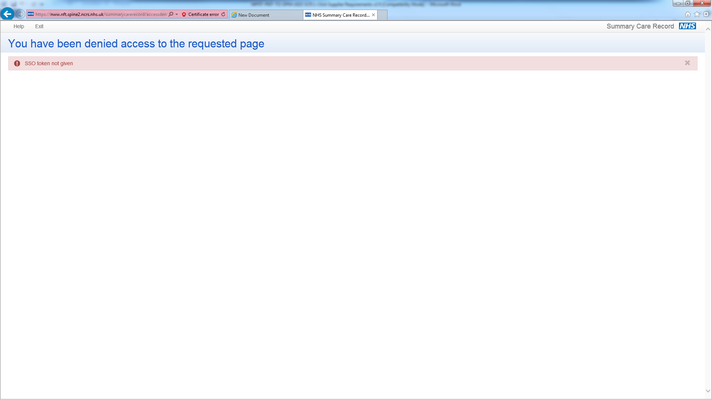

|  |  |
| --- | --- |
| **Issue** | **Error Message** |
| The URL call to invoke the 1-Click Service is incorrect | *The Summary Care Records Spine Application has encountered an error: 404: Not Found* |
| The SSO Token does not reference a current valid Spine Session | *Unable to retrieve details of user from Security Broker* |
| The URP ID does not match the Spine session referenced in the SSO Token parameter | *Invalid User Profile ID - does not match information on Security Token* |
| The NHS Number of the referenced patient is incorrect / invalid | *No patient found for NHS Number* |
| The format of the ASID parameter is incorrect | *ASID invalid* |
| No SSO Token has not been provided in the call to the 1-Click Service | *SSO token not given* |
| A URP ID has not been provided in the call to the 1-Click Service | *User role id not given* |
| A NHS number has not been provided in the call to the 1-Click Service | *Patient NHS number not given* |
| A JState parameter has not been provided in the call to the 1-Click Service. | *JS state value is not given* |
| An ASID has not been provided in the call to the 1-Click Service | *ASID not given* |
| The User referenced in the URP ID does not have appropriate Role Based Access in their current role to gain access to the 1-Click Service. | *User's current role does not allow access to OneClick GPSummary* |
| A Spine recorded Legitimate Relationship does not currently exist between the patient and the referenced user and the user does not have the appropriate RBAC permissions to create a Legitimate Relationship via the 1-Click Service. | *You have been denied access* |
| The user’s current Spine Session has ended for some reason. | *The page you have been directed to is prohibited in One-Click mode.* |
| A second attempt has been made to invoke the 1-Click Service, causing the first 1-Click session to end. | *Due to inactivity your session has timed out. Re-launch SCRa Application* |

## Appendix 1 – RBAC Activities

The RBAC activities associated with gaining access to patient’s SCR via the 1-Click service are defined in the table below:

|  |  |  |
| --- | --- | --- |
| **Function in 1-Click** | **RBAC Activities required to undertake the action via 1-Click** | **Notes** |
| **Access the patient's SCR with the patient's permission** | B0257 |  |
| **Emergency access to a patient's SCR** | B0257 AND B0168 |  |
| **Legal access to a patient's SCR** | B0257 AND B0082 |  |
| **Create a Self-Claim Legitimate Relationship via the 1-Click Service** | B0085 | The RBAC activity required to create a Spine Legitimate Relationship via 1-Click. |
| **Access the patient's Child Protection - Information Sharing Flag (CP-IS) information** | B0107 | The RBAC Activity required to access any CP-IS Information associated with the selected patient |

## Gateway Activities

In order for a User to access the 1-Click service without any error, their current URP ID MUST have either of the following activities

**B0257 -** Access the patient's SCR with the patient's permission

OR

**B0107 -** Access the patient's Child Protection - Information Sharing Flag (CP-IS) information

## Clinical Access and Spine Legitimate Relationships

* A Spine Legitimate Relationship (LR) MUST always exist to access a specific patient's SCR, regardless of the reason for access. The Spine LR may be created via the 1-Click Service or separately to 1-Click, via the Calling Application or another system.
* A Spine LR can only be created via 1-Click ONLY if the User has the RBAC activity B0085 associated with their current URP ID. The table below illustrates some valid combinations of RBAC activities.

|  |  |
| --- | --- |
| **User Actions** | **RBAC Activities Required** |
| Access the patient’s SCR with the patient permission and create a Spine LR | B0257 AND B0085 |
| Access the patient’s SCR with permission or for emergency reasons and create a Spine LR | B0257 AND B0085 AND B0168 |
| Access the patient’s SCR with permission or for legal reasons or emergency reasons and create a Spine LR | B0257 AND B0085 AND B0082 AND B0168 |

* Any attempt to access a patient’s SCR using 1-Click will fail, if a Spine LR does not exist between the User and the selected patient and user does not have the RBAC activity in their current URP to create a LR.
* A SPINE LR is NOT required to access CP-IS information.

## Appendix 2 – 1-Click Screens

The screen flows below illustrate the common scenarios for accessing a SCR using 1-Click.

**Example Screen Flow 1 – A User accesses the patient’s SCR with the patient’s permission and Permission to View does not currently exist.**

1. The user is asked if they have the patient’s permission to view their Summary Care Record.

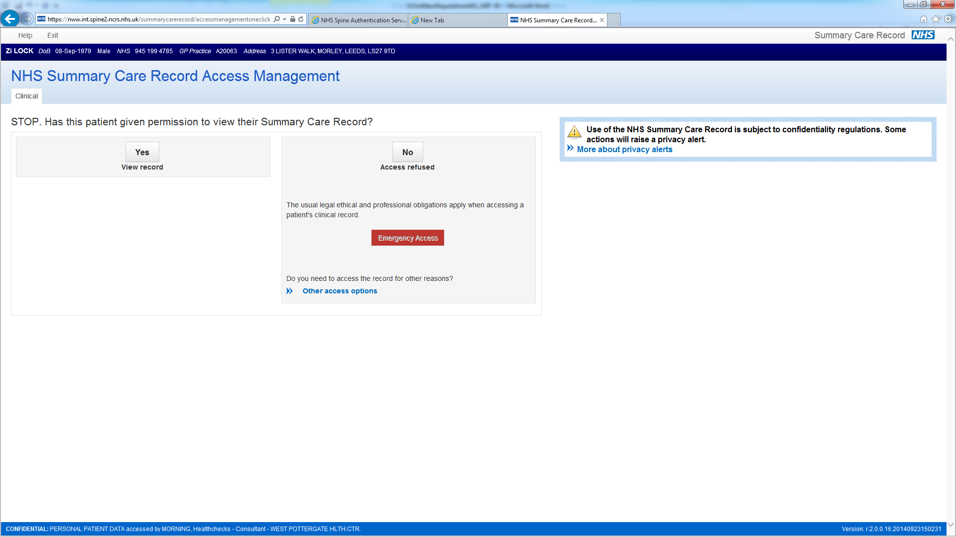

2. The user chooses to access with the patient’s permission by selecting the “Yes – View Record” button.

* Permission to View is recorded for 5 days.
* 1-Click creates a SPINE Self-Claim LR in the background if the user has the appropriate RBAC and a LR does not currently exist between the user and patient.
* A Self-Claim Spine Alert is generated.
* The GP Summary is displayed (below):

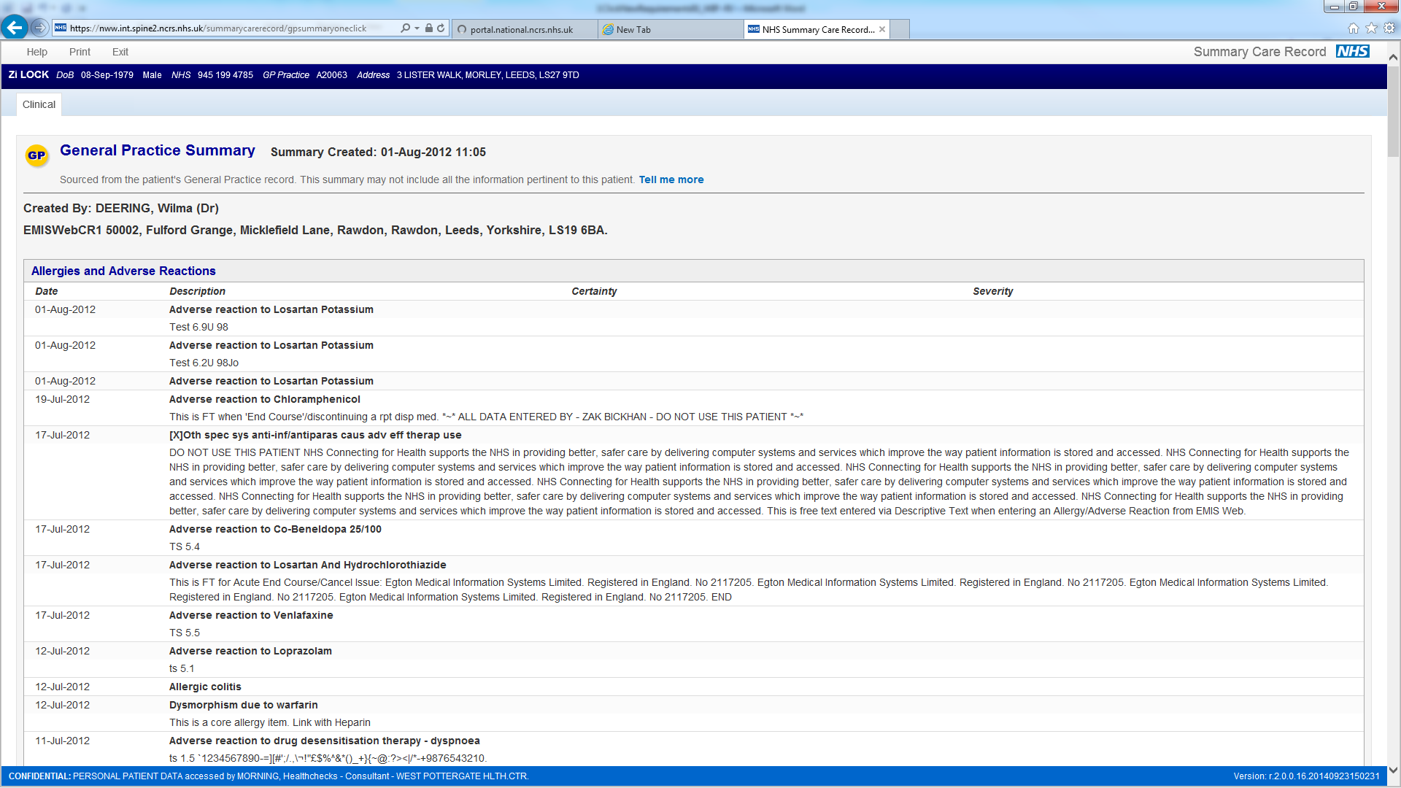

**Example Screen Flow 2 – User accesses the patient’s SCR when Permission to View already exists**

1) The patient’s GP Summary is displayed and there are no other prompts / screens. Note a Self- Claim LR and Alert will be created if in the background if the user has the appropriate RBAC and a LR does not currently exist between the user and patient.



**Example Screen Flow 3 – User access the patient’s SCR for “Emergency Reasons”**

1. The user is asked if they have the patient’s permission to view their Summary Care Record.

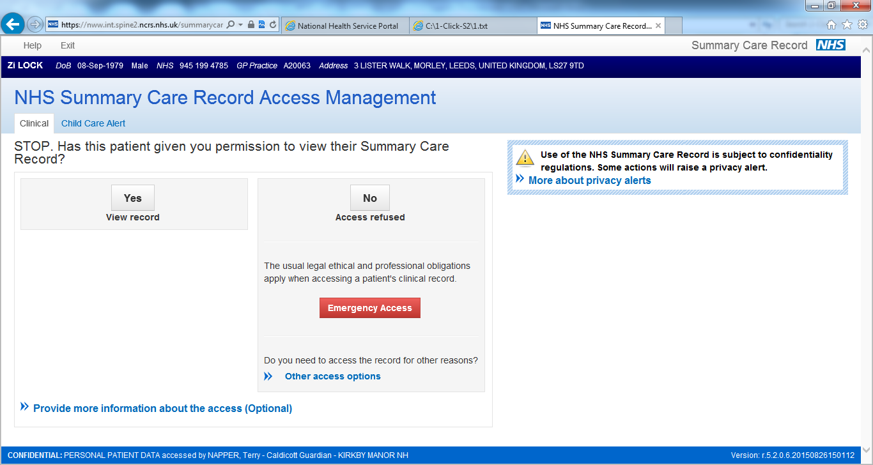

2. The user chooses to access for “Emergency Reasons” and is prompted to provide a reason for access (below).

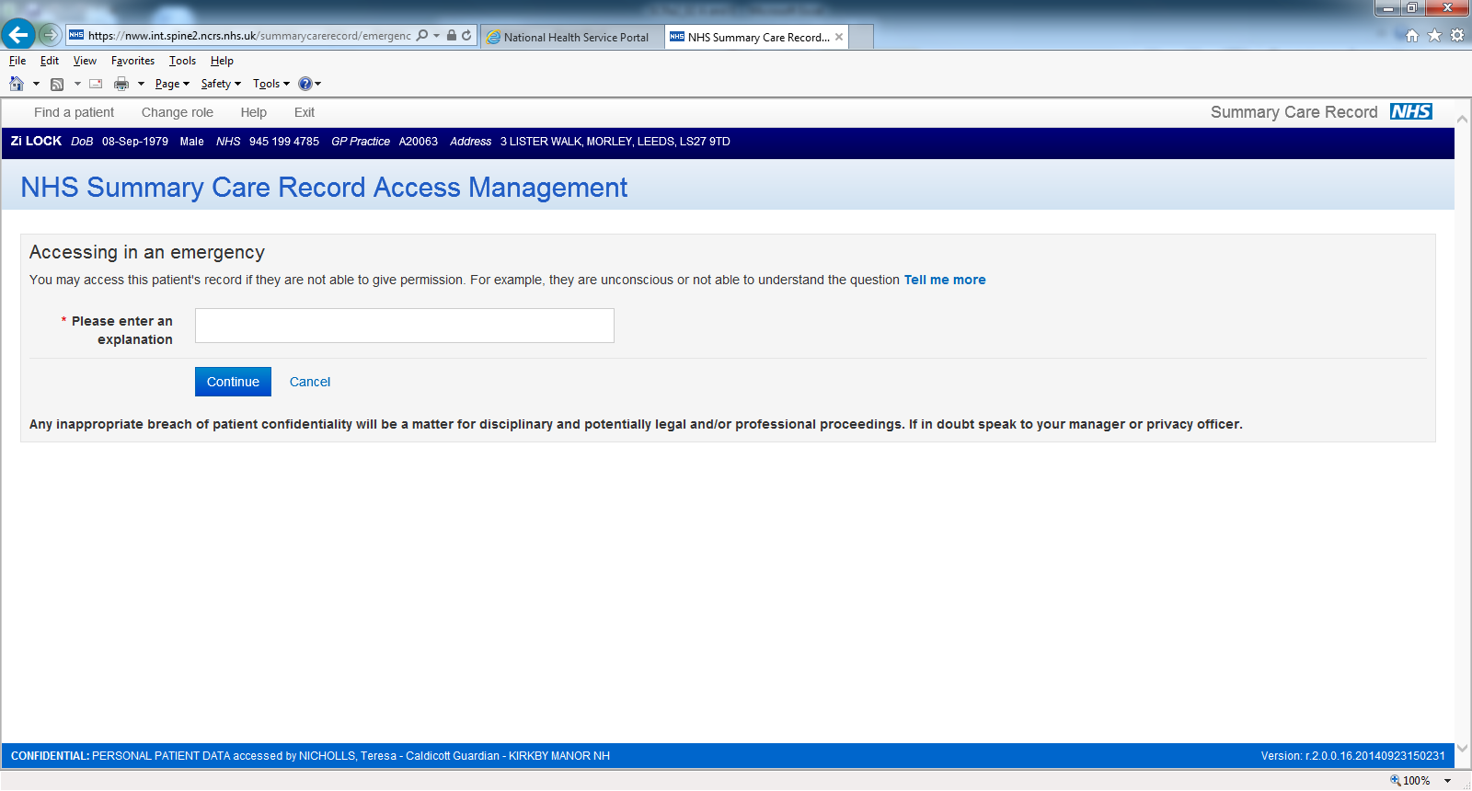

3. The user provides a reason for the access and the 1-Click application:

* 1-Click creates a SPINE Self-Claim LR and generates a Self-Claim Alert in the background as a LR does not currently exist between the user and patient.
* An Access Alert is generated.
* The GP Summary is displayed (below)



**Example Screen Flow 4 – User access the patient’s SCR for “Legal Reasons”**

1. The user is asked if they have the patient’s permission to view their Summary Care Record.

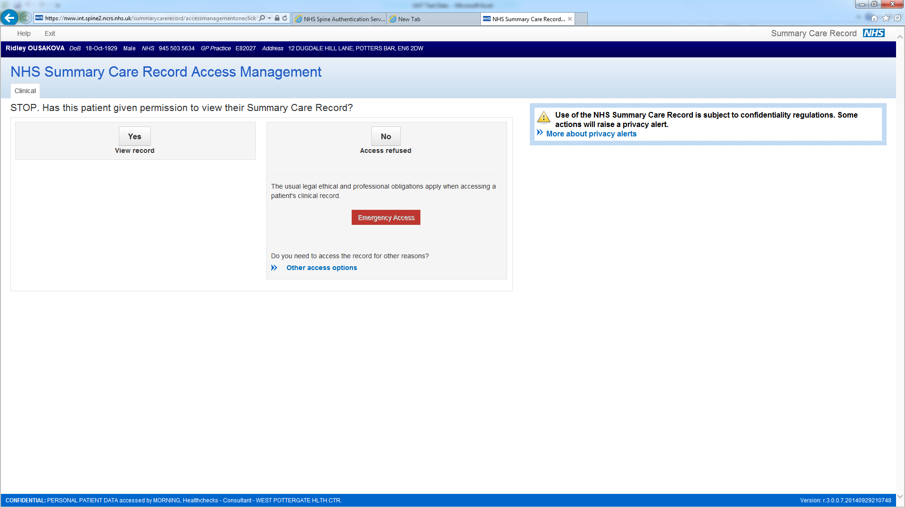

2. The user chooses to access for “Legal Reasons” and is prompted to provide a reason for access (below).

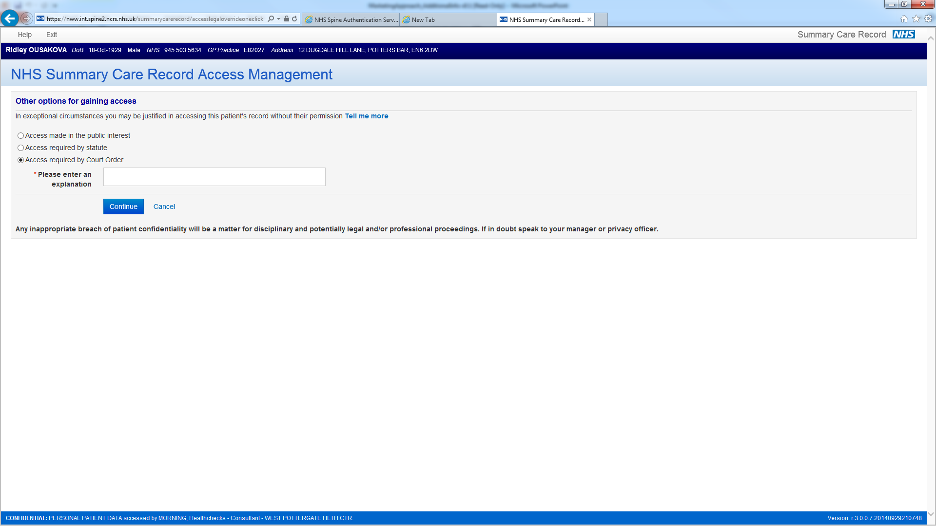

3. The user provides a reason for the access and the 1-Click application:

* 1-Click creates a SPINE Self-Claim LR and generates a Self-Claim Alert in the background as a LR does not currently exist between the user and patient.
* An Access Alert is generated.
* The GP Summary is displayed (below)

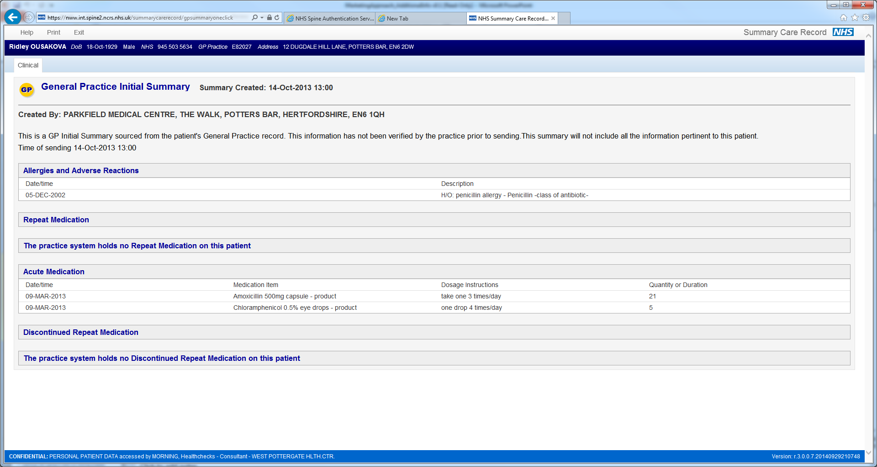

**Example Screen Flow 5 – Patient refuses access to the SCR.**

1. The user is asked if they have the patient’s permission to view their Summary Care Record.

**.**

2. The patient does not provide permission to access their SCR and the user selects the “No – Access Refused” button.

* 1-Click displays a screen indicating that the access has been refused (below).

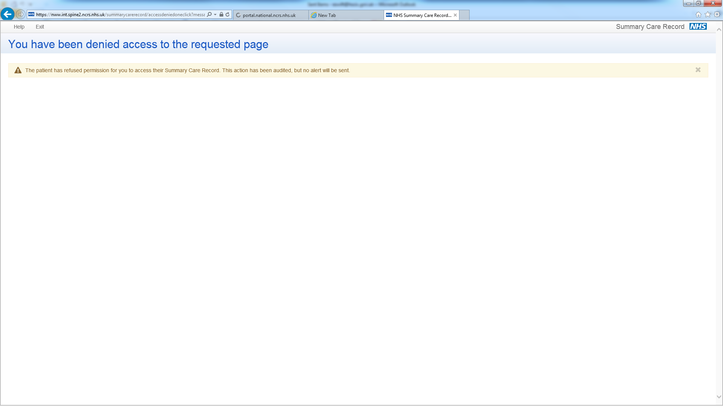

## Appendix 3 - Obtaining the SSO Token ID and URP ID and ASID

## Introduction and Glossary of Technical Terms

|  |  |
| --- | --- |
| Acronym | Detail |
| IA | Smartcard Identity Agent |
| SAML | Security Assertion Mark-up Language |
| SDS | Spine Directory Service |
| SSB | Spine Security Broker |
| SSO | Single Sign On |
| TMS | Spine Transaction Messaging Service |
| URP | User Role Profile |
| UUID | Universally Unique Identifier |
| XML | Extensible Mark-up Language |

This section provides a brief technical note on how an application can interact with the NHS Smartcard Identity Agent (IA) running on a client and the Spine Security Broker (SSB) running on Spine to discover the user id and role profile id for a Spine user who has successfully smartcard authenticated on a client computer.

## Smartcard Authentication

A client computer with the NHS IA installed allows a user with an NHS smartcard to insert it in the card reader. The IA then pops up a dialog window where the user of the smartcard enters their PIN and then selects the role to use – where they have more than one role associated with their user id. If the IA successfully authenticates them it gets a unique SSO Session Token from SSB which remains valid while their smartcard is left in the reader or until a timeout limit is reached. The IA securely stores the SSO Token on the client.

## Getting the SSO Token

An application running on the client computer can get the SSO Ticket by calling an API on the IA. Details are provided in the EIS v11.6 Part 7 [Ref.2].

…

String sso_token = getTicket();

…

The sso token is just an opaque string that contains no information about the user id or role profile id.

## Getting the User and Role Ids

To get the user id and selected role profile id that are linked to the SSO token, the application needs to make a request to URL that will be provided on request by HSCIC. The URL below illustrates the format.

[https://sbapi.national.ncrs.nhs.uk/saml/RoleAssertion?token=<sso_ticket](https://sbapi.national.ncrs.nhs.uk/saml/RoleAssertion?token=%3csso_ticket)>

This will return SAML. This SAML contains the user id and role profile id values. An example response is shown below with the relevant values highlighted:

<samlp:Response xmlns:samlp="urn:oasis:names:tc:SAML:1.0:protocol" ResponseID="null" InResponseTo="null" MajorVersion="1" MinorVersion="1" IssueInstant="2012-04-05T14:21:46Z" Recipient="172.16.143.51">

<samlp:Status>

<samlp:StatusCode Value="samlp:Success"/>

</samlp:Status>

<saml:Assertion xmlns:saml="urn:oasis:names:tc:SAML:1.0:assertion" MajorVersion="1" MinorVersion="1" AssertionID="sb87df68e2c3eef794a01cf0cd8c70a465bff9659" Issuer="http://nisu010-uksr-ap.hosts.nis1.national.ncrs.nhs.uk:80" IssueInstant="2012-04-05T14:21:46Z">

<saml:Conditions NotBefore="2012-04-05T14:18:46Z" NotOnOrAfter="2012-04-05T14:22:46Z"/>

<saml:AttributeStatement>

<saml:Subject>

<saml:NameIdentifier NameQualifier="o=nhs">uid=983113567512,ou=People,o=nhs</saml:NameIdentifier>

<saml:SubjectConfirmation>

<saml:ConfirmationMethod>urn:com:sun:identity</saml:ConfirmationMethod>

<saml:SubjectConfirmationData>

<saml:Assertion MajorVersion="1" MinorVersion="1" AssertionID="s82f20a0e20b60ecc168525a876d98496bb9ce4a1" Issuer="http://nisu010-uksr-ap.hosts.nis1.national.ncrs.nhs.uk:80" IssueInstant="2012-04-05T14:21:46Z">

<saml:Conditions NotBefore="2012-04-05T14:18:46Z" NotOnOrAfter="2012-04-05T14:22:46Z"/>

<saml:AuthenticationStatement AuthenticationInstant="2012-04-05T14:20:51.000Z" AuthenticationMethod="urn:com:sun:identity:ExtendedLoginModule">

<saml:Subject>

<saml:NameIdentifier NameQualifier="o=nhs">uid=983113567512,ou=People,o=nhs</saml:NameIdentifier>

<saml:SubjectConfirmation>

<saml:ConfirmationMethod>urn:com:sun:identity</saml:ConfirmationMethod>

<saml:SubjectConfirmationData>AQIC5wM2LY4SfcyN9VmsmwcAWPirwqz394zNoji6wbKOEMM=@AAJTSQACMDI=#</saml:SubjectConfirmationData>

</saml:SubjectConfirmation>

</saml:Subject>

<saml:SubjectLocality IPAddress="172.16.143.51"/>

</saml:AuthenticationStatement>

</saml:Assertion>

</saml:SubjectConfirmationData>

</saml:SubjectConfirmation>

</saml:Subject>

<saml:Attribute AttributeName="ssbAssertionVersion" AttributeNamespace="http://www.syntegra.com">

<saml:AttributeValue>1.1</saml:AttributeValue>

</saml:Attribute>

<saml:Attribute AttributeName="cn" AttributeNamespace="http://www.syntegra.com">

<saml:AttributeValue>Gordon Simon</saml:AttributeValue>

</saml:Attribute>

**<saml:Attribute AttributeName="uid" AttributeNamespace="http://www.syntegra.com">**

**<saml:AttributeValue>983113567512</saml:AttributeValue>**

**</saml:Attribute>**

**<saml:Attribute AttributeName="ssbSessionRoleUid" AttributeNamespace="http://www.syntegra.com">**

**<saml:AttributeValue>629447231511</saml:AttributeValue>**

**</saml:Attribute>**

<saml:Attribute AttributeName="ssbMode" AttributeNamespace="http://www.syntegra.com">

<saml:AttributeValue>0</saml:AttributeValue>

</saml:Attribute>

<saml:Attribute AttributeName="nhsIdCode" AttributeNamespace="http://www.syntegra.com">

<saml:AttributeValue>X09</saml:AttributeValue>

</saml:Attribute>

<saml:Attribute AttributeName="o" AttributeNamespace="http://www.syntegra.com">

<saml:AttributeValue>NHS CONNECTING FOR HEALTH</saml:AttributeValue>

</saml:Attribute>

<saml:Attribute AttributeName="nhsAreaOfWorkCodes" AttributeNamespace="http://www.syntegra.com">

<saml:AttributeValue>P0020:Q0300:T0630</saml:AttributeValue>

<saml:AttributeValue>P0060:Q0580:T1140</saml:AttributeValue>

</saml:Attribute>

<saml:Attribute AttributeName="nhsAreaOfWork" AttributeNamespace="http://www.syntegra.com">

<saml:AttributeValue>"Surgery":"Surgery":"Surgery"</saml:AttributeValue>

<saml:AttributeValue>"Pathology":"Pathology":"Pathology"</saml:AttributeValue>

</saml:Attribute>

<saml:Attribute AttributeName="nhsJobRole" AttributeNamespace="http://www.syntegra.com">

<saml:AttributeValue>"Clinical":"Clinical Support":"Clinical Coder Access Role"</saml:AttributeValue>

</saml:Attribute>

<saml:Attribute AttributeName="uniqueIdentifier" AttributeNamespace="http://www.syntegra.com">

<saml:AttributeValue>293974539513</saml:AttributeValue>

</saml:Attribute>

<saml:Attribute AttributeName="nhsJobRoleCode" AttributeNamespace="http://www.syntegra.com">

<saml:AttributeValue>S8000:G8001:R8007</saml:AttributeValue>

</saml:Attribute>

<saml:Attribute AttributeName="nhsIdCode" AttributeNamespace="http://www.syntegra.com">

<saml:AttributeValue>8A162</saml:AttributeValue>

</saml:Attribute>

<saml:Attribute AttributeName="o" AttributeNamespace="http://www.syntegra.com">

<saml:AttributeValue>GALLOWAY T R (PODIATRIST)</saml:AttributeValue>

</saml:Attribute>

<saml:Attribute AttributeName="nhsBusinessFunctions" AttributeNamespace="http://www.syntegra.com">

<saml:AttributeValue>Record Patient Medication</saml:AttributeValue>

<saml:AttributeValue>Manage Detailed Health Records</saml:AttributeValue>

<saml:AttributeValue>Manage Health Records</saml:AttributeValue>

</saml:Attribute>

<saml:Attribute AttributeName="nhsBusinessFunctionsCodes" AttributeNamespace="http://www.syntegra.com">

<saml:AttributeValue>B8029</saml:AttributeValue>

<saml:AttributeValue>B0055</saml:AttributeValue>

<saml:AttributeValue>B0069</saml:AttributeValue>

</saml:Attribute>

<saml:Attribute AttributeName="nhsJobRole" AttributeNamespace="http://www.syntegra.com">

<saml:AttributeValue>"M&amp;D":"Medical - M&amp;D":"General Medical Practitioner"</saml:AttributeValue>

</saml:Attribute>

<saml:Attribute AttributeName="uniqueIdentifier" AttributeNamespace="http://www.syntegra.com">

<saml:AttributeValue>629447231511</saml:AttributeValue>

</saml:Attribute>

<saml:Attribute AttributeName="nhsJobRoleCode" AttributeNamespace="http://www.syntegra.com">

<saml:AttributeValue>S0010:G0020:R0260</saml:AttributeValue>

</saml:Attribute>

<saml:Attribute AttributeName="nhsIdCode" AttributeNamespace="http://www.syntegra.com">

<saml:AttributeValue>8A162</saml:AttributeValue>

</saml:Attribute>

<saml:Attribute AttributeName="o" AttributeNamespace="http://www.syntegra.com">

<saml:AttributeValue>GALLOWAY T R (PODIATRIST)</saml:AttributeValue>

</saml:Attribute>

<saml:Attribute AttributeName="nhsBusinessFunctions" AttributeNamespace="http://www.syntegra.com">

<saml:AttributeValue>Access SCR Application (Perform Patient Trace)</saml:AttributeValue>

</saml:Attribute>

<saml:Attribute AttributeName="nhsBusinessFunctionsCodes" AttributeNamespace="http://www.syntegra.com">

<saml:AttributeValue>B0264</saml:AttributeValue>

</saml:Attribute>

<saml:Attribute AttributeName="nhsJobRole" AttributeNamespace="http://www.syntegra.com">

<saml:AttributeValue>"AHP":"Medical - AHP":"Chiropodist/Podiatrist Consultant"</saml:AttributeValue>

</saml:Attribute>

<saml:Attribute AttributeName="uniqueIdentifier" AttributeNamespace="http://www.syntegra.com">

<saml:AttributeValue>807370483511</saml:AttributeValue>

</saml:Attribute>

<saml:Attribute AttributeName="nhsJobRoleCode" AttributeNamespace="http://www.syntegra.com">

<saml:AttributeValue>S0040:G0130:R0760</saml:AttributeValue>

</saml:Attribute>

</saml:AttributeStatement>

</saml:Assertion>

</samlp:Response>