NHS e-Referral Service Compliance Document for Referring Users

Published 03 May 2017

Document management
Revision History
Version | Date | Summary of Changes
0.1 | 13th Feb 2018 | First draft for comment
0.2 | 2nd May 2018 | Second draft for comment
1.0 | 2nd Aug 2018 | Final Draft
1.1 | 8th Feb 2022 | Update to detail removal of HTML files from accepted attachment file type

Contributers
Contributor name | Title/ Responsibility | Date | Version
Siouxsie Trenaman | NHS e-RS Compliance Manager |  | 0.1
Matthew Brown | Technical Architect |  | 0.1

Reviewers
This document Must be reviewed by the following people:
Reviewer name | Title/ Responsibility | Date | Version
Simon Branton |  | 12th March 2018 | 0.1
Michelle Durham |  | 12th March 2018 | 0.1
Suzie Colenutt | Business Partners Project Manager | 15th Feb 2018 | 0.1
Ullrich Cox |  |  | 0.1
Matthew Brown | Technical Architect | 3rd May 2018 | 0.2
Noor Altaf | Business Analyst |  | 1.1

Approved by
This document Must be approved by the following people:
Name | Signature | Date | Version
Paul Denton |  | 2nd Aug 2018 | 1.0

Glossary of Terms
Term / Abbreviation | What it stands for
API | Application Programming Interface
CAP | Common Assurance Process. A single end to end process for assuring development and delivery of high quality and clinically safe IT.  It provides assurance to the NHS, patients and other key stakeholders that a Service meets a given set of requirements.
CaB | Choose and Book
Connecting Systems | See ESP below.
CRI | Clinical Referral Information
DevMAC | Development Milestone Achievement Certificate.
eBS | Electronic Booking Service
ESP | Existing System Provider. For the purpose of this document, an ESP is Supplier delivering software or products outside of the scope of LSP or NASP contracts. This includes, but is not limited to, GP Systems of Choice (GPSoC) and Independent Sector Treatment Centre (ISTC) Suppliers.
HL7 | Health Level-7. A set of international standards for transfer of clinical and administrative data between software applications used by various healthcare providers.
IG | Information Governance.
LSP | Local Service Provider.
NCRS | National Care Records Service
PDS | Personal Demographic Service.
RBAC | Role Based Access Control.
RTM | Requirements Traceability Matrix. Document detailing the requirements in scope for a given module and whether or not the solution under test meets these requirements.
SA | Solution Assurance.
SDS | Spine User Directory
SIRO | Senior Information Risk Owner. An Executive Director or Senior Management Board Member who will take overall ownership of the Organisation’s Information Risk Policy, act as champion for information risk on the Board and provide written advice to the Accounting Officer on the content of the Organisation’s Statement of Internal Control in regard to information risk.
SCN | Supplier Change Notification.
SRO | Senior Responsible Owner. The SRO is accountable for the overall success of the project or programme. They are accountable for ensuring that the project or programme meets its objectives and that the expected benefits are realised. In relation to items on the NHS Digital Portfolio, the SRO is therefore the individual ultimately accountable for the successful delivery of the Portfolio Item.
SSD | Systems and Service Delivery
UBRN | Unique Booking Reference Number
V&P | Volume and Performance.

Related Documents
Doc Reference Number | Title | Version
https://developer.nhs.uk/library/interoperability/message-implementation-manuals-mims/ | Message Implementation Manual (NHS e-RS) | 3.1.09
https://developer.nhs.uk/library/interoperability/message-implementation-manuals-mims/ | Message Implementation Manual (PDS) | 6.3
https://nhsconnect.github.io/spine-eis-basics/ | External Interface Specification (EIS) | 11.6
https://digital.nhs.uk/services/nhs-e-referral-service/document-library | NHS e-Referrals Data Dictionary
https://digital.nhs.uk/services/registration-authorities-and-smartcards | National Role Based Access Code (RBAC) table
https://digital.nhs.uk/services/nhs-e-referral-service/document-library | Install Reference Guide

Document Control:
The controlled copy of this document is maintained in the NHS Digital corporate network. Any copies of this document held outside of that area, in whatever format (e.g. paper, email attachment), are considered to have passed out of control and should be checked for currency and validity.

Contents
1 Introduction 7
Purpose of Document 7
Background of NHS e-Referrals Service 7
Information Flow between NHS e-RS, Spine and External Systems 8
Compliance Versions 8
NHS e-Referrals API Service 8
Changes in this version 9
2 Technical Requirements 10
System Requirements 10
Messaging 11
External Interface Specification (EIS) 13
Message Timeouts 13
Personal Demographics Service 14
Security and Information Governance 14
Message Logging and Error Handling 16
Home Page Seamless Transition 18
Messaging 20
3 Create Request 21
Decision to Refer 21
UBRN Seamless Transition 25
Create Request Requirements 26
4 Referral Letter Requirements 28
Overview 28
Population of the Notify Referral 30
Referral Letter Content Mapping to the Care Record 32
Sending the Notify Patient Referral message 34
Sending Relevant Information 37
Representation of Commonly Used Concepts within Messaging 38
Message Population 40
Notify Patient Referral Requirements 40
Referral Attachment 43
Referral Errors 51
Appendix A – Message Error Handling 52
A1. Request Service – PRPA_IN010000UKnn 52
A2. Notify Patient Referral – PRPA_IN030000UKnn 52
Appendix B - Referring systems communicating errors to NHS e-RS 53
B1. Confirm Service Request - PRPA_IN020000UKnn 53
Appendix C – Contract Properties 54
C1. Compliance Version 2 (MiM 3.09.01) 54
Appendix D - Notes on Interaction Diagrams 55
Appendix E – Referral Letter Components 56
E1. Component Details 56
E2. Referral Letter Breakdown 57

Introduction

Purpose of Document
The purpose of this document is to provide a complete and detailed specification of the NHS e-Referrals Service Referring system compliance requirements. These requirements include the historic requirements inherited from Choose and Book integration with some enhancements and clarifications since moving to the NHS e-Referral Service (NHS e-RS).
Previous requirements have spanned a number of documents. These have been amalgamated and simplified for this version which will be solely for Referring Systems. This document DOES NOT cover any of the requirements for systems that wish to provide services on the NHS e-Referral Service. This document therefore incorporates and supersedes the following documents:
Document | Author | Version
BA011 v8 CAB Compliance | ATOS | V8 (2007)
NHS e-Referral Service 'Usability Changes and Issue Resolution' | NHS Connecting for Health | V1 (2008)
NPFIT-EBS-DES-0075.08 Referral Message Requirements and Guidance Document | NHS Connecting for Health | V8 (2010)

Background of NHS e-Referrals Service
In 2003, the National Programme for IT (NPfIT) procured an electronic booking system (eBS) which was rebranded as Choose and Book (CaB) in 2005 as the system was developed to enable patient hospital choice. The contract was awarded to Atos Origin and the software was based on Cerner Corporation's Millennium e-Booking software.
Choose and Book was an e-Booking software application for the National Health Service (NHS) in England which enabled patients needing an outpatient appointment to choose which hospital they were referred to by their general practitioner (GP), and to book a convenient date and time for their appointment.
Choose and Book was replaced by the NHS e-Referral Service in June 2015 and although this was fundamentally a like for like replacement with regards to existing external system integration, it has enabled a more agile approach to developing the software and enhancements to integration with external systems with the use of new Application Programming Interfaces (APIs). These APIs are envisioned to complement the existing messaging as opposed to replacing it

Information Flow between NHS e-RS, Spine and External Systems
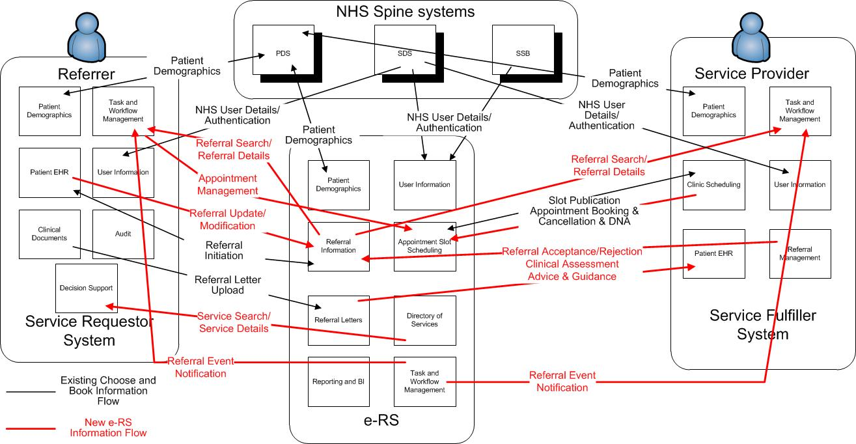

Compliance Versions
Since the inception of eBS, there have been a number of compliance documents produced by ATOS that have been available to the connecting suppliers with clarified and increased compliance requirements as the understanding of the system and its usage increased. These documents are detailed below.

Previous compliance document versions
Version | Date | Document Title | Approved Version
2 | 06 Feb 2004 | BA011 v2 CAB Compliance
3 | 18 Apr 2004 | BA011 v3 CAB Compliance
4 | 20 Jan 2005 | BA011 v4 CAB Compliance
5 | 07 Apr 2005 | BA011 v5 CAB Compliance
6 | 20 Feb 2006 | BA011 v6 CAB Compliance
7 | 24 Jul 2006 | BA011 v7 CAB Compliance | 7c
8 | 09 May 2007 | BA011 v8 CAB Compliance | 8f

NHS e-Referrals API Service
Further to the current messaging detailed in this document, the NHS e-Referrals programme is enhancing the integration to the NHS e-Referrals Service with the use of Application Programme Interfaces (APIs). In the longer term, the NHS e-Referrals API Service is intended for use by staff working at referring and provider sites to use the NHS e-Referral functionality in more integrated way with their current GP or Provider system. There will be a suite of API families that provide different levels of integration.
The first of the API families to be developed is the authentication API which allows authentication to the NHS e-RS Service and the CRI API which allows a system with a legitimate relationship to download the Clinical Information about a referral directly into their referring or provider system.
Future developments are likely to include Service Searching from within local applications and creation of UBRNs amongst others but these will be prioritised and developed to satisfy user need and provide benefits to the NHS.
For Further information on enhanced integration, please go to https://developer.nhs.uk/apis/

Changes in this version
The referrer compliance requirements were previously contained in a single compliance specification document, along with the provider requirements. There were also a couple of addendums for the referring systems around the population of the referral letter message and usability requirements. Therefore, this requirements document now only details the referrer requirements from these 3 documents.
The following are the main changes since the previous version of the referrer requirements:
- The descriptive text has been updated to reflect current processing;
- The requirements themselves have been presented in tabular format along with new IDs and a new status to make the requirements clearer to readers;
- In the most part there are no fundamentally new requirements, but where it was felt appropriate, the previous requirements have been elaborated.
Within the new tabular format, the following information is provided for each requirement:
- Reqt ID: A unique identifier for the requirement.
- Requirement Text: The full textual description of the requirement.
- Status: Whether the requirement Must be met or should be met.
Requirements are arranged into hierarchies where the child is a more specific elaboration of the parent. The relationship of a sub-requirement to its parent can be clearly seen in the IDs. EG. SYS-1.1 is an elaboration of SYS-1.

Technical Requirements
This section specifies detailed technical requirements relevant to all local referrer systems that integrate with NHS e-Referral Service (NHS e-RS). Specific requirements around the messaging interactions
This section contains descriptions, concepts and requirements common for all applications wishing to integrate with NHS e-Referral Service to perform electronic bookings.

System Requirements
Reqt. ID | Original Reqt ID | Requirement Text | Status
SYS-1 |  | Desktop components of the compliant system Must be capable of running side by side with the NHS e-Referral Service Professional web application. | Must
SYS-1.1 |  | Desktop components of the compliant system Must be compatible with a desktop environment supported by NHS e-Referral Service as specified in the Install Reference Document | Must
SYS-1.1.1 |  | Desktop components of the compliant system Must support the IA Client and a compatible browser. | Must
SYS-1.1.2 |  | Desktop components of the compliant system Must be compatible with at least one of the browser versions supported by NHS  e-Referral Service as specified in the Install Reference Document | Must
SYS-1.1.3 |  | Desktop components of the compliant system Must be compatible with ActiveX control or the Chrome plugin as specified in the Install Reference Document. | Must
SYS-1.1.4 |  | Desktop components of the compliant system Must be compatible with a screen resolution of 1024x768 or greater. | Must
SYS-2 | V6-C1 | Servers Must be time synchronised to an agreed time server and use this time in messages and logs. | Must
SYS-2.1 |  | Servers Must be synchronised to within 250 milliseconds of a reference time source agreed by The Authority. | Must
SYS-2.1.1 |  | Servers may be synchronised to one of the following reference time sources:  · ntp0.pipex.net (158.43.128.33)  · ntp1.pipex.net (158.43.128.66)  · ntp2.pipex.net (158.43.192.66)  · utserv.mcc.ac.uk (130.88.200.6)  · lanczos.maths.tcd.ie (134.226.81.3) | May
SYS-2.2 |  | All ebXML related message interactions MUST be time stamped with UTC time (i.e. creationTime). | Must
SYS-2.2.1 |  | Other times derived from the message interaction creation time (e.g. time to live) Must also be based upon UTC time. | Must

Messaging
NHS e-Referral Service exchanges messages with Referrer systems via the messaging standards documented in the Message Implementation Manual (MiM) and External Interface Specification (EIS) as specified in the document references section. It is assumed that the reader fully understands the content of the EIS and MiM.
Although NHS e-Referral Service currently supports two message interaction patterns, new suppliers/upgrading suppliers MUST implement MiM3.01.09. Each MiM version contains specific versions of the NHS e-Referral Service message interactions and the NHS e-Referral Service application only supports those interaction versions with the correct version of the MiM/EIS.
NHS e-Referral Service DOES NOT support any other versions of the MiM.
Complaint applications register their ‘end point’ in the SDS together with which message interactions they support. Applications use this end point registration to determine which message interactions and which version of each message interaction is supported by the system they wish to send the message to. NHS e-Referral Service expects compliant applications to register all ebooking interactions that can be received from NHS e-Referral Service, that are relevant to the role the system is playing, in this case a referring role, from a single version of the MiM.
Reqt. ID | Original Reqt ID | Requirement Text | Status
MSGMIM-1 |  | Systems Must use compatible and supported message interaction versions for all messaging with NHS e-Referral Service. | Must
MSGMIM-1.1 | V7-C1 | A compliant system Must use a single MIM version for all NHS e-Referral Service interactions. Current supported MiM versions for NHS e-Referral Service messages are MiM 3.1.09. | Must
MSGMIM-1.2 |  | A compliant system may use other MiM versions for other MiM domains. For example, MiM 3.1.09 for NHS e-Referral Service messages and MiM 6.03.01 for PDS messages. | May
MSGMIM-1.3 |  | A system coming through Compliance for the first time will be expected to use the latest supported version of NHS e-Referral Service messages. Currently this is MiM3.1.09. | Must
MSGMIM-2 |  | Systems Must comply with the requirements specified in the relevant MiM and EIS for all messages that it uses, except where otherwise agreed by The Authority. | Must
MSGMIM-2.1 |  | Systems Must fulfil the responsibilities of the roles that they play in message interactions. | Must
MSGMIM-2.2 |  | Systems Must send messages that meet the formatting requirements of the MiM. | Must
MSGMIM-2.2.1 |  | Systems Must send messages that are well-formed XML. | Must
MSGMIM-2.2.2 |  | Systems Must send messages that are valid against the XML schemas provided in the MiM. | Must
MSGMIM-2.2.3 |  | Systems Must send messages whose data conforms with the values in the NHS e-RS Data Dictionary. | Must
MSGMIM-2.2.4 |  | Systems should be designed to be as flexible as possible in supporting changes to message vocabularies. For example by making use of configurable vocabularies. | Must
MSGMIM-2.2.5 |  | Systems Must be able to support changes to the vocabulary with 3 months’ notice via GPSoC | Must

External Interface Specification (EIS)
Reqt. ID | Original Reqt ID | Requirement Text | Status
MSGEIS-1 |  | Systems Must comply with the requirements in the appropriate Spine External Interface Specification for the delivery of messages. | Must
MSGEIS-1.1 | V4-C7 | Suppliers Must use the appropriate version of the Spine External Interface Specification depending on the MiM version being used. As the External Interface Specifications are updated per Spine release, the specific versions to be used at a particular time should be agreed with The Authority. See document references section | Must
MSGEIS-2 |  | Compliant systems Must use the appropriate message behaviour patterns for each message interaction, as described in the relevant Spine External Interface Specification. | Must
MSGEIS-2.1 | V6-C6 | To utilise MiM 3.1.09 messaging, compliant systems Must support the Multi-Hop Intermediary Reliability pattern as described in the relevant Spine External Interface Specification. | Must
MSGEIS-2.3 |  | Compliant systems using the Multi-Hop Intermediary Reliability message behaviour pattern Must implement ebXML duplicate elimination. | Must
MSGEIS-2.4 |  | Compliant systems Must have a mechanism for picking up the latest service data (including contract properties) from SDS. | Must

Message Timeouts
Reqt. ID | Original Reqt ID | Requirement Text | Status
MSGTO-1 |  | When a user is waiting while the system waits for a message interaction to complete, the system Must not time out until a configurable User Timeout Period has elapsed. | Must
MSGTO-1.1 |  | Systems should set the default value for the configurable User Timeout Period to 2 minutes. | MUST
MSGTO-2 |  | When the system is waiting for an application acknowledgement message interaction MCCI_IN010000UK13 from NHS e-Referral Service, it Must wait until a configurable Application Acknowledgment Timeout Period has elapsed before placing a message interaction in the error log for investigation. | Must
MSGTO-2.1 |  | Systems should set the default value for the configurable Application Acknowledgement Timeout Period to 15 minutes. | Must

Personal Demographics Service

Patient Demographics
Reqt. ID | Original Reqt ID | Requirement Text | Status
PDS-1 |  | All systems that participate in electronic referral and booking with NHS e-Referral Service Must utilise the Spine Personal Demographics Service (PDS) as the master source of demographics. | Must
PDS-1.1 |  | A Master Patient Index search for a patient Must be performed against data sourced from PDS. | Must
PDS-1.2 |  | If a Compliant system caches data locally then the patient record Must be synchronised with the PDS at appropriate and regular intervals when the patient record is accessed. | Must
PDS-1.3 |  | Messages sent to NHS e-Referral Service that contain an NHS Number Must use the 10 digit NHS Number of the Patient. Currently this affects the Request Service and Notify Referral message interactions. | Must
PDS-2 |  | Prior to initiating NHS e-Referrals, patient demographics MUST be synchronised with PDS as this is the source of demographics for provider systems. | Must

Security and Information Governance

User Authentication and Role Based Access Control
Reqt. ID | Original Reqt ID | Requirement Text | Status
SAUTH-1 |  | All compliant systems Must utilise the National Care Records Service (NCRS) Spine Security Broker (SSB) to authenticate users and determine their role based access permissions. | Must

Role Based Access Control
Reqt. ID | Original Reqt ID | Requirement Text | Status
SRBAC-1 |  | If a user is registered to NCRS with more than one Role Profile then an NCRS compliant system Must ensure the user selects a specific Role Profile (i.e. Role and Organisation) for each application session. | Must
SRBAC-2 |  | To support the evolution of Role Based Access Control, systems Must be flexible enough to support BAU changes to the National Role Database (NRD) - in particular additions and removals of Activities – without the need for a new software release. | Should
SRBAC-2.1 |  | Although deprecated in the latest RBAC model, the business functions B1101 and B1102 MUST be the only business functions that allow access to initiate a NHS e-Referral Service referral | Must

Message Logging and Error Handling

Message Logging
Reqt. ID | Original Reqt ID | Requirement Text | Status
LOG-1 |  | Systems Must keep a log of all e-RS messages sent and received for a period of at least 3 months. | Must
LOG-1.1 |  | The log Must be available to a suitably authorised administrator in a human readable form suitable for error investigation. | Must
LOG-1.2 |  | Logs Must include key header information (timestamp, message type, UBRN, NHS Number, Service ID) as well as full message content including HTTP, SOAP and ebXML wrappers. | Must
LOG-1.3 |  | All date/time stamps Must be synchronised with the reference time source. | Must
LOG-2 |  | Systems Must keep a log of all errors relating to e-RS messages for a period of at least 3 months. | Must
LOG-2.1 |  | The log Must be available to a suitably authorised administrator in a human readable form suitable for error investigation. | Must
LOG-2.2 |  | The log Must contain timestamp, the message ID and type to which the error relates, UBRN, NHS Number and Service ID as well as an error code and error text. | Must
LOG-2.3 |  | All date/time stamps Must be synchronised with the reference time source. | Must

Error Handling
Reqt. ID | Original Reqt ID | Requirement Text | Status
LOG-3 |  | Systems Must provide a mechanism to investigate and resolve message errors. | Must
LOG-3.1 |  | Systems Must allow resubmission of messages and these Must be audited. | Must
LOG-3.2 |  | A notification mechanism should be provided (e.g. email or worklist) to alert the administrator of an error situation that Must be investigated, rather than relying on the administrator having to query the application to find out if an error has occurred. | Should
LOG-4 |  | Compliant systems Must provide a mechanism for administrators to manually resolve the non-receipt of an application acknowledgment. | Must
LOG-4.1 |  | After the Application Acknowledgement Timeout Period has elapsed the administrator should be notified of the non-receipt of the Application Acknowledgement. | Should
LOG-4.2 |  | The system Must allow manual resolution of the non-receipt of an Application Acknowledgement. Eg. To resend the original message if appropriate. | Must
LOG-4.3 |  | If after manual resolution has occurred, the delayed Application Acknowledgement is received it can be treated as a duplicate unless it contradicts the manual resolution applied, in which case it Must be flagged on the Error Log. | Must
LOG-5 |  | Clear documentation Must be provided on how to use the investigation and error correction software. | Must
LOG-5.1 |  | The system supplier Must provide detailed documentation of the procedures to be followed by the administrator to investigate and resolve errors, along with clear instructions as to how to use the supplied software. | Must

System Performance
Reqt. ID | Original Reqt ID | Requirement Text | Status
PERF-1 |  | Systems Must be designed for optimal performance and suppliers will be expected to show they intend to achieve this in their system design documentation.  Please note the current V&P test model is as follows:  Test Ref Description Duration (minutes) No. of Bookings Equivalent Bookings per hour Equivalent Bookings per minute  VP1 Average Load 20 60 180 3  VP2 Normal Load 20 100 300 5  VP3 Peak Load 20 200 600 10  VP4 Short Burst 1 1 12 720 12  VP5 Short Burst 2 1 24 1,440 24  VP6 Short Burst 3 1 60 3,600 60  VP7 Soak Test 240 (min duration) 2400 600 10  This model is subject to change and is provided as an indication on acceptable timings. | Must
PERF-1.1 |  | Interface component design Must be robust, handle errors gracefully, and report on usage, on error and on performance statistics to their system administrator. | Must

Home Page Seamless Transition

Overview
Compliant systems Must support a mechanism for a logged on user to invoke the NHS e-Referral Service home page in the context of their (single) Role Profile in use in the compliant system. NHS e-Referral Service is invoked by a URL address and passed the user’s current role profile code in the query string; NHS e-Referral Service will respond by displaying the user’s home page.
The Compliant system Must provide this facility in appropriate places and contexts within their system. It Must be easy to use and when the user invokes a home page seamless transition the effect is for the user to enter NHS e-Referral Service with no further user interaction (unless the role profile has more than one NHS e-Referral Service business function in which case NHS e-Referral Service will prompt the user to select the relevant one).
Home Page seamless transition is separate from the UBRN seamless transition (detailed later in the requirements) which used to direct a user in the patients context to the service search screens.
The seamless transition support within NHS e-Referral Service (both home page seamless transition and UBRN seamless transition) allows an integrated Referrer to launch NHS e-Referral Service in context within a browser window. The browser window can be a new window or can be an embedded browser control.
Currently, there is no recommended configuration for using a Web Browser Control to access NHS e-Referral Service, and in view of the large number of possible configurations it is unlikely that NHS Digital will produce a definitive statement of a standard configuration.
The reference implementation for the Web interface to NHS e-Referral Service will continue to be Microsoft Internet Explorer configured according to the current installation instructions on the NHS e-Referral Service web site https://digital.nhs.uk/services/nhs-e-referral-service/. It is the responsibility of the application provider to configure their system to perform in a similar way to the reference implementation. This Must be tested as part of the acceptance process. In “Table 1 – Seamless Transition reference Implementation” below, we have indicated the requirement and, where possible given hints which may help the application provider to meet the requirement.
Table 1 - Seamless Transition Reference Implementation
Ref. | Requirement | Hints
1 | Use an approved browser | Latest versions of Microsoft Internet Explorer, Chrome or Firefox
2 | Install the ActiveX control | Refer to the Install reference Document
3. | Allow pop-up windows
4. | Disable forward/back navigation buttons/keys | Disable toolbar on initial load of WBC

Requirements
Reqt. ID | Original Reqt ID | Requirement Text | Status
TRANS-1 |  | Systems Must support a Home Page Seamless Transition that enables a user to easily launch NHS e-Referral Service in a browser from within the system. | Must
TRANS-1.1 |  | Systems Must provide a single valid role profile ID from the users’ Spine Security Broker login session. | Must
TRANS-1.2 |  | When implementing Home Page seamless transition to NHS e-Referral Service, the browser window can be a new window or can be an embedded browser control. | Must
TRANS-1.3 |  | If using an embedded browser, once the user has completed the actions in NHS e-RS, the session should be terminated. | Must
TRANS-1.4 |  | To ensure that NHS e-Referral Service will function correctly within the browser, the system should follow the reference implementation set out in Table 1 - Seamless Transition Reference Implementation. | Should
Example
https://nww.ebs.ncrs.nhs.uk/app-ebs/login.do?roleProfileCode=123456789012
User is then presented with all of the NHS e-RS activities associated with that role
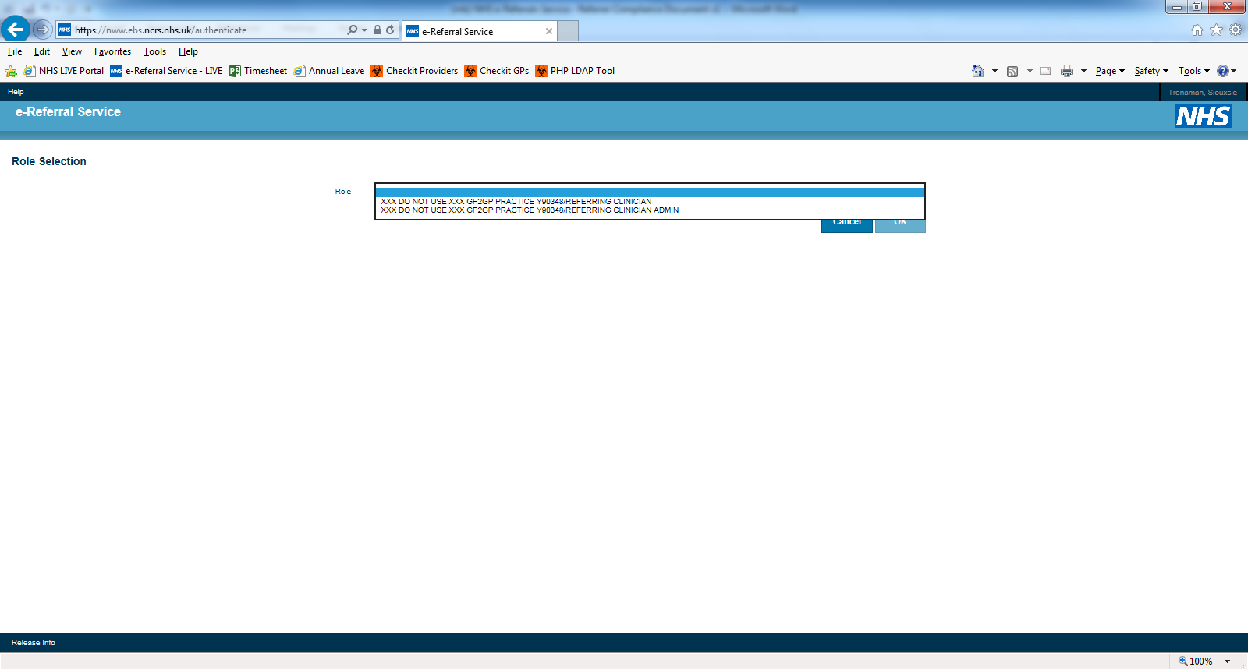

Messaging
The latest approved messaging set for NHS e-Referral Service referrer systems is MIM3.01.09 and any new systems coming through compliance MUST conform to this version of the messaging.

Requirements
Reqt. ID | Original Reqt ID | Requirement Text | Status
REF-1 |  | Compliant Referrer systems Must implement the latest set of MIM messaging available. | Must
REF-2 | V4-R1 | Compliant Referrer systems Must implement the role of Service Requestor PRPA_AR010000UKnn as defined in the MIM. | Must
REF-2.1 | V4-R2 | Implement the following NHS e-Referral Service MIM interactions:  Request Service PRPA_IN010000UKnn  Confirm Service Request PRPA_IN020000UKnn  Notify Patient Referral PRPA_IN030000UKnn  Application Acknowledgement MCCI_IN010000Uknn | Must

Create Request

Decision to Refer

Overview
The decision to refer Must occur as a ‘seamless transition’ from the Referrer System into NHS e-Referral Service where the user is not prompted for any further input. It Must occur as rapidly as possible as the user is waiting for a system response. The steps are as follows:
- The Referrer decides to refer the patient and to ensure that the correct patient is being referred on NHS e-Referral Service (as the NHS number is the only value sent in the message to identify the patient), the patient demographic details Must have been verified against PDS before the local system allows the referrer to initiate the NHS e-Referral Service request.
- The Referrer decides to refer the patient and presses a “refer” button or similar within the Referrer system with the patient in context. (The button Must not be called “book appointment” or similar as this is misleading to the referrer. Although this can be done after the service shortlist, in the majority of cases the shortlist is completed and the booking of the appointment is done by the patient, administrator etc at a later time)
- The Referrer System sends a Request Service message interaction, to request a UBRN from NHS e-Referral Service containing the Patients NHS Number and Priority of referral.
- NHS e-Referral Service responds with a Confirm Service Request message interaction that contains the UBRN.
- The Referrer System stores this as the unique reference for the patient’s referral and invokes NHS e-Referral Service using its URL, passing the user’s Unique User Identifier (UUID) and the newly created UBRN in the query string. This places the user in the context of the selected patient at the booking screen to enable the user to shortlist Services.
- User shortlists and saves the shortlist to make the UBRN valid. Before the shortlist is saved, the UBRN is not valid and therefore cannot be viewed on the NHS e-Referral Service web application or used to book an appointment. It is therefore vital that this service selection is completed immediately after the UBRN is sent to the referring system in the confirm service request.

When the referrer has entered NHS e-Referral Service they complete the shortlist of services and provide additional information to create the Appointment Request. Optionally they may book an appointment. A referral letter can be sent once the Appointment Request has been saved.

Demographic Data
Patients are referred via NHS e-Referral Service using their 10 digit NHS Number as the identifier; this is provided to NHS e-Referral Service in the Request Service message. The NHS e-Referral Service retrieves patient demographics from the PDS so demographics are not sent in the Request Service message interaction. Therefore, the patient MUST have been matched and verified as having the correct NHS number prior to referring to NHS e-Referral Service.
A compliant Referring System Must direct users to send any patient demographic updates for the patient to the PDS before initiating a NHS e-Referral Service referral and sending the Request Service interaction to NHS e-Referral Service to get a UBRN. This is because as the message interaction contains only the NHS Number, NHS e-Referral Service and the subsequent Provider systems will get patient demographics from the PDS. Failure to update the PDS Must not prevent the Request Service message interaction being sent. Patients not on PDS, or who have an old or temporary NHS number, or who have been stop-noted cannot be electronically referred. It is also not possible to refer a patient that does not have a registered GP.

Ability to Refer
There is a single, simple criterion that determines whether or not someone is able to refer using NHS e-Referral Service. This is that the referrer needs to have a smartcard and associated role with an Activity of "Manage Outbound Referrals", code B1101 (This was formerly called a Business Function of "Referring Clinician" but still with code B1101). If a proxy user, such as a secretary, is acting on behalf of such a referrer, the proxy needs to have an Activity of "Manage Outbound Referrals Admin", code B1102, and the referrer on whose behalf they are acting Must have B1101.
The "Author" field in the Request Service message (PRSC_IN010000UKnn) payload should always contain the UUID of the healthcare professional who made the decision to refer the patient, i.e. the UUID of a person with the B1101.
In MIM 3.1.09, the "Author" field in the Control Act wrapper is where the person who is actually logged in should be identified, B1101 or B1102, depending on whether it is actually the clinician themselves or someone on their behalf.
Systems MUST not allow a proxy to refer on behalf of a user whose UUID is not known, as it would not be possible to determine whether this person has a B1101 Activity. However, referrals should not be limited to the principal GP or indeed a GP at all, as NHS e-Referral Service does allow Nurse Practitioners etc. to make a referral.
NHS e-Referral Service compliance does allow for a ‘nullFlavor’ to be sent in the author field in the payload but we would strongly recommend that this option is not used, as it creates work for Service Provider users (in some cases, Patient Administration Systems incorrectly reject such referrals) and would not allow GPs to be reimbursed for any referrals that they had made.
The Activity of "Manage Appointment Bookings", B1103 (This was formerly called a Business Function of "Referring Admin" but still with code B1103), is NOT a valid user access for UBRN Seamless Transition. Users with this level of access MUST not have access to clinical information and therefore would use web based NHS e-Referral Service to manage appointment bookings only.
Note that, as described in the overview above, the UBRN request and invoking the NHS e-Referral Service URL in the context of the UBRN and users Role Profile Code are two parts of the same logical transaction “Seamless Transition”. If any user is ineligible to perform the second part of this transaction, the service selection in the NHS e-Referral Service application, they MUST not be permitted to perform the first part, retrieve a UBRN.

Request Service Interaction PRPA_IN010000UKnn
The Request Service interaction PRPA_IN010000UKnn is used by the referring system to request a UBRN from NHS e-Referral Service.
Notes on message fields:
- RequestService:PriorityCode is mandatory and allows the Referrer to set the priority of the Appointment Request within the Referrer System and pass the priority to NHS e-Referral Service. The value passed in the message is used to default the value within the NHS e-Referral Service booking screen. If the Referrer does not select a priority in the compliant Referrer System then an empty string Must be populated into the message, i.e. <priorityCode code="" />. NHS e-Referral Service will then require the Referrer to make a selection in the Booking screen. Currently the MiM incorrectly states that the value “1” (meaning routine) should be used as a default value in the message, but this is wrong because the NHS e-Referral Service business process requires that the referrer Must explicitly set the priority either within the Referrer System or NHS e-Referral Service.
- RequestService:Subject
Patient is mandatory
Patient:ID is mandatory and is the NHS Number of the patient.
Patient:patientPerson is optional and is ignored by NHS e-Referral Service.
Patient:SourceOf is optional and is ignored by NHS e-Referral Service
The Referring system Must not send patient demographics or GP information in the message as they are ignored by NHS e-Referral Service, but instead ensure the PDS holds the most up to date data.
- Author. Mandatory. Is identified with the SDS Role Profile Id and SDS User Id of the clinician who made the decision to refer the patient. The Author information is used by NHS e-Referral Service to set the Referring Clinician on the Appointment Request on the NHS e-Referral Service database, and it is also forwarded to the Service Provider when an appointment is booked. MIM 3.1.09 incorrectly states that the Author should be the user who is logged on at the time the message is sent.
If the referral is being entered into the Referrer System by a clinical administrator rather than the referrer themselves, and the RoleProfileCode of the clinician is not known, then the Referring System Must send a nullFlavor in place of the clinician’s Role Profile Code.
<author typeCode="AUT">
<AgentPersonSDS classCode="AGNT">
<id nullFlavor="UNK"/>
<agentPersonSDS classCode="PSN" determinerCode="INSTANCE">
<id root="1.2.826.0.1285.0.2.0.65" extension="SDS User Id"
</agentPersonSDS>
</AgentPersonSDS>
</author>
NHS e-Referral Service does not use the sent RoleProfileCode itself, but does send it to the Service Provider System in Request Appointment Confirmation PRSC_IN040000UKnn when an appointment is booked.

Confirm Service Request Interaction PRPA_IN020000UKnn
When NHS e-Referral Service receives the Request Service Interaction PRPA_IN010000UKnn the message is validated and any errors reported back to the Referring system in the Confirm Service Request Interaction PRPA_IN020000Uknn, without generating a UBRN. Possible error texts are indicated in Appendix A – Message Error Handling.
If processing of the message is successful, the Confirm Service Request Interaction PRPA_IN020000UKnn is used to send the allocated UBRN from NHS e-Referral Service back to the Referrer System.
If NHS e-Referral Service cannot deliver the Confirm Service Request interaction then NHS e-Referral Service will log an error. It is expected that the sending system that originated the Request Service interaction will notify the user that the response message has not been received and provide applicable user options to re-submit the request.
Notes on message fields:
- ConfirmedService:ID contains the UBRN if one is successfully allocated.

Application Acknowledgement MCCI_IN010000Uknn
Upon receipt of the Confirm Service Request Interaction PRPA_IN020000Uknn the Referring system sends to NHS e-Referral Service an Application Acknowledgement MCCI_IN010000Uknn with either a success or failure code. If the Referring system encounters an error processing the Confirm Service Request Interaction PRPA_IN020000UKnn then an error code describing the error can be passed to NHS e-Referral Service as detailed in Appendix A – Message Error Handling.

Request Service - Interaction Diagram
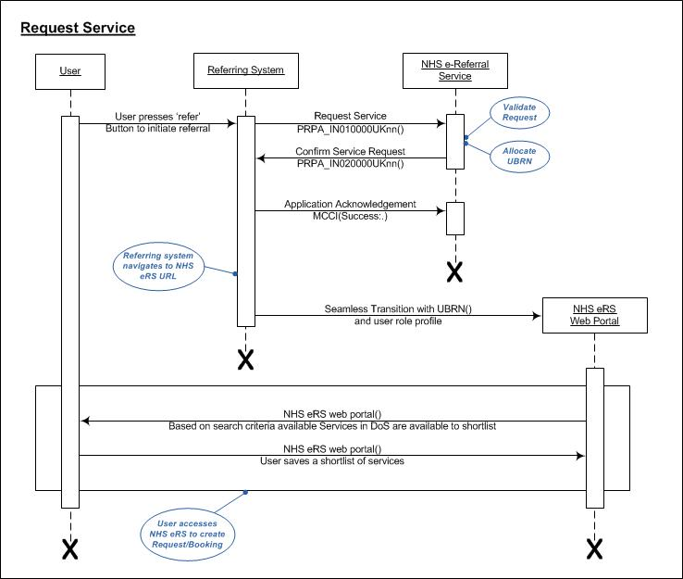
General notes on the interaction diagrams in this document can be found in Appendix E - Notes on Interaction Diagrams.

UBRN Seamless Transition

Overview
Features in common with the home page seamless transition are described in the Common Compliance Requirements section above, e.g. role profile code.
The Compliant Referrer system Must support the UBRN Seamless Transition in a way that is easy for the user to use and in appropriate places and contexts within the Referrer System. When the user invokes a seamless transition the effect is for the user to enter NHS e-Referral Service with no further user interaction.
In UBRN Seamless Transition the user invokes NHS e-Referral Service during the referral process in the context of the user’s currently logged on Role Profile and the currently selected patient. The Business Function in the Role Profile Must be Referring Clinician or Referring Clinician Admin, otherwise NHS e-Referral Service will reject the login.
If the UBRN Seamless Transition is not used during the referral process or the user does not complete the Appointment Request, then it can be completed by going to the homepage and searching for the UBRN from there.
The format of the URL query string is:
https://nww.ebs.ncrs.nhs.uk/app-ebs/login.do?UBRN=123456789012&roleProfileCode=0987654321237
Query string parameters are:
- UBRN – mandatory. This is the UBRN received on the previous Confirm Service Request message interaction. It is used by NHS e-Referral Service to establish patient and UBRN context so that the user does not have to re-select the patient.
- Role Profile Code – Mandatory. This is the role profile in force in the user’s current Referring System session. It is required to avoid NHS e-Referral Service having to challenge the user to select their Role Profile where they have more than one, and to avoid them selecting a different Role Profile to that in force when the referral was initiated in the Referrer System.
The referring system Must ensure the role profile in the UBRN seamless transition is associated to the same referring organisation as was used to make the Request Service (to obtain the UBRN). If the user’s Organisation and the UBRN's Organisation do not match then the user will not be able to view the UBRN once they have seamlessly transferred into NHS e-Referral Service.

Create Request Requirements

Decision to Refer Requirements
Reqt. ID | Original Reqt ID | Requirement Text | Status
DTR-1 | V6-R5 | Patients are identified by their 10 digit NHS Number. | Must
DTR-1.1 |  | The Patient Must have been matched and verified as having the correct NHS Number prior to referring to NHS e-Referral Service | Must
DTR-1.2 | V6-R6 | The PDS Must be updated with latest demographics before the Request Service message is sent to NHS e-Referral Service | Must
DTR-1.3 |  | Demographic information should not be sent in the Request Service Message as NHS e-Referral Service does not use this information | Should
DTR-2 | V6-R7 | A referring system Must provide a mechanism to initiate the UBRN seamless transition in the context of a patient | Must
DTR-2.1 | Usability 5 | All compliant solutions Must ensure that any user with the appropriate business function is able to refer. | Must
DTR-3 | V6-R8 | The Request/Confirm Service Interaction is used to exchange the URBN prior to the UBRN seamless transition | Must
DTR-3.1 | V6-R9 | During this process the user Must experience seamless transition from their Referrer system into NHS e-Referral Service | Must
DTR-3.2 | V4-R3 | Referring systems Must store the UBRN allocated by NHS e-Referral Service in its database against the referral as the unique reference for the Appointment Request | Must

UBRN Seamless Transition Requirements
Reqt. ID | Original Reqt ID | Requirement Text | Status
UST-1 | V4-R4 | Implement the UBRN seamless transition to support the referral process | Must
UST-1.1 | V6-R10 | The UBRN seamless transition Must provide an intuitive mechanism for the user to refer a patient. | Must
UST-1.2 | V6-R11 | The referring system Must ensure the role profile of the referring user contains the Referring Clinician or Referring Clinician Admin business function. | Must
UST-1.3 | V6-R12 | The referring system Must ensure the Role Profile in the UBRN seamless Transition is for the same organisation as originated the Request Service. | Must

Referral Letter Requirements

Overview
The referral letter requirements section is to provide GP system suppliers with clinical and technical guidance as to the data and information that should be sent in the NHS e-Referral Service referral message. Sections of the referral letter requirements could also be used to inform end-user expectations of the referral message that will be displayed in the NHS e-Referral Service application.
The advantage of using the elements of the integrated referral message is that it shows at a glance the relevant Clinical Information relating to the referral thus providing an improved user experience for the receiving clinician. They no longer need to wait whilst the application required to display the content of an attachment opens.

Summary of Notify Patient Referral PRPA_IN030000UKnn
Referring systems Must send the Referral Letter to NHS e-Referral Service using the Notify Patient Referral PRPA_IN030000Uknn interaction once the UBRN has been allocated and the Appointment Request and Service shortlist created in NHS e-Referral Service. The dispatch of the letter is not linked to the booking of an appointment which may be performed by the referrer, practice staff, Telephone Appointments Line, or the patient over the internet. The referral letter can be applied to the UBRN before or after the appointment has been booked.
Referral attachments are supported in NHS e-Referral Service using the W3C SOAP MIME attachments standard which can be located at http://www.w3.org/TR/SOAP-attachments. The purpose of this attachment facility is to allow the communication of small items of data that cannot be adequately described in the structured content of the HL7 referral message. While this facility is not intended as an alternative to putting clinical information in the structured part of the referral message it is technically possible to do this since fields in the referral message are optional.
The UBRN sent in the Notify Patient Referral message Must be the one previously received on the Confirm Service Request Interaction PRPA_IN020000Uknn. A referring system Must account for the fact that a patient may have many open referrals and Must attach the correct UBRN to the correct Referral Letter message. A single consultation may result in more than one referral.
Referring systems Must allow a Referrer to update a Referral Letter previously sent to NHS e-Referral Service, for example to add additional information or attachment, and to re-send the Notify Patient Referral message to NHS e-Referral Service. When a referring user wants to update a referral they Must be presented with the previous version to amend, i.e. they Must not be required to start creating the referral again. Previous versions of the referral Must be stored and be viewable in the Referrer system to maintain the clinical audit trail. As the new referral message to NHS e-Referral Service completely replaces the previous one, the new message Must contain all the remaining elements of the current referral information (even if parts of it have not changed) and so be a complete replacement for the previous one. A new message ID Must be used.
When NHS e-Referral Service receives the Notify Patient Referral PRPA_IN030000UKnn, it validates the following information:
- A valid UBRN exists in the Referral.id
- The referral has not been tagged as frozen by the Service Provider because the Service “freeze time” has been reached or the appointment date is in the past
- If a Referral Letter already exists for the UBRN, then the Referral Letter was previously received by a Notify Patient Referral interaction and not built in NHS e-Referral Service.
If the validation fails or for any reason the referral cannot be stored, NHS e-Referral Service will return an error in the Application Acknowledgement. Possible error texts are indicated in Appendix A – Message Error Handling
Due to message size, compliant Referrer systems MUST implement the Notify Patient Referral as an asynchronous interaction, i.e. where the user is not waiting for the application acknowledgement from NHS e-Referral Service. If NHS e-Referral Service does not accept the Notify Patient Referral interaction it sends a negative application acknowledgement to the referrer system and it is important that this is flagged to the relevant user so that the error can be resolved.
It is obviously a clinical safety risk if a negative application acknowledgement is received by the referrer system and is not acted upon by relevant staff in a timely manner.
Notes on message fields:
- Referral:ID is the mandatory UBRN.
- Referral:PriorityCode is the priority of the referral. This field is ignored by NHS e-Referral Service. The consequence of this is that the priority of Appointment Request can only be set by the Referrer System via the Request Service Interaction PRPA_IN010000UKnn or by a suitably authorised end user via the NHS e-Referral Service user interface. Referrer systems can no longer update the priority of a referral via the Notify Patient Referral interaction PRPA_IN030000UKnn.
- Subject:Patient contains the mandatory NHS Number, but the optional demographics need not be filled in as NHS e-Referral Service ignores them. The NHS Number supplied Must be the one used when the Appointment Request was created.
- Referral: Author. Mandatory. Is identified with the SDS Role Profile Id and SDS User Id of the clinician who made the decision to refer the patient. MIM 3.1.09 incorrectly states that the Author should be the user who is logged on at the time the message is sent.
If the referral is being entered into the Referrer System by a clinical administrator rather than the referrer themselves, and the RoleProfileCode of the clinician is not known, then the Referring System Must send a nullFlavor in place of the clinician’s Role Profile Code.
<author typeCode="AUT">
<AgentPersonSDS classCode="AGNT">
<id nullFlavor="UNK"/>
<agentPersonSDS classCode="PSN" determinerCode="INSTANCE">
<id root="1.2.826.0.1285.0.2.0.65" extension="SDS User Id"
</agentPersonSDS>
</AgentPersonSDS>
</author>
- ReferralComponents – See Appendix F for information on how the NHS e-Referral Service processes and displays the information in the Referral Letter.
Referrer systems Must place clinically relevant data only into components of the message that are displayed to the user by NHS e-Referral Service. Data placed in non-displayed components will not be displayed when the user views the letter in NHS e-Referral Service. For more information see Appendix F – Referral Letter Components

Population of the Notify Referral

Logical Structure of the Referral Letter
This section sets the context for the remainder of this document by describing the basic logical structure of the referral information. This is the information that is transmitted in the referral message and then displayed to users of the application. It is not describing the message structure at this stage

Display Structure
This information is structured roughly as illustrated in Figure 1 - Logical Structure of a Referral. This diagram indicates both the logical components of the referral letter and the order in which they will be presented.
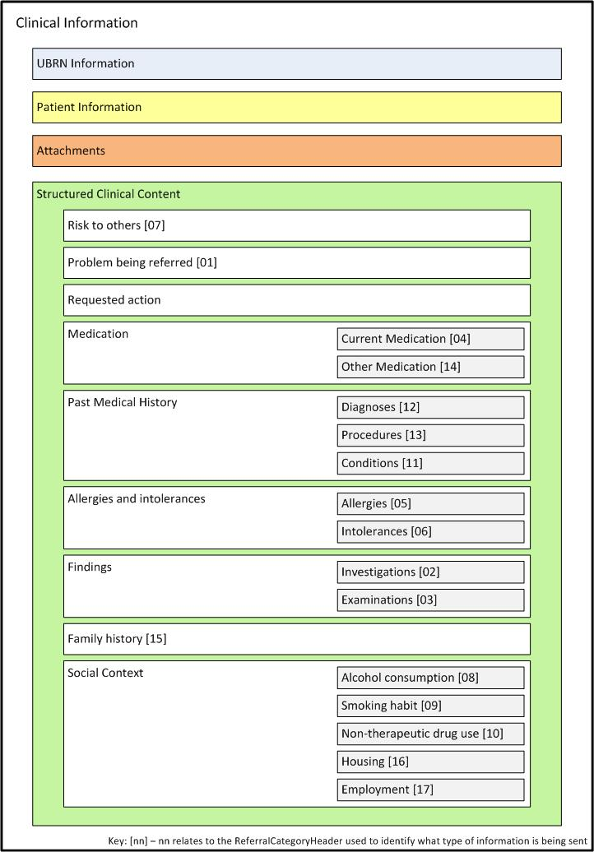
Figure 1 - Logical Structure of a Referral
The elements of this logical structure are summarised below:
- UBRN Information – This information is mostly administrative, and includes date of referral, priority, problem, requested procedure, date the referral letter was created, information about the referring GP, registered practice etc.
- Patient Information – This information includes the patient’s NHS number, name, gender, date of birth, contact details, address etc.
- Attachments – This is intended to hold information that supplements the structured clinical content below (e.g. an image to illustrate a finding that is described in the structured content).
- Structured Clinical Content – This is the heart of the referral letter and will be the focus of much of this document. Content is further categorised into the logical sub-categories indicated (Risk to others, Problem being referred, etc).

Referral Letter Content Mapping to the Care Record
The category headers that are displayed in the clinical information section of the Integrated Referral Letter have been defined in conjunction with the definitions within the NHS Care Record Elements document (NPFIT-NCR-DES-0135.08). This document can also be used to provide guidance as to how the NHS e-Referral Service referral message should be populated. See the embedded document which is the most current version of this document at the time of writing this guidance.

Rationalised Categories
When an integrated referral letter is sent from a GP system, these details are displayed on the ‘Clinical Information’ pane when viewing the Integrated Referral Letter. Within this section, the categories have been re-defined to display the clinical data in a rational way to the end user.
The NHS e-RS referral message (PRPA_MT030101UK05) contains a number of ‘Category Headers’ that are used to group the information that is contained within the referral message.
The Care Record Element definitions and descriptions should be interpreted for use within the NHS e-RS referral message. For example ‘Medication’ should only contain details that are relevant to the referral.

Menu Lists and Headings displayed in the Clinical Information Screen on NHS e-RS
Category Headers | Sub Headings | Care Record Element Mapping
Attachments
Risk to Others |  | Risks and Warnings
Problem Being Referred |  | Problems and Issues
Requested Action
Medication | Current Medication | Medication Record
 | Other Medication | Medication Record
Past Medical History | Diagnoses | Diagnoses
 | Procedures | Procedures  - Treatments  - Investigations  - Administrative Procedures  - Provision of Advice and Information to Patients and Carers
 | Conditions | Problems and Issues
Allergies and Intolerances | Allergies | Risks and Warnings  - Allergies and Adverse Reactions
 | Intolerances | Risks and Warnings  - Allergies and Adverse Reactions
Findings | Investigations | Findings  - Investigation Results
 | Examinations | Findings  - Clinical Observations and Findings
Family History |  | Family History
Social Context | Alcohol Consumption | Social Context  - Lifestyle
 | Smoking Habit | Social Context  - Lifestyle
 | Non-therapeutic Drug Use | Social Context  - Lifestyle
 | Housing | Social Context  - Social and Personal Circumstances
 | Employment | Social Context  - Social and Personal Circumstances

Sending the Notify Patient Referral message

Interaction Diagrams
The Notify Patient Referral Message is sent from the Referring Clinical System and is triggered by a user interaction. The message process flow is as follows:

Notify Patient Referral Interaction Diagram
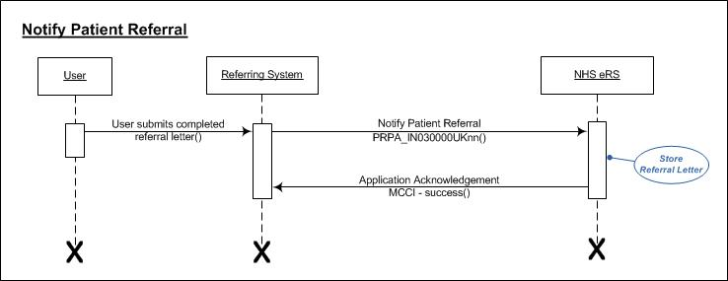

Error Handling of the Notify Patient Referral PRPA_IN030000UKnn
When a referral message is sent from the referring system to NHS e-RS, it is possible that this message can fail to process in NHS e-RS due to a number of reasons. Some examples of the reasons are as follows (this is not an exhaustive list)
- It is no longer possible to update the letter as it now falls within the Freeze Date (period up to the appointment where an update to a referral is not accepted as the service provider is not likely to pick this update up)
- Appointment date is in the past or the UBRN has been cancelled by the Service Provider
- There is an issue with the referring users details sent in the message
- There is a processing issue with NHS e-RS (eg. Scheduled downtime for an update release)
If there is a failure processing the message, NHS e-RS returns an error in the MCCI_IN010000UK13 message with the error code and error text to enable users to investigate. This error Must be logged with an administrator and the option to resend the message MUST be available. See details of the error flows in the following interaction diagrams.

Notify Patient Referral Interaction Diagram – Error Received
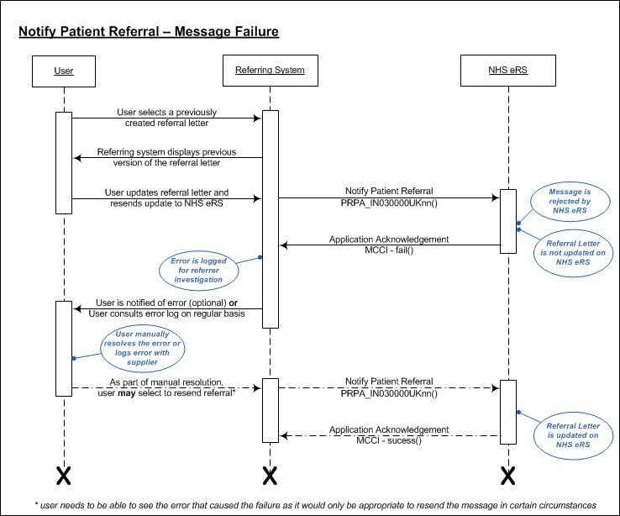

Notify Patient Referral Interaction Diagrams – Non receipt of Acknowledgment
When no acknowledgment is received from NHS e-RS to say that the referral message was received, the sending system Must log the non-receipt of the acknowledgment after 15 mins. The administrator will need to check NHS e-RS to see if the referral was received and either disregard the error or allow the user to resend the Notify Patient Referral Message.
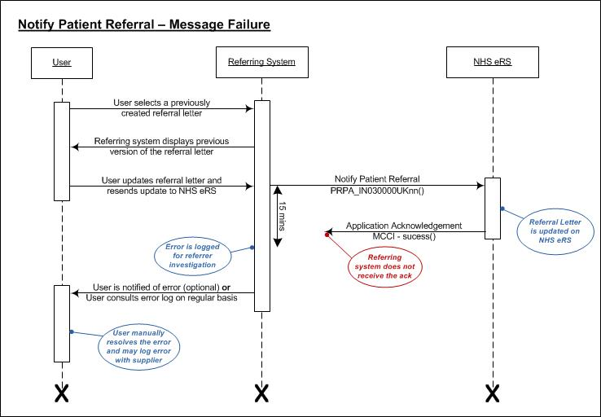

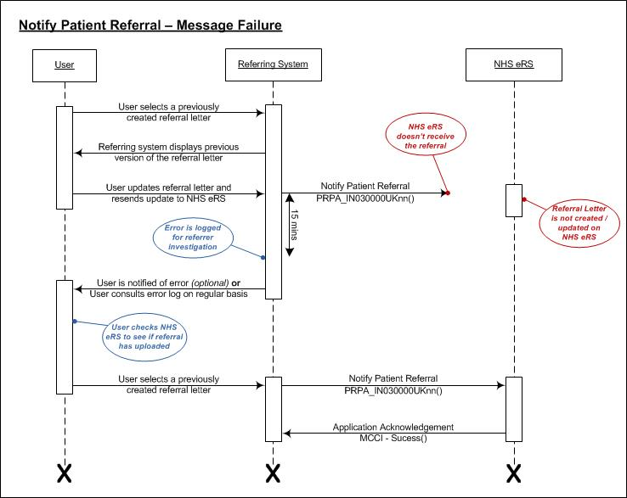

Sending Relevant Information
The purpose of a referral letter is to articulate succinctly the clinical context so that the receiver can quickly understand why the patient has been referred and have access to the relevant clinical information.
The referral letter has to cater for a wide range of referral types and therefore has quite a rich structure, most of which will not be relevant for any given referral. For example, a patient’s intolerance of lactose is probably not relevant to a routine orthopaedic referral.
The fields from the referral message that are displayed by the NHS e-RS application are specified in Appendix F – Referral Letter Components There is no additional logic within NHS e-RS to filter out irrelevant information from the data that is sent.
GP systems should provide functionality that facilitates the population of the referral letter with only the data that is relevant to the specific referral. This will ensure that the receiving Clinician is not overloaded with irrelevant information. The guiding principle here is to make it as easy as possible for the user to provide just the right information in the referral with the minimum amount of interaction with the application.

Auto-population
To ensure systems exclude by default the potentially large amounts of past medical history that will often be irrelevant, auto-population MUST be kept to a minimum. It is however, recommended and acceptable to have some auto-populated values when sending a referral letter but these MUST be limited to:
- Current Medication (as per Summary Care Record, defined as below)
  - Current Repeat Medication (including repeat dispenses)
  - Acute Medication (currently to be configured to be the last 6 months)
  - Discontinued Repeat Medication (currently to be configured to be those discontinued in the last 6 months)
- Allergies & Intolerances
- Risk to Others
- Last Blood Pressure reading
- Latest/Current Smoking Observation
- Latest/Current Alcohol Consumption Observation
- Latest/Current Non-Therapeutic Drug Use Observation

Absence of Information in Category Headers
It should be noted that no clinical implication should be drawn if there is an absence of information within a particular Category Header. For example where there is no information within the ‘Non-Therapeutic Drug Use’ Category Header, there could be information elsewhere within the referral that may be of relevance. This is dependent on how the GP supplier system groups and sends information through to NHS e-RS.

Coded Value (CV) and Concept Descriptor (CD) datatypes
As with Choose and Book, there is no logic within NHS e-RS to interpret the data that is sent, other than to display it. NHS e-RS DOES NOT interpret codes but instead displays the ‘displayName’ attribute of any elements of type coded value (CV) and Concept Descriptor (CD).
If a supplier is not compliant and does not send a displayName in the message for a Coded Value or Concept Descriptor, then, depending on the specific element, the code may be displayed. As this is of little use to the user, suppliers MUST send a display name for any code value sent. Unless otherwise specified, supplier MUST use Coded Plain for all Coded Values and Concept Descriptors.

Representation of Commonly Used Concepts within Messaging
The Message Implementation Manual (MIM) v3.1.09 references a document providing more information on common messaging terms (NPFIT-NCR-DES-0422.03 Representation of Commonly Used Concepts within Messaging).
The following subsections provide more information on areas of particular relevance to the NHS e-RS referral message.

Blood Pressure
Blood Pressure readings will be sent in the Referral Message as separate diastolic and systolic readings.
NHS e-RS will not currently display the readings in the format: [systolic] / [diastolic]. It is therefore recommended that suppliers send the observations as a battery in order that they are grouped within the NHS e-RS application.
Where possible, GP suppliers should send last Blood Pressure reading in the auto-population of the message and allow any others to be added by the GP if medically relevant.

Lifestyle
For the Lifestyle related elements (for example Smoking, Alcohol Consumption and Non-Therapeutic Drug Use), as a default the current observation should be sent in the referral message and others sent only where relevant to the referral.

Dates and Times
GP systems should only populate multiple date fields within the referral message when it is relevant to distinguish between the dates. There is no need for GP systems to automatically pre-populate date information and send dates through where no further information is provided other than that provided by sending the most clinically relevant date. For example where a GP supplier system does not store and distinguish between dates that are within the referral message then the date fields that are not stored in the GP system should not be defaulted within the referral message.
The bullets below describe how the date and time fields are displayed within the NHS e-RS application:
- ‘Effective Time’: this is the ‘Clinically Significant Date’
  - On anything other than the Medication, ‘Effective Time’ be represented to the left hand side with no label
  - ‘Effective Time’ on a Medication statement will display within the reveal with a label of “Treatment Date”
- ‘Activity Time’: this is more of an administrative date and is displayed as following:
  - Compound Statement (within the reveal this is displayed as “Treatment from”)
  - Observation Statement (displayed as “Observation Date”)
  - Medication Statement (displayed as “Prescription Date”)
- ‘Availability Time’: this can be provided in a Compound Statement or Narrative Statement, but is not displayed in NHS-eRS.

Time Intervals
As defined in the MIM, for certain times, they can be sent as a time interval. This can either be expressed using "low" and "high" child elements to define the bounds of the interval (if only one of these is sent, then the other is assumed to be unbounded), or by sending the "center" element to express a single point in time combined with the "width" element.
The "width" would be used to state that a symptom lasted for 30 minutes, centred on the time represented in the “center” element. Note that if "center" is present, then neither "low" nor "high" may be included. Currently NHS e-RS ignores the width value so will not display this value as part of the referral letter content.
If time is sent as a Low and/or High element, NHS e-RS will display the labels from: and to: respectively. If the date/time is sent as a center value with a width (i,e, + or – 2days) then the range is ignored and the date/time is displayed with no label.

Medication
GP systems should ONLY send medication that is significant to the referral. There is no need to send all previous medication unless it is relevant to the specific referral.
With regards to the quantity fields in the Medication statement:
- doseQuantity – this is the amount of a single dose (label: “Single Dose Quantity”);
- Substance > quantity – this is the amount in a tablet, for example 500mg (label: “Drug Strength”); and
- SupplyEvent > quantity – this is the total amount supplied (label: “Total Amount Supplier”). THIS ELEMENT IS PRESENTLY NOT DISPLAYED BY NHS e-RS
As an example, the statement ‘take 120mg, as 2 60mg tablets, 56 tablets supplied’ has all three quantity types.

Current Medication
Only the following medication should be sent with the ‘Current Medication’ category header
- Current Repeat Medication (including repeat dispenses)
- Acute Medication (currently to be configured to be the last 6 months)
- Discontinued Repeat Medication (currently to be configured to be those discontinued in the last 6 months)

Other Medication
Any medication that has been chosen by the referrer to be relevant to the referral that does not meet the categories in the Current medication section Must be sent using the ‘Medication’ ReferralCategoryHeader.

Message Population
This section provides further guidance as to the information that is used to populate the referral message:
- ‘Problem being referred’ Category Header - MUST always be populated in the referral message;
- ‘Conditions’ Category Header – can accommodate ‘Active’ and ‘Significant Past Problems’ as separate Compound Statements. For consistency with the Care Record Elements these should be named ‘Problems and Issues – Current’ and ‘Problems and Issues – Non Current’;
- Ordering of Data - The NHS e-RS application will display items in the order received in the message. Items that need to be in a specific order (for example chronological) should be ordered by the GP system when populating the message; and
- Ethnicity / Religion - should be recorded in the referral on an exception basis where there may be implications on the care to be provided.

Notify Patient Referral Requirements

Referral Sending Requirements
Reqt. ID | Original Reqt ID | Requirement Text |  | Status
RLR-1 | V4-R20 | Referring systems Must send the Referral Letter to NHS e-Referral Service using the Notify Patient Referral PRPA_IN030000Uknn interaction. |  | Must
RLR-1.1 | V6-R16 | The Notify Patient Referral message Must contain the UBRN previously obtained for the referral from NHS e-Referral Service in the Confirm Service Request. |  | Must
RLR-2 | V6-R17 | Changes to a referral letter Must result in an entire replacement letter being sent to NHS e-Referral Service. |  | Must
RLR-2.1 | V6-R18 | Changing a referral letter Must be an easy process, with the previous letter being presented to the user for editing. |  | Must
RLR-2.1 | V6-R19 | The referring system Must maintain a clinical audit trail of each letter sent to NHS e-Referral Service. |  | Must
RLR-3 | V4-R16 | Referrer systems Must provide user functionality to populate the referral message with only the information from the patient record that is clinically required, respecting Information Governance principles. |  | Must
RLR-3.1 | V6-R13 | Referrer systems Must not place sealed or confidential information in the referral message unless the patient agrees to it being shared with the clinician to which the referral is made. |  | Must
RLR-3.2 | V6-R21 | Referring systems Must only place clinically relevant data into components of the Notify Patient Referral message that are displayed to the user by NHS e-Referral Service. |  | Must
RLR-3.3 |  | Auto-populated values when sending a referral letter but these MUST be limited to:  Current Medication (as per Summary Care Record, defined as below)  Current Repeat Medication (including repeat dispenses)  Acute Medication (currently to be configured to be the last 6 months)  Discontinued Repeat Medication (currently to be configured to be those discontinued in the last 6 months)  Allergies & Intolerances  Risk to Others  Last Blood Pressure reading  Latest/Current Smoking Observation  Latest/Current Alcohol Consumption Observation  Latest/Current Non-Therapeutic Drug Use Observation | Must
RLR-3.4 |  | Coded Values MUST be sent in a recognised format by e-RS | Must
RLR-3.5 |  | For Coded Values, unless otherwise specified, supplier MUST use Coded Plain for all Coded Values and Concept Descriptors | Must
RLR-3.6 |  | Coded Values, MUST be sent using a format that includes “displayName” | Must
RLR-3.7 |  | For grouped information to display correctly on e-RS, it MUST be sent in a compound statement | Must
RLR-3.8 |  | Logically grouped results and observations (e.g.: [systolic] / [diastolic] Blood pressure readings) Must be sent as a battery in order that they are grouped within the e-RS application. | Must
RLR-3.9 |  | Dates and Times Must only be sent if specifically defined in the GP system | Must
RLR-3.10 |  | Where a GP supplier system does not store and distinguish between dates that are within the referral message then the date fields that are not stored in the GP system should not be defaulted within the referral message. | Must
RLR-3.11 |  | The ‘Clinically Significant Date’ Must be sent in the ‘Effective Time’: | Must
RLR-3.12 |  | The ‘Administrative Date’ Must be sent in ‘Activity Time’: | Must
RLR-3.13 |  | GP systems should ONLY send medication that is significant to the referral | Should
RLR-3.14 |  | Quantity fields Must be sent using the following quantity fields  doseQuantity – this is the amount of a single dose (label: “Single Dose Quantity”);  Substance > quantity – this is the amount in a tablet, for example 500mg (label: “Drug Strength”); and  SupplyEvent > quantity – this is the total amount supplied | Must
RLR-3.15 |  | Only the following medication MUST be sent with the ‘Current Medication’ category header  Current Repeat Medication (including repeat dispenses)  Acute Medication (currently to be configured to be the last 6 months)  Discontinued Repeat Medication (currently to be configured to be those discontinued in the last 6 months) | Must
RLR-3.16 |  | Any medication that has been chosen by the referrer to be relevant to the referral that does not meet the categories in the Current medication section Must be sent using the ‘Medication’ ReferralCategoryHeader | Must
RLR-3.17 |  | Message population Must contain at least one component2 | Must
RLR-3.18 |  | ‘Reason for Referral’ Category Header - MUST always be populated in the referral message; | Must
RLR-3.19 |  | Ordering of Data - Items that need to be in a specific order (for example chronological) should be ordered by the GP system when populating the message as the NHS e-RS application will display items in the order received in the message. | Should
RLR-3.20 |  | Ethnicity / Religion* - should be recorded in the referral on an exception basis where there may be implications on the care to be provided.  *please note that NHS e-RS currently does not display these as there is no component defined to send these. | Should
RLR-3.21 |  | It MUST be possible to add Ethnicity / Religion* to the referral is deemed necessary.  *please note that NHS e-RS currently does not display these as there is no component defined to send these. | Should
RLR-3.22 |  | Systems MUST NOT enable sending of ‘Soon’ in the Priority Code element | Must

Referral Attachment

Redefined Requirements
In the previous version of the compliance documentation (v8) it states that suppliers should implement a parameterised limit to the size of individual attachments and the total size of all attachments. Since this was written, the guidance has changed and there should no longer be a limit put onto attachment sizes or the number of attachments that can be sent in a message. However, there is still a limit to the overall size of the message including all encoded attachments, message elements and wrappers of 5MB. If the overall size of the message exceeds this then the spine message handler will reject the message and NHS e-RS will not receive it. Therefore, there Must be a check within the integrated system to ensure messages of this size are not sent. If a message is rejected due to size then appropriate error handling MUST be put in place to notify the user that the referral has been rejected, why it was rejected and appropriate guidance given to allow them to rectify and resend.
It is possible to send an attachment using 4 different methods, 7bit, 8bit, binary or base64. Depending on which method is used, will depend on the size of the attachments once encoded. If for example, the attachment is sent through Base64 encoding, this inflates the attachment by approx. one third. Therefore, if no clinical content is sent in the message, the maximum attachment size would be about 3.7MB. Therefore an early check /notification for the user building the referral content should be used where possible based on the combined maximum attachment size that could be sent.
NHS e-RS will accept one or more attachments to a Referral embedded in the SOAP message in a multipart MIME structure in accordance with the W3C Note 11 December 2000 – SOAP Messages with Attachments. The latest version of this document is located at http://www.w3.org/TR/SOAP-attachments.
NHS e-RS will not support URI references to the attachments from an ED data type in the HL7 Referral Message payload. The attachments will be identified and referenced in a separate section of the referral display.
The following is an example MHS message with a Referral that has attachments.

Example Referral Message with attachments
Attached below is a complete example of a referral message, and how it displays on the screen.
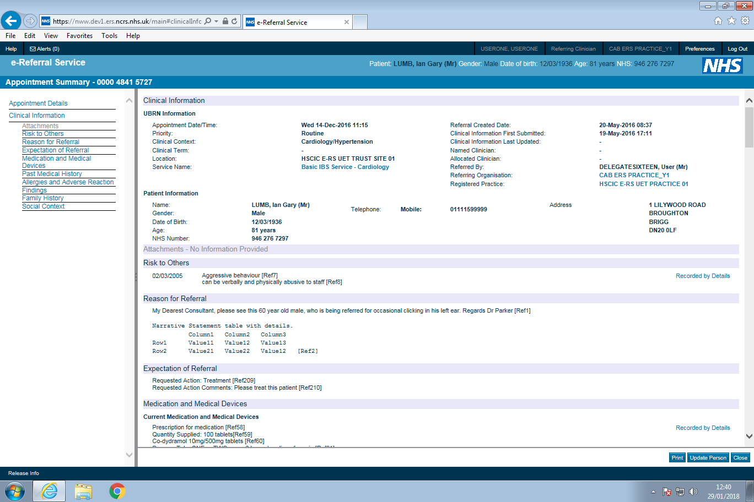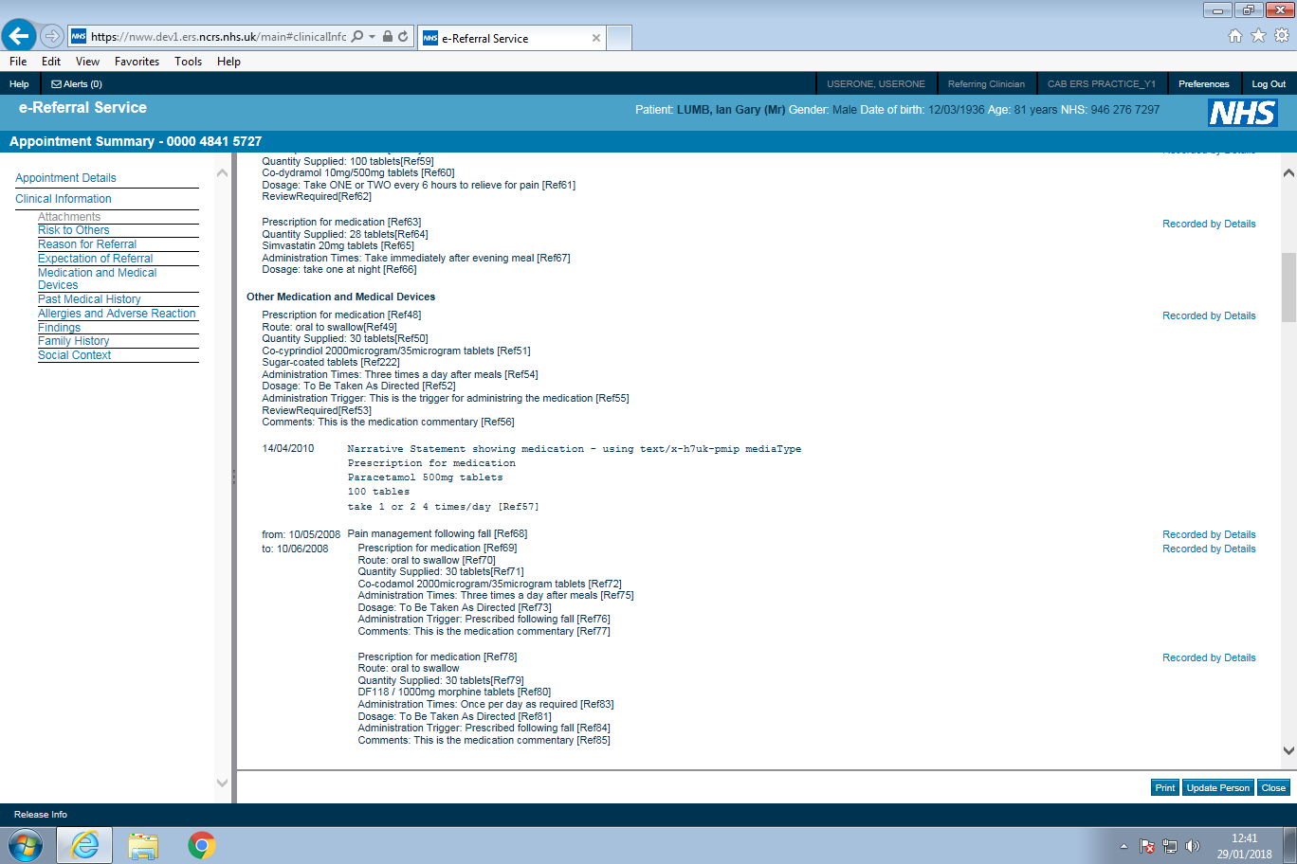
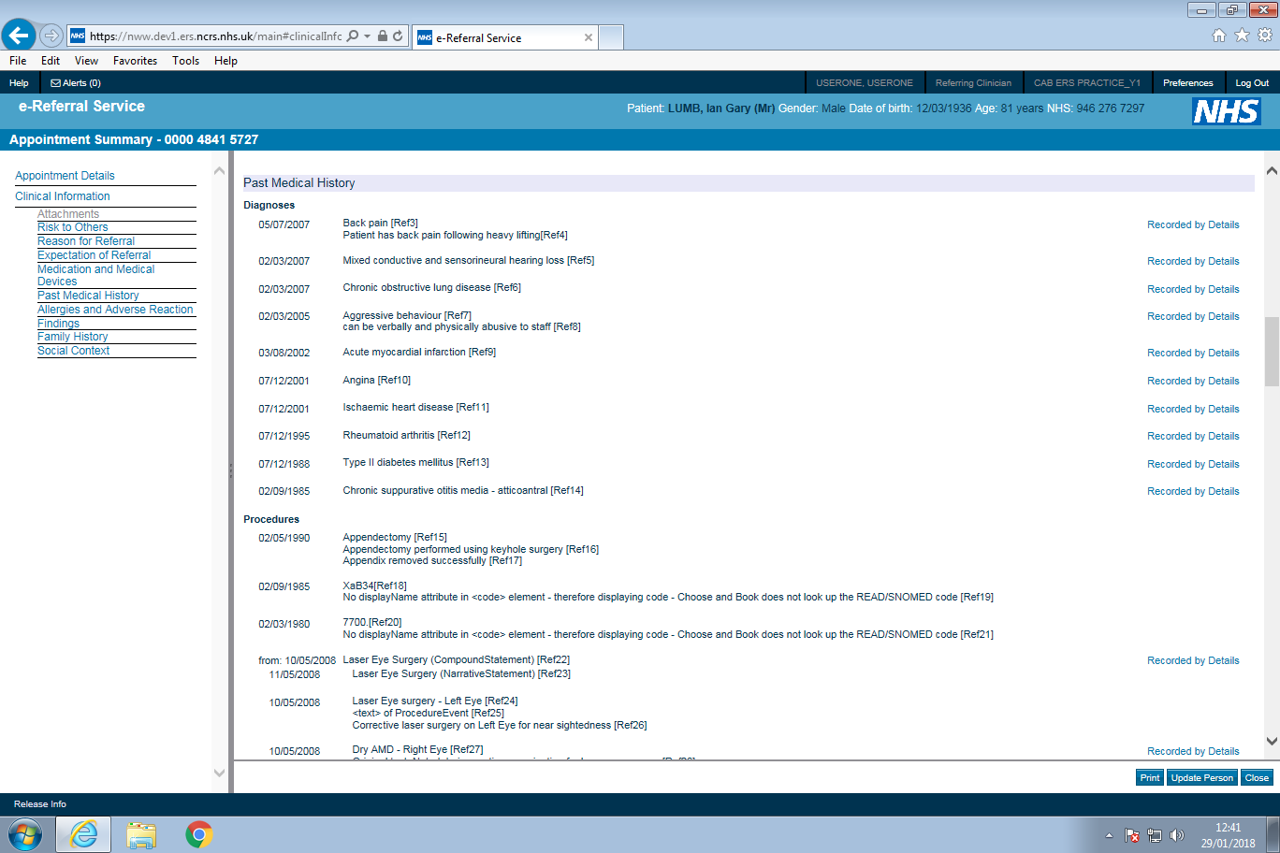
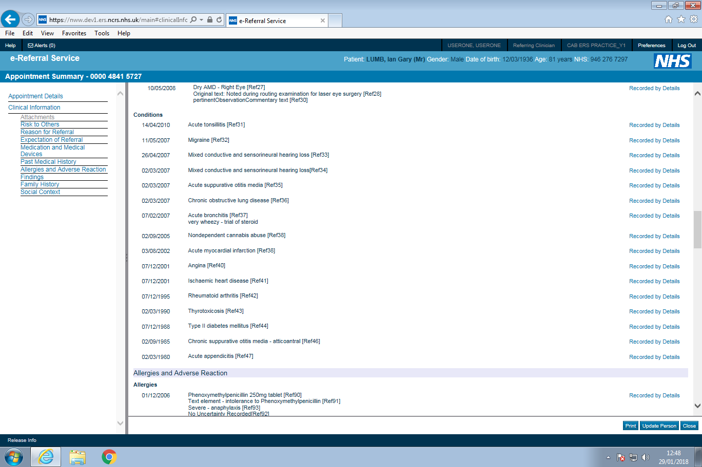
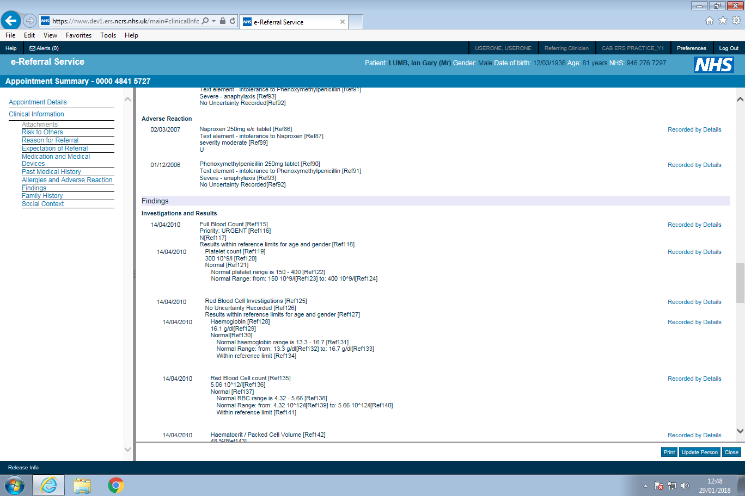
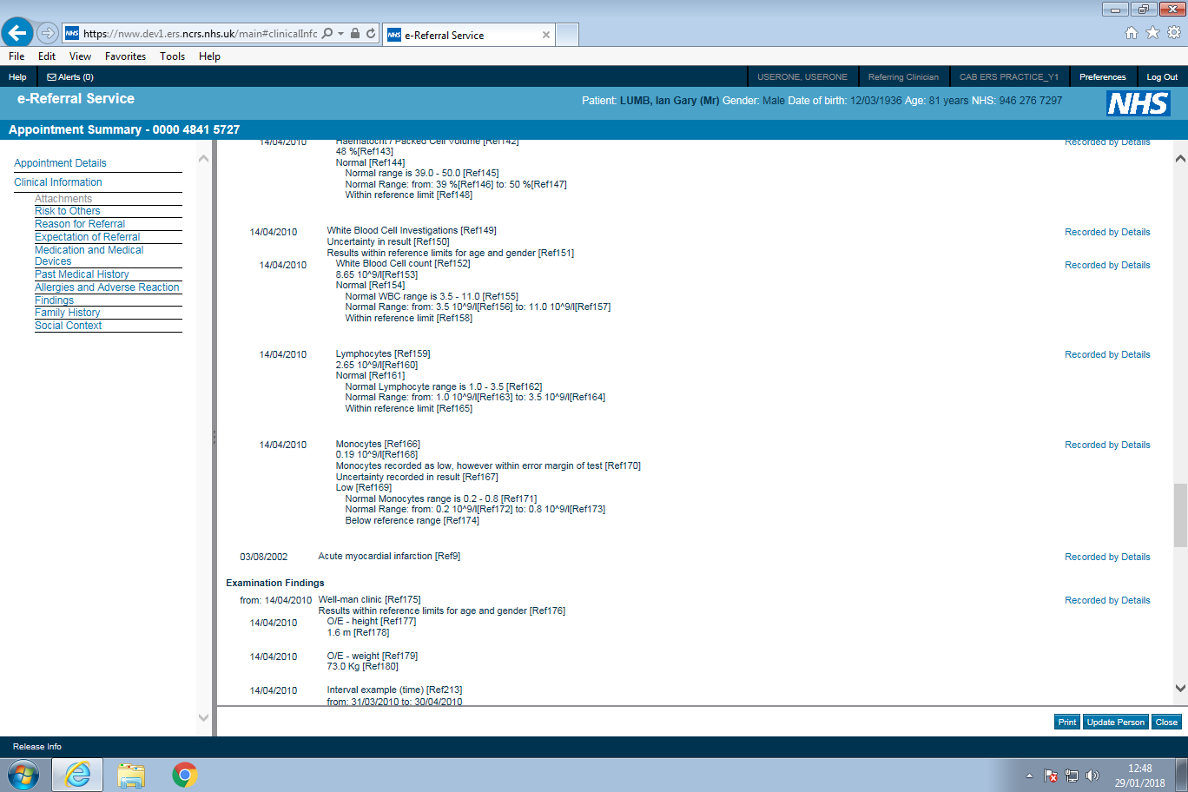
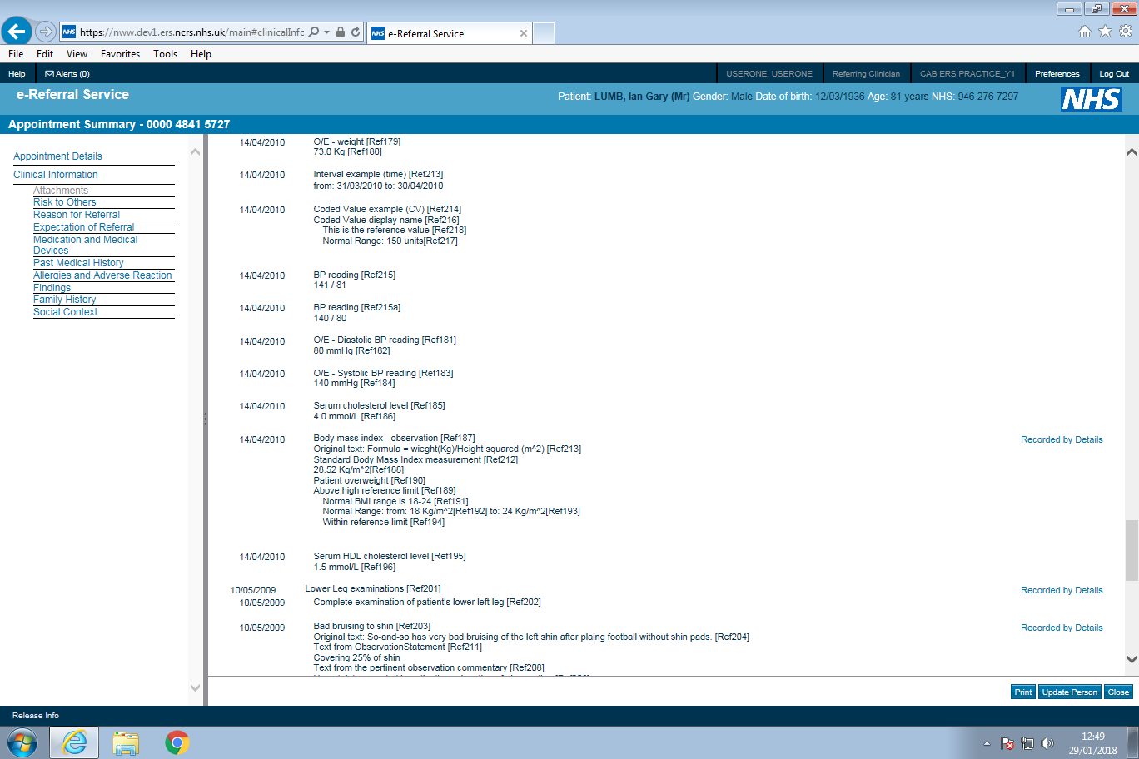
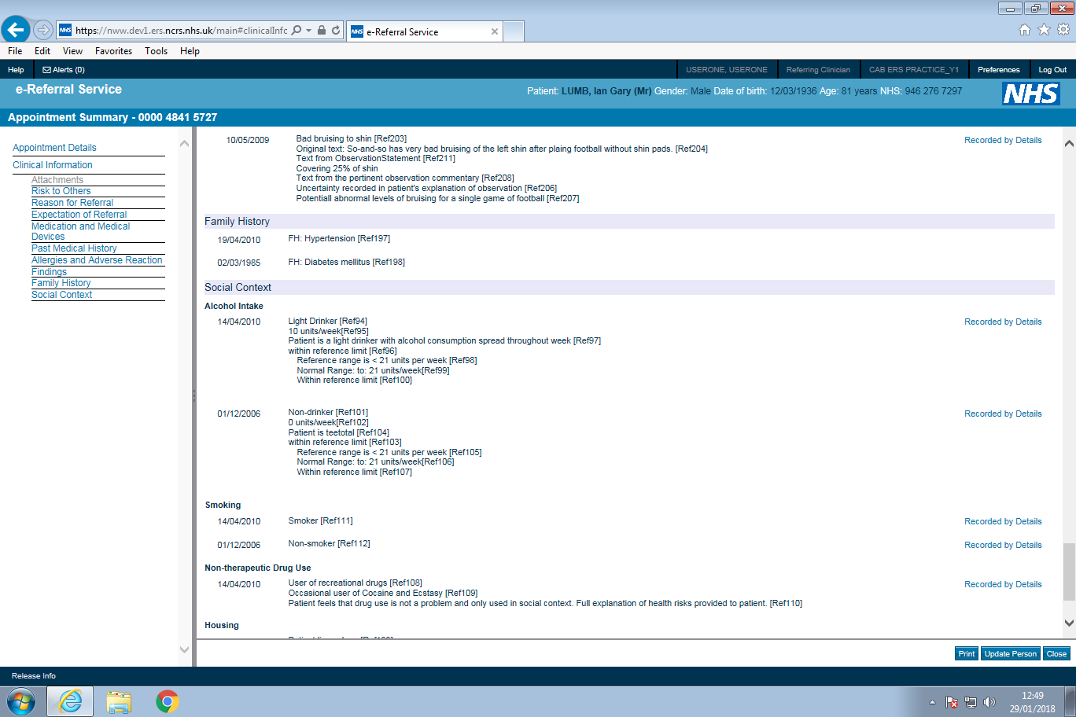
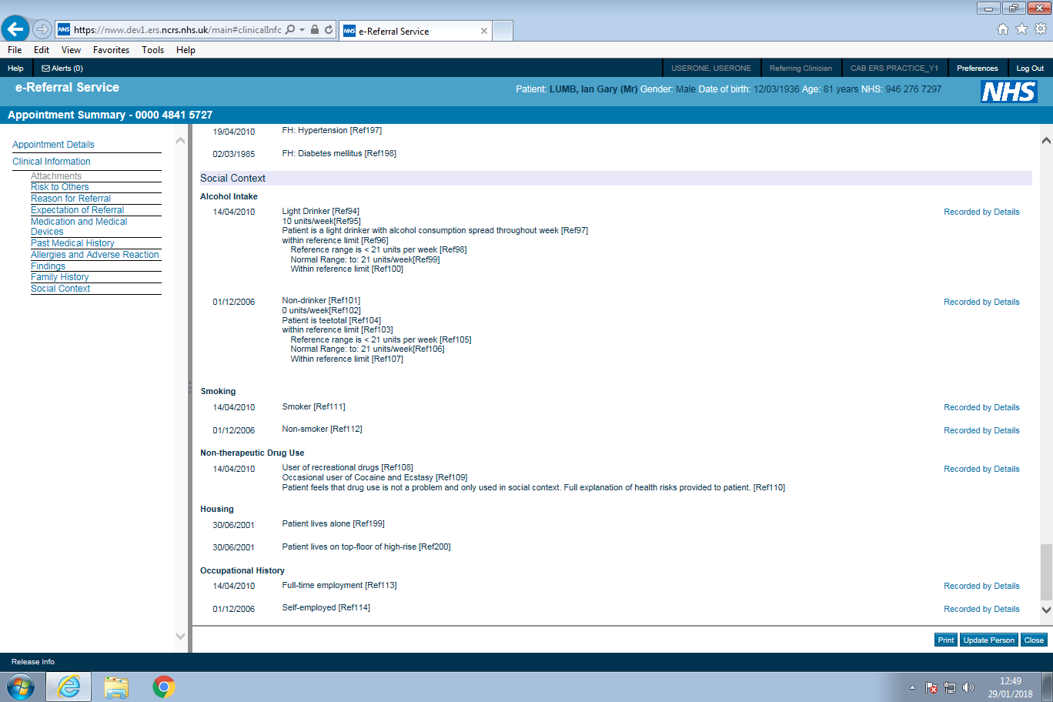

SOAP
Below is an extract of the SOAP interaction highlighting the reference to the attachments in the ebXML Manifest, as well as the MIME parts containing the attachments themselves.
The overall message sent to Spine currently Must be less than 5MB in total (this example the message size is just less than 350KB – as shown by the HTTP Content-Length header).
POST /reliablemessaging/forwardreliable HTTP/1.1
Host: rmmid.nis1.national.ncrs.nhs.uk
SOAPAction: urn:nhs:names:services:ebs/PRPA_IN030000UK08
Content-Length: 346373
Content-Type: multipart/related; boundary="--=_MIME-Boundary"; type="text/xml"; start="<ebXMLHeader@spine.nhs.uk>"
Connection: close

----=_MIME-Boundary
Content-Id: <ebXMLHeader@spine.nhs.uk>
Content-Type: text/xml; charset=UTF-8
Content-Transfer-Encoding: 8bit

<?xml version="1.0" encoding="UTF-8"?>
<SOAP:Envelope xmlns:xsi="http://www.w3c.org/2001/XML-Schema-Instance" xmlns:SOAP="http://schemas.xmlsoap.org/soap/envelope/" xmlns:eb="http://www.oasis-open.org/committees/ebxml-msg/schema/msg-header-2_0.xsd" xmlns:hl7ebxml="urn:hl7-org:transport/ebxml/DSTUv1.0" xmlns:xlink="http://www.w3.org/1999/xlink">
<SOAP:Header>
<eb:MessageHeader SOAP:mustUnderstand="1" eb:version="2.0"><eb:From>
<eb:PartyId eb:type="urn:nhs:names:partyType:ocs+serviceInstance">RHM-801710</eb:PartyId></eb:From>
<eb:To><eb:PartyId eb:type="urn:nhs:names:partyType:ocs+serviceInstance">YEF-802178</eb:PartyId>
</eb:To>
<eb:CPAId>S2019082A2085989</eb:CPAId>
<eb:ConversationId>2CE548B4-6A3C-11DF-B82B-0168CE0FFE07</eb:ConversationId>
<eb:Service>urn:nhs:names:services:ebs</eb:Service>
<eb:Action>PRPA_IN030000UK08</eb:Action>
<eb:MessageData><eb:MessageId>2CE548B4-6A3C-11DF-B82B-0168CE0FFE07</eb:MessageId>
<eb:Timestamp>2010-05-28T10:34:12Z</eb:Timestamp></eb:MessageData>
<eb:DuplicateElimination/></eb:MessageHeader>
<eb:AckRequested SOAP:mustUnderstand="1" eb:version="2.0" eb:signed="false" SOAP:actor="urn:oasis:names:tc:ebxml-msg:actor:nextMSH"/>
</SOAP:Header>
<SOAP:Body>
<eb:Manifest SOAP:mustUnderstand="1" eb:version="2.0">
<eb:Reference xlink:href="cid:2ce548b5-6a3c-11df-b82b-0168ce0ffe07@spine.nhs.uk">
<eb:Schema eb:location="http://www.nhsia.nhs.uk/schemas/HL7-Message.xsd" eb:version="1.0"/>
<eb:Description xml:lang="en">HL7 payload</eb:Description>
<hl7ebxml:Payload style="HL7" encoding="XML" version="3.0"/></eb:Reference>
<eb:Reference xlink:href="cid:2ce792a6-6a3c-11df-b82b-0168ce0ffe07">
<eb:Description xml:lang="en">image.jpeg</eb:Description></eb:Reference>
<eb:Reference xlink:href="cid:2ce792a7-6a3c-11df-b82b-0168ce0ffe07">
<eb:Description xml:lang="en">image.png</eb:Description></eb:Reference>
<eb:Reference xlink:href="cid:2ce792a8-6a3c-11df-b82b-0168ce0ffe07">
<eb:Description xml:lang="en">worddoc.pdf</eb:Description></eb:Reference>
<eb:Reference xlink:href="cid:2ce792a9-6a3c-11df-b82b-0168ce0ffe07">
<eb:Description xml:lang="en">worddoc.doc</eb:Description></eb:Reference> </eb:Manifest></SOAP:Body>
</SOAP:Envelope>

----=_MIME-Boundary
Content-Id: <2ce548b5-6a3c-11df-b82b-0168ce0ffe07@spine.nhs.uk>
Content-Type: application/xml; charset=UTF-8
Content-Transfer-Encoding: 8bit

<PRPA_IN030000UK08… </PRPA_IN030000UK08>

----=_MIME-Boundary
Content-Id: <2ce792a6-6a3c-11df-b82b-0168ce0ffe07>
Content-Type: image/jpeg
Content-Transfer-Encoding: base64

/9j/4AAQSkZJRgABAQEAYABgAAD/2wBDAAgGBgcGBQgHBwcJCQgKDBQNDAsLDBkS……………

----=_MIME-Boundary
Content-Id: <2ce792a7-6a3c-11df-b82b-0168ce0ffe07>
Content-Type: image/png
Content-Transfer-Encoding: base64

iVBORw0KGgoAAAANSUhEUgAAA8AAAASwCAIAAAC7MbSDAAAAAXNSR0IArs4c6QAA………

----=_MIME-Boundary
Content-Id: <2ce792a8-6a3c-11df-b82b-0168ce0ffe07>
Content-Type: application/pdf
Content-Transfer-Encoding: base64

JVBERi0xLjUNCiW1tbW1DQoxIDAgb2JqDQo8PC9UeXBlL0NhdGFsb2cvUGFnZXMg…………

----=_MIME-Boundary
Content-Id: <2ce792a9-6a3c-11df-b82b-0168ce0ffe07>
Content-Type: application/msword
Content-Transfer-Encoding: base64

0M8R4KGxGuEAAAAAAAAAAAAAAAAAAAAAPgADAP7/CQAGAAAAAAAAAAAAAAABAAAA………

----=_MIME-Boundary--

Accepted Attachment File Types
NHS e-RS will accept the following MIME types as attachments. To open and view an attachment, the end user is dependent upon the correct application software on their desktop, for example to view a PDF attachment the end user's desktop must have a suitable version of PDF viewing software. The MIME type rather than the file extension is used to identify the application required to open the attachment.
Code | Name | Definition
text/plain | Plain text | For any plain text. This is the default and is equivalent to a character string (ST) data type.
text/html | HTML Text | Due to the cyber security threat that html files pose, HTML files MUST no longer be available to send from a referring system.
application/pdf | PDF | Recommended for written text that is completely laid out and read-only.
text/xml | XML | Text for structured character based data. Risk that general SGML/XML is too powerful to allow a sharing of general SGML/XML documents between different applications.
text/rtf | RTF | Text RTF does have compatibility problems, as it is quite dependent on the word processor.
audio/basic | Basic Audio | For single channel audio, encoded using 8bit ISDN mu-law [PCM] at a sample rate of 8000 Hz. Standardized by: CCITT, Fascicle III.4 Recommendation G.711. Pulse Code Modulation (PCM) of Voice Frequencies. Geneva, 1972.
audio/mpeg | MPEG | audio layer 3 Audio compression algorithm and file format defined in ISO 11172-3 and ISO 13818-3.
image/png | PNG | Image Portable Network Graphics (PNG) [http://www.w3.org/TR/PNG] is a widely supported lossless image compression standard with open-source code available.
image/gif | GIF | Image Popular format that is universally well supported; however, patent encumbered and should be used with caution.
image/jpeg | JPEG | Image Required for high compression of high color photographs.
image/tiff | TIFF | Image International standard that has many interoperability problems.
video/mpeg | MPEG | Video Highly efficient for high color video; open source code exists; highly interoperable.
application/ms word | MSWORD | This format is very prone to compatibility problems. If sharing of edit-able text is required, text/plain. e-RS will accept .doc and .docx files.

Attachment Requirements
Reqt. ID | Original Reqt ID | Requirement Text | Status
ATT-1 | V4-R28 | Referring systems Must ensure that attachment(s) are identified in the ebXML manifest along with the message payload. Each attachment Must be identified and carried in a separate MIME part. The reference to an attachment Must be a URI that conforms to the Xlink specifications. | Must
ATT-1.1 | REF-7.1.3 | It is possible to send an attachment using 4 different methods, 7bit, 8bit, binary or base64. Depending on which method is used, will depend on the size of the attachments once encoded. Systems should make it clear to users the approx. encoded size of attachments to enable informed choice of what to include. | Should
ATT-2 | REF-7 | Suppliers MUST NOT set a parameterised limit to the size of individual attachments and the total size of all attachments | Must
ATT-2.1 | REF-7.1 | Due to the spine message handler limiting the size of single messages, systems Must check the overall size of the message including all encoded attachments, message elements and wrappers and only send if less than the current allowable limit. | Must
ATT-2.2 |  | Suppliers MUST implement a configurable overall message size that can be easily amended if the SPINE adjusts the message size that it can accept.  Note: this limit is currently set to 5MB but this is likely to be increased | Must
ATT-2.3 | REF-7.1.1 | Suppliers MUST NOT limit attachments sizes to 1MB | Must
ATT-2.4 | REF-7.1.2 | Suppliers MUST NOT limit the number of attachments that can be sent. | Must
ATT-2.5 | REF-7.1.4 | There should be an early check /notification for the user building the referral content where possible based on the combined maximum attachment size that could be sent  e.g. Attachments sent through Base64 encoding, inflates the attachment by approx. one third. Therefore, for message size of 5MB, if no clinical content is sent in the message, the maximum attachment size would be about 3.7MB. | Should
ATT-2.6 |  | Suppliers MUST only allow users to select attachments with an accepted file type that will be accepted by the Spine/e-RS | Must
ATT-3 | REF-7.2 | Suppliers Must validate names given to files (e.g. referral letters/scanned documents) and disallow users from attaching files that have invalid characters in their name, or have a filename length of over 40 characters or have a missing or invalid extension. | Must
ATT-3.1 |  | Suppliers MUST ensure that all files sent to e-RS have unique filenames | MUST

Referral Errors

Requirements
There are a number of reasons why a referral letter sent from a GP system could be rejected. These rejections need to be recorded and flagged to a user for investigation. These errors could indicate a change in the referral status or that it is too close to the appointment to update the clinical information or a system error that needs to be raised with the GP supplier and/or NHS Digital. It is therefore important that the error handling requirements are adhered to in order to ensure the clinical safety of the patients information.

Error Handling Requirements
Reqt. ID | Original Reqt ID | Requirement Text | Status
ERR-1 | V6-R20 | If a negative application acknowledgement is received by the referring system, or no application acknowledgement is received, in response to a Notify Patient Referral, this Must be notified to the relevant clinical or management users in a timely and appropriate manner so that the error can be resolved. | Must
ERR-1.1 |  | If an error is received in the MCCI, the error code and error text Must be logged for investigation/resolution | Must
ERR-1.2 |  | If no ack is received and the administrator determines that the referral letter has been successfully received by NHS e-RS, they Must be able to disregard the error and update their system to indicate that the referral was successfully received | Must
ERR-1.3 |  | If no ack is received and the administrator determines that the referral letter was not successfully received by NHS e-RS, they Must be given the ability to resend the Notify Patient Referral message to NHS e-RS | Must
ERR-1.4 | REF-7.3.1 | If a referral letter message is rejected due to the letter freeze, users Must be directed to contact the hospital directly with updated information. It is not appropriate to try and resend as the letter will continue to get rejected. | Must
ERR-1.5 | REF-7.3.2 | If a referral letter message is rejected due to size of message exceeding 5MB, users Must be given information to understand the error and enable them to amend the size of the message for resend. | Must
ERR-1.6 | REF-7.3.3 | If a referral letter message is rejected because NHS e-Referral Service was unable to process the message (code 99), the user should be presented with the option to resend the letter from the error log. | Should
ERR-1.7 | REF-7.3.4 | If a referral letter message is rejected with an error that the referring system does not recognise, this should be displayed along with the error text to the user for investigation. | Should

Appendix A – Message Error Handling
This appendix contains information about the mechanism used by NHS e-RS to communicate errors to third party systems when processing HL7 messages.
NHS e-RS will support error handling using the message structures provided in MIMv3.1.09. NHS e-RS will notify the sending system of business processing errors using the DetectedIssueEvent class in the Trigger Event Control Act – MCAI_MT040101UKnn.
The "code" attribute will contain an error code, the “displayName” attribute will contain error text, and the “codeSystem” attribute will contain the OID 2.16.840.1.113883.2.1.3.2.4.17.100.

A1. Request Service – PRPA_IN010000UKnn
Errors will be returned in the Confirm Service Request PRPA_IN020000UKnn.
Error | typeCode | code | displayname | Description
Missing NHS Number | AE | 11 | No Patient Specified | NHS e-RS requires an NHS number in order to assign a UBRN
NHS e-RS Failure | AE | 99 | Unable to process message | NHS e-RS failure that contributed to inability to process message

A2. Notify Patient Referral – PRPA_IN030000UKnn
Errors will be returned in the Application Acknowledgement MCCI_IN010000UKnn.
Error | typeCode | code | displayname | Description
Letter Frozen | AE | 07 | Referral letter is frozen | The referral cannot be updated because it has been tagged as frozen by the Service Provider or the appointment date is in the past.
Non-interfaced referral | AE | 08 | Non interfaced referral letter | The referral cannot be updated via the message interface because it was original created in the NHS e-RS
Invalid UBRN | AE | 09 | Invalid UBRN recieved | The Referral.id is missing or not found in the NHS e-RS
NHS e-RS Failure | AE | 14 | Unable to process message
NHS e-RS Failure | AE | 15 | Missing or Invalid UBRN
NHS e-RS Failure | AE | 99 | Unable to process message | NHS e-RS failure that contributed to inability to process message

Appendix B - Referring systems communicating errors to NHS e-RS
This section describes the error texts that a Referring system may send to NHS e-RS. Referring systems Must use the method of including error text specific to the problem encountered in the referring system. Currently, NHS e-RS only logs these error codes and texts for audit and error investigation purposes.

B1. Confirm Service Request - PRPA_IN020000UKnn
The referring system has sent a Request Service interaction to CAB which has returned a Confirm Service interaction, but the referring system cannot process the Confirm Service and sends a negative application acknowledgement.
The error is sent to NHS e-RS in the MCCI_IN010000UK Application Acknowledgement.
Error Code | NHS e-RS meaning | NHS e-RS future behaviour | Example Error Text from Referrer system
E100 | Unspecified data error | TBC
E200 | Unspecified business rule failure | TBC
E300 | Cant process message now | TBC
E400 | Unspecified processing error | TBC
E500 | Unspecified other error | TBC

Appendix C – Contract Properties
Contract properties for NHS e-RS are owned by the NHS e-Referral Service programme. The definitive source of documentation of the contract properties is the SDS, but they are duplicated here for information purposes.

C1. Compliance Version 2 (MiM 3.09.01)
When supporting NHS e-RS MiM3.01.09 the following ebXML contract properties are to be used.
 | IE-R-EBS-S1: Reliable  EBS Short Lived | IE-RM2: Reliable  Medium Lived
RetryInterval (in Seconds) | 2 | 60
Retries | 2 | 2
PersistDuration | PT4M | PT10M
DuplicateElimination | Always | Always
SyncReplyMode | None | None
ackRequested | Always | Always
Actor | nextMSH | nextMSH
IsAuthenticated | Transient | Transient
Intermediary Latency Seconds | 10 | 20
Max End-to-End time | 18 | 260

Request Service
Request Service (PRPA_IN010000UKnn) | IE-R-EBS-S1: Reliable EBS Short Lived
Confirm Service Request (PRPA_IN020000UKnn) | IE-R-EBS-S1: Reliable EBS Short Lived
Application Acknowledgement | IE-R-EBS-S1: Reliable EBS Short Lived

Notify Patient Referral
Notify Patient Referral (PRPA_IN030000UKnn) | IE-RM2: Reliable Medium Lived
Application Acknowledgement | IE-R-EBS-S1: Reliable EBS Short Lived

Appendix D - Notes on Interaction Diagrams
Diagram Notation
The following UML sequence diagram-like notation is used to describe the interactions between the user, Choose and Book, and the Service Provider and Referrer systems.

{unsucessfully booked} | Text within a rectangular box denotes a condition that Must be satisfied before this path is executed.
Reserve slot  for UBRN | Text with an oval shape denotes an activity that occurs at that point.
Application Acknowledgement MCCI - success() | An arrow denotes a message between applications. Application acknowledgement messages show whether they carry a success or failure indication. If failure, see Appendix A for types of failures that NHS e-RS may generate.

A single diagram is used to document each set of interactions that can occur. Each diagram covers all the success and failure paths that can occur. Like in sequence diagrams, time is represented down the side of the diagram and the messages between applications are shown across the page.
It should be noted that NHS e-RS will eventually time-out waiting for a response to a message. When this occurs NHS e-RS will inform the user (assuming a user is waiting for a response) but it takes no other action. If NHS e-RS subsequently receives a response to the message it timed-out on, then it generates a negative Application Acknowledgement.

Appendix E – Referral Letter Components
This appendix describes which components of the Referral Letter are displayed to the NHS e-Referrals user when the letter is viewed in NHS e-Referrals Service.

E1. Component Details
Kind of referral component → |  | Compound statement | Observation | Narrative | Procedure | Medication
Code ↓ | Refer. category header ↓
01 | Problem being referred | Yes | Yes | Yes | - | -
02 | Investigation | Yes | Yes | Yes | - | -
03 | Examination | Yes | Yes | Yes | - | -
04 | Current Medication | Yes |  | Yes | - | Yes
05 | Allergy | Yes | Yes | Yes | - | -
06 | Intolerance | Yes | Yes | Yes | - | -
07 | Risk to Others | Yes | Yes | Yes | - | -
08 | Alcohol consumption | Yes | Yes | Yes | - | -
09 | Smoking habit | Yes | Yes | Yes | - | -
10 | Non therapeutic drug use | Yes | Yes | Yes | - | -
14 | Medication | Yes |  | Yes | - | Yes
11 | Condition | Yes | Yes | Yes | - | -
12 | Diagnoses | Yes | Yes | Yes | - | -
13 | Procedure | Yes | Yes | Yes | Yes | -
15 | Family History | Yes | Yes | Yes | - | -
16 | Housing | Yes | Yes | Yes | - | -
17 | Employment | Yes | Yes | Yes | - | -
- | Religion | Yes | Yes | Yes | - | -
- | Ethnic Origin | Yes | Yes | Yes | - | -
- | Language | Yes | Yes | Yes | - | -
As per section 7.12 of the MIM, this table above shows each referral heading together with which referral components they may contain. Although Religion, Ethnic Origin and Language are displayed in this table, there is no category header code defined in MIM 3.01.09 to send these values.
In the following tables, the Referral Letter, category heading, requested action and each referral component is further broken down to show which fields will be displayed to the user by NHS e-RS.
The information in brackets denotes the “type” of the element. The final column shows which fields will be displayed in NHS e-RS.

E2. Referral Letter Breakdown
The following covers the Referral element and child elements, however in the PRPA_IN03 root section, there is a creationTime element (which is not a child element of the Referral element) and this is displayed with the Label ‘Referral Letter Created:’ <date and time>. See the previous Example Referral Message with attachments for an example of this.
The Referral element is described by the tables in the following sections. The following conventions have been used;
- Object – this column is used to indicate an element within the message which has child element nodes. The actual element name as it would appear in the referral message is used
  - [target] is used where the Object is a choice
- Element – this column is used to indicate child elements of the parent element contained in the Object column
  - The format of the element is as follows – element name (element datatype)
  - Where a child element is not a direct child of the parent element in the Object column the intermediate elements are all shown e.g. intermediaryelement1 (intermediaryelement1 datatype).childelement (childelement datatype)
- Mandatory – specifies whether the schema for the referral message identifies the Element as mandatory. This is relative to the Parent element – e.g. if the parent Element is optional then the child element is only mandatory when the parent element is included in the message.
- Shown in NHS e-RS – this identifies whether the element contains data that is shown in NHS e-RS.
  - Where relevant any attributes of the element that are displayed (as opposed to the text of the element) are identified in this column. An example is the “displayName” attribute of CV and CD datatypes.
  - Where a child element contains the data that is displayed, this element is referred to.

Referral element breakdown
Object | Element | Mandatory | Shown in NHS e-RS | Label in NHS e-RS | Value Expected by NHS e-RS
Referral | id (“II”) | Y | N, used to match the UBRN created from the service request | - | UBRN
 | priorityCode (“CS”) | Y | N – It is the priority code from the service selection that is displayed. | Referral Priority: | 1, 2 or 3
 | subject (“SUBJECT”).patient (“PATIENT”) | Y | See patient below | - | -
 | author (“AUTHOR”).participant (“PARTICIPANT”) | Y | See participant below | - | -
 | component2 (“COMPONENT2”) | Y | At least one component2 element required in the referral message. See component2 below. | - | -
 | component1 (“COMPONENT1”).CategoryHeader (“CATEGORYHEADER”) | Y | At least one component1 element required in the referral message. See CategoryHeader below. | - | -
 | pertinentInformation (“PERTINENTINFORMATION”). pertinentRequestedAction (“REQUESTEDACTION”) | Y | See pertinentRequestedAction below | - | -
patient | id (“II”) | Y | N, used to match the UBRN/NHS Number. If incorrect NHS Number for UBRN, CaB would return an error. | - | NHS Number of the patient
 | patientPerson (“PERSON”) | N | See patientPerson below | N/A | -

Object | Element | Mandatory | Shown in NHS e-RS | Label in NHS e-RS | Value Expected by NHS e-RS
patientPerson | religiousAffiliationCode (“CV”) | N | N | N/A | -
 | ethnicGroupCode (“CV”) | N | N | N/A | -
participant | AgentPersonSDS (“AGENTPERSONSDS”) | Y | See AgentPersonSDS below | - | -
AgentPersonSDS | id (“II”) | Y | N – the details of the referring clinician from the service request are displayed | N/A | SDS Role Profile ID of Referring Clinician who made the service request
 | agentPersonSDS (“PERSONSDS”) | Y | See agentPersonSDS below | - | -
agentPersonSDS | id (“II”) | Y | N – the details of the referring clinician from the service request are displayed | N/A | SDS User ID of Referring Clinician who made the service request
component2 | CompoundStatement (“COMPOUNDSTATEMENT”) | Y – one of either compound, observation, medication, procedure or narrative Must be included. | See Section 5.4 Compound Statement breakdown Below | - | -
 | ObservationStatement (“OBSERVATIONSTATEMENT”) |  | See Section 5.5 Observation Statement breakdown Below | - | -
 | Medication (“MEDICATION”) |  | See Section 5.6 Medication breakdown Below | - | -
 | ProcedureEvent (“PROCEDUREEVENT”) |  | See Section 5.7 Procedure Event breakdown Below | - | -
 | NarrativeStatement (“NARRATIVESTATEMENT”) |  | See Section 5.8 Narrative Statement breakdown Below | - | -

Object | Element | Mandatory | Shown in NHS e-RS | Label in NHS e-RS | Value Expected by NHS e-RS
CategoryHeader | id (“II”) | Y | N | N/A | -
 | code (“CS”) | Y | N - Not displayed in Choose and Book, but identifies the header under which the referral components indicated by each component.actRef will be displayed. | N/A | 01 – 17 as defined in the MIM
 | component (“COMPONENT”) | Y | One or more component elements Must be present within the categoryHeader. See component below | - | -
component | actRef (“ACTREF”) | Y | See actRef below | - | -
actRef | id (“II”) | Y | N – this id matches the id of one of the referral components. See sections 5.4, 5.5, 5.6, 5.7, & 5.8 below | N/A | -
pertinentRequestedAction | code (“CV”) | Y | Y – displayName attribute | Requested Action: | 01-05, 99 plus description in displayName attribute as defined in the MiM
 | text (“ST”) | N | Y | Requested Action Comments:

Compound Statement breakdown
A compound statement groups together items that have a logical connection. For this to display in NHS e-RS in a readable format, it is recommended that compound statements are not embedded more than 3 levels.
Only use a compound statement where needed, like grouping a number of details under a topic i.e. Blood pressure results, pathology results like liver function tests.
It is not mandatory that a message includes compound statements but the mandatory column below indicates the fields that are mandatory within a compound statement if included.
Object | Element | Mandatory | Shown in NHS e-RS | Label in NHS e-RS | Value Expected by NHS e-RS
CompoundStatement | id (“II”) | Y | N | N/A | This id is referred to from within the categoryHeader.component.actRef
 | code (“CD”) | Y | Y – displayName attribute | - | -
 | statusCode (“CS”) | Y | N | N/A | As per MIM
 | effectiveTime (“IVL<TS>”) | N | Y – to the left of the code displayName attribute | - | The clinically relevant date and time.
 | activityTime (“IVL<TS>”) | N | Y – within the ‘Recorded by Details’ reveal. | Dependent upon the linked Category Header | Time when the observations or actions actually took place.
 | availabilityTime (“TS”) | Y | N | N/A | -
 | priorityCode (“CV”) | N | Y - displayName attribute | Priority:
 | uncertaintyCode (“CS”) | N | Y - displayName attribute | - | As per MIM (see footnote)
 | interpretationCode (“CV”) | N | Y – displayName attribute | - | -
 | component (“COMPONENT”) | Y | At least one component element required in the referral message. See component below. | - | -
component | CompoundStatement (“COMPOUNDSTATEMENT”) | Y – one of either compound, observation, medication, procedure or narrative Must be included. | See Section 5.4 Compound Statement breakdown Below | - | -
 | ObservationStatement (“OBSERVATIONSTATEMENT”) |  | See Section 5.5 Observation Statement breakdown Below | - | -
 | Medication (“MEDICATION”) |  | See Section 5.6 Medication breakdown Below | - | -
 | ProcedureEvent (“PROCEDUREEVENT”) |  | See Section 5.7 Procedure Event breakdown Below | - | -
 | NarrativeStatement (“NARRATIVESTATEMENT”) |  | See Section 5.8 Narrative Statement breakdown Below | - | -

Observation Statement breakdown
When sending an observation, only send coded values using the ‘Coded values with Original Text’ format where the original text differs from the description. Where the description and original text is the same, send as Coded Plain.
It is not mandatory that a message includes observation statements but the mandatory column below indicates the fields that are mandatory within an observation statement if included.
Object | Element | Mandatory | Shown in NHS e-RS | Label in NHS e-RS | Value Expected by NHS e-RS
ObservationStatement | id (“II”) | Y | N | N/A | This id is referred to from within the categoryHeader.component.actRef
 | code (“CD”) | Y | Y – displayName attribute | -
 | code(“CD”).originalText(“ST”) | N | Y | Original text:
 | text (“ST”) | N | Y | -
 | effectiveTime (“TS”) | N | Y | - | Clinically relevant Date
 | activityTime (“IVL<TS>”) | N | Y – within the ‘Recorded by Details’ reveal. | Y – Dependent upon the linked Category Header | Time when the observations or actions actually took place.
 | uncertaintyCode (“CS”) | N | Y - displayName attribute2 | - | As per MIM (see footnote)
 | value (“ANY”) | N | Y | - | Types supported by CaB are ST, PQ, IVL_TS, RTO_QTY_QTY and CV
 | interpretationCode (“CV”) | N | Y - displayName attribute | -
 | pertinentInformation (“PERTINENTINFORMATION”) | N | Y | See pertinentInfo rmation below
 | referenceRange (“REFERENCERANGE”) | N | Y | See referenceRan ge below
pertinentInformation | pertinentObservationCommentary (“OBSERVATIONCOMMENTARY”) | N | Y | See pertinentObs ervationCommentary below
pertinentObservationCommentary | text (“ST”) | N | Y | -
referenceRange | referenceNormalRange (“NORMALRANGE”) | N | Y | See referenceNor malRange below
referenceNormalRange | text (“ED”) | N | Y | - | Choose and Book will only accept “Plain Text” datatype for this element.  “Text and Line Breaks”, “Limited HTML”, “Attachment Reference” and “Attachment” are not supported for this element.
 | value (“IVL_PQ”) | N | Y | See value below
 | interpretationCode (“CV”) | N | Y | -
value | low | N | Y | from:
 | high | N | Y | to:
 | center | N | Y | Normal Range:
 | width | N | N | N/A | When center & width are sent, NHS e-RS will only display the center value

Medication breakdown
Object | Element | Mandatory | Shown in NHS e-RS | Label in NHS e-RS | Value Expected by NHS e-RS
Medication | Id (“II”) | Y | N | N/A | This id is referred to from within the categoryHeader.component.actRef
 | code (“CV”) | Y | Y - displayName attribute | - | As per MedicationActType defined in MIM
 | effectiveTime (“IVL<TS>”) | N | Y – within the ‘Recorded by Details’ reveal. | Treatment Date: | Date/time or period of intended or actual treatment
 | activityTime (“TS”) | N | Y – within the ‘Recorded by Details’ reveal. | Prescription Date: | The date of prescription of the medication
 | routeCode (“CE”) | N | Y | Route:
 | doseQuantity (“PQ”) | N | Y | Quantity Supplied:
 | maxDoseQuantity (“PQ”) | N | N | N/A
 | consumable (“CONSUMABLE”) | Y | Y | See consumable below
 | component (“COMPONENT”) | N | N | N/A
 | pertinentInformation2 (“PERTINENTINFORMATION2”) | N | Y | See pertinentInfo rmation2 below
 | pertinentInformation4 (“PERTINENTINFORMATION4”) | N | Y | See pertinentInfo rmation4 below
 | pertinentInformation1 (“PERTINENTINFORMATION1”) | N | Y | See pertinentInfo rmation1 below
 | pertinentInformation3 (“PERTINENTINFORMATION3”) | N | Y | See pertinentInfo rmation3 below
 | pertinentInformation5 (“PERTINENTINFORMATION5”) | N | Y | See pertinentInfo rmation5 below
consumable | medicine (“MEDICINE”) | Y | Y | See medicine below
medicine | manufacturedSubstance (“SUBSTANCE”) | Y | Y | See manufacture dSubstance below
manufacturedSubstance | code (“CE”) | Y | Y - displayName attribute | -
 | quantity (“PQ”) | N | N | N/A
 | name (“ST”) | Y | N | N/A
 | formCode (“CE”) | N | Y - displayName attribute | -
pertinentInformation2 | pertinentMedicationDosage (“MEDICATIONDOSAGE”) | N |  | See pertinentMe dicationDosage below
pertinentMedicationDosage | text (“ST”) | N | Y | Dosage:
pertinentInformation4 | pertinentMedicationReviewReq (“MEDICATIONREVIEWREQ”) | N | Y | See pertinentMe dicationReviewReq below
pertinentMedicationReviewReq | code (“CS”) | N | Y (when value (see below) = true)  – code attribute | -
 | value (“BL”) | N | N | N/A | true or false – determines whether code (see above) is displayed
pertinentInformation1 | pertinentMedicationTiming (“MEDICATIONTIMING”) | N | Y | See pertinentMe dicationTiming below
pertinentMedicationTiming | text (“ST”) | N | Y | Administration Times:
pertinentInformation3 | pertinentMedicationAdminTrigger (“MEDICATIONADMINTRIGGER”) | N | Y | See pertinentMe dicationAdminTrigger below
pertinentMedicationAdminTrigger | text (“ST”) | N | Y | Administration Trigger:
pertinentInformation5 | pertinentMedicationCommentary (“MEDICATIONCOMMENTARY”) | N | Y | See pertinentMe dicationCommentary below
pertinentMedicationCommentary | text (“ST”) | N | Y | Comments:

Procedure Event breakdown
Object | Element | Mandatory | Shown in NHS e-RS | Label in NHS e-RS | Value Expected by NHS e-RS
ProcedureEvent | id (“II”) | Y | N | N/A | This id is referred to from within the categoryHeader.component.actRef
 | code (“CD”) | Y | Y - displayName attribute | -
 | text (“ST”) | N | Y | -
 | effectiveTime (“TS”) | N | Y | - | Clinically relevant Date
 | pertinentInformation (“PERTINENTINFORMATION”) | N | Y | See pertinentInfo rmation below
pertinentInformation | pertinentProcedureCommentary (“PROCEDURECOMMENTARY”) | N | Y | See pertinentPro cedureCommentary below
pertinentProcedureCommentary | text (“ST”) | N | Y | - | Additional comments about a procedure.

Narrative Statement breakdown
Object | Element | Mandatory | Shown in NHS e-RS | Label in NHS e-RS | Value Expected by NHS e-RS
NarrativeStatement | id (“II”) | Y | N | N/A | This id is referred to from within the categoryHeader.component.actRef
 | text (“ED”) | Y | Y | - | NHS e-RS will accept “Plain Text” or “Text and Line Breaks” datatypes.  “Limited HTML”, “Attachment Reference” and “Attachment” are not supported
 | statusCode (“CS”) | Y | N | N/A | The code attribute shall be set to "completed”
 | availabilityTime (“TS”) | N | Y | -

This id should refer only to top-level referral components (direct child elements of the component2 element). Lower-level referral components held within a CompoundStatement should not be referenced, as this will result in information being duplicated on the referral letter display.
Although uncertaintyCode is a CS datatype, the vocabulary defined in the MIM (U or N) will mean nothing to the end user. Choose and Book will look for a displayName attribute if the uncertaintyCode is included. Suppliers MUST add a displayName to provide a clinically relevant description of the uncertainty. Whilst from a technical perspective, this will result in a message that is not schematically complianct, it will be successfully processed by Choose and Book.
To send a quantity with no units displayed (e.g. apgar score) construct as “quantity in arbitrary units”, with a blank value for the “originalText” element.
When sending a datatype of RTO_QTY_QTY the unit attribute of the numerator and denominator should be present but have no value e.g. unit=””.
A use of text which explicitly includes use of fixed font, maintained white space and hard line breaks. Designed to meet the need for compatibility with UK NHS PMIP tabular text formats. All TAB characters should be converted to the requisite number of spaces in this format. HTML special characters (e.g. < > &) are not supported.

