Solution Assurance Approach - GPDPR
GP Data for Planning and Research

23 September 2021

Document filename: | Solution Assurance Document
Project / Programme | GP Data for Planning and Research
Status | Final | Version | 1.0
Author | Mandy Panesar | Version issue date | 23/09/2021

Contents
Contents
2. Overview 4
3. Solution Assurance Output Report 5
a. Test Artefacts 5
b. Test Plans 7
i. Integration Testing 7
ii. Functional Testing 7
iii. Static Content Testing 8
iv. Appointments Testing 8
v. Data Minimisation Testing 9
4. Static Content and Appointments Testing Strategy 10
a. Overview 10
b. Approach 10
i. Static Content Testing 11
ii. Appointments Testing 12
iii. Test Data Principles 12
iv. Test Data Outline 13
v. Annotated Technical Output Specification 14
vi. Differencing/Regression/Techniques 14
vii. Jira Logging 16
5. Appendix A 18

Overview
GP Data for Planning and Research (GPDPR) establishes a new technical approach for the extraction, transfer, and controlled utilisation of GP data for secondary uses.
The GPDPR supplier requirements pack specifies the functional and non-functional requirements to be met by clinical systems suppliers. It details the data feeds required to be developed to meet the GPDPR Capability.
In summary, the data feeds and reporting required for GPDPR are as follows:
- Patient Feed –a de-identified extract of patient records meeting the GPDPR schema. There are two kinds of patient feed, both of which need to be delivered daily for each GP practice serviced by the supplier:
  - Patient Delta Feed: The full patient record for any patient where the patient record has undergone a change
  - Patient Reconciliation Feed: The full patient record for a percentage of the remaining unchanged patients in each practice
- Appointment Feed – is an extract of appointment data meeting the GPDPR schema, with de-identified patient linkage where applicable. There are two kinds of appointment feed:
  - Appointment snapshot feed: The initial appointment extract for a practice will be the snapshot, and will contain all appointments
  - Appointment delta feed: All subsequent extracts for a practice will contain the appointment details for new and changed appointments
- Extract Report File – Also referred to as the “End of Submission Report”, this is a daily report per feed which shows expected vs. actual submissions for the GPDPR feeds

This Solution Assurance Approach document describes how NHS Digital (NHSD) will evaluate supplier solutions against the GPDPR supplier requirements pack and record assurance outcomes in the Solution Assurance Output Report (see Appendix A for template).
Note that assurance activity conducted with NHSD is supplemental to internal testing carried out by the GP System Supplier (GPSS).

Solution Assurance Output Report
Assurance will be performed by a combination of functional and integration testing alongside provision of self-certification evidence. The Solution Assurance Output Report is a formal assurance document that will be maintained by NHSD during the solution assurance process. Once assurance has been completed, NHSD will issue the completed document to the supplier.
A template for the Solution Assurance Output Report has been embedded in Appendix A of this document. It consists of the following worksheets, each of which covers one or more facets of the overall assurance process:

- Test Artefacts:
- Risk Assessment (RA)
- Requirements Traceability Matrix (RTM)
- Test Plans:
- Integration Testing
- Functional Testing
  - Reconciliation Test Cases
  - Delta Test Cases
- Static Content Test Cases
- Appointments Test Cases
- Data Minimisation Test cases

NHSD can be flexible to individual supplier solutions, and test plans can be modified to support variation in the methods suppliers may use to meet the requirements. Suppliers are to inform the NHSD Solution Assurance team during the development and assurance process to agree any tailoring that may be necessary.
Note: Suppliers providing both Patient and Appointment Feeds will be required to complete all the assurance activities, whereas suppliers only providing the Appointments Feeds will perform the assurance activities required for the Appointments Feeds only.

Test Artefacts
The test artefacts worksheets are used to record the overall status of supplier assurance activity. The criteria for assurance are based on a matrix of risk-based assurance alongside assurance of the itemised requirements.
In each of the test artefact worksheets, the Supplier Evidence column has been highlighted in purple. Where appropriate, the supplier will be required to provide documentary evidence of their conformance. This may consist of self-certification statements or reference to supporting documents (e.g. test reports).
NHSD will capture any additional information supporting the test outcomes in the assurance notes column.

- Risk Assessment (RA)
The risk assessment forms the basis of the risk-based approach which enables assurance effort to focus on high impact, complex and known problem areas. Assurance methods are influenced by the severity of the identified risks, with high-risk areas requiring more involved assurance.
The following areas have been identified as high delivery risk areas of the solution and will therefore form the basis and driver for key testing and assurance areas:
- GPSS Data Extraction, which includes the upholding of patient objections and adherence to the schema.
- De-Identification of Data, and the supplier implementation of Privitar, with the subsequent tokenisation and re-id stages on the Data Processing Service (DPS) side
- Data transfer to NHSD, which will include the suppliers use of MESH or secure cloud to cloud as the data transfer mechanism.
- Data submission to NHSD, schema validation and acknowledgements.
Content:
- An overall risk score has been calculated for each risk identified and categorising them into high, medium, and low RAG status.
- The RAG status classifies the type of assurance to be performed:
  - Low (Green) – Supplier will provide a statement of self-certification.
  - High (red) and medium (amber) – Both NHSD and the Supplier will perform the assurance activities outlined in Column “K” of the test report (Risk Assessment worksheet).
- Evidence provided by the GPSS during the assurance process will be included in the SUPPLIER EVIDENCE column “O” of the worksheet by NHSD. This information must be reflective of the expected evidence (as outlined in EVIDENCE column “K”)
- During the assurance process, NHSD Solution Assurance Team will update the RISK TEST STATUS column “N” to reflect the assurance status of each risk.

- Requirements Traceability Matrix (RTM)
The RTM lists all the supplier requirements from the GPDPR supplier specification pack v1.5, where possible mapped to the risk IDs from the risk assessment document.
During the assurance process, NHSD Solution Assurance Team will document the results of assurance activities for each requirement.

Content:
- The supplier will be required to provide supporting assurance output documents outlined in column “F” and update column “G” with supporting evidence.
- Assurance notes will be captured by NHSD in Column “J”.
- On completion and approval of the assurance activities, NHSD will mark the REQ TEST STATUS column “I” as Pass.

Test Plans
GPDPR test plans are documented sets of pre-requisites, inputs and expected results which the NHSD Solution Assurance lead will use to determine whether the system under test meets the requirements. All assurance work will be carried out collaboratively with the supplier.
For static content testing, the supplier will create patient records in the test environment that allows NHSD assurance to validate the content found in the cross-cutting concerns worksheet. The output files will be emailed to NHSD by the GPSS only if they are using the secure cloud to cloud (S3 bucket) transfer method.

Integration Testing
Integration testing will be conducted between the GPSS and NHSD to demonstrate that the chosen file transfer mechanism (i.e. MESH or secure cloud to cloud) is working as designed. It covers the following:

- Schema Validation
- Acknowledgment processing

Content:

- On completion and approval of the assurance activities, NHSD will mark the INTEGRATION STATUS column “H” as Pass for completion.

Functional Testing
The functional tests will cover the following functional areas of the supplier system:

- Patient Inclusion
- Patient Delta Feed
- Patient Reconciliation feed
- Practice moves / closures
- Appointment snapshot
- Appointment Delta
- Patient objections
- Cut-off times
- Exclusions
- Configurable requirements
- Pseudonymisation
- End of Day messages

Content:

- These tests will be executed over several days to validate the test scenarios across the various data feed types.
- On completion and approval of the assurance activities, NHSD will mark the FUNCTIONAL TEST STATUS Column “H” as Pass.

Reconciliation and Delta Testing

  - Reconciliation Test Cases
- The reconciliation feed is the full patient record for a percentage of the unchanged Patients in the Practice. The test scenarios will check that appropriate patients are included in the reconciliation feed.

    - The testing is planned to be conducted over a period of 5 days. Test scenarios will be grouped together over this period.

    - On completion and approval of the assurance activities, NHSD will mark the FUNCTIONAL TEST STATUS Column “L” as Pass.

  - Delta Test Cases
- The delta feed is the full patient record for every Patient in the Practice that has undergone any change.

- The testing is planned to be conducted over 3-5 days. Test scenarios will be grouped together over this period.

- On completion and approval of the assurance activities, NHSD will mark the FUNCTIONAL TEST STATUS Column “K” as Pass.

Static Content Testing
Static Content Testing will test that the mapping from the supplier’s clinical system into the GPDPR schema has been carried out correctly. See Section 3 for further details.

Appointments Testing
The Appointment Testing is designed to provide assurance that the supplier solution generates appropriate data for the Snapshot and Delta appointment feeds. See Section 3 for further details.

Data Minimisation Testing
Test cases and assurance for the data minimisation elements of GPDPR. The tests that will be carried out are as follows:

- 10 Year Cap
  - The test cases specified in the test report workbook are to ensure the 10-year limit has been correctly applied to medications and referrals.

- Configurability of 10-year Cap
  - GPSS to provide evidence that the cap period for medications and referrals is configurable

- SNOMED CT Exclusions
  - Event Exclusions
  - Problem Exclusions

Static Content and Appointments Testing Strategy

Overview

GPDPR Static Content and Appointment testing is the primary means by which assurance that the content of GPDPR extracts is being correctly generated from source patient records/Appointments book.
This assurance activity is independent from but complementary to other elements of the overall GPDPR Assurance. GPDPR Functional and Integration test looks at assuring other aspects of the solution such as the operation of the reconciliation feed, delta triggering, file transmission and naming conventions etc.
This section provides an overview of Static Content and Appointment testing in terms of process and approach.

Approach

The diagram below illustrates the approach on how the assurance activities will be conducted.
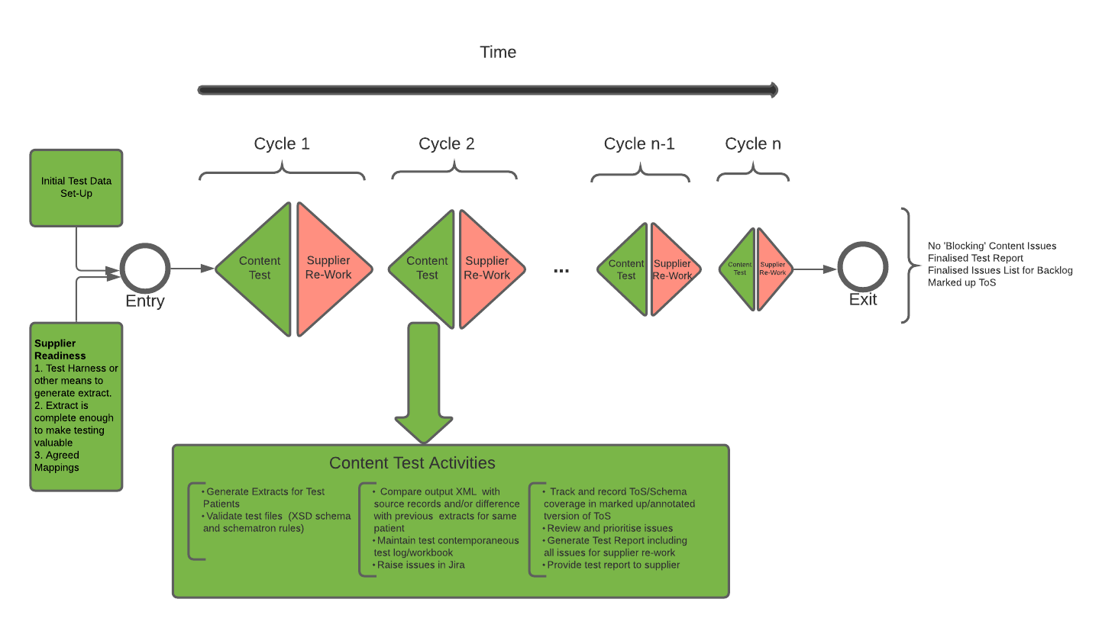

Static Content Testing

An agreed (or at least reviewed) supplier mapping (Technical Output Specification) document is the strongly preferred starting point for static content and appointment testing and subsequent prioritisation.
The supplier mapping exercise itself may identify system or other design changes which are required for GPDPR delivery and are added to the Supplier Backlog.
It is recognised there are some core/central aspects that GPDPR must get correct e.g., codes, dates, attribution but there are also optional attributes/qualifiers in areas where there is little standardisation or commonality between systems e.g., referrals. In these cases, the degree of standardisation offered by the GPDPR extract is a stretching target across all systems and the absence of an attribute may be allowable if for example population of the attribute is difficult or imperfect adding little value to the extract as a whole.

The test approach is an empirical black box testing model.
- Test data in the form of a number of test patient records is constructed (or curated from pre-existing sources) that provides maximal coverage of system content types and variations.
- Patient extracts generated from test are then visually compared against the source records in the system assessing correctness against schema and TOS, looking for missing information that would be expected to be present and looking for information that is present but should not be.

The approach follows an approach that has been used to assure other complex clinically rich data extracts such as GP2GP and GP Connect.
The basis of this approach is that.
- Test data needs to reflect the breadth and complexity of the information structure in the source patient record otherwise there is no basis for confidence that the extract can correctly handle the breadth of information found in real patient records in the live versions of these systems.
- By information structure we mean the way the clinical record is organised and linked so the categories of content seen by the user i.e., how the patient record is broken down into content types like medications, allergies etc …, how that information is grouped and organised e.g., consultations and problems, how information is coded on systems e.g., use of local code systems and how information is attributed to users.
- This information structure is related to but not generally the same as the physical data model, database schema of a supplier (system even if all suppliers were willing to share these models).
- The test data set up (and subsequent testing) is informed by rather than constrained or limited by supplier supplied mapping information as these products are often incomplete, subject to change and do not adequately cover negative test scenarios.
- Without access to supplier source code, it is impossible to determine the degree to which extract functionality is common across all content e.g., is there single logic for date formatting or are there multiple instances in the codebase.
- This information structure is different between systems and specific to the system under test.
Externally created test data cannot replicate the breadth and complexity of the source system records, even ignoring the discrepancies generated by attempting to load such externally generated data into test systems.

Appointments Testing

- For Appointments testing, initially the supplier should provide an annotated Technical Output Specification, detailing their mappings, and associated logic, expected values and highlight any gaps.
- This will then be used by NHSD to firstly review and comment and secondly to document which fields of the extract have been checked and their status (passed/failed).
- The supplier will be expected to replicate the Appointments feed as it will behave in live. Therefore, it will be necessary to run initially the ‘Snapshot’ evidencing the future booked and scheduled state has been provided. The supplier will then on the subsequent days provide the appointment ‘Delta’. Appointments included in the initial ‘Snapshot’ will have their properties or status changed and new appointments will be created to test the behaviour of the ‘Delta’ feed.

Test Data Principles

- The aim is for maximal ‘practical’ coverage of test records. There is clearly a combinatorial explosion arising from attempting to re-create all possible permutations of data (dates, codes, attribution) across all content types.

- It is however possible with around 5 days effort create adequate test records for GPDPR test purposes across a relatively small number of test records e.g., 10 patients/Appointments.

- There is a trade-off between number of records to be tested and record size/complexity – clearly most test cases could be accommodated in a single large test record, but it would be very onerous and potentially confusing to check such a patient record against its corresponding extract, hence it is better to break the record content down against 5-10 core test records organised logically by content type e.g., one for medications, one for problems etc.

- Using test records of this size and complexity is generally possible to complete a round of content testing in approximately 5 days but possibly longer in the early stages where more issues may be found/require investigation etc.

- Initial checking is by visual comparison between extract and source patient records/Appointments. As testing progresses to a more stable foundation, testing transitions to a regression model utilising differencing techniques where new extract XML is compared against extract XML from previous test rounds as a baseline. This is far quicker than ‘eyeballing’ extracts where little may have changed. The same differencing techniques may be used for future regression testing but improved by automation.

- There are some major elements of content that cannot be created manually but need to be evidenced in testing – specifically records generated from GP2GP imports, record content derived from pathology messaging and the need to simulate some fields that are hard to generated on non-spine connected test systems (medication EPS Id, referral e-RS UBRN).

- For appointments: There are some major elements of content that cannot be created manually but need to be evidenced in testing; specifically, appointments that are booked via GP Connect or Online and external organisation or patient bookings. These will be handled on a case-by-case basis and may be determined by the supplier’s test environment. In these cases, self-certification may be necessary from the supplier and evidence of the code logic.

- Unless related to one of the externally sourced data types like GP2GP, pathology GPDPR Data test data is largely created by hand in the same way a user of the system would do it. This maximises realism and avoids the compromises inevitably associated with imported data from external sources e.g., affects attribution.

Test Data Outline

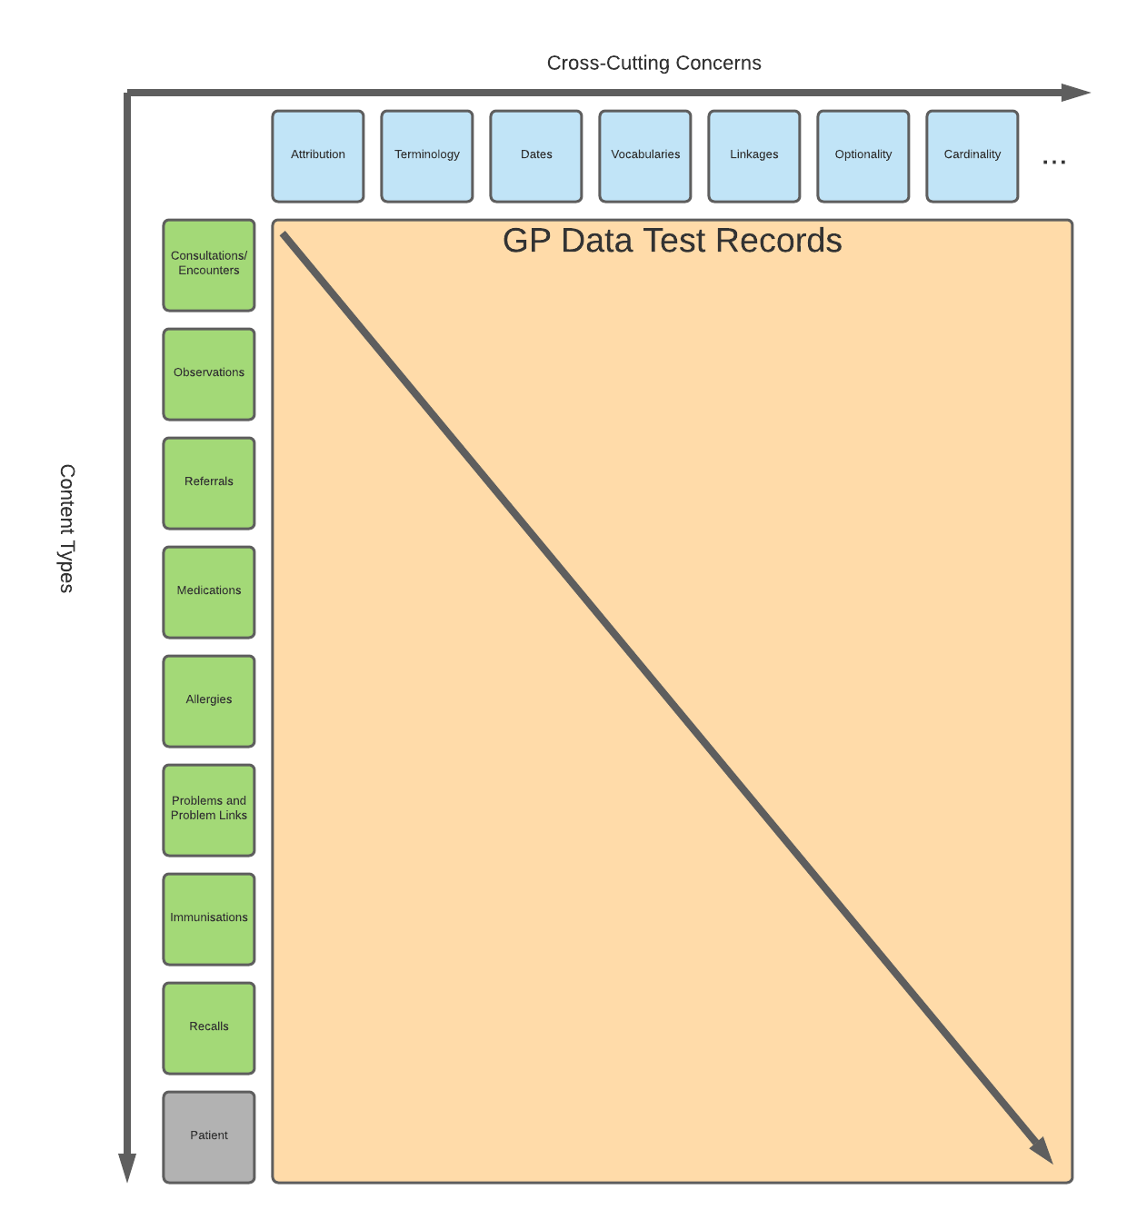
The test data design is based on the combination of 2-axes.
- In any system and in the GPDPR extract there are a number of data attributes that are common concerns across all record content e.g., attribution, use of terminology, optionality, vocabulary coverage etc … These can be thought of as ‘cross-cutting’ concerns.
- There is a range of defined system content e.g., Observations, allergies, medications to which the cross-cutting concerns may apply.

The records used in GPDPR testing are the combination of these 2 axes – generated applying the cross-cutting concerns across the range of content types in the system.
This approach leads to a basic test data template outline which is expanded/tailored to a given system and can be found in the cross-cutting tab in the test report along with the static content tests.
The test cases in the appointments tab in the test report gives an overview of the items that will need testing; however, the supplier’s appointment book may give rise to changes and NHSD reserve the right to test other elements of the appointment feed if they have any concerns.

Annotated Technical Output Specification

Formal test evidence is provided in the form of an annotated Technical Output Specification (TOS) document which records which fields of the extract have been checked.
A secondary purpose of this annotated TOS is at the end of testing to provide information for analysts and other consumers of the dataset on the usability of each field, any recorded issues/defects affecting the field and other useful information.
The annotated TOS should be merged with supplier mapping documentation to provide a consolidated guide to the extract implementation by a particular supplier at the end of testing.

Differencing/Regression/Techniques
Once a certain maturity/stability in the extract has been reached, the test process transitions from visually comparing test records to extracts to a semi manual approach based on XML differencing. This can also be used as the basis of future regression testing with automation.

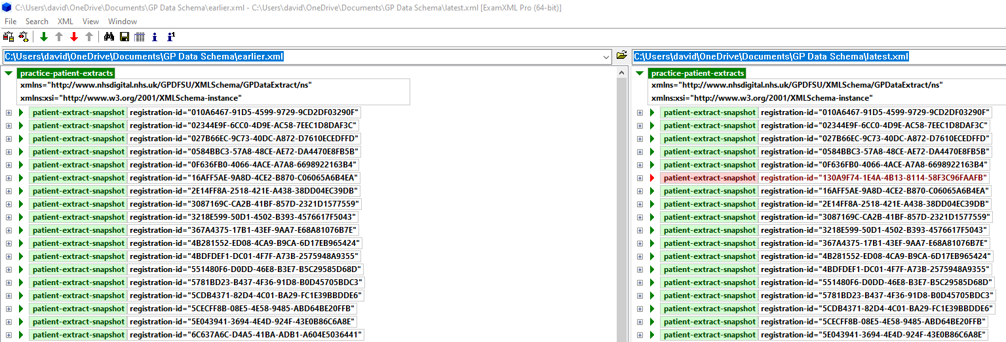
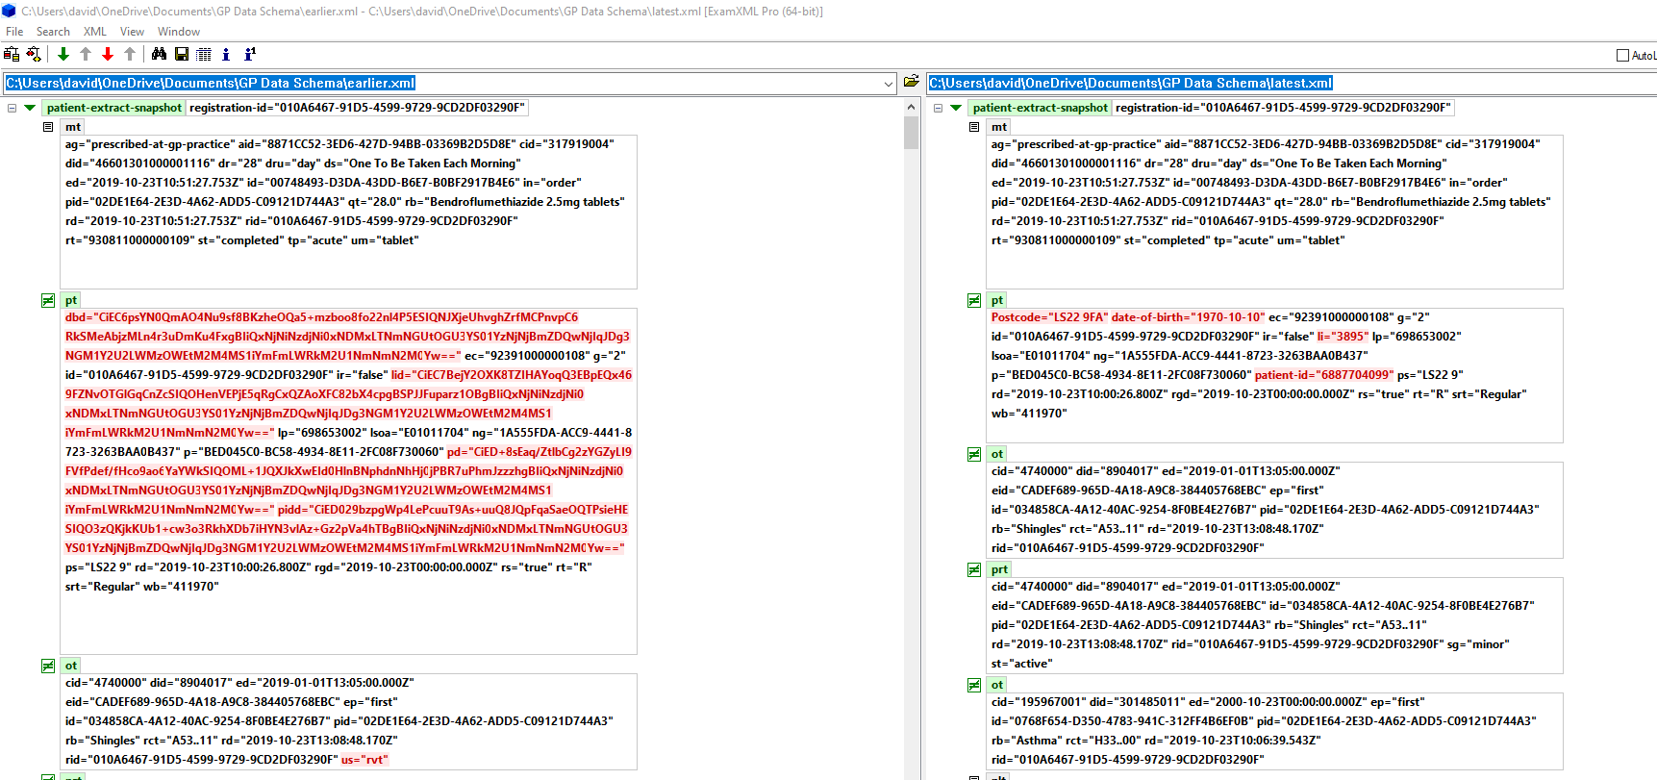

The tool used in this instance is ExamXML (http://www.a7soft.com/examxml.html) which also supports command line automation, but other tools and approaches are possible.
The differencing process can be rendered more difficult when there is a significant re-ordering or re-structuring of content within an extract, perhaps in response to new or added content. It is generally better to maintain stable test records for comparison purposes to avoid these issues.
A sort of transform was developed to provide a canonical sort of records to assists with re-ordering issues but is not usually required and in most cases the tool shown can handle changes between test versions of the extract.

Jira Logging
Prioritisation

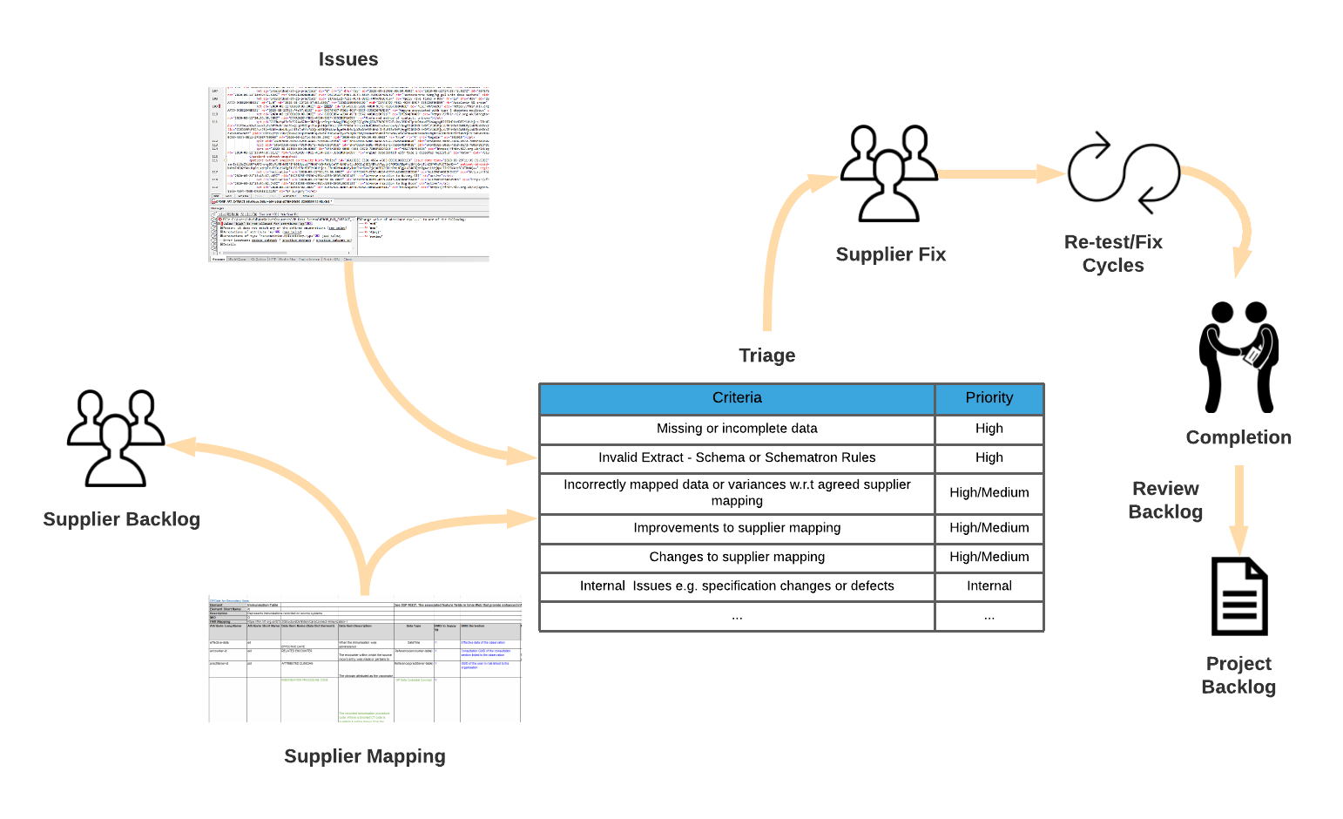

Issue prioritisation is a potentially complex task with a strong subjective and pragmatic element that takes into account delivery timescales and supplier capability/co-operation in assessing the priority to attach to a given problem.
A priority of High or above is used to indicate issues which must be addressed to go live with the product.
High priority is generally reserved for instances of missing data, invalid extracts against the defined GPDPR schema products or significant and unexpected departures from the agreed mapping.
Priorities of medium and below are reserved for minor issues that do not prevent the product going live. Minor discrepancies on non-key fields between stated supplier mappings and the extract may fall into this category.
All appropriate issues are fed back to suppliers at the end of each test cycle for fix or addition to the backlog.
Once all ‘High’ priority issues are addressed the product is considered ready for live use from all testing perspective.
At that point remaining lower priority issues may be re-prioritised and placed on the supplier backlog for future releases alongside future GPDPR change requests and improvements.

- Test Report
A test report is generated as the output of each test cycle.
This includes.
- Test environments used.
- Test records/data/extracts used.
- Issues found, closed, re-prioritised etc.

A test closure report will be generated after the final testing cycle. At that point it is expected that there is no more blocking High priority issued to be found.

Appendix A
The Solution Assurance Output Report workbook:

